SI Table.1 List of the 23 plant species sampled in this study. Samples were collected from heights of 0.5 m, 1.5 m and 2.5 m above the ground surface. D = Deciduous species, E = Evergreen species. AD = adaxial surface, AB = abaxial surface, LA = average leaf area per leaf, TLA = total leaf area of the measured sample, NA = no stomata or trichomes were observed. n is the number of samples.
Plant types | Plant species | Leaves  number | Stomatal density  number/mm² | Trichomes  number/mm² | Mean LA  cm²
0.5 m-Lianas-D  (n=14) | Parthenocissus quinquefolia (n=14) | 19 | AB: 121.74 | NA | 50.55
0.5 m-Shrubs-D  (n=51) | Prunus×cistena (n=24) | 110 | AB: 226.09 | NA | 11.35
 | Berberis thunbergii (n=27) | 405 | AB: 226.09 | NA | 1.59
0.5 m-Shrubs-E  (n=205) | Buxus megistophylla (n=42) | 215 | AB: 347.83 | NA | 9.28
 | Ligustrum×vicaryi (n=66) | 549 | AB: 417.39 | NA | 7.56
 | Buxus sinica (n=70) | 1050 | AB: 130.43 | NA | 1.79
 | Rosa chinensis (n=27) | 89 | AB: 117.39 | NA | 17.37
1.5 m-Shrubs-D  (n=73) | Amygdalus persica (n=17) | 60 | AB: 139.13 | NA | 26.99
 | Syzygium aromaticum (n=32) | 41 | AD: 60.87 | NA | 35.29
 |  |  | AB: 243.48 | NA
 | Lonicera maackii (n=6) | 28 | AB: 278.26 | AD: 2.17 | 18.59
 |  |  |  | AB: 34.78
 | Amygdalus triloba (n=18) | 66 | AB: 136.96 | AD: 2.17 | 20.01
1.5 m-Shrubs-E  (n=35) | Prunus Cerasifera (n=35) | 166 | AB: 286.96 | NA | 17.18
1.5 m-Trees-D  (n=40) | Malus×micromalus Makino (n=8) | 34 | AB: 217.39 | NA | 20.48
 | Cerasus yedoensis (n=21) | 41 | AB: 356.52 | NA | 41.78
 | Sophora japonica f. pendula (n=11) | 86 | AB: 147.83 | NA | 11.25
2.5 m-Trees-D  (n=183) | Fraxinus chinensis (n=6) | 16 | AB: 193.48 | NA | 24.29
 | Ailanthus altissima (n=16) | 38 | AB: 460.87 | AD: 10.87 | 27.44
 |  |  |  | AB: 8.70
 | Salix babylonica (n=34) | 164 | AB: 23.91 | AD: 26.09 | 13.16
 |  |  |  | AB: 2.08
 | Robinia pseudoacacia (n=27) | 205 | NA | AD: 43.48 | 9.18
 |  |  |  | AB: 78.26
 | Sophora japonica (n=61) | 490 | AB: 217.39 | AD: 6.52 | 9.05
 | Salix matsudana (n=4) | 28 | AB: 8.70 | NA | 9.64
 | Ginkgo biloba (n=15) | 33 | AB: 60.87 | NA | 23.66
 | Ulmus pumila (n=20) | 123 | AB: 134.78 | NA | 9.31

SI Table 2 Multiple comparisons results of One-way ANOVA (k-w) performed among seven groups (0.5 m-Lianas-D, 0.5 m-Shrubs-D, 0.5 m-Shrubs-E,1.5 m-Shrubs-D, 1.5 m-Shrubs-E, 1.5 m-trees-D, 2.5 m-trees-D). Statistically significant differences (p<0.05) are highlighted in bold. D = Deciduous, E = Evergreen. weight = weight of trapped particles, SIRM_{u} = SIRM of unwashed plant leaves, SIRM_{u-w} = SIRM of deposited particles, SIRM_{w} = SIRM of washed plant leaves.
(i) group | (j) group | weight | SIRM_{u} | SIRM_{u-w} | SIRM_{w}
0.5 m-Lianas-D | 0.5 m-Shrubs-D | 1 | 1 | 1 | 1
 | 0.5 m-Shrubs-E | 0.948 | 0.587 | 1 | 0.165
 | 1.5 m-Shrubs-D | 1 | 1 | 1 | 1
 | 1.5 m-Shrubs-E | 1 | 1 | 1 | 1
 | 1.5 m-trees-D | 1 | 1 | 1 | 1
 | 2.5 m-trees-D | 1 | 1 | 1 | 0.605
0.5 m-Shrubs-D | 0.5 m-Shrubs-E | <0.0001 | <0.0001 | <0.0001 | <0.0001
 | 1.5 m-Shrubs-D | 0.019 | 1 | 0.978 | 1
 | 1.5 m-Shrubs-E | <0.0001 | 0.006 | 0.006 | 0.194
 | 1.5 m-trees-D | 1 | 1 | 1 | 1
 | 2.5 m-trees-D | 0.819 | 1 | 1 | 0.006
0.5 m-Shrubs-E | 1.5 m-Shrubs-D | 0.013 | <0.0001 | 0.001 | 0.017
 | 1.5 m-Shrubs-E | 1 | 1 | 1 | 1
 | 1.5 m-trees-D | <0.0001 | <0.0001 | <0.0001 | 0.015
 | 2.5 m-trees-D | <0.0001 | <0.0001 | <0.0001 | 1
1.5 m-Shrubs-D | 1.5 m-Shrubs-E | 0.765 | 0.582 | 0.724 | 1
 | 1.5 m-trees-D | 0.401 | 1 | 1 | 1
 | 2.5 m-trees-D | 1 | 1 | 1 | 0.391
1.5 m-Shrubs-E | 1.5 m-trees-D | 0.003 | 0.020 | 0.016 | 1
 | 2.5 m-trees-D | 0.003 | 0.104 | 0.005 | 1
1.5 m-trees-D | 2.5 m-trees-D | 1 | 1 | 1 | 0.203

SI Table 3 One-way ANOVA results performed among different functional areas (traffic areas, residential areas and parks) for seven plant types. Statistically significant differences (p < 0.05) are highlighted in bold. D = Deciduous, E = Evergreen. weight = weight of trapped particles, SIRM_{u} = SIRM of unwashed plant leaves, SIRM_{u-w} = SIRM of deposited particles, SIRM_{w} = SIRM of washed plant leaves.
Group | weight | SIRM_{u} | SIRM_{u-w} | SIRM_{w}
1.5 m-Lianas-D | 0.159 | 0.351 | 0.216 | 0.851
0.5 m-Shrubs-D | 0.474 | 0.146 | 0.131 | 0.520
0.5 m-Shrubs-E | <0.0001 | <0.0001 | <0.0001 | <0.0001
1.5 m-Shrubs-D | <0.0001 | <0.0001 | <0.0001 | <0.0001
1.5 m-Shrubs-E | 0.256 | 0.069 | 0.043 | 0.201
1.5 m-trees-D | 0.128 | 0.006 | 0.008 | 0.050
2.5 m-trees-D | <0.0001 | <0.0001 | <0.0001 | <0.0001

SI Table 4 Multiple comparisons results of One-way ANOVA (k-w) performed among three functional areas (traffic area, residential area and park) for seven groups. Statistically significant differences (p < 0.05) are highlighted in bold. “\” = no significant differences. D = Deciduous, E = Evergreen. weight = weight of trapped particles, SIRM_{u} = SIRM of unwashed plant leaves, SIRM_{u-w} = SIRM of deposited particles, SIRM_{w} = SIRM of washed plant leaves.
Sample(i)-sample(j) | Residential area - park |  |  |  | Residential area - traffic area |  |  |  | Park - traffic area
 | weight | SIRM_{u} | SIRM_{u-w} | SIRM_{w} | weight | SIRM_{u} | SIRM_{u-w} | SIRM_{w} | weight | SIRM_{u} | SIRM_{u-w} | SIRM_{w}
0.5 m-Liana-D | \ | \ | \ | \ | \ | \ | \ | \ | \ | \ | \ | \
0.5 m-Shrub-D | \ | \ | \ | \ | \ | \ | \ | \ | \ | \ | \ | \
0.5 m- Shrub-E | 1 | 0.928 | 1 | 0.418 | <0.0001 | <0.0001 | <0.0001 | <0.0001 | <0.0001 | <0.0001 | <0.0001 | 0.032
1.5 m- Shrub-D | 0.818 | 0.702 | 1 | 0.500 | 0.003 | <0.0001 | <0.0001 | 0.001 | 0.006 | <0.0001 | <0.0001 | 0.003
1.5 m- Shrub-E | \ | \ | \ | \ | \ | \ | \ | \ | \ | \ | \ | \
1.5 m-Tree-D | 0.869 | 1 | 1 | \ | 0.054 | 0.028 | 0.028 | \ | 0.034 | 0.030 | 0.041 | \
2.5 m-Tree-D | 0.993 | 1 | 1 | 1 | <0.0001 | <0.0001 | <0.0001 | 0.003 | 0.35 | 0.101 | 0.061 | 0.501

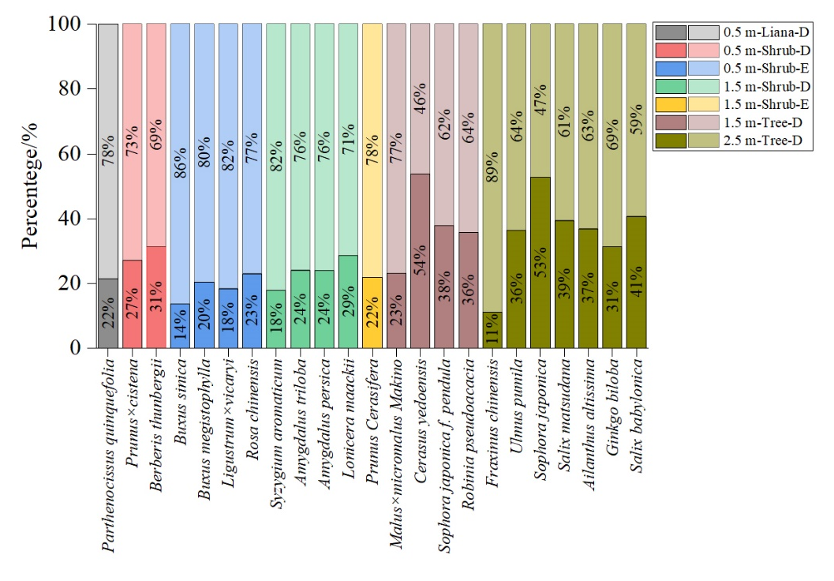
SI Fig. 1 Percentages of SIRM_{u-w}/SIRM_{u} (the under bars) and SIRM_{w}/SIRM_{u} (the upper bars) for the considered plant types (n=23). D= Deciduous (n=361), E=Evergreen (n=240).

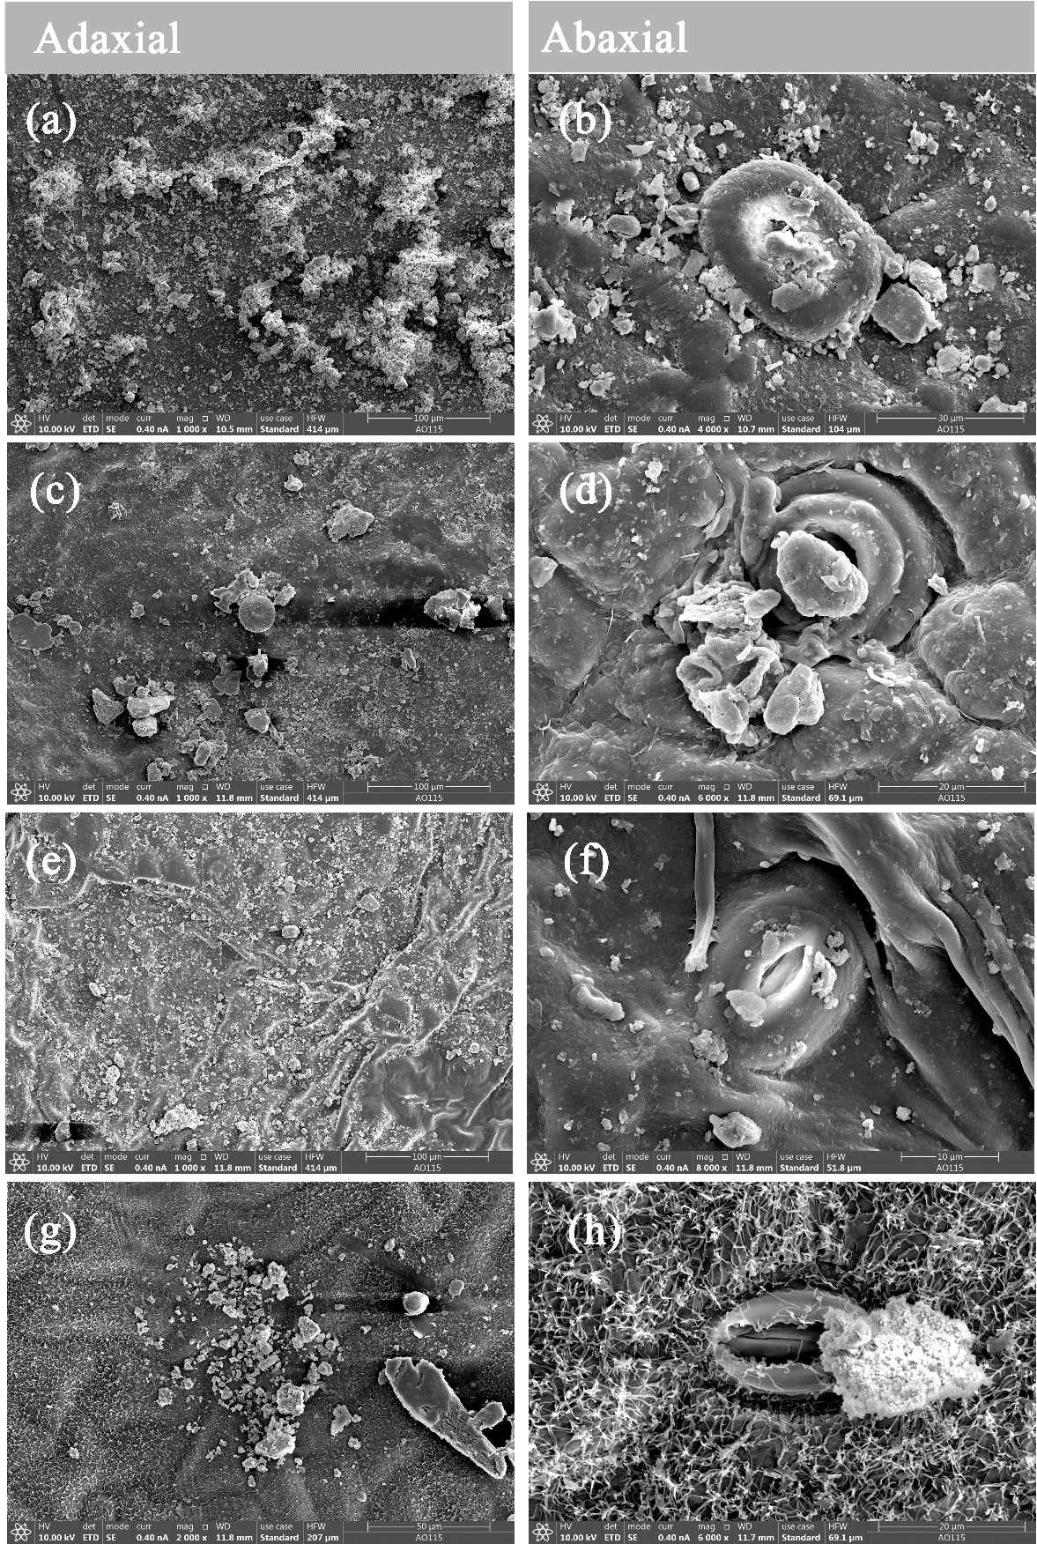
SI Fig. 2 SEM images showing the micromorphology and attachment of particles to adaxial and abaxial surfaces of leaves of 0.5 m-Shrub-E Buxus sinica (a) (b), Buxus megistophylla (c) (d), Ligustrum×vicary (e) (f) and Rosa chinensis (g) (h)
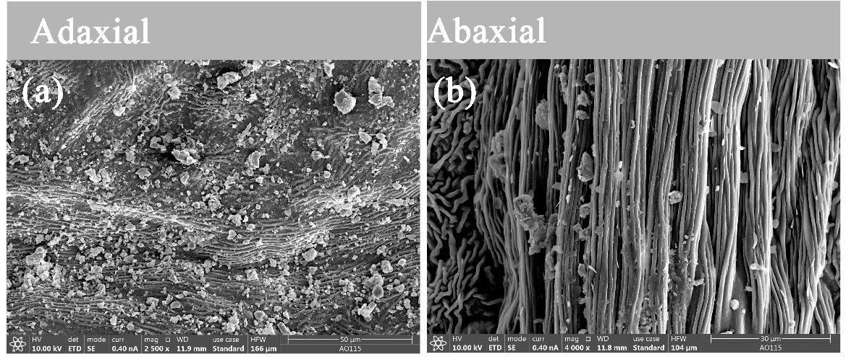
SI Fig. 3 SEM images showing the micromorphology and attachment of particles to the adaxial and abaxial surfaces of leaves of 1.5 m-Shrubs-E. Prunus Cerasifera (a) (b).

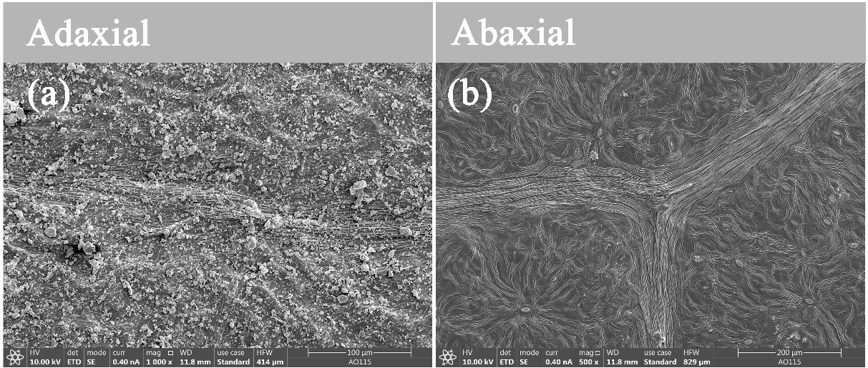
SI Fig. 4 SEM images showing the micromorphology and attachment of particles to the adaxial and abaxial surfaces of leaves of 0.5 m-Lianas-D. Parthenocissus quinquefolia (a) (b).

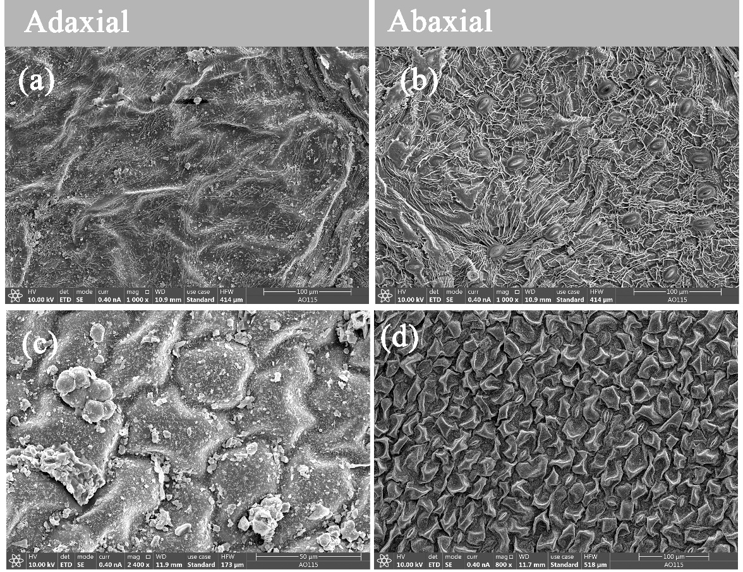
SI Fig. 5 SEM images showing the micromorphology and attachment of particles to the adaxial and abaxial surfaces of leaves of 0.5 m-Shrubs-D. Prunus×cistena (a) (b) and Berberis thunbergii (c) (d)

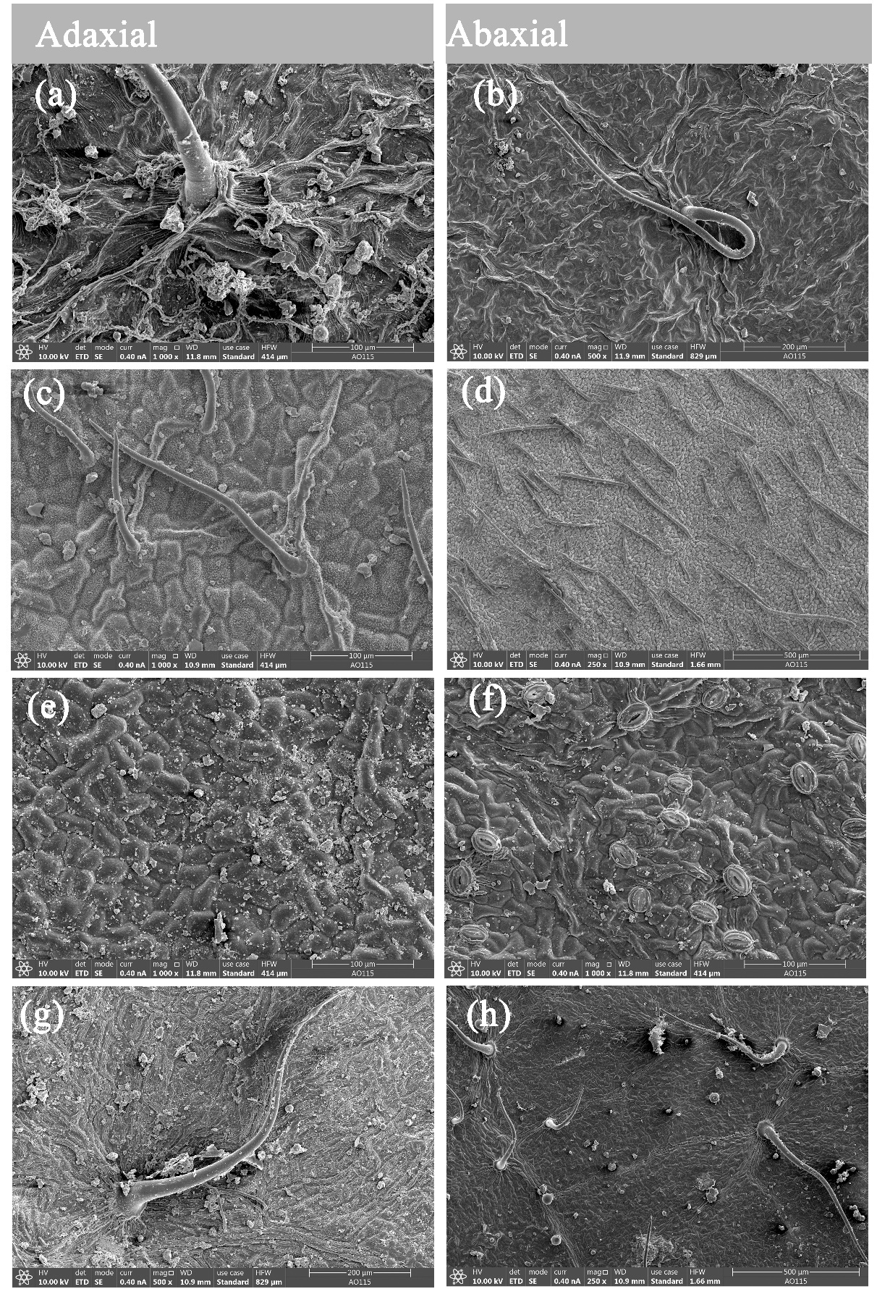
SI Fig. 6 SEM images showing the micromorphology and attachment of particles to the adaxial and abaxial surfaces of leaves of 1.5 m-Shrubs-D. Amygdalus triloba (a) (b), Syzygium aromaticum (c) (d), Amygdalus persica (e) (f) and Lonicera maackii (g) (h)
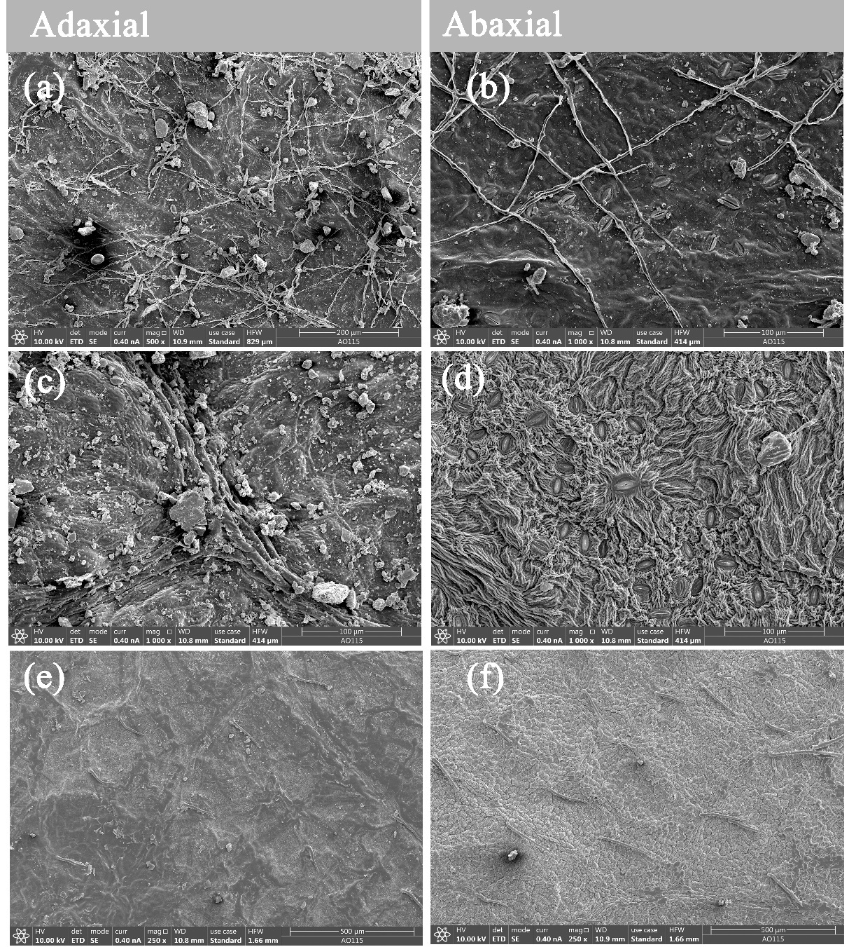
SI Fig. 7 SEM showing the micromorphology and attachment of particles to the adaxial and abaxial surfaces of leaves of 1.5 m-Tree-D. Malus×micromalus Makino (a) (b), Cerasus yedoensis (c) (d) and Sophora japonica f. pendula (e) (f)

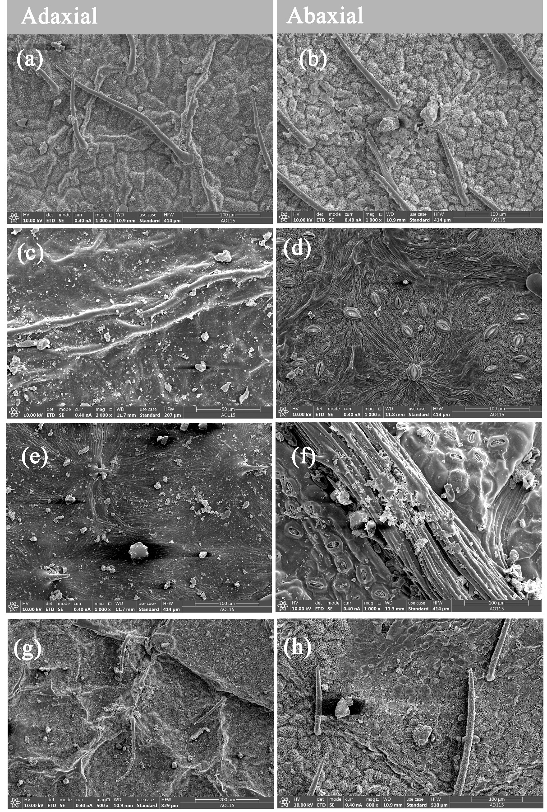
SI Fig. 8 SEM images showing the micromorphology and attachment of particles to the adaxial and abaxial surfaces of leaves of 2.5 m-Trees-D. Robinia pseudoacacia (a) (b), Fraxinus chinensis (c) (d), Ulmus pumila (e) (f), Sophora japonica (g) (h).
1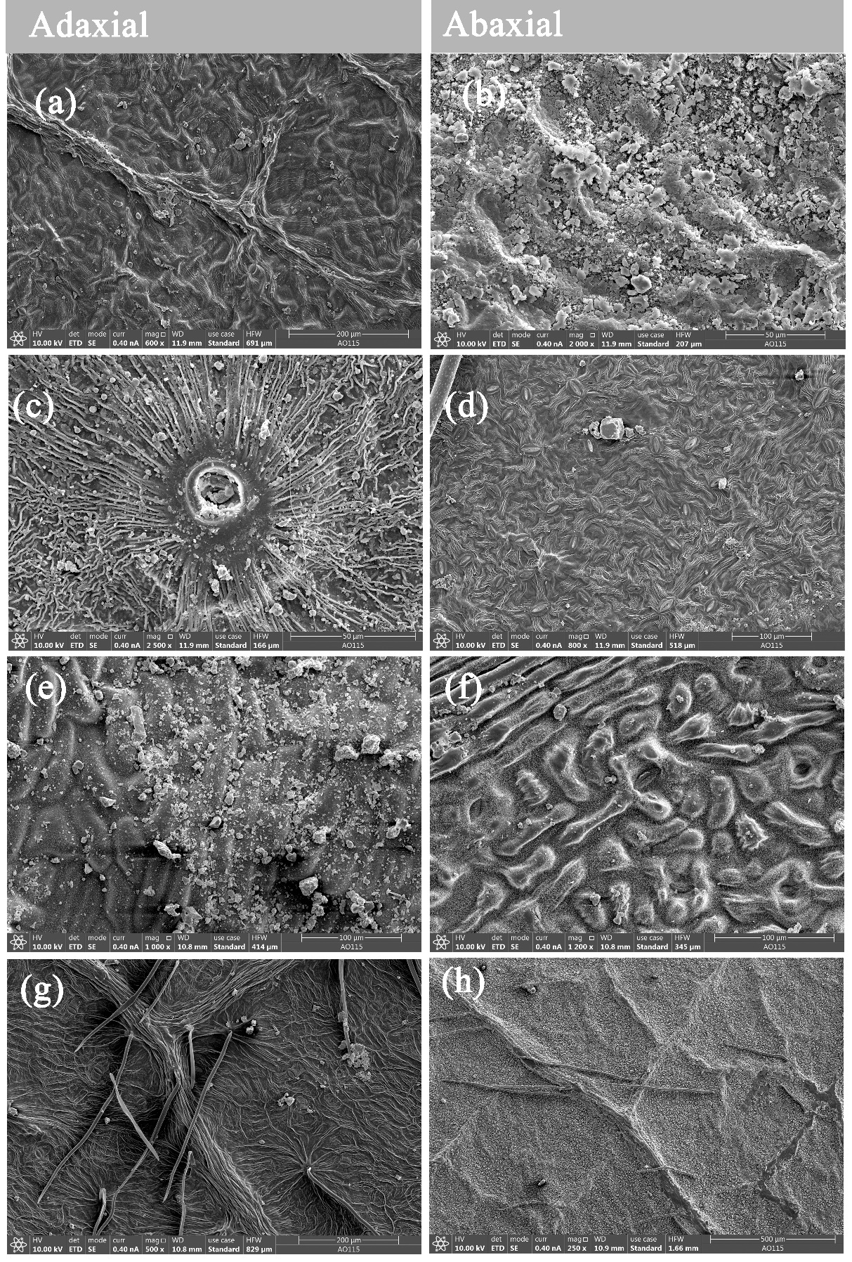
SI Fig. 9 SEM images showing the micromorphology and attachment of particles to the adaxial and abaxial surfaces of leaves of 2.5 m-Trees-D. Salix matsudana (a) (b), Ailanthus altissima (c) (d), Ginkgo biloba (e) (f) and Salix babylonica (g) (h)

