Supplementary material

Table S1. Three-way ANOVA test on leaf-level WUE and iWUE
Sources |  | numDF | Sum Square | Mean Square | F-value | p-value
Leaf-level WUE
 | Model formula: aov( leaf-level WUE~ Thinning*Aspect*Date)
Thinning |  | 1 | 4 | 3.9 | 0.534 | 0.465
Aspect |  | 1 | 2 | 2.3 | 0.317 | 0.573
Date |  | 1 | 1413 | 1412.9 | 193.612 | <0.001
Thinning × Aspect |  | 1 | 0 | 0.4 | 0.059 | 0.808
Thinning × Date |  | 1 | 0 | 0.4 | 0.048 | 0.826
Aspect × Date |  | 1 | 8 | 8.5 | 1.160 | 0.282
Thinning × Aspect × Date |  | 1 | 1 | 0.6 | 0.077 | 0.781
Residuals |  | 538 | 3926 | 7.3
Leaf-level WUEi
 | Model formula: aov( leaf-level WUEi~ Thinning*Aspect*Date)
Thinning |  | 1 | 89634 | 89634 | 43.709 | <0.001
Aspect |  | 1 | 10 | 10 | 0.005 | 0.946
Date |  | 1 | 271598 | 271598 | 132.443 | <0.001
Thinning × Aspect |  | 1 | 468 | 468 | 0.228 | 0.633
Thinning × Date |  | 1 | 4540 | 4540 | 2.214 | 0.137
Aspect × Date |  | 1 | 1221 | 1221 | 0.595 | 0.441
Thinning × Aspect × Date |  | 1 | 5 | 5 | 0.003 | 0.959
Residuals |  | 538 | 1103266 | 2051

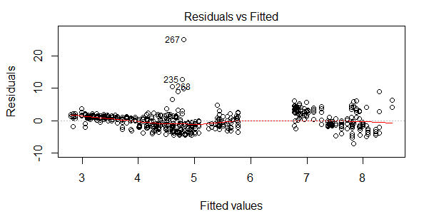
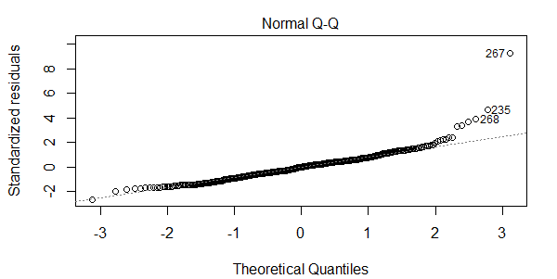
Figure S1 Residual check for the three-way ANOVA model for leaf-level WUE.

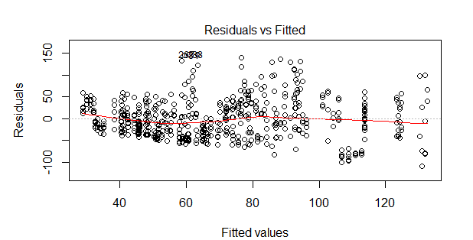
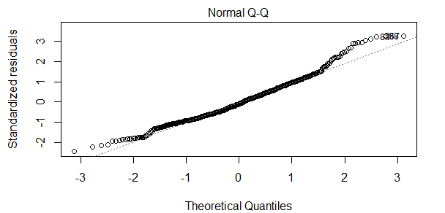
Figure S2 Residual check for the three-way ANOVA model for leaf-level WUEi.

Table S2. ANCOVA test on tree-level WUE
Model structure: Intercept + Initial DBH + Thinning + Year + Thinning * Year
Source | Type III Sum of Squares | df | Mean Square | F | Sig.
Corrected Model | 14.667ª | 6 | 2.445 | 2.962 | .028
Intercept | 12.089 | 1 | 12.089 | 14.651 | .001
Initial DBH | 8.484 | 1 | 8.484 | 10.282 | .004
Thinning | 6.578 | 2 | 3.289 | 3.986 | .033
Year | .608 | 1 | .608 | .736 | .400
Thinning * Year | .294 | 2 | .147 | .178 | .838
Error | 18.154 | 22 | .825
Total | 42.966 | 29
Corrected Total | 32.821 | 28
Note:
a. R Squared = .447 (Adjusted R Squared = .296)
Levene's Test of Equality of Error Variances p =0.532.

Table S3. ANCOVA test on initial tree DBH
Model structure: Intercept + Treatment + Year + Treatment * Year
Source | Type III Sum of Squares | df | Mean Square | F | Sig.
Corrected Model | 344.282ª | 5 | 68.856 | .408 | .838
Intercept | 98275.994 | 1 | 98275.994 | 582.642 | .000
Thinning | 224.560 | 2 | 112.280 | .666 | .524
Year | 107.138 | 1 | 107.138 | .635 | .434
Thinning * Year | 31.272 | 2 | 15.636 | .093 | .912
Error | 3879.482 | 23 | 168.673
Total | 102542.208 | 29
Corrected Total | 4223.764 | 28
Note:
a. R Squared = .082 (Adjusted R Squared = -.118)
Levene's Test of Equality of Error Variances p =0.987.

Fig. S3. Leaf-level WUE (top) WUEi (bottom) versus VPD for C, T1 and T2 with fitted logarithmatic equations.

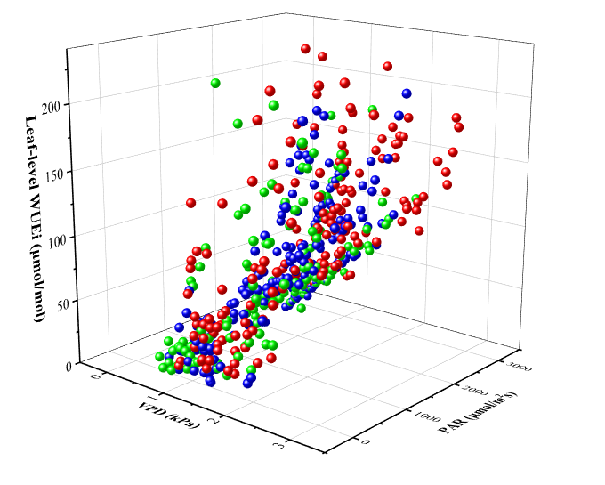
Figure S4. 3D scatter plot of leaf-level WUEi against VPD and PAR for C (in red), T1 (in green) and T2 (in blue).

Table S4. Two-way ANOVA test on log-transformed stand-level WUE
Model structure: Intercept + Treatment + Year + Treatment * Year
Source | Type III Sum of Squares | df | Mean Square | F | Sig.
Corrected Model | 0.862ª | 5 | 0.172 | 11.865 | 0.002
Intercept | 0.028 | 1 | 0.028 | 1.913 | 0.204
Thinning | 0.046 | 2 | 0.023 | 1.567 | 0.267
Year | 0.623 | 1 | 0.623 | 42.860 | 0.000
Thinning * Year | 0.077 | 2 | 0.039 | 2.662 | 0.130
Error | 0.116 | 8 | 0.015
Total | 1.161 | 14
Corrected Total | 0.978 | 13
Note:
a. R Squared = .881 (Adjusted R Squared = 0.807)
Levene's Test of Equality of Error Variances p =0.103.

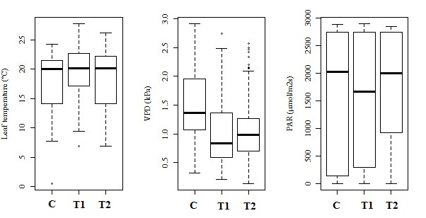
Figure S5. Temperature, VPD and PAR in C, T1 and T2 during leaf measurement periods.

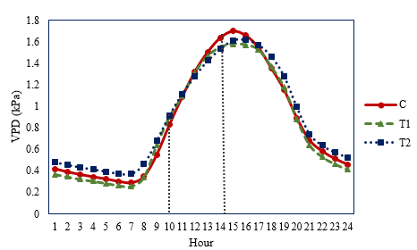
Figure S6. Daily VPD variations in C, T1 and T2. Leaf-level measurements took place between 10 am to 14 pm.

