AR-23 derivatives with high endosomal disrupting ability enhance Poly(L-lysine)-mediated gene transfection

Shi-Kun Zhang^{1#}, Lin Gong^{1,3#}, Xue Zhang¹, Zhi-min Yun¹, Su-Bo Li¹, Hong-Wei Gao¹, Cong-Jie Dai²，Jian-Jun Yuan²，Jing-ming Chen⁴, Feng Gong*¹, Ying-Xia Tan*¹, Shou-Ping Ji*^{1,2}

- Department of Stem Cell and Regenerative Medicine, Institute of Health Service and Transfusion Medicine, Beijing, China.
- College of Oceanology and Food Sciences，Quanzhou Normal University, Quanzhou, Fujian.
- PLA navy No. 971hospital, Qingdao, Shandong.
- Quanzhou Preschool Education College, Quanzhou, Fujian.
*Correspondence to: Shou-Ping Ji, Ying-Xia Tan and Feng Gong. Department of Stem Cell and Regenerative Medicine Laboratory, Institute of Health Service and Transfusion Medicine, 27 Taiping Road, Beijing 100850, China. Tel.: +8601066931937; fax: +8601068151876 E-mail: jisp2020@qztc.edu.cn; tuanhu333@126.com; gongfeng@nic.bmi.ac.cn.

# these authors contributed equally to this work.

Figure s1. Agarose gel electrophoresis of PLL/DNA and PEI/DNA/peptide; the peptide was added at different concentrations as indicated behind the peptide. 1. Marker; 2. DNA (Plasmid); 3. PLL/DNA; 4. PLL/DNA + AR-23 (2.5 µM); 5. PLL/DNA + aAR1 (10 µM); 6. PLL/DNA + aAR2 (20 µM); 7. PLL/DNA + aAR3 (40 µM).
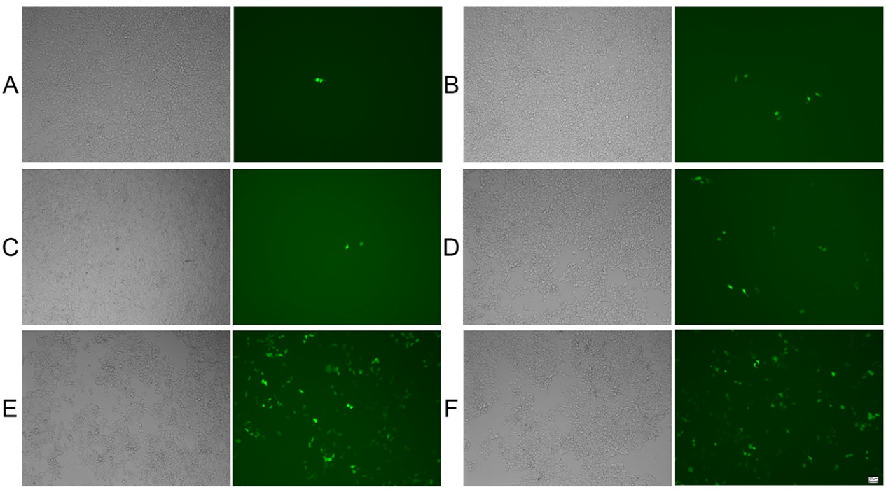
Figure s2. Transfection efficiency of PLL/DNA and PLL/DNA/peptide in HEK-293 cells, images were acquired with an inverted fluorescence microscope (scale bar = 50 µm). A. PLL/DNA; B. PLL/DNA + AR-23 (2.5 µM); C. PLL/DNA + aAR3 (5 µM); D PLL/DNA + aAR2 (20 µM); E. PLL/DNA + aAR3 (40 µM); F. Lipfectamine 2000.

