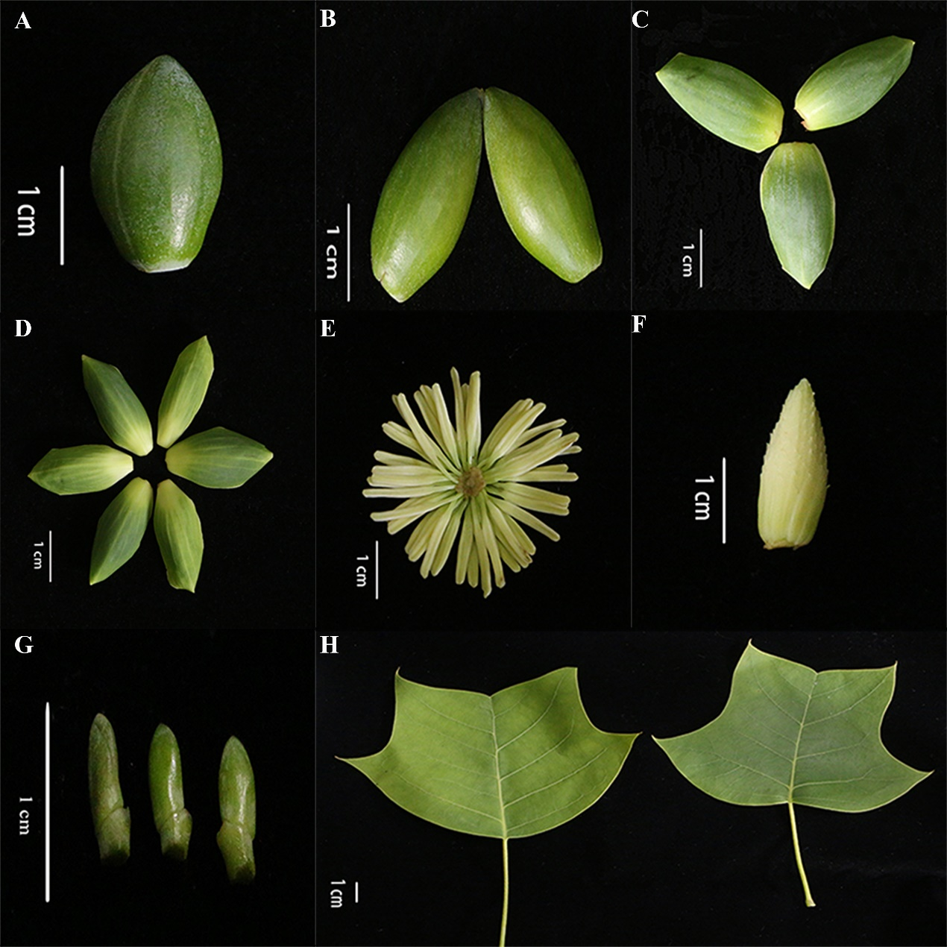
Fig. S8 L. chinense materials used for sequencing. a Expanded flower bud. b Bracts. c Sepals. d Petals. e Stamens. f Pistils. g Shoot apex (less than 1 cm). h Mature leaves.

