Supplementary Materials
Using hemodynamic parameters quantified with computational fluid dynamics to explore potential mechanisms of occurrence and progression in Alzheimer Disease
Jian Xie^{§1}, Zaiheng Cheng^{§2}, LiHua Gu¹, Bokai Wu², Gao-jia Zhang³,Wen-Shin Shiu², , Rongliang Chen², Zan Wang¹, Chang Liu², Xiao-chuan Cai⁴, Li-Ping Wang², Jia Liu*², Zhijun Zhang¹*
§ These authors contributed equally to this work.
*Correspondence: janemengzhang@vip.163.com; jia.liu@siat.ac.cn.
¹Zhijun Zhang, PhD& MD, Department of Neurology, Affiliated ZhongDa Hospital, School of Medicine , Southeast University , Nanjing , Jiangsu 210009 , China.
²Jia Liu, PhD, Shenzhen Institutes of Advanced Technology, Chinese Academy of Sciences, Shenzhen, Guangzhou 518055, China.

Contents
Supplementary TableS1, TableS2.
Supplementary FigureS1.

Supplementary Table S1: Supplementary demographics and clinical characteristics of participants
Characteristics |  | AD(n=30) | VaD(n=29) | HCs(n=34) | F value | P value
MAP(mmHg) |  | 95.40±9.22 | 99.26±13.87 | 97.34±11.12 | 0.842 | 0.434
HR(p/min) |  | 73.72±10.43 | 75.04±7.43 | 73.62±8.54 | 0.23 | 0.80
BMR |  | 23.72±21.22 | 23.03±14.93 | 24.91±14.98 | 0.09 | 0.91
History of  Atrial fiberration |  | 1 | 1 | 0
Alcohol Abuse |  | 1 | 2 | 1
ASCVD  risk | Low-risk | 2 | 0 | 6 | χ²=7.05 | 0.11
 | Mid-risk | 3 | 1 | 7
 | High-risk | 15 | 12 | 15
Hb(g/L) |  | 127.64±12.10 | 125.92±15.65 | 134.48±17.56 | 0.08 | 2.62
Total serum protein(g/L) |  | 64.61±5.72 | 63.94±7.38 | 66.52±6.01 | 1.32 | 0.27
Low serum albumin |  | 1 | 3 | 2
ALT(U/L) |  | 18.86±8.67 | 19.42±16.56 | 19.41±10.09 | 0.02 | 0.98
UN(mmol/L) |  | 5.43±1.71 | 6.57±4.14 | 5.28±1.22 | 2.164 | 0.121
SHcy (umol/L) |  | 15.22±9.49 | 15.37±12.60 | 15.31±9.94 | 0.001 | 0.99
HbA1c(%) |  | 6.47±1.63 | 6.82±1.79 | 6.19±1.17 | 1.123 | 0.33
Abbreviations: MAP: mean artery pressure, HR: heart rate, BMR: basic metabolism rate=(HR+MAP)-111, Hb: Hemoglobin, ALT: alanine aminotransferase, Cr: creatinine, sHcy: serum homocysteine, HbA1c: glycosylated hemoglobin, ASCVD: Arteriosclerotic Cardiovascular Disease.

Supplementary Table S2 Hemodynamic parameters of all subjects
 | CBF | CVR
number | 93 | 93
minimum | 4.69 | 4110.93
maximum | 20.88 | 25529.00
mean value | 10.96 | 10170.52
standard deviation | 3.47 | 4273.141
25th percentile | 8.52 | 7000.00
50th percentile | 10.11 | 9368.15
75th percentile | 13.51 | 12813.89
a)

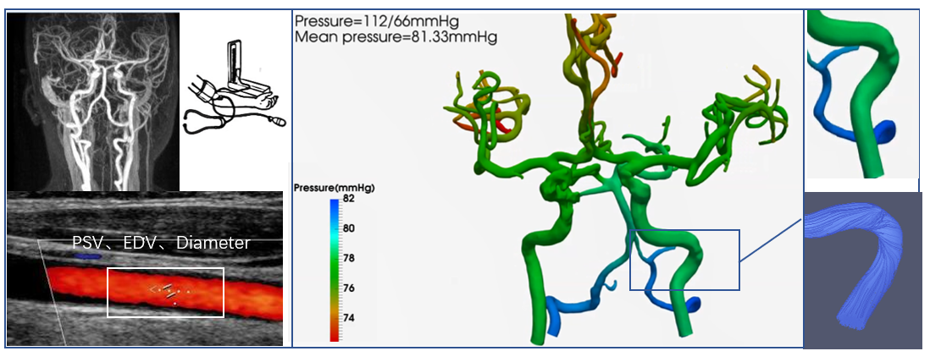
b)
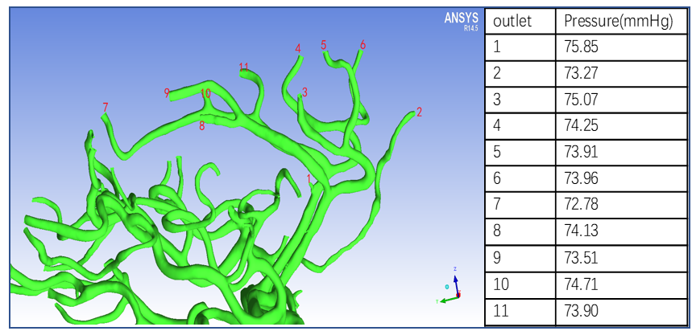
Supplementary figure S1 Procedure of CFD model, (a) a whole brain intracranial arterial tree was rebuilt, the pressure of every vessel was shown in color map, (b) pressure of every branch could be calculated.

