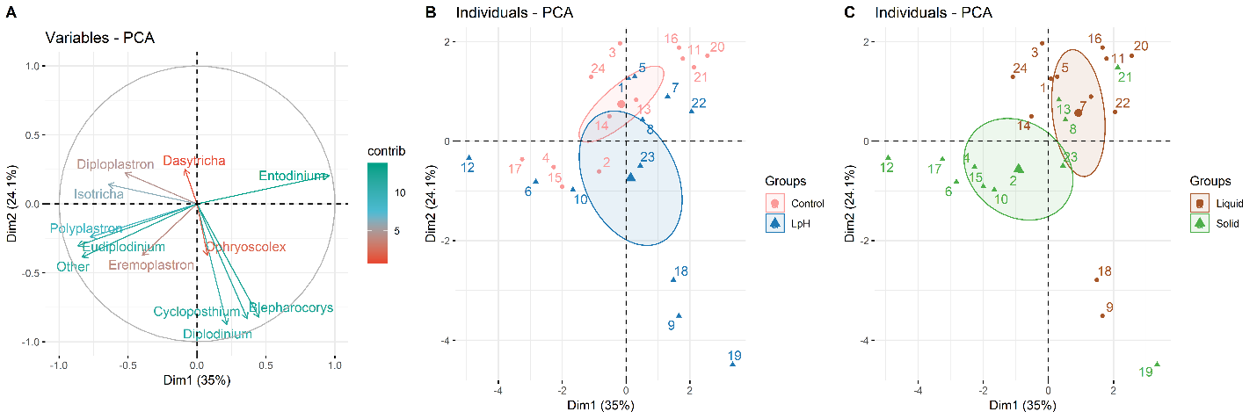
Figure S1. Principal component analyses (PCA) of overall protozoal composition among all samples at the general level. Variable contributions to the first two components are labelled with different colors (A). All variables were represented by arrows, and individuals were represented by points with numbers. Points were colored by treatment group (B) or ruminal sample fraction group (C). All the sequence counts were transformed to centered log ratios before PCA analyses.
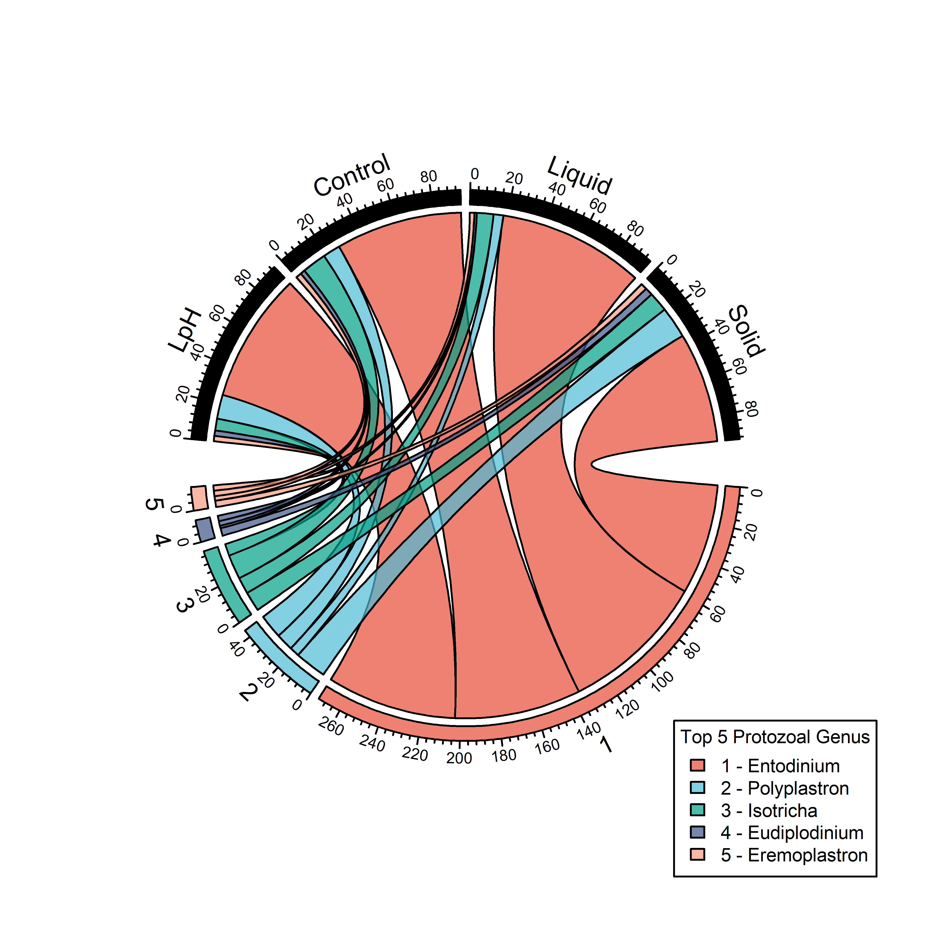
Figure S2. Taxonomic composition of the ruminal microbiome in the liquid and solid fractions in response to high and low pH. The top 10 protozoal genera were selected. Sequences were expressed as relative abundance.

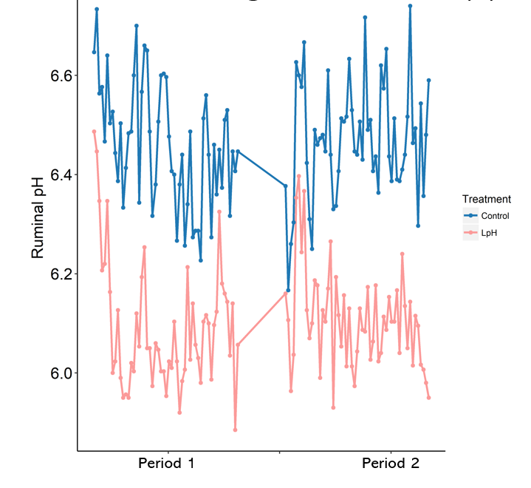
Figure S3. Ruminal pH achieved during each of 10-day period.
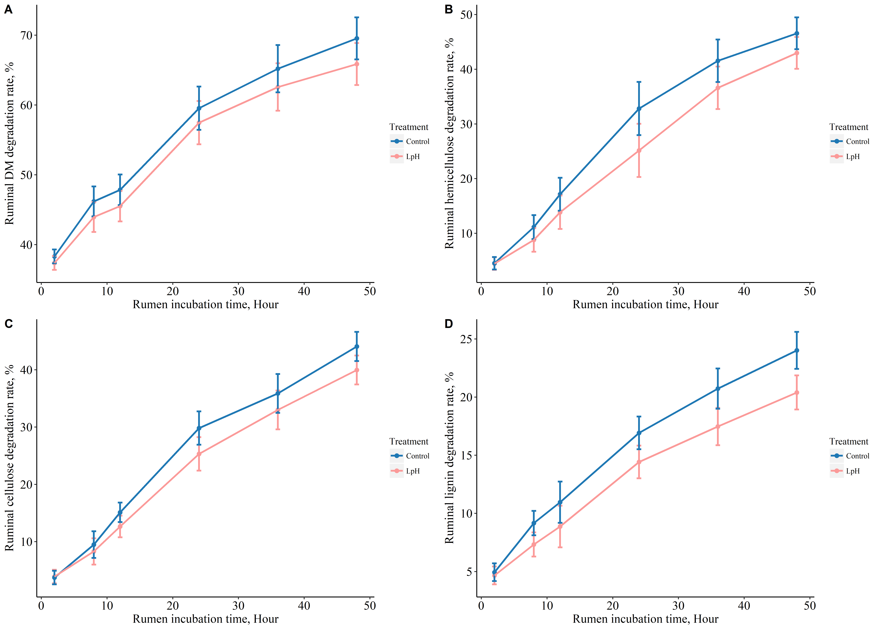
Figure S4. In situ degradation of dietary DM, hemicellulose, cellulose, and lignin with respect to the rumen incubation time.
Table S1. Ingredient composition and nutrient content of the ration¹.
Ingredient | % of DM
Corn silage | 33.54
Chopped grass hay | 48.52
Wheat middlings | 5.27
Corn meal | 2.53
Corn distillers dried grains | 1.01
Corn gluten feed | 3.53
Soybean meal | 3.33
Soybean hulls | 1.67
Limestone | 0.28
Salt | 0.22
Vitamin-mineral mix² | 0.11
Nutrient content | % of DM
DM (59.8% as fed) | 100
CP | 12.6
Ether extract | 5.30
NDF | 46.2
ADF | 23.6
Hemicellulose | 22.6
Cellulose | 21.0
Lignin | 2.6
Starch | 15.4
Ash | 5.03
¹Ingredients other than the corn silage and chopped hay were provided as a pelleted mix.
²Provided (per kg of pellet concentrate): vitamin A (9600 IU), vitamin D (3200 IU), vitamin E (41.2 mg), copper (26.9 mg), manganese (126 mg), zinc (200 mg), selenium (1.2 mg), monensin (27.2 mg), cobalt (0.1 mg), and iodine (2.1 mg).
Table S2. Effects of sampling site and ruminal pH on index of richness, alpha diversity, and evenness among treatments at bacterial and protozoal genera level.
Variable | Control |  | LpH |  | SEM | P value
 | Liquid | Solid | Liquid | Solid |  | Liquid  Con vs LpH | Solid  Con vs LpH | Liq vs Sol
Bacterial genera
Observed species | 56 | 102 | 70 | 101 | 6.82 | 0.09 | 0.89 | < 0.001
Richness index (Menhinick's) | 0.19 | 0.19 | 0.25 | 0.19 | 0.02 | 0.02 | 0.92 | 0.04
Evenness index (Hill's ratio) | 0.04 | 0.02 | 0.04 | 0.02 | 0.003 | 0.21 | 0.95 | < 0.001
Alpha diversity (Shannon-Wiener) | 2.25 | 2.87 | 2.68 | 2.87 | 0.09 | < 0.001 | 0.94 | < 0.001
Protozoal genera
Observed species | 9 | 9 | 10 | 9 | 1 | 0.15 | 0.83 | 0.23
Richness index (Menhinick's) | 0.96 | 0.95 | 1.08 | 0.97 | 0.06 | 0.15 | 0.78 | 0.31
Evenness index (Hill's ratio) | 0.15 | 0.19 | 0.13 | 0.19 | 0.02 | 0.28 | 0.83 | 0.004
Alpha diversity (Shannon-Wiener) | 0.65 | 1.06 | 0.66 | 1.01 | 0.14 | 0.96 | 0.79 | 0.005

Table S3. The effect of sampling site and treatment on bacterial phyla¹.
Variable | Control |  | LpH |  | SEM | P value
 | Liquid | Solid | Liquid | Solid |  | Con vs LpH² | Con vs LpH³ | Liq vs Sol⁴
Actinobacteria | 0.09 | 0.59 | 0.24 | 0.49 | 0.10 | 0.30 | 0.49 | < 0.001
Bacteroidetes | 4.28 | 3.22 | 3.56 | 3.09 | 0.15 | < 0.001 | 0.49 | < 0.001
Chloroflexi | 0.07 | 0.33 | 0.25 | 0.28 | 0.06 | 0.05 | 0.61 | 0.02
Cyanobacteria | 0.64 | 0.16 | 0.40 | 0.11 | 0.13 | 0.13 | 0.76 | 0.001
Elusimicrobia | 1.04 | 0.57 | 0.65 | 0.44 | 0.18 | 0.08 | 0.55 | 0.03
Firmicutes | 3.89 | 4.34 | 3.61 | 4.00 | 0.13 | 0.14 | 0.07 | 0.002
Kiritimatiellaeota | 2.56 | 1.01 | 2.39 | 1.21 | 0.30 | 0.69 | 0.63 | < 0.001
Lentisphaerae | 2.60 | 1.60 | 2.50 | 1.68 | 0.25 | 0.78 | 0.83 | < 0.001
Patescibacteria | 0.17 | 0.16 | 0.09 | 0.21 | 0.04 | 0.03 | 0.16 | 0.04
Proteobacteria | 4.89 | 4.08 | 3.60 | 3.84 | 0.24 | < 0.001 | 0.39 | 0.15
Spirochaetes | 2.77 | 3.39 | 2.55 | 3.28 | 0.13 | 0.25 | 0.55 | < 0.001
Verrucomicrobia | 1.36 | 0.51 | 1.03 | 0.46 | 0.31 | 0.37 | 0.91 | 0.01
¹Data are centered log ratios of sequence counts of the bacterial phyla
²Control versus LpH within the ruminal liquid fraction
³Control versus LpH within the ruminal solid fraction
⁴Ruminal sample fraction effect regardless of ruminal pH
Table S4. Bacterial genera that were significantly different among treatments¹.
Variable | Control |  | LpH |  | SEM | P value
 | Liquid | Solid | Liquid | Con vs LpH² |  | Con vs LpH² | Con vs LpH³ | Liq vs Sol⁴
Actinobacteria
Bifidobacterium | 0.14 | 0.39 | 0.92 | 1.33 | 0.33 | 0.07 | 0.03 | 0.29
Olsenella | 0.97 | 2.53 | 1.13 | 2.21 | 0.26 | 0.67 | 0.39 | < 0.001
Bacteroidetes
Prevotella_1 | 6.37 | 4.90 | 5.55 | 4.85 | 0.29 | 0.04 | 0.92 | < 0.001
Prevotella_9 | 2.35 | 1.36 | 0.85 | 2.32 | 0.46 | 0.003 | 0.05 | 0.51
Prevotellaceae_NK3B31_group | 0.33 | 1.02 | 0.46 | 1.20 | 0.31 | 0.76 | 0.69 | 0.02
Prevotellaceae_UCG-001 | 1.81 | 2.48 | 1.78 | 2.88 | 0.34 | 0.93 | 0.25 | < 0.001
Prevotellaceae_YAB2003_group | 2.25 | 0.13 | 2.06 | 0.98 | 0.44 | 0.75 | 0.17 | < 0.001
Chloroflexi
Flexilinea | 1.08 | 2.25 | 2.38 | 2.21 | 0.27 | < 0.001 | 0.90 | 0.06
Elusimicrobia
Elusimicrobium | 2.71 | 1.18 | 3.04 | 1.34 | 0.42 | 0.55 | 0.77 | < 0.001
Firmicutes
Acetitomaculum | 1.72 | 3.44 | 2.25 | 2.85 | 0.44 | 0.40 | 0.34 | 0.01
Anaerosporobacter | 4.00 | 3.49 | 2.27 | 3.15 | 0.46 | 0.002 | 0.54 | 0.63
Asteroleplasma | 3.01 | 1.08 | 2.84 | 2.02 | 0.47 | 0.80 | 0.16 | 0.004
Butyrivibrio_2 | 1.18 | 2.88 | 1.53 | 2.83 | 0.36 | 0.49 | 0.92 | < 0.001
Erysipelotrichaceae_UCG-004 | 5.69 | 4.51 | 5.95 | 4.90 | 0.27 | 0.48 | 0.30 | < 0.001
Family_XIII_AD3011_group | 0.24 | 1.79 | 0.50 | 1.32 | 0.21 | 0.40 | 0.13 | < 0.001
Lachnospiraceae_AC2044_group | 0.15 | 1.63 | 0.66 | 1.52 | 0.21 | 0.08 | 0.70 | < 0.001
Lachnospiraceae_NK3A20_group | 2.02 | 4.69 | 2.39 | 4.07 | 0.59 | 0.66 | 0.45 | < 0.001
Mogibacterium | 0.48 | 3.10 | 1.53 | 2.71 | 0.28 | 0.01 | 0.32 | < 0.001
Moryella | 0.32 | 3.08 | 0.87 | 2.38 | 0.32 | 0.22 | 0.12 | < 0.001
Papillibacter | 0.61 | 1.58 | 2.09 | 1.85 | 0.40 | 0.01 | 0.63 | 0.36
Pseudobutyrivibrio | 1.02 | 1.43 | 0.82 | 2.15 | 0.31 | 0.65 | 0.10 | 0.005
Ruminococcaceae_UCG-005 | 0.58 | 0.90 | 1.55 | 1.20 | 0.39 | 0.03 | 0.51 | 0.96
Ruminococcaceae_UCG-010 | 2.15 | 1.68 | 3.58 | 2.05 | 0.40 | 0.01 | 0.51 | 0.01
Ruminococcus_1 | 3.95 | 5.20 | 3.56 | 4.86 | 0.27 | 0.29 | 0.36 | < 0.001
Saccharofermentans | 2.86 | 3.86 | 2.77 | 3.73 | 0.24 | 0.78 | 0.69 | < 0.001
Selenomonas_1 | 0.59 | 1.41 | 0.93 | 1.80 | 0.29 | 0.38 | 0.31 | 0.002
Lentisphaerae
Horsej-a03 | 2.99 | 2.50 | 3.94 | 2.54 | 0.37 | 0.07 | 0.93 | 0.01
Proteobacteria
Desulfovibrio | 0.83 | 2.05 | 1.33 | 1.95 | 0.29 | 0.10 | 0.74 | < 0.001
Ruminobacter | 6.12 | 5.10 | 5.66 | 5.01 | 0.32 | 0.20 | 0.81 | 0.001
Succinimonas | 5.85 | 4.98 | 3.98 | 4.60 | 0.50 | 0.003 | 0.55 | 0.78
Succinivibrio | 4.06 | 2.54 | 3.84 | 3.02 | 0.39 | 0.69 | 0.38 | 0.003
Spirochaetes
Sediminispirochaeta | 2.31 | 2.41 | 3.17 | 2.37 | 0.28 | 0.03 | 0.93 | 0.22
Sphaerochaeta | 3.50 | 2.56 | 3.43 | 2.64 | 0.30 | 0.86 | 0.84 | 0.004
Treponema | 2.35 | 2.92 | 3.16 | 3.13 | 0.31 | 0.03 | 0.58 | 0.32
Treponema_2 | 5.95 | 6.43 | 6.10 | 6.55 | 0.19 | 0.57 | 0.65 | 0.01
Synergistetes
Pyramidobacter | 0.52 | 1.63 | 1.27 | 1.57 | 0.26 | 0.02 | 0.84 | 0.001
Tenericutes
Anaeroplasma | 4.88 | 3.74 | 4.79 | 4.19 | 0.32 | 0.84 | 0.32 | 0.01
¹ Sequence counts of the bacterial genera were transformed to centered log ratio to avoid compositional data problem
²Control versus LpH within the ruminal liquid fraction
³Control versus LpH within the ruminal solid fraction
⁴Ruminal sample fraction effect regardless of ruminal pH
Table S5. Protozoal genera that differed among treatments¹
Variable | Control |  | LpH |  | SEM | P value
 | Liquid | Solid | Liquid | Solid |  | Con vs LpH² | Con vs LpH³ | Liq vs Sol⁴
Diploplastron | 0.16 | 0.20 | 0.13 | 0.28 | 0.05 | 0.63 | 0.27 | 0.04
Entodinium | 6.60 | 5.81 | 5.70 | 5.77 | 0.36 | 0.02 | 0.92 | 0.20
Eudiplodinium | 2.09 | 3.06 | 1.85 | 3.04 | 0.29 | 0.51 | 0.95 | 0.001
Isotricha | 4.09 | 3.90 | 2.22 | 3.65 | 0.46 | 0.004 | 0.70 | 0.18
¹Sequence counts of the protozoal genera were transformed to centered log ratio to avoid compositional data problem
²Control versus LpH within the ruminal liquid fraction
³Control versus LpH within the ruminal solid fraction
⁴Ruminal sample fraction effect regardless of ruminal pH

Table S6. Archaea genera that differed among treatments¹
Variable | Control |  | LpH |  | SEM | P value
 | Liquid | Solid | Liquid | Con vs LpH² |  | Con vs LpH² | Con vs LpH³ | Liq vs Sol⁴
Candidatus_Methanomethylophilus | 2.72 | 2.28 | 2.69 | 2.25 | 0.22 | 0.91 | 0.93 | 0.05
Methanobrevibacter | 1.39 | 2.13 | 1.56 | 2.02 | 0.19 | 0.38 | 0.56 | < 0.001
Methanosphaera | 0.03 | 0.02 | 0.02 | 0.03 | 0.01 | 0.71 | 0.83 | 0.72
¹Sequence counts of the bacterial genera were transformed to centered log ratio to avoid compositional data problem.
²Control versus LpH within the ruminal liquid fraction
³Control versus LpH within the ruminal solid fraction
⁴Ruminal sample fraction effect regardless of ruminal pH
Table S7. Carbohydrate-active degrading enzymes that differed among treatments¹.
Variable | Control |  | LpH |  | SEM | P value
 | Liquid | Solid | Liquid | Solid |  | Con vs LpH² | Con vs LpH³ | Liq vs Sol⁴
Alpha-glucosidase | 3.31 | 2.13 | 2.99 | 2.04 | 0.37 | 0.53 | 0.85 | 0.003
Amylase | 5.31 | 3.75 | 5.03 | 3.39 | 0.47 | 0.65 | 0.56 | < 0.001
Beta-galactosidase | 2.01 | 1.79 | 2.67 | 1.46 | 0.37 | 0.16 | 0.49 | 0.03
Cellulase celA | 2.73 | 1.37 | 2.77 | 1.31 | 0.52 | 0.95 | 0.91 | 0.001
Glucan 1,4-alpha-maltotetraohydrolase | 0.02 | 0.90 | 0.001 | 0.64 | 0.26 | 0.97 | 0.47 | 0.003
Glucan phosphorylase | 0.83 | 2.14 | 1.69 | 1.91 | 0.35 | 0.05 | 0.61 | 0.01
Glucosidase Cel1C | 0.91 | 0.63 | 2.21 | 1.09 | 0.40 | 0.01 | 0.38 | 0.06
Glycoside hydrolase family 43 | 0.30 | 3.17 | 1.44 | 3.07 | 0.53 | 0.11 | 0.89 | < 0.001
Glycosyl hydrolase family 16 | 1.16 | 0.84 | 0.13 | 0.41 | 0.31 | 0.02 | 0.31 | 0.95
Glycosyl hydrolase family 43 | 2.00 | 3.51 | 2.60 | 1.81 | 0.53 | 0.42 | 0.02 | 0.49
Glycosyl hydrolase family 51 | 0.43 | 1.28 | 0.72 | 1.00 | 0.26 | 0.37 | 0.38 | 0.01
Glycosyl hydrolase family 57 | 3.08 | 2.13 | 2.67 | 2.30 | 0.27 | 0.27 | 0.64 | 0.01
Glycosyltransferase 36 | 0.52 | 2.32 | 0.89 | 1.58 | 0.37 | 0.48 | 0.16 | 0.001
Isoamylase domain/esterase family protein | 0.29 | 1.09 | 0.53 | 0.57 | 0.20 | 0.40 | 0.07 | 0.03
Pectate lyase | 0.16 | 0.53 | 1.11 | 1.22 | 0.23 | < 0.001 | < 0.001 | 0.16
Penicillin-binding protein 1A | 1.77 | 0.99 | 2.13 | 1.38 | 0.38 | 0.51 | 0.47 | 0.04
Putative 4-alpha-glucanotransferase | 3.96 | 3.52 | 3.82 | 2.91 | 0.25 | 0.68 | 0.07 | 0.005
Putative alpha-xylosidase | 3.00 | 2.47 | 2.90 | 2.08 | 0.31 | 0.82 | 0.36 | 0.03
Putative carbohydrate-active enzyme | 2.99 | 1.90 | 3.24 | 1.72 | 0.42 | 0.59 | 0.71 | < 0.001
Putative glycosyl transferase | 2.16 | 1.03 | 0.75 | 1.65 | 0.46 | 0.03 | 0.33 | 0.80
Rhamnogalacturonan acetylesterase | 0.05 | 0.20 | 0.70 | 0.24 | 0.26 | 0.05 | 0.90 | 0.51
Sucrose alpha-glucosidase | 2.36 | 0.32 | 0.13 | 0.24 | 0.41 | < 0.001 | 0.88 | 0.01
UDP-3-0-acyl N-acetylglucosamine deacetylase | 1.46 | 2.00 | 2.46 | 1.44 | 0.34 | 0.04 | 0.24 | 0.47
¹Sequence counts of the enzyme expression were transformed to centered log ratio to avoid compositional data problem.
²Control versus LpH within the ruminal liquid fraction
³Control versus LpH within the ruminal solid fraction
⁴Ruminal sample fraction effect regardless of ruminal pH
Table S8. Effects of ruminal pH on DMI and ruminal short chain fatty acid concentrations.
Variable | Treatment |  | SEM | P value
 | Control | LpH
pH | 6.44 | 6.09 | 0.04 | < 0.0001
DMI, kg/d | 9.75 | 7.82 | 0.66 | 0.04
Total VFA, mM | 82.84 | 62.31 | 3.80 | 0.001
Acetate, mM | 54.71 | 42.12 | 2.38 | 0.001
Propionate, mM | 20.05 | 14.61 | 1.24 | 0.001
Butyrate, mM | 5.94 | 3.96 | 0.50 | 0.001
Isobutyrate, Mm | 0.79 | 0.58 | 0.05 | 0.001
Valerate, mM | 0.68 | 0.51 | 0.06 | 0.04
Isovalerate, Mm | 0.43 | 0.31 | 0.03 | 0.003

Table S9. Effects of ruminal pH change on in situ fiber degradation kinetics¹.
Variable | Treatment |  | SEM | P value
 | Control | LpH
DM
a | 35.15 | 34.14 | 0.94 | 0.31
b | 47.19 | 45.84 | 6.11 | 0.81
K_{d} | 3.30 | 3.60 | 1.20 | 0.78
ED | 50.62 | 48.76 | 0.64 | 0.06
Hemicellulose
a | -0.79 | -0.03 | 0.78 | 0.43
b | 65.97 | 79.19 | 7.80 | 0.13
K_{d} | 3.30 | 2.00 | 0.50 | 0.09
ED | 20.53 | 17.30 | 0.74 | 0.02
Cellulose
a | -0.08 | 0.50 | 0.94 | 0.33
b | 69.78 | 72.81 | 5.61 | 0.61
K_{d} | 2.30 | 1.80 | 0.20 | 0.15
ED | 18.15 | 16.24 | 0.63 | 0.02
Lignin
a | 3.49 | 3.19 | 0.34 | 0.49
b | 33.03 | 35.77 | 8.39 | 0.75
K_{d} | 2.70 | 2.20 | 0.50 | 0.50
ED | 12.12 | 10.29 | 0.31 | 0.002
¹a represents proportion of rapidly degradable fraction (%); b represents proportion of potentially degradable fraction (%); K_{d} represents the degradation rate constant of b (%/h); ED is effective degradability (%).

