Supplementary Information
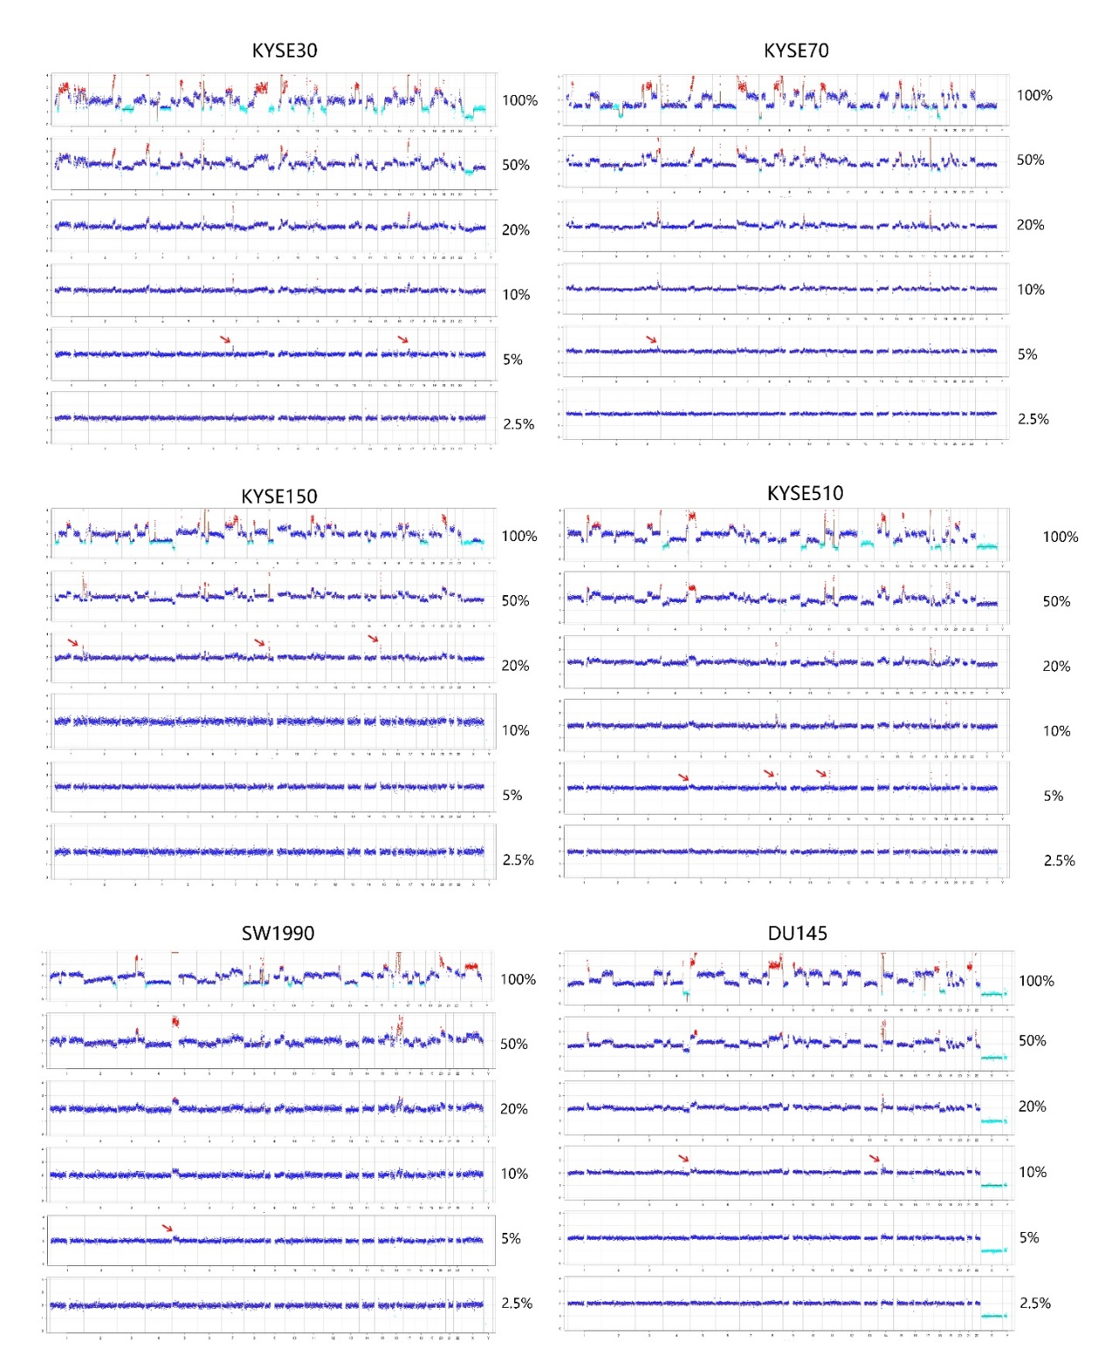

Figure S1. The sensitivity of Onco-mNGS was tested by mixing six cancer cell lines with normal cells at different ratios. The red arrows show abnormalities detected in samples at the minimum proportion of cancer to normal cell ratio.

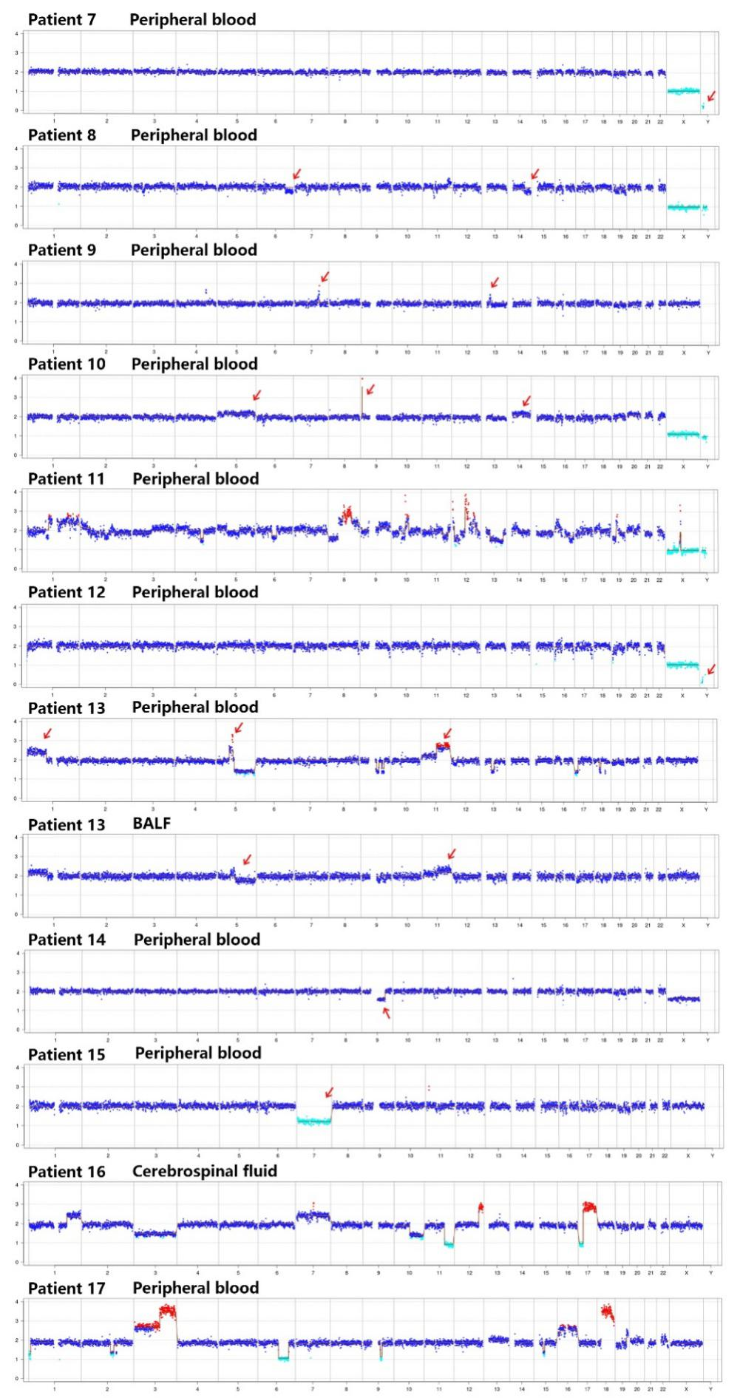
Figure S2. CNVs of cancer patients. These images show abnormal CNVs of patients (#s 7-17) with histories of malignancy. The red arrows indicate abnormal CNVs.
Table S1. Clinical characteristics of the rest 12 patients with CNV changes and a history of malignance
No. | Sex, year | History of malignance | Diagnosis before NGS | Diagnosis of Discharge | Syndrome | Prior antimicrobial agents use | Clinically relevant pathogen detected in mNGS | Clinically relevant pathogen detected in culture result | CNVs details
7 | Male, 62 | Acute promyelocytic leukemia | Pneumonia;  Central nervous system infection | Pneumonia;  Central nervous system infection | Fever;  Change in metal status | Meropenem;  Tigercycline;  Linezonaid; | None | None | ChrY Loss
8 | Male, 59 | Stomach;  Lymphoma | Pneumonia | Pneumonia | None | Ceftriaxone;  Moxifloxacin;  Piperacillin/Tazobactam;  Levofloxacin;  Sulfamonomethoxine/Trimethoprim | Balf: Pneumocystis jirovecii  Blood: Pneumocystis jirovecii | None | Chr6q Del;  Chr14q Del;  Chr11q Dup
9 | Female, 56 | Gallbladder cancer | Pneumonia | Lung lesion: pneumonia possible, tumor possible | Cough; Sputum;  Weakness | Imipenem;  Doxycycline | Blood: None  Balf: Human parainfluenza virus type 4; Streptococcus pneumoniae | None | Chr4q(dup2.4Mb);  Chr7q(dup 4.2Mb)
Patient No. | Sex, year | History of malignance | Diagnosis before NGS | Diagnosis of Discharge | Syndrome | Prior antimicrobial agents use | Clinical relevant pathogen detected in mNGS | Clinical relevant pathogen detected in culture result | CNVs details
10 | Male, 71 | Lymphoma | Skin and soft tissue infection | T-cell lymphoma possible;  Skin and soft tissue infection ;  Pneumonia | Fever;  Sweat | Piperacillin/Tazobactam;  Cefoperazone/sulbactam;  Levofloxacin; | None | None | Chr5 Dup;  Chr14 Dup;  Chr9p (dup_2.1Mb)
11 | Male, 91 | Prostate cancer with bone metastasis | Pro-operative brain injury | Pro-operative brain injury;  Pneumonia | Fever | Piperacillin/Tazobactam;  Tigercycline | None | None | Multiple Chrs Del/Dup
12 | Male, 59 | None | Acute myeloid leukemia | Acute myeloid leukemia | Fever | Levofloxacin;  Meropenem;  Imipenem;  Posacozole | None | None | ChrY Loss
13 | Female, 56 | Myelodysplastic syndrome | Myelodysplastic syndrome | Myelodysplastic syndrome;  Pneumonia | Fever;  Cough;  Headache | Isoniazid;  Imipenem | BALF: Neisseria flavescens;  Blood: None | None | Multiple Chrs del/dup;
Patient No. | Sex, year | History of malignance | Diagnosis before NGS | Diagnosis of Discharge | Syndrome | Prior antimicrobial agents use | Clinically relevant pathogen detected in mNGS | Clinically relevant pathogen detected in culture result | CNVs details
14 | Female, 55 | None | Acute myeloid leukemia | Acute myeloid leukemia; Bloodstream Infection | Fever;  Cough;  Sputum | Imipenem;  Posacozole;  Vancomycin;  Cefoperazone/sulbactam;  Tigercycline | Blood: Stenotrophomonas maltophilia | Blood: Stenotrophomonas maltophilia | Chr9q Dup;  ChrX Del;
15 | Female, 49 | None | Acute myeloid leukemia | Acute myeloid leukemia | Fever | Imipenem;  Posacozole;  Cefoperazone/sulbactam;  Piperacillin/Tazobactam;  Entecavir | None | None | Chr7 Del
16 | Female, 6 | Medullo-  blastoma | Medullo-  blastoma | Central nervous system infection | Fever;  Facial paralysis | Fluconazole;  Fosfomycin; | None | None | Multiple Chrs Del/Dup
17 | Female, 68 | Pituitary tumor | Pneumonia | Pneumonia | Fever;  Cough | Piperacllin/tazobactam;  Lineizoid | Pleural fluid: Acinetobacter baumannii  Sputum: Acinetobacter baumannii | None | Multiple Chrs Del/Dup
Chr, chromsome; Dup, duplication; Del, deletion

