Supplementary Information to manuscript “Root porosity contributes to root trait space among wetland monocotyledons independently of economics traits.”
Table S1 Air temperature during the experiment recorded in the common garden.
 |  | Mean monthly temperature (°C) | Average daily maximum temperature (°C) | Average daily minimum temperature (°C)
2019 | May | 8.8 | 13.9 | 3.6
 | June | 15.6 | 21.6 | 9.5
 | July | 20.3 | 26.8 | 13.7
 | Aug | 17.4 | 23.7 | 11.1
 | Sep | 13.3 | 18.4 | 8.2
 | Oct | 6.6 | 11.2 | 2
 | Nov* | -4 | -0.7 | -7.3
 | Dec* | -8.3 | -4.2 | -12.3
2020 | Jan* | -8.3 | -4.1 | -12.5
 | Feb* | -10.4 | -5.1 | -15.6
 | Mar* | -3.4 | -1.4 | -8.1
 | Apr* | 2 | 7.6 | -3.6
 | May | 10.3 | 16.3 | 4.4
 | June | 16.7 | 23.2 | 10.2
 | July | 21.1 | 26.8 | 15.4
 | Aug | 18 | 23 | 12.9
 | Sep | 11.3 | 16.5 | 6.1

*November 2019-April 2020 the plants were covered with tarps and straw at 0.5-2.0°C.

Table S2 Mean values (±1SEM) of the traits in basal roots and lateral roots of sixteen wetland monocot species.
 | Basal roots |  |  |  |  |  |  | Lateral roots
Species (n) | Root porosity  (cm³ cm⁻³) | SRL  ( m g⁻¹) | RCSA  (mm²) | RTD  (g cm⁻³) | RTDA  (g cm⁻³) | Fresh root cellular density (g cm⁻³) | RDMC  (g g⁻¹) | Root porosity  (cm³ cm⁻³) | SRL  ( m g⁻¹) | RCSA  (mm²) | RTD  (g cm⁻³) | RTDA  (g cm⁻³) | Fresh root cellular density (g cm⁻³) | RDMC  (g g⁻¹) | Lateral to basal root length ratio
Iris versicolor (4) | 0.549 | 4.3 | 1.932 | 0.123 | 0.273 | 1.105 | 0.247 | 0.187 | 42.7 | 0.123 | 0.192 | 0.236 | 1.070 | 0.220 | 7.3
SEM | 0.018 | 0.31 | 0.207 | 0.007 | 0.010 | 0.006 | 0.008 | 0.010 | 2.57 | 0.006 | 0.003 | 0.005 | 0.003 | 0.004 | 0.91
Glyceria canadensis (4) | 0.527 | 16.5 | 0.659 | 0.094 | 0.198 | 1.060 | 0.187 | 0.075 | 395.2 | 0.019 | 0.135 | 0.147 | 1.049 | 0.140 | 6.1
SEM | 0.007 | 1.28 | 0.054 | 0.004 | 0.006 | 0.010 | 0.007 | 0.020 | 15.03 | 0.001 | 0.008 | 0.011 | 0.021 | 0.008 | 0.55
Eleocharis palustris (3) | 0.446 | 28.3 | 0.415 | 0.091 | 0.164 | 1.052 | 0.156 | 0.029 | 119.2 | 0.030 | 0.286 | 0.294 | 1.101 | 0.266 | 9.1
SEM | 0.070 | 4.08 | 0.070 | 0.014 | 0.005 | 0.012 | 0.003 | 0.009 | 6.60 | 0.002 | 0.033 | 0.031 | 0.015 | 0.025 | 0.47
Carex magellanica (5) | 0.304 | 12.3 | 0.568 | 0.146 | 0.211 | 1.051 | 0.201 | 0.168 | 157.6 | 0.035 | 0.195 | 0.235 | 1.101 | 0.213 | 14.9
SEM | 0.036 | 0.86 | 0.021 | 0.009 | 0.015 | 0.012 | 0.014 | 0.019 | 14.85 | 0.003 | 0.023 | 0.027 | 0.023 | 0.022 | 2.64
Carex oligosperma (4) | 0.556 | 12.5 | 0.689 | 0.120 | 0.271 | 1.072 | 0.253 | 0.124 | 73.7 | 0.043 | 0.334 | 0.379 | 1.150 | 0.328 | 5.0
SEM | 0.010 | 1.11 | 0.078 | 0.005 | 0.010 | 0.010 | 0.011 | 0.021 | 5.87 | 0.005 | 0.033 | 0.031 | 0.038 | 0.019 | 1.12
Schoenoplectus tabernaemontani (4) | 0.531 | 43.3 | 0.303 | 0.077 | 0.167 | 1.046 | 0.160 | 0.158 | 204.4 | 0.021 | 0.248 | 0.297 | 1.117 | 0.266 | 1.1
SEM | 0.040 | 3.07 | 0.016 | 0.003 | 0.011 | 0.011 | 0.011 | 0.048 | 31.64 | 0.004 | 0.011 | 0.025 | 0.047 | 0.019 | 0.14
Scirpus cyperinus (4) | 0.416 | 9.7 | 0.776 | 0.135 | 0.230 | 1.080 | 0.213 | 0.046 | 261.7 | 0.026 | 0.156 | 0.164 | 1.052 | 0.156 | 4.5
SEM | 0.004 | 1.05 | 0.048 | 0.006 | 0.009 | 0.003 | 0.009 | 0.006 | 46.26 | 0.004 | 0.022 | 0.023 | 0.013 | 0.021 | 0.68
Carex lasiocarpa (4) | 0.415 | 16.8 | 0.359 | 0.177 | 0.303 | 1.087 | 0.279 | 0.060 | 204.7 | 0.020 | 0.248 | 0.264 | 1.098 | 0.240 | 20.0
SEM | 0.012 | 2.39 | 0.046 | 0.011 | 0.018 | 0.010 | 0.017 | 0.026 | 26.51 | 0.002 | 0.011 | 0.016 | 0.030 | 0.009 | 4.17
Dulichium arundinaceum (5) | 0.253 | 15.7 | 0.436 | 0.146 | 0.196 | 1.064 | 0.184 | 0.169 | 176.0 | 0.037 | 0.154 | 0.189 | 1.018 | 0.185 | 0.7
SEM | 0.022 | 0.68 | 0.036 | 0.009 | 0.016 | 0.013 | 0.016 | 0.027 | 17.14 | 0.007 | 0.019 | 0.014 | 0.009 | 0.013 | 0.13
Triglochin maritima (5) | 0.302 | 14.1 | 0.342 | 0.214 | 0.308 | 1.101 | 0.279 | 0.160 | 94.3 | 0.039 | 0.275 | 0.327 | 1.094 | 0.314 | 0.7
SEM | 0.012 | 0.95 | 0.020 | 0.018 | 0.028 | 0.011 | 0.024 | 0.020 | 11.34 | 0.003 | 0.024 | 0.033 | 0.040 | 0.034 | 0.14
Sagittaria latifolia (4) | 0.490 | 121.5 | 0.278 | 0.030 | 0.058 | 1.029 | 0.056 | 0.127 | 1153.4 | 0.012 | 0.070 | 0.081 | 1.021 | 0.079 | 1.8
SEM | 0.014 | 18.86 | 0.047 | 0.001 | 0.002 | 0.004 | 0.002 | 0.006 | 118.3 | 0.001 | 0.003 | 0.002 | 0.008 | 0.002 | 0.20
Sparganium emersum (5) | 0.415 | 26.8 | 0.608 | 0.065 | 0.112 | 1.057 | 0.107 | 0.081 | 412.5 | 0.025 | 0.098 | 0.106 | 1.013 | 0.105 | 7.8
SEM | 0.029 | 3.48 | 0.049 | 0.004 | 0.010 | 0.012 | 0.010 | 0.008 | 35.78 | 0.002 | 0.003 | 0.004 | 0.006 | 0.004 | 0.93
Alisma triviale (5) | 0.489 | 102.1 | 0.252 | 0.039 | 0.076 | 1.047 | 0.072 | 0.100 | 724.6 | 0.020 | 0.069 | 0.077 | 1.031 | 0.075 | 4.5
SEM | 0.016 | 6.93 | 0.018 | 0.001 | 0.002 | 0.004 | 0.002 | 0.010 | 78.97 | 0.001 | 0.008 | 0.010 | 0.009 | 0.009 | 0.83
Triglochin palustris (5) | 0.536 | 95.1 | 0.159 | 0.069 | 0.149 | 1.047 | 0.143 | 0.302 | 270.3 | 0.040 | 0.093 | 0.143 | 1.029 | 0.139 | 0.7
SEM | 0.006 | 9.45 | 0.015 | 0.003 | 0.004 | 0.012 | 0.005 | 0.016 | 14.28 | 0.002 | 0.005 | 0.005 | 0.025 | 0.005 | 0.10
Pontederia cordata (4) | 0.394 | 23.2 | 0.942 | 0.046 | 0.076 | 1.053 | 0.072 | 0.048 | 1025.4 | 0.008 | 0.129 | 0.136 | 1.051 | 0.129 | 8.6
SEM | 0.046 | 1.04 | 0.026 | 0.002 | 0.005 | 0.010 | 0.005 | 0.007 | 63.45 | 0.000 | 0.012 | 0.014 | 0.015 | 0.011 | 0.28
Rhynchospora alba (5) | 0.403 | 45.2 | 0.406 | 0.054 | 0.091 | 1.025 | 0.089 | 0.185 | 534.3 | 0.019 | 0.099 | 0.121 | 1.071 | 0.111 | 3.3
SEM | 0.021 | 6.09 | 0.049 | 0.003 | 0.008 | 0.011 | 0.008 | 0.027 | 67.81 | 0.001 | 0.010 | 0.016 | 0.025 | 0.018 | 0.55

SRL, specific root length; RCSA, mean root cross-sectional area; RTD, root tissue density; RTDA, root tissue density air-excluded; RDMC, root dry matter content.

Table S3 The descriptive statistics of root traits for basal roots and lateral roots of 16 wetland monocots
 | Traits | Root porosity | SRL | RCSA | RTD | RTDA | Fresh root cellular density | RDMC | Lateral/basal root length ratio
 | Unit | cm³ cm⁻³ | m g⁻¹ | mm² | g cm⁻³ | g cm⁻³ | g cm⁻³ | g g⁻¹ | m m⁻¹
Basal roots (n=16) | Mean | 44 | 36.7 | 0.57 | 0.102 | 0.180 | 1.06 | 0.169
 | SE | 2.4 | 9.1 | 0.11 | 0.013 | 0.021 | 0.006 | 0.019
 | Min | 25.3 | 4.3 | 0.159 | 0.030 | 0.058 | 1.025 | 0.056
 | Max | 55.6 | 122 | 1.932 | 0.214 | 0.308 | 1.105 | 0.279
 | C.V% | 21.5% | 99.6% | 73.8% | 52.0% | 45.9% | 2.2% | 44.6%
Lateral roots (n=16) | Mean | 13 | 366 | 0.032 | 0.174 | 0.200 | 1.067 | 0.185 | 6.0
 | SE | 1.8 | 83.9 | 0.007 | 0.021 | 0.023 | 0.010 | 0.020 | 1.4
 | Min | 2.9 | 42.7 | 0.008 | 0.069 | 0.077 | 1.013 | 0.075 | 0.7
 | Max | 30.2 | 1153 | 0.123 | 0.334 | 0.379 | 1.150 | 0.328 | 20.1
 | C.V% | 56.1% | 91.8% | 81.6% | 47.9% | 46.5% | 3.8% | 43.8% | 89.4%
Paired t-test | P-values | *** | *** | *** | *** | 0.219 | 0.586 | 0.207
The P-values indicates the significance of difference between basal and lateral roots with paired t-test. ***, P<0.001;**, P<0.01;*, P<0.05. C.V%, the coefficient of variation. SRL, specific root length; RCSA, mean root cross-sectional area; RTD, root tissue density; RTDA, root tissue density air-excluded; Fresh RTDA, fresh root tissue density air-excluded; RDMC, root dry matter content.
 | Dimension 1 (45.5%) |  |  |  | Dimension 2 (21.9%) |  |  |  | Dimension 3 (11.6%)
Variables (root types) | Loadings | Ctr.% | Cosine |  | Loadings | Ctr.% | Cosine |  | Loadings | Ctr.% | Cosine
SRL (lateral) | -0.94 | 21.6 | 0.89 |  | -0.28 | 3.92 | 0.08 |  | 0.01 | 0.02 | 0.00
RTDA (basal) | 0.91 | 20.0 | 0.82 |  | 0.04 | 0.07 | 0.00 |  | -0.17 | 2.98 | 0.03
SRL (basal) | -0.88 | 19.1 | 0.78 |  | 0.34 | 5.72 | 0.11 |  | -0.06 | 0.33 | 0.00
RTDA (lateral) | 0.78 | 14.9 | 0.61 |  | 0.12 | 0.78 | 0.02 |  | -0.18 | 3.22 | 0.03
RCSA (lateral) | 0.77 | 14.6 | 0.59 |  | 0.48 | 11.7 | 0.23 |  | 0.13 | 1.66 | 0.02
RCSA (basal) | 0.55 | 7.51 | 0.31 |  | -0.50 | 12.6 | 0.25 |  | 0.47 | 21.2 | 0.22
Lateral to basal root-length ratio | 0.29 | 2.1 | 0.09 |  | -0.68 | 23.1 | 0.46 |  | -0.11 | 1.08 | 0.01
Root porosity (basal) | -0.07 | 0.14 | 0.01 |  | 0.28 | 3.90 | 0.08 |  | 0.85 | 68.6 | 0.72
Root porosity (lateral) | 0.03 | 0.03 | 0.00 |  | 0.87 | 38.0 | 0.75 |  | -0.09 | 0.86 | 0.01
Table S4 Loadings of variables to the first three dimensions in the PCA
The order of variables in this table were arranged based on their contributions on the first dimension. SRL, specific root length; RTDA, root tissue density air-excluded; RCSA, root cross-sectional area.

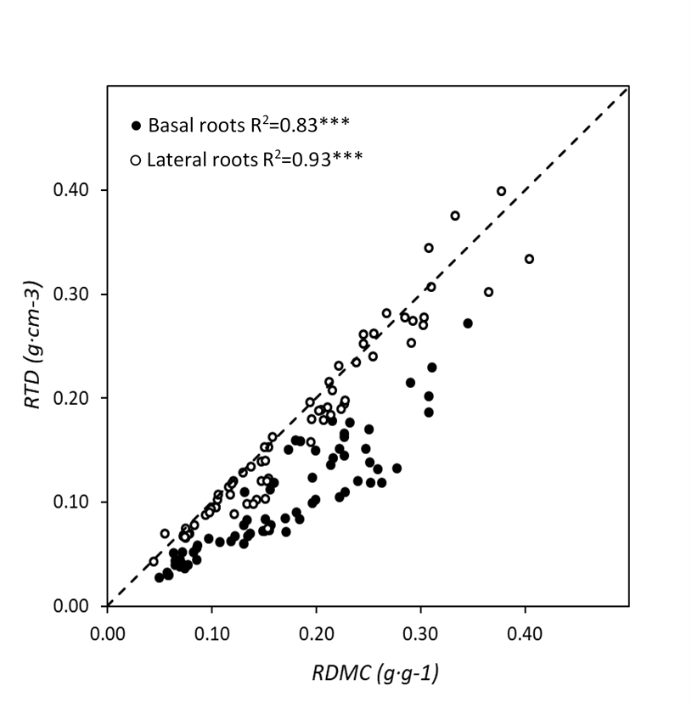
Fig. S1 Relationship between root dry matter content (RDMC) and root tissue density (RTD). R² of the major axis regression are given using original data of basal and lateral roots. For comparative purposes, the 1:1 ratio has been shown by a dotted line. ***, P<0.001.

