Supplementary figures and tables
Figure S1: Flow-Chart: Patient recruitment
PsA Patients
N = 95
Arthromark
Healthy Controls
N = 28
RA patients
N = 80
Pso Patients
N = 60

noted lesions on the hands at the time of the FOI scan or lesions on the hands that were not safely excluded
N = 75
All patients assessed for inclusion and exclusion criteria

FOI scan defect, therefore not analyzable
N = 5 (RA=2, healthy=3)

Final cohort
N = 183

Figure S2: Subdermal skin enhancement read in “Temperature mode”
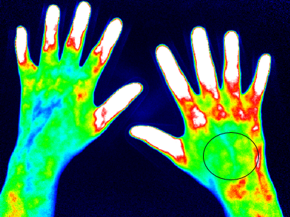 | 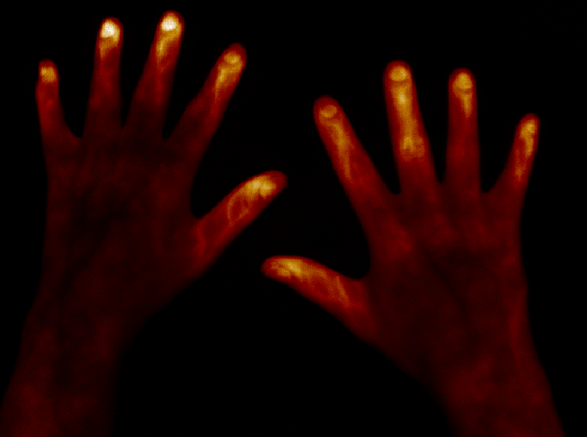
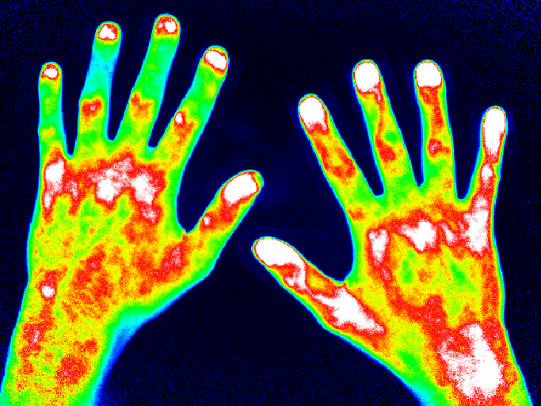 | 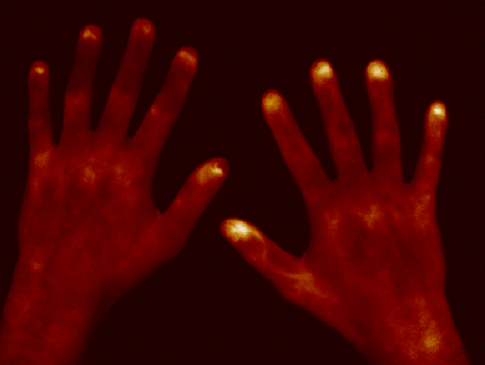
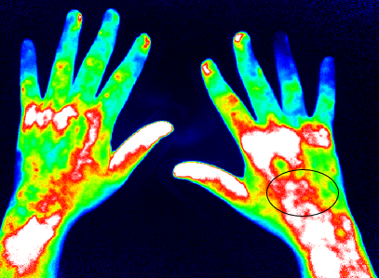 | 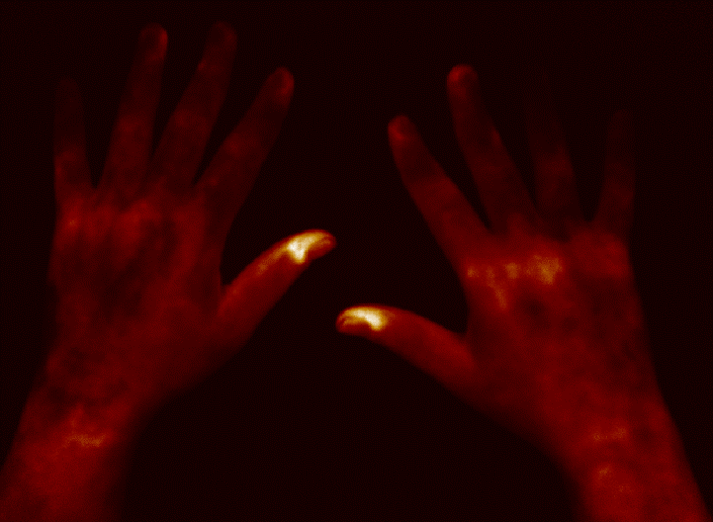
Comparison of the two possible modes to control suspected areas of subdermal skin enhancement for underlying blood vessels. The marked areas show no signs of blood vessels in the “Temperature mode”, which confirms that the enhancement is probably located in the (sub)-dermis.

Table S1: Current medication
 |  | Pso / PsA |  | RA |  |  | Healthy
 |  | n=80 |  | n=78 |  |  | n=25
 |  | N | % | N | N |  | % | N
Current medication
 | none | 37 | 46.3 | 9 | 11.5
 | csDMARD | 39 | 48.8 | 61 | 78.2
 | bDMARD | 35 | 43.8 | 14 | 18.0
 | NSAID | 38 | 47.5 | 44 | 56.4
 | Opioid | 8 | 10.0 | 4 | 5.1
 | PPI | 25 | 31.3 | 47 | 60.3
 | Antihypertensiva | 23 | 28.8 | 51 | 65.4
 | Antidiabetic therapy | 7 | 8.8 | 5 | 6.4
 | Insuline | 6 | 7.5 | 4 | 5.1
 | Platelet aggregation inhibitors | 2 | 2.5 | 8 | 10.3
 | Calcium antagonists | 9 | 11.3 | 6 | 7.7
 | Lipid lowering therapy | 4 | 5.0 | 9 | 11.5
 | Thyreostatics | 1 | 1.3 | 0 | 0.0
 | L-thyroxine | 7 | 8.8 | 8 | 10.3
 | Antidepressive treatment | 4 | 5.0 | 0 | 0.0
 | Supplements | 12 | 15.0 | 37 | 47.4
 | Glucocorticoids | 5 | 6.3 | 42 | 53.9
 | Inhaled glucocorticoids | 1 | 1.3 | 1 | 1.3
 | Inhalative Betamimetika | 3 | 3.8 | 1 | 1.3
 | Urikostatika | 1 | 1.3 | 1 | 1.3
 | Topical psoriasis therapy | 17 | 21.3 | 0 | 0.0
 | Diuretics | 3 | 3.8 | 5 | 6.4
 | Antihistamines | 1 | 1.3 | 0 |  | 0.0
 | Anticonvulsants | 3 | 3.8 | 1 |  | 1.3
 | Antiemetics | 1 | 1.3 | 0 |  | 0.0
 | Triptans | 1 | 1.3 | 0 |  | 0.0
 | Contraceptives | 1 | 1.3 | 1 | 1.3
 | Parathyroid hormone analogs | 1 | 1.3 | 0 | 0.0
 | Myotonolytics | 0 | 0.0 | 1 | 1.3
 | Alpha blockers | 0 | 0.0 | 3 | 3.9
 | Aldosterone antagonists | 0 | 0.0 | 1 | 1.3
 | Progesterone | 0 | 0.0 | 1 | 1.3

Table S2: Cardiovascular risk factors
 |  | Pso / PsA |  | RA |  | Healthy
 |  | n=80 |  | n=78 |  | n=25
 |  | N | % | N | N | % | N
Cardiovascular Risk factors
 | No comorbid disease | 35 | 44.9 | 30 | 38.5
 | Hypertension | 29 | 37.2 | 43 | 55.1
 | Metabolic syndrome | 1 | 1.3 | 10 | 12.8
 | Adipositas | 6 | 7.7 | 3 | 3.9
 | Prior thyroidectomy/ hypothyroidism | 9 | 11.5 | 5 | 6.4
 | Angina pectoris | 11 | 14.1 | 8 | 10.3
 | Venous insufficiency/ varicosis | 2 | 2.6 | 3 | 3.9
 | Hyperlipidemia | 5 | 6.4 | 17 | 21.8
 | Coronary artery disease | 0 | 0.0 | 3 | 3.9
 | Prior myocardial infarction | 0 | 0.0 | 3 | 3.9
 | Heart failure | 0 | 0.0 | 2 | 2.6
 | Prior stroke/ TIA | 0 | 0.0 | 2 | 2.6
 | Obstructive sleep apnea syndrome | 0 | 0.0 | 1 | 1.3
 | Graves' disease | 1 | 1.3 | 0 | 0.0
 | Diabetes mellitus | 10 | 12.8 | 8 | 10.3
 | Prior deep vein thrombosis | 3 | 3.9 | 0 | 0.0
 | Atrial fibrillation | 1 | 1.3 | 0 | 0.0
 | Cancer | 1 | 1.3 | 1 | 1.3
 | COPD | 0 | 0.0 | 1 | 1.3
 | HDL in mg/dl. mean (SD) | 60.7 (17.12) |  | 58.1 (21.29)
 | LDL in mg/dl. mean (SD) | 135.9 (73.24) |  | 131.9 (50.67)
 | Total cholesterol in mg/dl. mean (SD) | 213.7 (87.80) |  | 213.6 (48.68)
 | Triglyceride in mg/dl. mean (SD) | 130.6 (98.94) |  | 161.2 (96.01)

