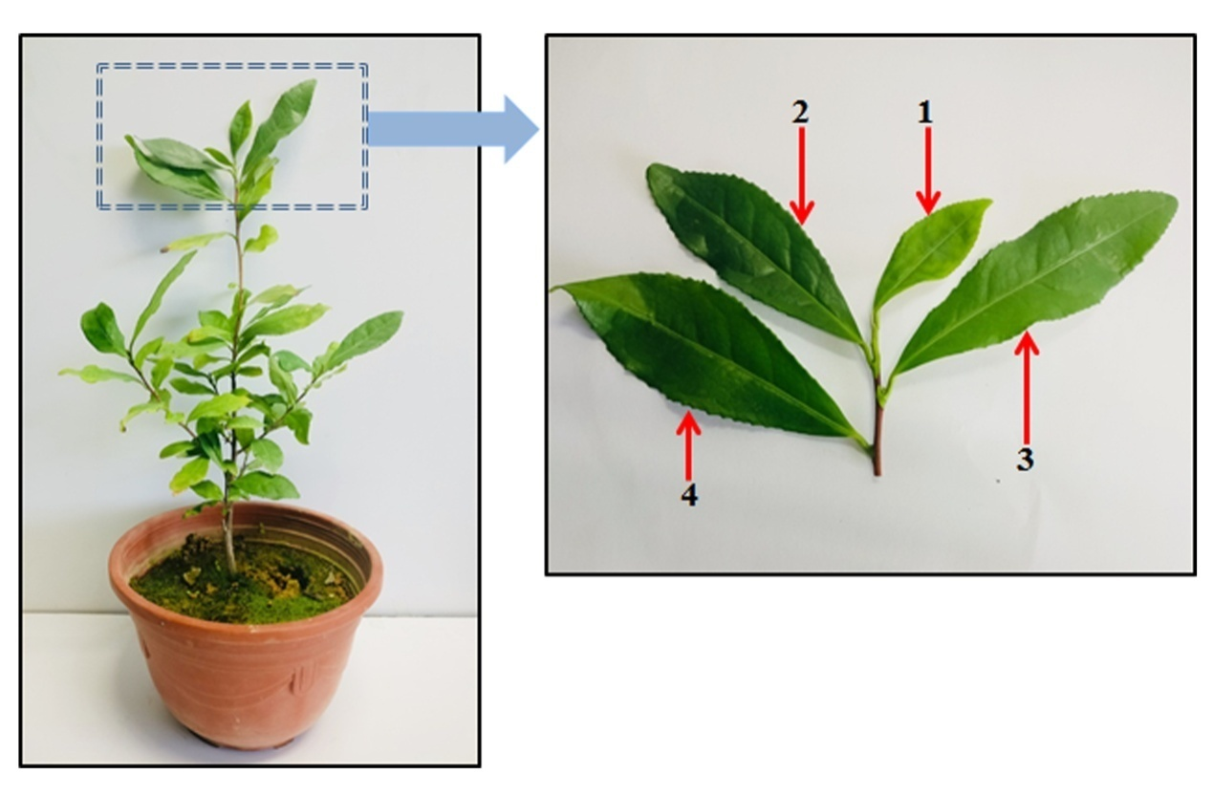
Fig. s1. Leaf position of tea samples.

