Supporting information

Appendix S1. Average biomass of plant functional types, vascular plant leaf area indices, and bryophytes production and length growth in study sites. Average values are brought with ± SE, statistical significance was tested with Kruskal-Wallis test, and pairwise comparison was conducted using Mann-Whitney tests with Bonferroni correction.
 | Kõrsa_{R} | Hara_{RN} | Hara_{RS} | Hara_{P} | Kõrsa_{P} | χ2 | p
Biomass (g dm^{–2})
Sphagnum | 8.5 ± 2.0^{ab} | 6.6 ± 0.6^{abc} | –^{c} | 8.2 ± 1.0^{b} | 7.2 ± 0.8^{ab} | 9.6 | < 0.05
True moss | 0.7 ± 0.4ª | 1.0 ± 1.0ª | –ª | –ª | –ª | 9.6 | < 0.05
Evergreen shrub | 0.4 ± 0.3ª | –^{abc} | –^{b} | 3.8 ± 1.4^{c} | 4.3 ± 1.4^{c} | 15.0 | < 0.01
Ombrotrophic forb | –ª | –ª | –ª | 0.0 ± 0.0ª | 0.0 ± 0.0ª | 5.5 | > 0.05
Ombrotrophic sedges | 2.0 ± 0.8ª | 3.4 ± 2.7ª | 4.1 ± 2.2ª | 0.1 ± 0.1ª | 2.4 ± 0.7ª | 8.4 | > 0.05
Trees | 0.1 ± 0.1ª | –ª | –ª | 0.0 ± 0.0ª | –ª | 9.5 | > 0.05
Vascular plant (total) | 2.6 ± 0.7ª | 3.4 ± 2.7ª | 4.1 ± 2.2ª | 4.0 ± 1.4ª | 6.7 ± 1.6ª | 3.5 | > 0.05
Plant (total) | 11.7 ± 1.7ª | 11.0 ± 3.0ª | 4.1 ± 2.2ª | 12.1 ± 2.0ª | 14.0 ± 2.3ª | 6.7 | > 0.05
Sphagnum increment (mm year^{–1})
Lawn | 15.0 ± 2.8ª | 11.6 ± 0.7^{ab} | –^{b} | 11.1 ± 2.4ª | 11.2 ± 1.2ª | 9.6 | < 0.05
Hummock | –ª | – ^{ab} | –ª | 15.4 ± 5.8^{ab} | 13.2 ± 3.3^{b} | 12.5 | < 0.05
Production (g dm^{–2} year^{–1})
Sphagnum | 2.2 ± 0.9ª | 2.4 ± 0.3^{ab} | –^{b} | 3.2 ± 1.0ª | 1.9 ± 0.3ª | 9.8 | < 0.05
Lawn | 2.2 ± 0.9ª | 2.4 ± 0.3^{ab} | –^{b} | 0.9 ± 0.3ª | 0.9 ± 0.2ª | 12.5 | < 0.05
Hummock | –ª | – ^{ab} | –ª | 2.3 ± 0.9^{ab} | 1.1 ± 0.5^{b} | 12.5 | < 0.05
True moss | 0.1 ± 0.1ª | 0.4 ± 0.4ª | –ª | –ª | –ª | 9.6 | < 0.05
Vascular plant LAI | 0.2 ± 0.1ª | 0.4 ± 0.0ª | 0.2 ± 0.1ª | 0.1 ± 0.1ª | 0.3 ± 0.1ª | 6.6 | > 0.05
– PFT is absent from the site.

Appendix S2. Measured NEE, R_{ECO} and PAR on Kõrsa and Hara rewetted and pristine sites. NEE is shown on light measurements (PAR > 0) and R_{ECO} is measured in dark conditions (PAR = 0).
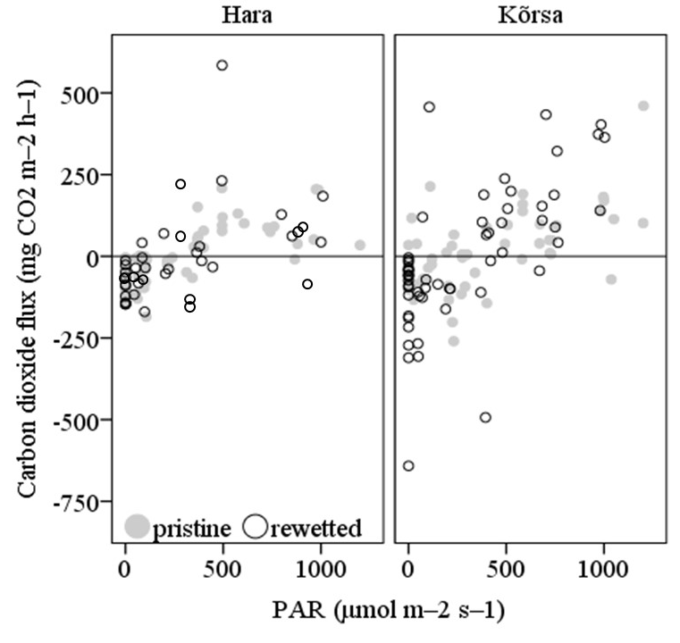

Appendix S3. Average photosynthesis (P_{max} (mg CO₂ m^{–2} h^{–1}), k (μmol m^{–2} s^{–1}), s(m² m^{–2})) and respiration (r₀ (mg CO₂ m^{–2} h^{–1}), b (1/ ºC)) model parameter values in rewetted and pristine sites of each site (±SE). Different small case letters indicate statistically significant (p < 0.05) difference between the site and it’s state. Statistical significance was tested with Kruskal-Wallis test and pair-wise comparison was done with Mann-Whitney test and Bonferroni correction was used.
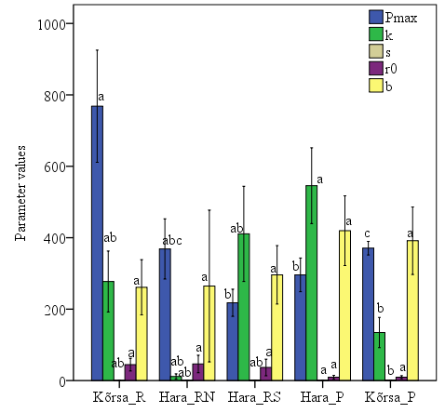

Appendix S4. Spearman correlation coefficient between vegetation variables and CO₂ fluxes in pooled samples, rewetted and pristine plots.
 | Pooled |  |  | Rewetted |  |  | Pristine
 | NEE | P_{g} | R_{ECO} | NEE | P_{g} | R_{ECO} | NEE | P_{g} | R_{ECO}
LAI_{vasc} | –0.05 | 0.16 | 0.20 | 0.30 | 0.06 | –0.33 | –0.19 | 0.24 | 0.86*
BIO_{bry} | 0.52* | 0.43 | –0.17 | 0.59 | 0.77** | 0.29 | 0.24 | 0.14 | –0.26
COV_{bry} | 0.61** | 0.33 | –0.47* | 0.80** | 0.77** | –0.11 | 0.11 | 0.08 | –0.36
COV_{vasc} | 0.13 | 0.03 | 0.08 | –0.07 | –0.15 | –0.07 | 0.43 | 0.57 | 0.60
BIO_{vasc} | –0.14 | 0.05 | 0.18 | 0.07 | 0.10 | 0.27 | –0.24 | 0.12 | 0.83*
BIO_{plant} | 0.28 | 0.36 | 0.12 | 0.53 | 0.73* | 0.53 | 0.05 | 0.24 | 0.29
COV_{plant} | 0.50* | 0.26 | –0.36 | 0.60 | 0.50 | –0.23 | 0.07 | 0.12 | 0.19
COV_{humSph} | 0.04 | –0.26 | –0.44 | – | – | – | –0.05 | 0.08 | 0.37
COV_{lawnSph} | 0.57* | 0.52* | –0.23 | 0.72* | 0.70* | –0.15 | 0.07 | –0.12 | –0.68
COV_{truemoss} | 0.21 | 0.60*: | 0.62** | 0.40 | 0.60 | 0.57 | – | – | –
COV_{shrub} | 0.05 | –0.22 | –0.38 | 0.14 | 0.45 | 0.43 | –0.25 | –0.42 | 0.11
COV_{ombforb} | –0.12 | –0.31 | –0.29 | – | – | – | –0.35 | –0.20 | 0.18
COV_{minforb} | 0.48* | 0.54* | 0.47* | 0.53 | 0.68* | 0.49 | – | – | –
COV_{ombsedg} | 0.14 | 0.28 | 0.34 | –0.08 | –0.16 | –0.08 | 0.58 | 0.83* | 0.40
COV_{tree} | –0.12 | –0.38 | –0.26 | –0.13 | –0.13 | –0.42 | –0.38 | –0.76* | –0.46
BIO_{tree} | 0.30 | 0.44 | 0.19 | 0.23 | 0.50 | 0.35 | 0.27 | 0.19 | –0.45
BIO_{shrub} | 0.12 | –0.10 | –0.32 | 0.30 | 0.60 | 0.46 | –0.29 | 0.07 | 0.69
BIO_{ombforb} | –0.15 | –0.23 | –0.14 | – | – | – | –0.35 | –0.20 | 0.18
BIO_{ombsedg} | 0.02 | 0.39 | 0.51* | –0.01 | –0.02 | 0.31 | 0.58 | 0.83* | 0.40
PRO_{humSph} | 0.02 | –0.26 | –0.43 | – | – | – | 0.31 | –0.17 | 0.05
PRO_{lawnSph} | 0.59** | 0.66** | –0.06 | 0.68* | 0.76* | 0.19 | 0.62 | 0.33 | –0.41
PRO_{truemoss} | 0.16 | 0.57* | 0.59* | 0.34 | 0.46 | 0.44 | – | – | –
PRO_{Sph} | 0.34 | 0.29 | –0.19 | 0.70* | 0.81** | 0.18 | –0.14 | –0.10 | 0.12
INC_{humSph} | –0.03 | –0.33 | –0.42 | – | – | – | –0.57 | –0.36 | 0.45
INC_{lawnSph} | 0.40 | 0.46 | 0.00 | 0.65* | 0.81** | 0.31 | –0.14 | –0.17 | 0.26
INC_{Sph} | 0.22 | 0.07 | –0.26 | 0.65* | 0.81** | 0.31 | –0.57 | –0.36 | 0.45

