Conceptual framework

Several factors play a role in determining the discontinuation of the Implanon. These are socio-demographic variables, gynecological variables, method related factors and others may be inter-related and contribute to Implanon discontinuation as indicated by the conceptual framework below (fig1).
Service related factors Place of insertion
Counseling
Previous influence from health provider
Satisfaction by service use Follow up

Socio- demographic factors
Age
Marital status
Religion
Educational level
Occupation

Implanon Discontinuation
Method related factors Health concerns and side effects Desire to use another method previous contraceptive use

Socio-cultural factors religious opposition Husband opposition Health information Discussion with spouth/parner

Fertility related factors
Number of children Need to have additional child
Abortion Desire to prevent unintended pregnancy
Partner Desire for pregnancy

Fig1: Frame work of Implanon discontinuation among women who used Implanon in Andabet district public health facilities, North-West Ethiopia, 2017.

Schematic presentation of sampling procedure (fig2)
Health institutions in Andabet district

Jaragedo HC (382)

Atsede-Mariam HC (214)
Andabet HC (265)

Genete-Mariam HC (189)

Gono HC (226)

SRS
83
99
116
94
168

544 women

Note: SRS= systematic random sampling method
Fig2: Schematic presentation of the sampling frame based on the number of women who requested removal of Implanon for three-months prior to the study, Andabet district, public health facilities, North-West Ethiopia, 2017.

Results

Figure 3, Reported side effects of the study participants who requested removal of Implanon in Andabet district; Ethiopia: 2017
Reasons for implanon discontinuation
From the reason of discontinuation women who discontinue secondary to development of side effect were causes for earlier discontinuation compared to discontinue secondary to want to pregnant, and from the side effects women who were develop headache discontinue earliest, followed by pain at insertion arm (fig3).
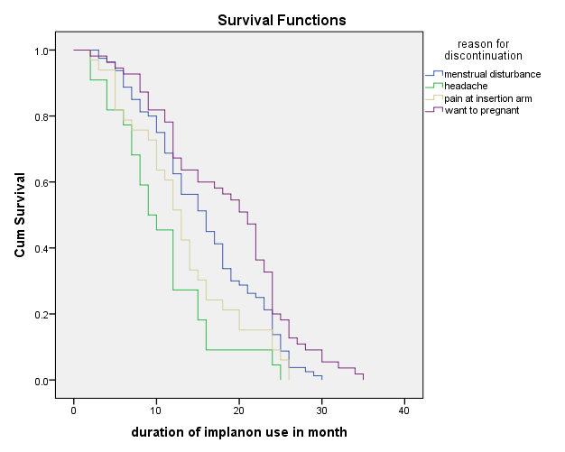
Fig3: Kaplan Meier survival distribution of the main reasons for implanon discontinuation among women who requested removal of implanon in Andabet district, public health facilities; North-West Ethiopia: 2017.

