Appendix 1. CASP results for individual studies
 | 1. Was there a clear statement of the aims of the research? | 2. Is a qualitative methodology appropriate? | 3. Was the research design appropriate to address the aims of the research? | 4. Was the recruitment strategy appropriate to the aims of the research? | 5. Were the data collected in a way that addressed the research issue? | 6. Has the relationship between researcher and participants been adequately considered? | 7. Have ethical issues been taken into consideration? | 8. Was the data analysis sufficiently rigorous? | 9. Is there a clear statement of findings? | 10. How valuable is the research?
Aghaizu et al. (2011) | T | T | T | T | T | N | T | T | T | T
Al Knawy et al. (2019) | T | T | T | P | T | P | N | T | T | T
Andertun et al. (2016) | T | T | T | T | T | P | T | T | T | T
Bensimon et al. (2007) | T | T | T | T | P | T | P | T | T | T
Bergeron et al. (2006) | T | T | P | P | P | N | P | P | T | T
Broom et al., (2017) | T | T | T | P | N | N | P | P | T | T
Chen et al. (2020) | N | T | P | N | P | N | N | N | T | T
Chiang et al. (2007) | T | T | T | P | T | N | T | T | P | P
Chung et al. (2004) | T | T | P | T | T | T | T | T | T | T
Erland & Dahl (2017) | T | T | T | T | T | T | T | T | T | T
Fawaz & Samaha (2020) | T | T | T | T | T | T | T | T | T | T
Gershon et al. (2016) | T | T | T | P | T | P | T | T | T | T
Guimard et al. (1999) | P | T | T | N | P | N | N | N | P | P
Hewlett & Hewlett (2005) | T | T | T | P | P | N | N | N | T | P
Honey & Wang (2012) | T | P | T | T | T | N | P | P | T | T
Im et al. (2018) | T | T | T | P | P | N | N | N | P | P
Ives et al. (2009) | T | T | T | T | T | N | P | T | T | T
Kim (2018) | T | T | T | T | T | P | T | T | T | T
Koh et al. (2011) | T | T | T | T | T | P | N | T | T | T
Lam & Hung (2012) | T | T | T | T | T | T | T | T | T | T
Lamb (2018) | T | T | T | T | T | T | T | P | P | T
Lau & Chen (2004) | T | T | T | N | P | N | N | P | P | T
Lee et al. (2005) | T | T | T | T | P | N | P | T | T | T
Liu & Liehr (2009) | T | T | T | T | T | N | P | T | T | P
Liu et al. (2019) | T | T | T | T | T | P | T | T | T | T
Liu et al. (2020) | T | T | T | T | T | T | T | T | T | T
Locsin et al. (2009) | T | T | T | T | T | P | P | P | T | T
McMahon et al. (2017) | T | T | T | T | T | P | T | T | T | T
Mok et al. (2005) | T | T | T | P | P | N | T | T | T | P
Moore et al. (2005) | T | T | T | P | P | N | N | P | P | P
O’Boyle et al. (2006) | T | T | T | T | T | N | T | T | T | T
O'Sullivan et al. (2009) | T | T | T | T | T | N | N | T | T | T
Pearce et al. (2011) | T | T | T | T | P | N | N | N | T | T
Raven et al. (2018) | T | T | T | N | T | T | T | T | T | T
Raven, Wurie, & Witter (2018) | T | T | T | T | T | N | T | T | T | T
Rubin et al. (2016) | T | T | T | P | P | T | T | T | T | T
Sarikaya & Erbaydar (2007) | T | T | T | P | P | N | P | T | P | T
Shaw et al. (2006) | T | T | T | T | T | P | P | P | T | T
Shih et al. (2007) | T | T | T | P | T | T | T | T | T | P
Shih et al. (2008) | T | T | T | P | T | P | T | T | T | T
Smith et al. (2017) | T | T | T | P | P | N | P | P | T | P
Sun et al. (2020) | T | T | T | T | T | T | T | T | T | P
Taylor et al. (2018) | T | T | T | P | T | N | P | T | T | T
von Strauss et al. (2017) | T | T | T | P | P | N | T | P | T | T
Wong et al. (2011) | T | T | T | P | P | N | T | T | T | T
Yin & Zeng (2020) | T | T | T | P | P | N | T | T | T | T

T = totally met, P = partially met, N = not met
Appendix 2. Search Strategy

PsychINFO search strategy
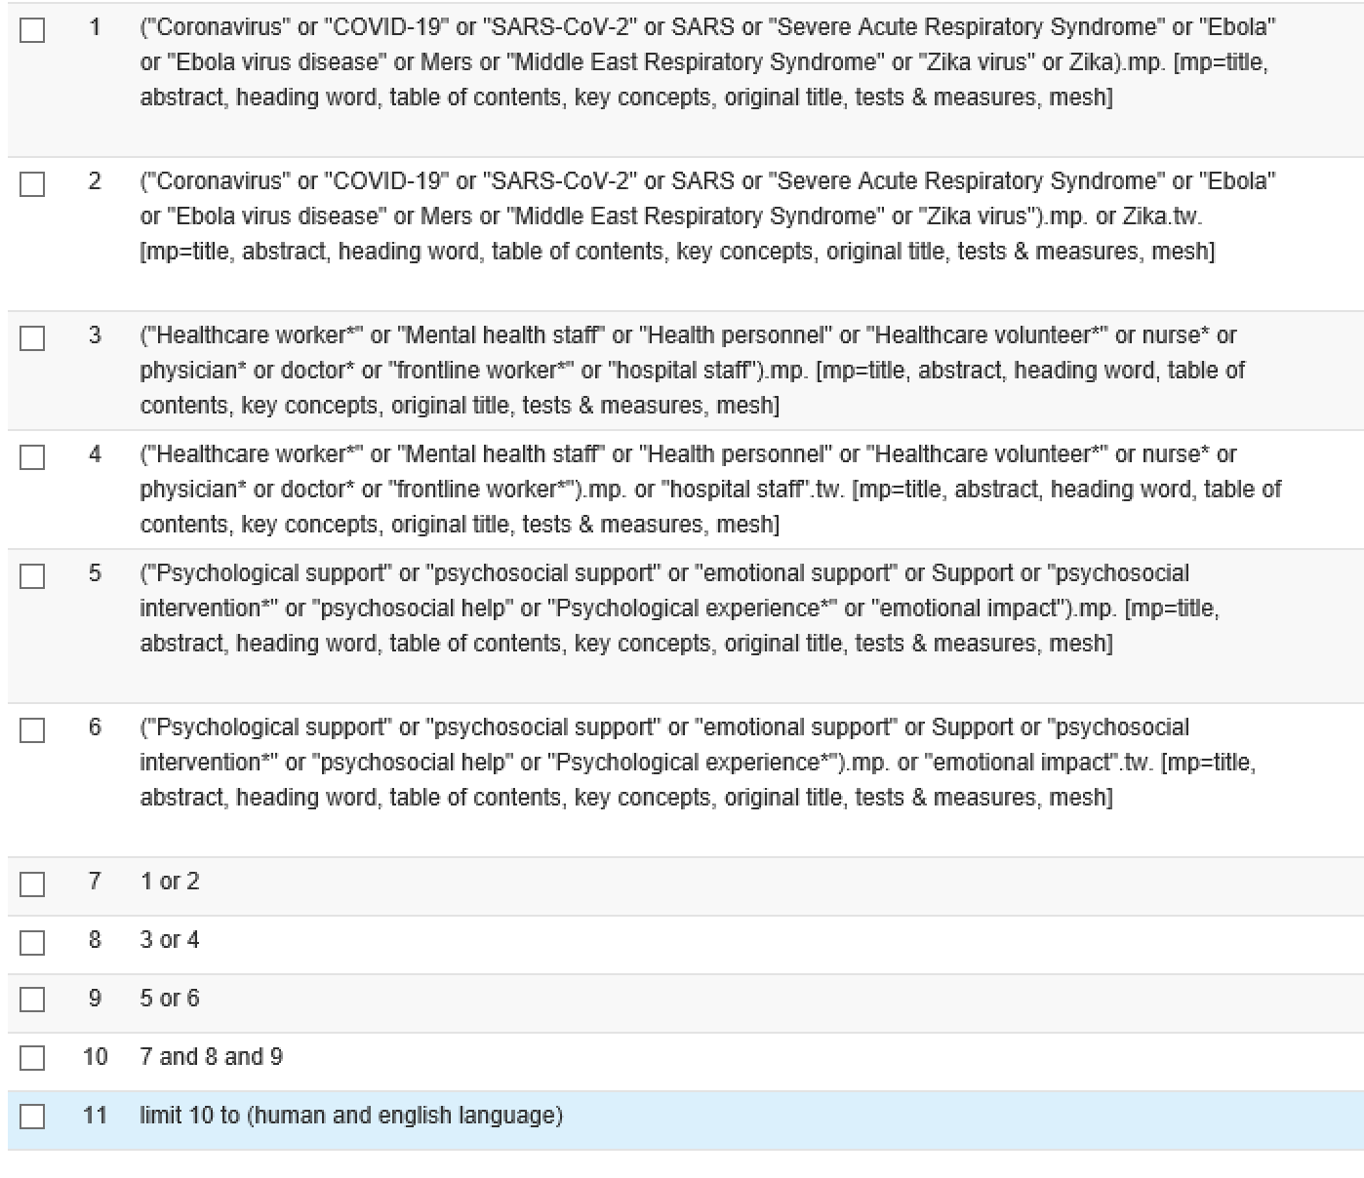

Medline search strategy
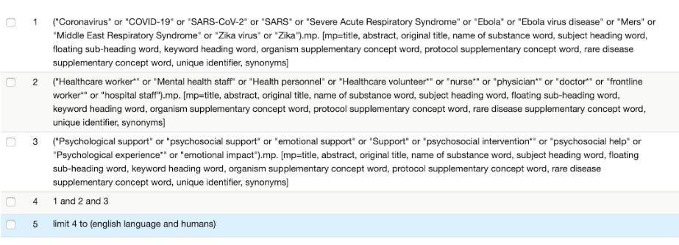

PubMed search strategy
“Coronavirus” OR “COVID-19” OR “SARS-CoV-2” OR SARS OR “Severe Acute Respiratory Syndrome” OR “Ebola” OR “Ebola virus disease” OR “Mers” OR “Middle East Respiratory Syndrome” OR “Zika virus” OR Zika

AND

“Healthcare worker*” OR “Mental health staff” OR “Health personnel” OR “Healthcare volunteer*” OR nurse* OR physician* OR doctor* OR frontline worker* OR “hospital staff”

AND

“Psychological support” OR “psychosocial support” OR “emotional support” OR Support OR “psychosocial intervention*” OR “psychosocial help” OR “Psychological experience*” OR “emotional impact”

