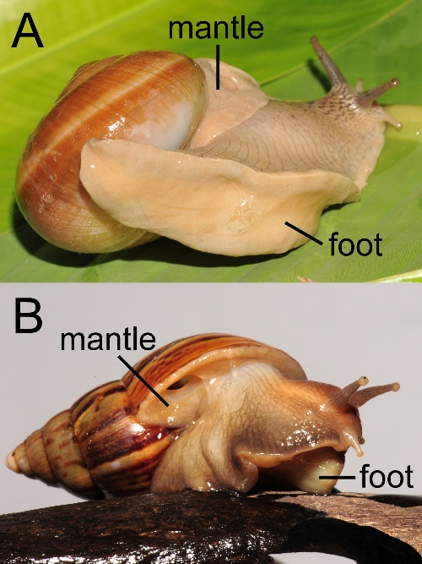

Additional file 1: Figure S1. Dorsal and ventral images of Lissachatina fulica and Hemiplecta distincta. The mantel collar and foot of the snails were indicated.

