Additional file 1: Phytochemical screening of Tarmarindus indica
Table 1: Qualitative analysis of ethyl acetate fraction of Tarmarindus indica
Constituent | Inference
Alkaloid | -
Carbohydrate | +
Reducing sugar | -
Flavonoid | +
Tannins | -
Saponin | -
Glycoside | -
Cardiac glycoside | -
Steroids | -
Triterpenes | -
Barfoed | -
+ = Present, - = Absent
Gas chromatography
Helium was deployed as a carrier gas at a steady flow rate of 1.59 ml/min. The diluted samples (1 µl) were injected automatically using Autosampler AS1310 coupled with GC in the split mode (split ratio 1.0), with a solvent delay of 3 min. The column initial oven temperature was held at 70°C and then raised at 10°C /min until a temperature of 250 °C was attained then held for 4 min. The temperature was finally raised 280°C at 15°C /min then held for another 4 min. The injector and MS transfer line temperatures were kept at 270, 250°C respectively. The components were identified by comparison of their retention times and mass spectra with those of the NIST 05 mass spectral database.

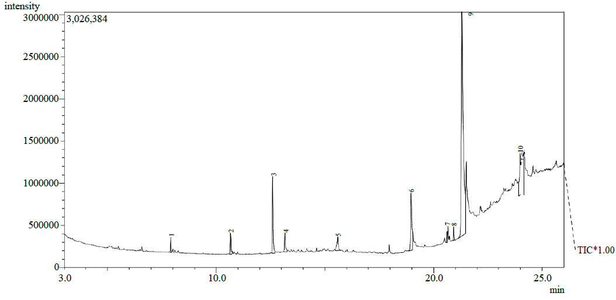

Figure 1: Quantitative analysis of ethyl acetate fraction of Tarmarindus indica. Total ion chromatogram of the analyzed sample showed peaks which were used to identify analytes.

