Appendix 2 – Phase 1 results tables and figures

Appendix 2 Table 1: Bibliometric data

Country
 | (million) | (thousand) |  |  | pubs. | cit. | pubs. | pubs. | Coll. | Coll. | Coll. | author
Algeria | 159,049 | 40,606 | 8,043 | 57,188 | 6,473 | 28,931 | 437 | 1,138 | 52.7 | 10.1 | 34.4 | 2.7
Angola | 95,335 | 28,813 | 446 | 4,827 | 120 | 489 | 21 | 85 | 92.5 | 0.3 | 7.2 | 0.0
Benin | 8,583 | 10,872 | 2,427 | 22,042 | 1,166 | 7,435 | 161 | 290 | 80.7 | 1.0 | 17.8 | 0.6
Botswana | 15,581 | 2,250 | 1,766 | 28,298 | 756 | 4,583 | 113 | 245 | 79.7 | 3.5 | 12.9 | 3.8
Burkina Faso | 11,693 | 18,646 | 3,104 | 36,231 | 1,336 | 8,663 | 216 | 388 | 84.5 | 0.8 | 14.2 | 0.4
Burundi | 3,007 | 10,524 | 243 | 2,250 | 67 | 311 | 6 | 40 | 87.4 | 0.0 | 11.4 | 1.2
Cameroon | 32,218 | 23,439 | 5,973 | 69,384 | 3,356 | 21,499 | 376 | 814 | 73.7 | 7.5 | 17.0 | 1.8
Cape Verde | 1,617 | 540 | 124 | 1,052 | 19 | 52 | 6 | 20 | 94.4 | 1.1 | 3.3 | 1.1
Central African Republic | 1,756 | 4,595 | 333 | 4,490 | 137 | 797 | 19 | 40 | 77.7 | 1.0 | 15.8 | 5.4
Chad | 9,601 | 14,453 | 203 | 2,105 | 55 | 357 | 15 | 41 | 94.8 | 0.0 | 5.2 | 0.0
Comoros | 617 | 796 | 61 | 419 | 13 | 33 | 2 | 7 | 77.8 | 2.8 | 19.4 | 0.0
Democratic Republic of the Congo | 35,382 | 78,736 | 1,535 | 26,099 | 609 | 3,330 | 64 | 261 | 86.2 | 0.5 | 12.2 | 1.2
Djibouti | 1,727 | 942 | 61 | 419 | 30 | 166 | 2 | 7 | 77.8 | 2.8 | 19.4 | 0.0
Egypt | 332,791 | 95,689 | 60,693 | - | - | - | 2,481 | 8,206 | 46.4 | 14.1 | 32.7 | 6.9
Equatorial Guinea | 10,685 | 1,221 | 114 | 1,714 | 12 | 43 | 6 | 12 | 100.0 | 0.0 | 0.0 | 0.0
Eritrea | 2,608 | 4,475 | 154 | 1,252 | 54 | 176 | 15 | 18 | 83.3 | 0.0 | 14.6 | 2.1
Ethiopia | 72,374 | 102,403 | 9,926 | 95,131 | 6,630 | 43,786 | 398 | 1,768 | 57.1 | 6.5 | 32.2 | 4.2
Gabon | 14,214 | 1,980 | 1,203 | 20,122 | 446 | 6,199 | 84 | 141 | 89.5 | 0.0 | 9.3 | 1.1
Gambia | 965 | 2,039 | 1,175 | 32,033 | 363 | 6,243 | 92 | 156 | 95.7 | 0.3 | 2.0 | 2.0
Ghana | 42,690 | 28,207 | 7,005 | 96,341 | 3,681 | 19,958 | 307 | 1,118 | 68.7 | 5.1 | 22.6 | 3.6
Guinea | 8,200 | 12,396 | 1,547 | 28,939 | 418 | 3,416 | 126 | 231 | 91.2 | 0.2 | 6.4 | 2.2
Guinea-Bissau | 1,165 | 1,816 | 333 | 5,016 | 111 | 1,963 | 18 | 48 | 99.1 | 0.5 | 0.0 | 0.5
Ivory Coast | 36,373 | 23,696 | 2,622 | 31,674 | 1,573 | 5,637 | 251 | 284 | 67.8 | 1.1 | 30.4 | 0.7

GDP
Pop.
Pubs. Cit.
F-a
F-a
2008
2017
Int.
Nat.
Inst.
Single

Table 1: Bibliometric data

Country
 | (million) | (thousand) |  |  | pubs. | cit. | pubs. | pubs. | Coll. | Coll. | Coll. | author
Kenya | 70,529 | 48,462 | 14,286 | 243,026 | 6,071 | 61,021 | 943 | 1,909 | 83.2 | 5.6 | 9.0 | 2.2
Lesotho | 2,291 | 2,204 | 186 | 2,581 | 64 | 478 | 14 | 22 | 88.6 | 0.0 | 9.5 | 1.9
Liberia | 2,101 | 4,614 | 258 | 3,733 | 45 | 296 | 7 | 57 | 92.8 | 1.4 | 3.4 | 2.4
Libya | 34,699 | 6,293 | 1,513 | 14,307 | 735 | 3,379 | 77 | 151 | 81.3 | 0.2 | 14.9 | 3.5
Madagascar | 10,001 | 24,895 | 1,999 | 23,688 | 680 | 4,113 | 157 | 264 | 86.2 | 0.3 | 12.5 | 0.9
Malawi | 5,433 | 18,092 | 3,442 | 56,398 | 1,204 | 13,344 | 228 | 540 | 90.5 | 1.1 | 6.0 | 2.3
Mali | 14,035 | 17,995 | 1,691 | 26,428 | 495 | 4,014 | 114 | 244 | 89.9 | 0.3 | 9.4 | 0.4
Mauritania | 4,739 | 4,301 | 227 | 1,719 | 83 | 400 | 13 | 32 | 90.9 | 0.0 | 8.4 | 0.7
Mauritius | 12,168 | 1,263 | 737 | 8,004 | 404 | 2,294 | 37 | 104 | 65.3 | 0.2 | 30.4 | 4.0
Morocco | 103,606 | 35,277 | 12,051 | 80,662 | 9,514 | 32,877 | 744 | 1,537 | 36.8 | 14.2 | 47.3 | 1.8
Mozambique | 11,015 | 28,829 | 1,731 | 39,885 | 542 | 5,014 | 81 | 290 | 93.4 | 1.2 | 3.8 | 1.6
Namibia | 10,948 | 2,480 | 1,026 | 10,156 | 337 | 1,386 | 44 | 154 | 83.9 | 0.4 | 8.3 | 7.4
Niger | 7,528 | 20,673 | 804 | 9,075 | 278 | 1,808 | 56 | 99 | 84.7 | 1.3 | 12.4 | 1.7
Nigeria | 404,653 | 185,990 | 31,023 | 205,135 | 25,853 | 109,386 | 2,443 | 3,369 | 36.3 | 14.1 | 45.1 | 4.5
Republic of the Congo | 7,834 | 5,126 | 921 | 11,026 | 351 | 1,496 | 50 | 102 | 80.9 | 0.3 | 17.1 | 1.6
Rwanda | 8,376 | 11,918 | 1,519 | 23,953 | 538 | 4,022 | 50 | 245 | 90.1 | 0.5 | 7.1 | 2.4
Sao Tome and Principe | 343 | 200 | 25 | 335 | 4 | 56 | 0 | 7 | 100.0 | 0.0 | 0.0 | 0.0
Senegal | 14,684 | 15,412 | 3,667 | 37,424 | 1,759 | 10,138 | 234 | 473 | 73.1 | 4.5 | 21.1 | 1.3
Seychelles | 1,427 | 95 | 339 | 5,631 | 57 | 567 | 31 | 44 | 83.0 | 0.5 | 4.5 | 2.0
Sierra Leone | 3,737 | 7,396 | 530 | 7,489 | 102 | 975 | 15 | 114 | 94.5 | 0.2 | 4.2 | 1.0
Somalia | 6,217 | 14,318 | 73 | 685 | 24 | 74 | 3 | 21 | 96.2 | 0.0 | 1.9 | 1.9
South Africa | 295,456 | 56,015 | 63,171 | - | - | - | 4,210 | 8,325 | 57.2 | 10.6 | 26.3 | 5.9
South Sudan | 9,015 | 12,231 | 80 | 587 | 19 | 102 | 4 | 20 | 83.6 | 4.5 | 11.9 | 0.0

GDP
Pop.
Pubs. Cit.
F-a
F-a
2008
2017
Int.
Nat.
Inst.
Single

Table 1: Bibliometric data

Country
 | GDP (million) | (thousand) |  |  | pubs. | cit. | pubs. | pubs. | Coll. | Coll. | Coll. | author
Sudan | 95,584 | 39,579 | 3,620 | 46,793 | 1,949 | 10,599 | 214 | 442 | 76.2 | 0.1 | 20.1 | 3.6
Swaziland | 3,721 | 1,343 | 542 | 5,871 | 199 | 1,727 | 31 | 92 | 86.8 | 0.7 | 7.9 | 4.6
Tanzania | 47,340 | 55,572 | 7,716 | 119,936 | 3,167 | 26,771 | 429 | 1,061 | 83.2 | 1.4 | 13.3 | 2.0
Togo | 4,400 | 7,606 | 924 | 6,331 | 562 | 1,739 | 51 | 107 | 65.2 | 0.0 | 34.5 | 0.3
Tunisia | 42,063 | 11,403 | 20,532 | 182,898 | 17,138 | 117,263 | 1,592 | 2,373 | 47.6 | 7.8 | 43.5 | 1.1
Uganda | 24,079 | 41,488 | 8,250 | 145,435 | 3,496 | 34,353 | 441 | 1,171 | 85.6 | 2.2 | 10.8 | 1.5
Zambia | 21,064 | 16,591 | 2,758 | 49,329 | 861 | 8,047 | 218 | 446 | 90.8 | 2.2 | 5.5 | 1.5
Zimbabwe | 16,620 | 16,150 | 3,005 | 45,515 | 1,320 | 9,604 | 205 | 469 | 75.2 | 1.8 | 19.6 | 3.4

Pop.
Pubs. Cit.
F-a
F-a
2008
2017
Int.
Nat.
Inst.
Single

Cit., citations; coll., collaboration; F-A, first-author; GDP, gross domestic product; inst., institutional; int., international; nat., national; pop., population; pubs., publications Collaboration figures are from SciVal and reflect outputs published in 2013-2017. All other data cover outputs published in 2008-2017.

Appendix 2 Table 2: Clinical trial infrastructures and intellectual property rights

GDP  Country |  | Pop. | Trials | Trials | Trials | Patent | Patent apps
 | (million) | (thousand) | (ICTRP) | per 1 mill. | (ct.gov) | apps | per 1 mill.
Algeria | 159,049 | 40,606 | 165 | 4.06 | 95 | 106 | 2.61
Angola | 95,335 | 28,813 | 16 | 0.56 | 3 | - | -
Benin | 8,583 | 10,872 | 54 | 4.97 | 38 | - | -
Botswana | 15,581 | 2,250 | 93 | 41.33 | 64 | 1 | 0.44
Burkina Faso | 11,693 | 18,646 | 186 | 9.98 | 126 | 2 | 0.11
Burundi | 3,007 | 10,524 | 19 | 1.81 | 11 | - | -
Cameroon | 32,218 | 23,439 | 113 | 4.82 | 68 | - | -
Cape Verde | 1,617 | 540 | 0 | 0.00 | 0 | - | -
Central African Republic | 1,756 | 4,595 | 13 | 2.83 | 6 | - | -
Chad | 9,601 | 14,453 | 12 | 0.83 | 7 | - | -
Comoros | 617 | 796 | 3 | 3.77 | 1 | - | -
Democratic Republic of the Congo | 35,382 | 78,736 | 87 | 1.10 | 55 | - | -
Djibouti | 1,727 | 942 | 4 | 4.24 | 1 | 1 | 1.06
Egypt | 332,791 | 95,689 | 3,711 | 38.78 | 2,409 | 918 | 9.59
Equatorial Guinea | 10,685 | 1,221 | 6 | 4.91 | 3 | - | -
Eritrea | 2,608 | 4,475 | 6 | 1.34 | 0 | - | -
Ethiopia | 72,374 | 102,403 | 188 | 1.84 | 124 | 12 | 0.12
Gabon | 14,214 | 1,980 | 63 | 31.82 | 44 | - | -
Gambia | 965 | 2,039 | 119 | 58.38 | 67 | - | -
Ghana | 42,690 | 28,207 | 238 | 8.44 | 137 | 14 | 0.50
Guinea | 8,200 | 12,396 | 31 | 2.50 | 20 | - | -
Guinea-Bissau | 1,165 | 1,816 | 62 | 34.15 | 51 | - | -
Ivory Coast | 36,373 | 23,696 | 72 | 3.04 | 39 | 26 | 1.10

Table 2: Clinical trial infrastructures and intellectual property rights

GDP  Country |  | Pop. | Trials | Trials | Trials | Patent | Patent apps
 | (million) | (thousand) | (ICTRP) | per 1 mill. | (ct.gov) | apps | per 1 mill.
Kenya | 70,529 | 48,462 | 639 | 13.19 | 417 | 144 | 2.97
Lesotho | 2,291 | 2,204 | 22 | 9.98 | 16 | - | -
Liberia | 2,101 | 4,614 | 25 | 5.42 | 16 | - | -
Libya | 34,699 | 6,293 | 19 | 3.02 | 6 | - | -
Madagascar | 10,001 | 24,895 | 27 | 1.08 | 15 | 6 | 0.24
Malawi | 5,433 | 18,092 | 317 | 17.52 | 201 | 3 | 0.17
Mali | 14,035 | 17,995 | 170 | 9.45 | 128 | - | -
Mauritania | 4,739 | 4,301 | 10 | 2.33 | 1 | - | -
Mauritius | 12,168 | 1,263 | 34 | 26.91 | 20 | 2 | 1.58
Morocco | 103,606 | 35,277 | 191 | 5.41 | 96 | 237 | 6.72
Mozambique | 11,015 | 28,829 | 97 | 3.36 | 68 | 15 | 0.52
Namibia | 10,948 | 2,480 | 7 | 2.82 | 3 | - | -
Niger | 7,528 | 20,673 | 34 | 1.64 | 26 | - | -
Nigeria | 404,653 | 185,990 | 342 | 1.84 | 139 | 50 | 0.27
Republic of the Congo | 7,834 | 5,126 | 52 | 10.14 | 37 | - | -
Rwanda | 8,376 | 11,918 | 97 | 8.14 | 71 | 2 | 0.17
Sao Tome and Principe | 343 | 200 | 2 | 10.00 | 0 | - | -
Senegal | 14,684 | 15,412 | 103 | 6.68 | 75 | - | -
Seychelles | 1,427 | 95 | 3 | 31.69 | 1 | - | -
Sierra Leone | 3,737 | 7,396 | 39 | 5.27 | 17 | - | -
Somalia | 6,217 | 14,318 | 14 | 0.98 | 0 | - | -
South Africa | 295,456 | 56,015 | 4,341 | 77.50 | 2,505 | 2,783 | 49.68
South Sudan | 9,015 | 12,231 | 2 | 0.16 | 0 | - | -

Table 2: Clinical trial infrastructures and intellectual property rights

GDP  Country |  | Pop. | Trials | Trials | Trials | Patent | Patent apps
 | (million) | (thousand) | (ICTRP) | per 1 mill. | (ct.gov) | apps | per 1 mill.
Sudan | 95,584 | 39,579 | 71 | 1.79 | 34 | 284 | 7.18
Swaziland | 3,721 | 1,343 | 22 | 16.38 | 13 | - | -
Tanzania | 47,340 | 55,572 | 433 | 7.79 | 290 | 1 | 0.02
Togo | 4,400 | 7,606 | 16 | 2.10 | 8 | - | -
Tunisia | 42,063 | 11,403 | 426 | 37.36 | 255 | 235 | 20.61
Uganda | 24,079 | 41,488 | 651 | 15.69 | 447 | 16 | 0.39
Zambia | 21,064 | 16,591 | 262 | 15.79 | 171 | 14 | 0.84
Zimbabwe | 16,620 | 16,150 | 190 | 11.76 | 111 | 8 | 0.50

Apps, applications; GDP, gross domestic product; ICTRP, International Clinical Trials Registry Platform.

Appendix 2 Table 3: R&D personnel

GDP  Country |  | Pop. | R&D staff | Researchers | Researchers | Researchers
 | (million) | (thousand) | per mill. | per mill. | (% M&HS) | (% PhD)
Algeria | 159,049 | 40,606 | 220.23 | 168.02 | 6.87 | 16.22
Angola | 95,335 | 28,813 | 84.15 | 47.48 |  | 20.09
Benin | 8,583 | 10,872 | - | - | - | -
Botswana | 15,581 | 2,250 | 570.35 | 179.47 | 18.31 | 29.37
Burkina Faso | 11,693 | 18,646 | 131.33 | 47.58 | 46.37 | 41.85
Burundi | 3,007 | 10,524 | - | - | - | -
Cameroon | 32,218 | 23,439 | - | - | - | -
Cape Verde | 1,617 | 540 | 72.83 | 49.21 | 0.00 | 72.00
Central African Republic | 1,756 | 4,595 | - | - | - | -
Chad | 9,601 | 14,453 | 75.90 | 58.33 | 6.49 | 29.72
Comoros | 617 | 796 | - | - | - | -
Democratic Republic of the Congo | 35,382 | 78,736 | 19.45 | 7.23 | 7.68 | 11.95
Djibouti | 1,727 | 942 | - | - | - | -
Egypt | 332,791 | 95,689 | 1,208.51 | 680.30 | 29.80 | 55.86
Equatorial Guinea | 10,685 | 1,221 | - | - | - | -
Eritrea | 2,608 | 4,475 | - | - | - | -
Ethiopia | 72,374 | 102,403 | 121.21 | 44.97 | 12.98 | 16.66
Gabon | 14,214 | 1,980 | - | - | - | -
Gambia | 965 | 2,039 | 603.31 | 33.56 | 40.96 | 55.63
Ghana | 42,690 | 28,207 | 122.57 | 38.37 | 14.40 | 34.39
Guinea | 8,200 | 12,396 | - | - | - | -
Guinea-Bissau | 1,165 | 1,816 | - | - | - | -
Ivory Coast | 36,373 | 23,696 | - | 69.21 | - | -

Table 3: R&D personnel

Country GDP |  | Pop. | R&D staff | Researchers | Researchers | Researchers
 | (million) | (thousand) | per mill. | per mill. | (% M&HS) | (% PhD)
Kenya | 70,529 | 48,462 | 1,029.40 | 225.03 | 25.82 | 6.07
Lesotho | 2,291 | 2,204 | 32.90 | 22.83 | 0.00 | 28.06
Liberia | 2,101 | 4,614 | - | - | - | -
Libya | 34,699 | 6,293 | - | - | - | -
Madagascar | 10,001 | 24,895 | 113.00 | 24.70 | 13.17 | 46.99
Malawi | 5,433 | 18,092 | 113.44 | 48.27 | 18.99 | 9.89
Mali | 14,035 | 17,995 | 73.45 | 30.79 | 11.25 | 61.79
Mauritania | 4,739 | 4,301 | - | - | - | -
Mauritius | 12,168 | 1,263 | 500.18 | 181.83 | 6.59 | 27.58
Morocco | 103,606 | 35,277 | 1,149.30 | 1,068.96 | 9.22 | 16.24
Mozambique | 11,015 | 28,829 | 82.83 | 41.48 | 11.65 | 13.99
Namibia | 10,948 | 2,480 | 235.68 | 143.32 | 3.47 | 21.76
Niger | 7,528 | 20,673 | 43.69 | 7.42 | - | -
Nigeria | 404,653 | 185,990 | 77.38 | 38.77 | - | 34.11
Republic of the Congo | 7,834 | 5,126 | 67.27 | 31.54 | - | -
Rwanda | 8,376 | 11,918 | - | 12.35 | - | 37.66
Sao Tome and Principe | 343 | 200 | - | - | - | -
Senegal | 14,684 | 15,412 | 622.86 | 549.32 | 14.07 | 38.68
Seychelles | 1,427 | 95 | 2,028.31 | 146.49 |  | 15.38
Sierra Leone | 3,737 | 7,396 | - | - | - | -
Somalia | 6,217 | 14,318 | - | - | - | -
South Africa | 295,456 | 56,015 | 742.51 | 473.12 |  | 35.22
South Sudan | 9,015 | 12,231 | - | - | - | -

Table 3: R&D personnel

Country GDP |  | Pop. | R&D staff | Researchers | Researchers | Researchers
 | (million) | (thousand) | per mill. | per mill. | (% M&HS) | (% PhD)
Sudan | 95,584 | 39,579 | - | - | - | -
Swaziland | 3,721 | 1,343 | 308.97 | 119.14 | 33.93 | 24.98
Tanzania | 47,340 | 55,572 | 38.84 | 18.34 | - | 32.78
Togo | 4,400 | 7,606 | 42.42 | 31.77 | 16.11 | 68.88
Tunisia | 42,063 | 11,403 | 2,068.71 | 1,964.97 | - | 35.07
Uganda | 24,079 | 41,488 | 41.54 | 26.47 | 19.55 | 30.51
Zambia | 21,064 | 16,591 | 162.81 | 40.97 | - | -
Zimbabwe | 16,620 | 16,150 | 118.34 | 88.72 | 0.23 | 13.45

GDP, gross domestic product; M&HS, medical and health sciences; mill., million; pop., population; PhD, doctor of philosophy; R&D, research and development. All data are from 2016 or most recent year available.

Appendix 2 Table 4: R&D expenditure

Country
 | (million) | (thousand) |  | (% GDP) | per capita | (M&HS) | per researcher | (M&HS %)
Algeria | 159,049 | 40,606 | 241,204.78 | 0.07 | 7.25 | - | 43.13 | -
Angola | 95,335 | 28,813 | - | - | - | - | - | -
Benin | 8,583 | 10,872 | - | - | - | - | - | -
Botswana | 15,581 | 2,250 | 184,247.17 | 0.54 | 86.56 | 23,143.69 | 482.32 | 30.04
Burkina Faso | 11,693 | 18,646 | 65,025.67 | 0.22 | 3.70 | 2,910.88 | - | 4.48
Burundi | 3,007 | 10,524 | 8,460.33 | 0.12 | 0.94 | - | - | -
Cameroon | 32,218 | 23,439 | - | - | - | - | - | -
Cape Verde | 1,617 | 540 | 2,211.43 | 0.07 | 4.35 |  | 88.46 | -
Central African Republic | 1,756 | 4,595 | - | - | - | - | - | -
Chad | 9,601 | 14,453 | 91,046.10 | 0.32 | 6.30 | 14,722.82 | 108.00 | 16.17
Comoros | 617 | 796 | - | - | - | - | - | -
Democratic Republic of the Congo | 35,382 | 78,736 | 10,234.03 | 0.02 | 0.13 | - | 18.58 | -
Djibouti | 1,727 | 942 | - | - | - | - | - | -
Egypt | 332,791 | 95,689 | 7,562,293.01 | 0.71 | 79.03 | - | 116.17 | -
Equatorial Guinea | 10,685 | 1,221 | - | - | - | - | - | -
Eritrea | 2,608 | 4,475 | - | - | - | - | - | -
Ethiopia | 72,374 | 102,403 | 787,274.45 | 0.60 | 8.30 | 34,522.66 | 184.52 | 15.50
Gabon | 14,214 | 1,980 | 131,865.44 | 0.58 | 83.10 | - | - | -
Gambia | 965 | 2,039 | 3,543.77 | 0.13 | 2.03 | - | 60.47 | -
Ghana | 42,690 | 28,207 | 276,671.79 | 0.38 | 11.29 | - | 294.14 | -
Guinea | 8,200 | 12,396 | - | - | - | - | - | -
Guinea-Bissau | 1,165 | 1,816 | - | - | - | - | - | -
Ivory Coast | 36,373 | 23,696 | - | - | - | - | - | -

GDP
Pop.
GERD
GERD
GERD
GERD
GERD
GERD

Table 4: R&D expenditure

Country
 | (million) | (thousand) |  | (% GDP) | per capita | (M&HS) | per researcher | (M&HS %)
Kenya | 70,529 | 48,462 | 788,176.89 | 0.79 | 19.06 | 216,530.58 | 84.70 | 27.47
Lesotho | 2,291 | 2,204 | 3,018.33 | 0.05 | 1.39 | 0.00 | 60.79 | 0.00
Liberia | 2,101 | 4,614 | - | - | - | - | - | -
Libya | 34,699 | 6,293 | - | - | - | - | - | -
Madagascar | 10,001 | 24,895 | 5,626.29 | 0.01 | 0.23 | 768.68 | 9.15 | 13.66
Malawi | 5,433 | 18,092
Mali | 14,035 | 17,995 | 112,531.28 | 0.31 | 6.44 | 9,256.23 | 209.22 | 8.23
Mauritania | 4,739 | 4,301 | - | - | - | - | - | -
Mauritius | 12,168 | 1,263 | 38,856.48 | 0.18 | 31.00 | 1,714.62 | 170.50 | 4.41
Morocco | 103,606 | 35,277 | 1,483,610.29 | 0.71 | 45.78 |  | 63.73
Mozambique | 11,015 | 28,829 | 112,790.11 | 0.34 | 4.03 | 32,234.22 | 97.08 | 28.58
Namibia | 10,948 | 2,480 | 81,658.45 | 0.34 | 34.44 | 1,585.30 | 240.31 | 1.94
Niger | 7,528 | 20,673 | - | - | - | - | - | -
Nigeria | 404,653 | 185,990 | 1,374,848.32 | 0.22 | 9.39 | 142,133.56 | 242.20 | 10.34
Republic of the Congo | 7,834 | 5,126 | - | - | - | - | - | -
Rwanda | 8,376 | 11,918 | - | - | - | - | - | -
Sao Tome and Principe | 343 | 200 | - | - | - | - | - | -
Senegal | 14,684 | 15,412 | 275,579.68 | 0.75 | 18.40 | - | 33.50 | -
Seychelles | 1,427 | 95 | 5,961.26 | 0.22 | 63.26 | - | 305.37 | -
Sierra Leone | 3,737 | 7,396 | - | - | - | - | - | -
Somalia | 6,217 | 14,318 | - | - | - | - | - | -
South Africa | 295,456 | 56,015 | 5,823,288.67 | 0.80 | 105.32 | 905,563.36 | 222.61 | 18.19
South Sudan | 9,015 | 12,231 | - | - | - | - | - | -

GDP
Pop.
GERD
GERD
GERD
GERD
GERD
GERD

Table 4: R&D expenditure

Country
 | (million) | (thousand) |  | (% GDP) | per capita | (M&HS) | per researcher | (M&HS %)
Sudan | 95,584 | 39,579 | 281,296.26 | 0.30 | 9.10 | - | - | -
Swaziland | 3,721 | 1,343 | 29,493.90 | 0.27 | 22.36 | 8,923.15 | 187.68 | 30.25
Tanzania | 47,340 | 55,572 | 623,754.21 | 0.53 | 12.32 | - | 671.75 | -
Togo | 4,400 | 7,606 | 27,209.82 | 0.27 | 3.76 | 4,317.74 | 100.19 | 15.87
Tunisia | 42,063 | 11,403 | 794,749.43 | 0.60 | 69.70 | - | 35.47 | -
Uganda | 24,079 | 41,488 | 114,149.62 | 0.17 | 2.94 | 14,811.03 | 111.06 | 12.98
Zambia | 21,064 | 16,591 | 100,756.29 | 0.28 | 7.70 | - | 187.98 | -
Zimbabwe | 16,620 | 16,150 | - | - | - | - | - | -

GDP
Pop.
GERD
GERD
GERD
GERD
GERD
GERD

GERD, gross expenditure on research and development; GDP, gross domestic product; M&HS, medical and health sciences; pop., population; PhD, doctor of philosophy; R&D, research and development.
All data are from 2016 or most recent year available.

Appendix 2 Table 5: Regulatory capacities

Country
 | (million) | (thousand)
Algeria | 159,049 | 40,606 | 1 | 0 | 2 | 0 | - | Y | 1
Angola | 95,335 | 28,813 | - | - | - | - | Y | - | 0
Benin | 8,583 | 10,872 | 0 | 1 | 0 | 0 | - | Y | 3
Botswana | 15,581 | 2,250 | 3 | 2 | 1 | 5 | - | Y | 4
Burkina Faso | 11,693 | 18,646 | 1 | 0 | 2 | 0 | - | Y | 4
Burundi | 3,007 | 10,524 | - | - | - | - | Y | - | 0
Cameroon | 32,218 | 23,439 | 1 | 0 | 1 | 1 | Y | - | 8
Cape Verde | 1,617 | 540 | - | - | - | - | Y | Y | 0
Central African Republic | 1,756 | 4,595 | - | - | - | - | - | - | 1
Chad | 9,601 | 14,453 | - | - | - | - | - | - | 0
Comoros | 617 | 796 | - | - | - | - | - | - | 0
Democratic Republic of the Congo | 35,382 | 78,736 | 0 | 1 | 0 | 0 | - | Y | 4
Djibouti | 1,727 | 942 | - | - | - | - | - | - | 0
Egypt | 332,791 | 95,689 | 2 | 1 | 1 | 0 | - | Y |  | 23
Equatorial Guinea | 10,685 | 1,221 | - | - | - | - | - | - | 0
Eritrea | 2,608 | 4,475 | - | - | - | - | - | - | 0
Ethiopia | 72,374 | 102,403 | 3 | 1 | 1 | 2 | Y | Y | 7
Gabon | 14,214 | 1,980 | - | - | - | - | - | Y | 1
Gambia | 965 | 2,039 | 1 | 0 | 0 | 1 | - | Y | 1
Ghana | 42,690 | 28,207 | 1 | 1 | 1 | 4 | Y | Y | 3
Guinea | 8,200 | 12,396 | 2 | 2 | 1 | 1 | Y | - | 0
Guinea-Bissau | 1,165 | 1,816 | - | - | - | - | Y | - | 0
Ivory Coast | 36,373 | 23,696 | 1 | 0 | 1 | 0 | Y | Y | 1

GDP
Pop.
Organizations Legislation Regulations Guidelines NPHI NEC IRBs

Table 5: Regulatory capacities

Country
 | (million) | (thousand)
Kenya | 70,529 | 48,462 | 4 | 3 | 2 | 2 | Y | - | 4
Lesotho | 2,291 | 2,204 | - | - | - | - | - | - | 1
Liberia | 2,101 | 4,614 | 2 | 0 | 2 | 1 | Y | - | 2
Libya | 34,699 | 6,293 | - | - | - | - | Y | - | 1
Madagascar | 10,001 | 24,895 | 0 | 1 | 0 | 0 | Y | Y | 2
Malawi | 5,433 | 18,092 | 8 | 5 | 2 | 8 | Y | Y | 2
Mali | 14,035 | 17,995 | 1 | 1 | 0 | 0 | - | Y | 1
Mauritania | 4,739 | 4,301 | - | - | - | - | - | - | 0
Mauritius | 12,168 | 1,263 | - | - | - | - | - | Y | 2
Morocco | 103,606 | 35,277 | - | - | - | - | Y | - | 2
Mozambique | 11,015 | 28,829 | 0 | 0 | 0 | 1 | Y | - | 0
Namibia | 10,948 | 2,480 | - | - | - | - | - | - | 1
Niger | 7,528 | 20,673 | - | - | - | - | - | - | 1
Nigeria | 404,653 | 185,990 | 5 | 2 | 0 | 6 | Y | Y | 26
Republic of the Congo | 7,834 | 5,126 | - | - | - | - | - | Y | 2
Rwanda | 8,376 | 11,918 | 1 | 0 | 0 | 1 | Y | Y | 3
Sao Tome and Principe | 343 | 200 | - | - | - | - | Y | - | 0
Senegal | 14,684 | 15,412 | 1 | 1 | 0 | 0 | - | Y | 2
Seychelles | 1,427 | 95 | - | - | - | - | - | - | 0
Sierra Leone | 3,737 | 7,396 | 3 | 0 | 3 | 3 | Y | - | 0
Somalia | 6,217 | 14,318 | - | - | - | - | Y | - | 0
South Africa | 295,456 | 56,015 | 11 | 5 | 7 | 9 | Y | Y | 30
South Sudan | 9,015 | 12,231 | - | - | - | - | - | - | 0

GDP
Pop.
Organizations Legislation Regulations Guidelines NPHI NEC IRBs

Table 5: Regulatory capacities

Country
 | (million) | (thousand)
Sudan | 95,584 | 39,579 | 5 | 3 | 0 | 4 | Y | Y | 7
Swaziland | 3,721 | 1,343 | - | - | - | - | - | - | 0
Tanzania | 47,340 | 55,572 | 5 | 5 | 3 | 3 | Y | - | 5
Togo | 4,400 | 7,606 | 2 | 0 | 1 | 2 | Y | Y | 1
Tunisia | 42,063 | 11,403 | - | - | - | - | - | Y | 2
Uganda | 24,079 | 41,488 | 2 | 2 | 0 | 1 | Y | Y | 9
Zambia | 21,064 | 16,591 | 2 | 3 | 0 | 1 | Y | - | 3
Zimbabwe | 16,620 | 16,150 | 5 | 6 | 3 | 4 | - | - | 3

GDP
Pop.
Organizations Legislation Regulations Guidelines NPHI NEC IRBs

GDP, gross domestic product; IRB, institutional review board; NEC, national ethics committee NPHI, national public health institute; pop., population.

Appendix 2 Table 6: Funding

Country | WT | MRC | NIH | CIHR | NHMRC | INSERM | DFG | HHMI |  | EC | CDMRP
Algeria | - | - |  | - | - | - | - | - |  | 1,568,955.24 | -
Benin | - | - | 1,446,653.00 | - | - | - | - | - |  | - | -
Botswana | 184,186.00 | - | 7,356,998.00 | - | - | - | - | - |  | - | -
Burkina Faso | 39,300.00 | - |  | - | - | - | - | - |  | - | -
Cameroon | 133,593.80 | - |  | - | - | - | - | - | 222 | 2,315,190.99 | -
Ivory Coast | 9,177,381.85 | - |  | - | - | - | - | - |  | - | -
Democratic Republic of the Congo | 0.00 | - | 451,242.00 | - | - | - | - | - |  | - | -
Egypt | 0.00 | - | 384,112.00 | - | - | - | - | - |  | 5,710,715.90 | -
Ethiopia | 0.00 | 156,726.38 | 4,045,740.00 | - | - | - | - | - |  | - | -
Gambia | 2,201,155.01 | 93,350,867.24 | 220,300.00 | - | - | - | - | - |  | - | -
Ghana | 6,802,150.11 | - | 19,915,940.00 | - | - | - | - | - |  | 17,641.05 | -
Kenya | 120,959,548.23 | 762,618.20 | 23,965,606.00 | - | - | - | - | - |  | 2,532,293.26 | -
Libya | - | - | - | - | - | - | - | - |  | 694,291.15
Madagascar | 0.00 | - | 269,867.00 | - | - | - | - | - |  | - | -
Malawi | 8,620,144.53 | - | 3,239,240.00 | - | - | - | - | - |  | - | -
Mali | 1,317,039.94 | - | 7,315,257.00 | - | - | - | - | - |  | - | -
Morocco | - | - | - | - | - | - | - | - | - | 3,357,582.35
Mozambique | 0.00 | - | 14,014,017.00 | - | - | - | - | - |  | - | -
Namibia | 0.00 | - |  | - | - | - | - | - |  | - | -
Nigeria | 1,002,984.47 | - | 34,273,898.00 | - | - | - | - | - |  | 17,641.05 | -
Rwanda | 0.00 | - | 1,539,861.00 | - | - | - | - | - |  | - | -
Senegal | 1,373,601.81 | 1,720,283.81 | - | - | - | - | - | - |  | 21,006.48  2,513,725 | -
South Africa | 77,994,865.15 | 13,302,915.07 | 388,950,849.00 | - | - | - | - | - |  | 2,513,725.77 | -
Sudan | 0.00 | - | - | - | - | - | - | - |  | - | -
Tanzania | 16,673,318.44 | - | 4,764,355.00 | - | - | - | - | - |  | - | -
Tunisia | 0.00 | - | 2,178,511.00 | - | - | - | - | - |  | 7,307,461.63 | -
Uganda | 17,943,085.72 | 40,607,133.72 | 35,999,665.00 | - | - | - | - | - |  | 17,641.05 | -

Table 6: Funding

Country | WT | MRC | NIH | CIHR | NHMRC | INSERM | DFG | HHMI | EC | CDMRP
Zambia | 15,720.00 | - | 13,073,179.00 | - | - | - | - | - | - | -
Zimbabwe | 1,389,486.87 | - | 21,663,497.00 | - | - | - | - | - | - | -

CIHR, Canadian Institutes of Health Research; CDMRP, Congressional Directed Medical Research Programs (Department of Defence); DFG, German Research Foundation (Deutsche Forschungsgemeinschaft); EC, European Commission; HHMI, Howard Hughes Medical Institute; INSERM, Institut national de la santé et de la recherche médicale; MRC, Medical Research Council; NHMRC, National health and Medical Research Council; NIH, National Institutes of Health; WT, Wellcome Trust

*Cells for CIHR, NHMRC, INSERM, HHMI, CDMRP, DFG are empty because data did not meet inclusion criteria. We excluded funding for research projects in which the principal investigators were based at non-African institutions, even if these projects included collaborators, field sites, or locations of research in Africa.

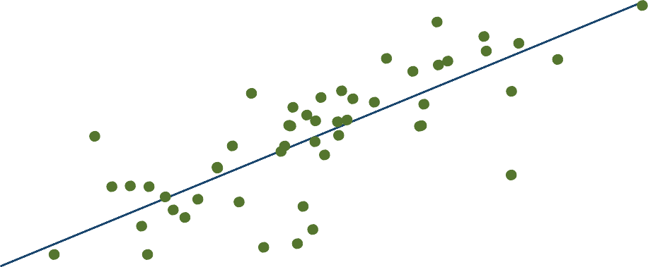
6
8
10
gdp_ln
12
14
95% CI
pub_ln
Fitted values
2
4
6
8
10
12

Appendix 2 Figure 1. The relationship between gross domestic product and publications
Note: Both variables are expressed as natural logs.

Appendix 2 Table 8. Regression summary for gross domestic product and number of publications

(1)
pub_ln

gdp_ln 0.934∗∗∗
(10.52)
Constant −1.630
(−1.93)
Observations 54
R2 0.680
Adjusted R2 0.674
t statistics in parentheses
∗ p < 0.05, ∗∗ p < 0.01, ∗∗∗ p < 0.001

−12
−10
−8
−6

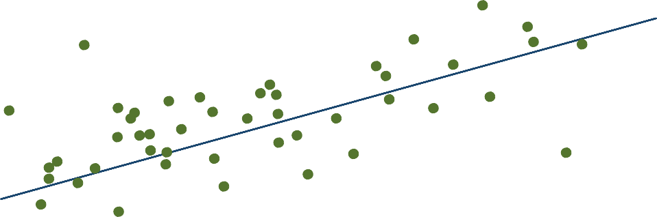
Appendix 2 Figure 2. The relationship between gross domestic product per capita and publications per capita
6
7
8
gdp_cap_ln
9
10
95% CI
pub_cap_ln
Fitted values
Note: Both variables are expressed as natural logs.

Appendix 2 Table 9. Regression summary for gross domestic product per capita and the number of publications per capita

(1)
pub_cap_ln

gdp_cap_ln 0.771∗∗∗
(5.56)
Constant −14.42∗∗∗
(−14.39)
Observations 54
R2 0.373
Adjusted R2 0.361
t statistics in parentheses
∗ p < 0.05, ∗∗ p < 0.01, ∗∗∗ p < 0.001

0
2
4
6
8

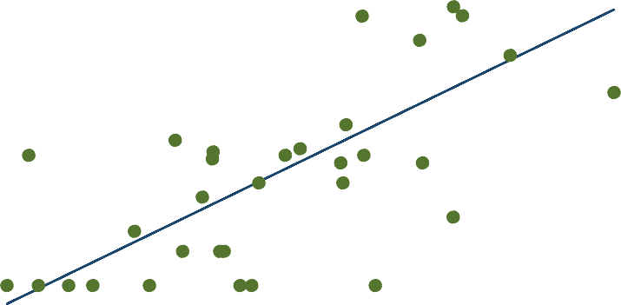
Appendix 2 Figure 3. The relationship between gross domestic product and patent applications
6
8
10
gdp_ln
12
14
95% CI
patent_ln
Fitted values
−2

Note: Both variables are expressed as natural logs.

Appendix 2 Table 10. Regression summary for gross domestic product and patent applications

(1)
patent_ln

gdp_ln 1.093∗∗∗
(6.27)
Constant −8.519∗∗∗
(−4.83)
Observations 34
R2 0.551
Adjusted R2 0.537
t statistics in parentheses
∗ p < 0.05, ∗∗ p < 0.01, ∗∗∗ p < 0.001

−2
0
2
4

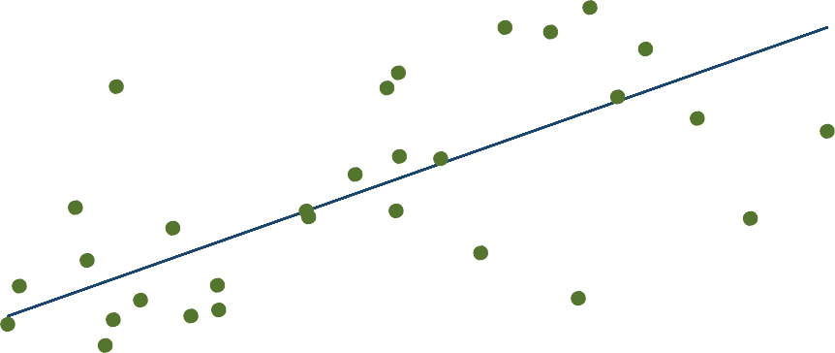
Appendix 2 Figure 4. The relationship between gross domestic product per capita and patent applications per capita
6
7
8
gdp_cap_ln
9
10
95% CI
patent_mill_ln
Fitted values
−4
Note: Both variables are expressed as natural logs.

Appendix 2 Table 11. Regression summary for gross domestic product per capita and patent applications per capita

(1)
patent_mill_ln

gdp_cap_ln 1.196∗∗∗
(4.65)
Constant −8.996∗∗∗
(−4.81)
Observations 34
R2 0.403
Adjusted R2 0.384
t statistics in parentheses
∗ p < 0.05, ∗∗ p < 0.01, ∗∗∗ p < 0.001

8
10
12
14
16

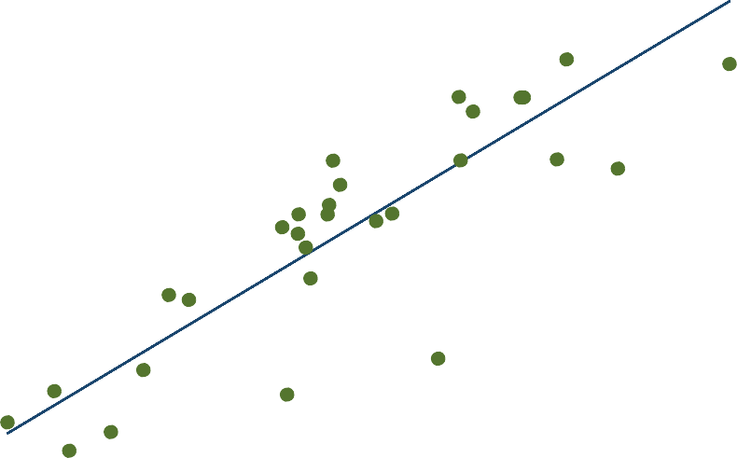
Appendix 2 Figure 5. The relationship between gross domestic product and GERD
6
8
10
gdp_ln
12
14
95% CI
gerd_ln
Fitted values

Note: Both variables are expressed as natural logs.
Appendix 2 Table 12. Regression summary for gross domestic product and GERD

(1)
gerd_ln

gdp_ln 1.190∗∗∗
(10.38)
Constant −0.188
(−0.16)
Observations 31
R2 0.788
Adjusted R2 0.781
t statistics in parentheses
∗ p < 0.05, ∗∗ p < 0.01, ∗∗∗ p < 0.001

0
2
4
6

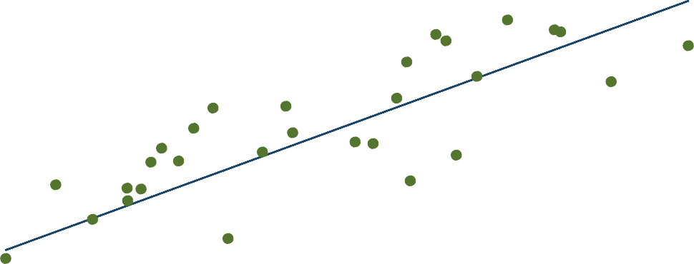
Appendix 2 Figure 6. The relationship between gross domestic product per capita and GERD per capita
6
7
8
gdp_cap_ln
9
10
95% CI
gerd_cap_ln
Fitted values
−2
Note: Both variables are expressed as natural logs.
Appendix 2 Table 13. Regression summary for gross domestic product per capita and GERD per capita

(1)
gerd_cap_ln

gdp_cap_ln 1.244∗∗∗
(7.17)
Constant −6.935∗∗∗
(−5.37)
Observations 31
R2 0.639
Adjusted R2 0.627
t statistics in parentheses
∗ p < 0.05, ∗∗ p < 0.01, ∗∗∗ p < 0.001

0
2
4
6

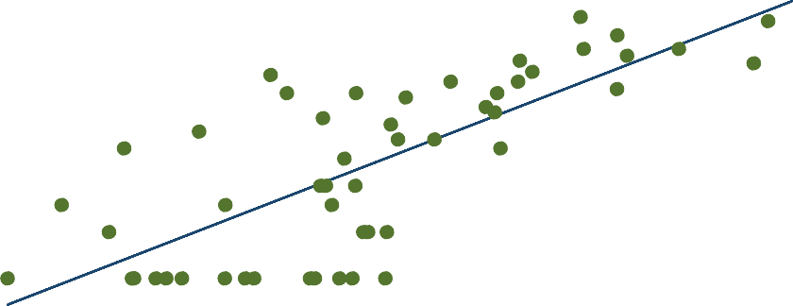
Appendix 2 Figure 7. The relationship between gross domestic product and universities
6
8
10
gdp_ln
12
14
95% CI
univ_ln
Fitted values
−2
Note: Both variables are expressed as natural logs.
Appendix 2 Table 14. Regression summary for gross domestic product and universities

(1)
univ_ln

gdp_ln 0.700∗∗∗
(8.55)
Constant −4.893∗∗∗
(−6.22)
Observations 52
R2 0.594
Adjusted R2 0.586
t statistics in parentheses
∗ p < 0.05, ∗∗ p < 0.01, ∗∗∗ p < 0.001

−2
0
2
4

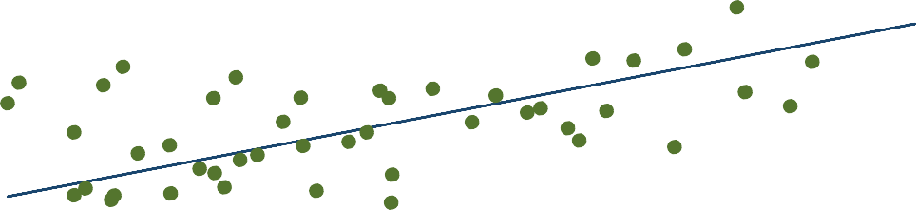
Appendix 2 Figure 8. The relationship between gross domestic product per capita and universities per capita
6
7
8
gdp_cap_ln
9
10
95% CI
univ_mill_ln
Fitted values
−4
Note: Both variables are expressed as natural logs.
Appendix 2 Table 15. Regression summary for gross domestic product per capita and universities per capita

(1)
univ_mill_ln

gdp_cap_ln 0.648∗∗∗
(5.06)
Constant −5.207∗∗∗
(−5.62)
Observations 52
R2 0.339
Adjusted R2 0.326
t statistics in parentheses
∗ p < 0.05, ∗∗ p < 0.01, ∗∗∗ p < 0.001

0
2
4
6
8

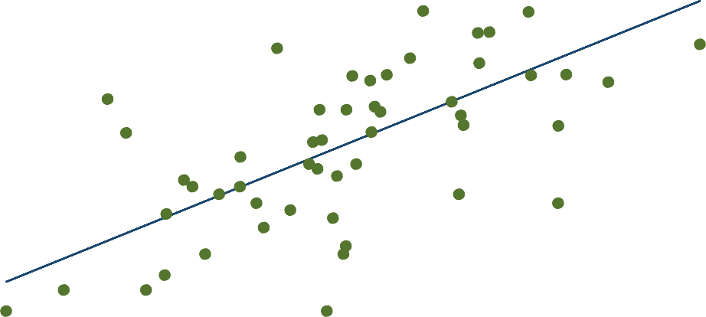
Appendix 2 Figure 9. The relationship between gross domestic product and clinical trials
6
8
10
gdp_ln
12
14
95% CI
ictrp_ln
Fitted values
Note: Both variables are expressed as natural logs.
Appendix 2 Table 16. Regression summary for gross domestic product and clinical trials

(1)
ictrp_ln

gdp_ln 0.765∗∗∗
(7.03)
Constant −3.212∗∗
(−3.09)
Observations 53
R2 0.492
Adjusted R2 0.482
t statistics in parentheses
∗ p < 0.05, ∗∗ p < 0.01, ∗∗∗ p < 0.001

0
2
4

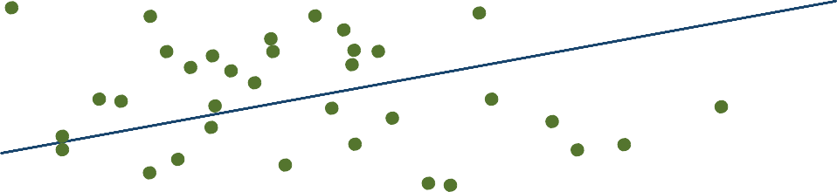
Appendix 2 Figure 10. The relationship between gross domestic product per capita and clinical trials per capita
6
7
8
gdp_cap_ln
9
10
95% CI
ictrp_mill_ln
Fitted values
−2
Note: Both variables are expressed as natural logs.
Appendix 2 Table 17. Regression summary for gross domestic product per capita and clinical trials per capita

(1)
ictrp_mill_ln

gdp_cap_ln 0.492∗∗
(2.98)
Constant −1.789
(-1.50)

Observations 53
R2 0.149
Adjusted R2 0.132
t statistics in parentheses
∗ p < 0.05, ∗∗ p < 0.01, ∗∗∗ p < 0.001

