Supplemental Information Figure 1
- 30 word clouds for prescription opioid dataset
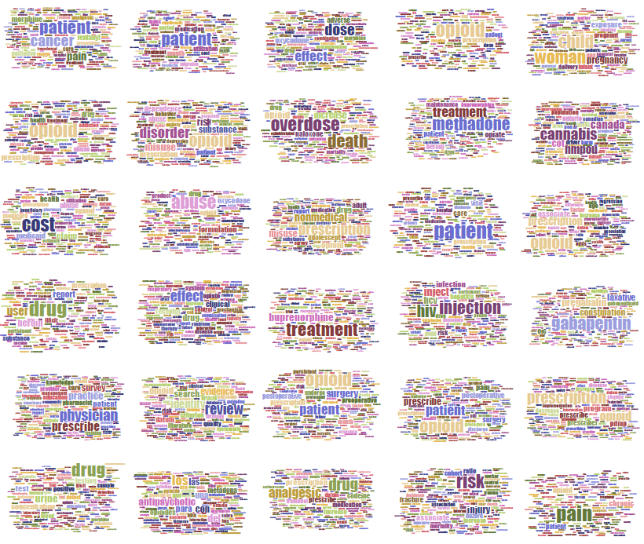

- 35 word clouds for codeine dataset
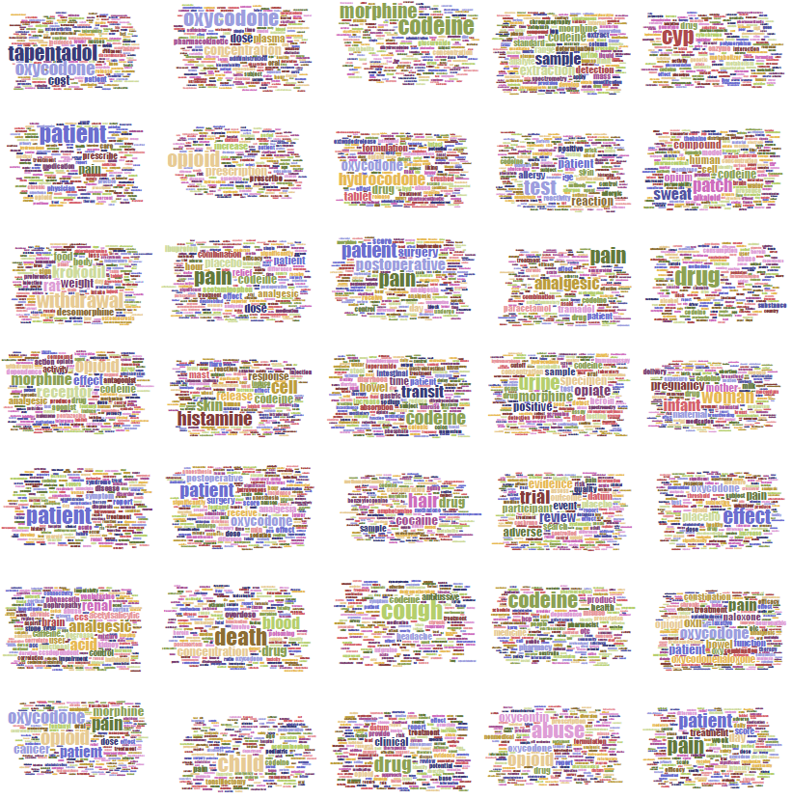

- 40 word clouds for morphine dataset
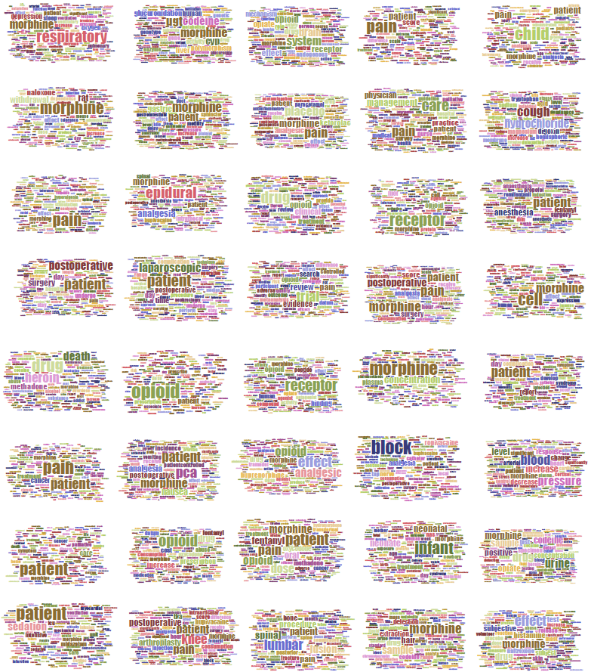

- 25 word clouds for hydrocodone dataset
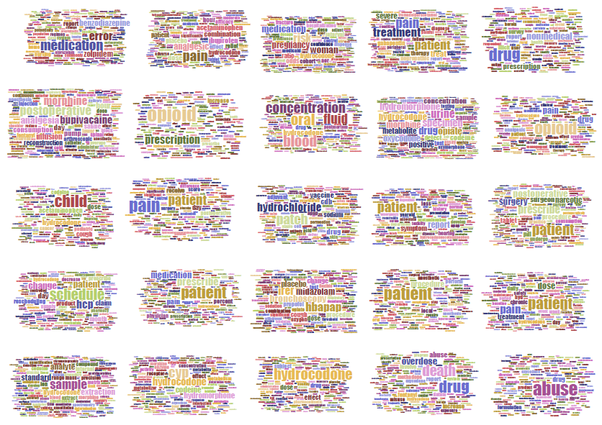

- 35 word clouds for oxycodone dataset
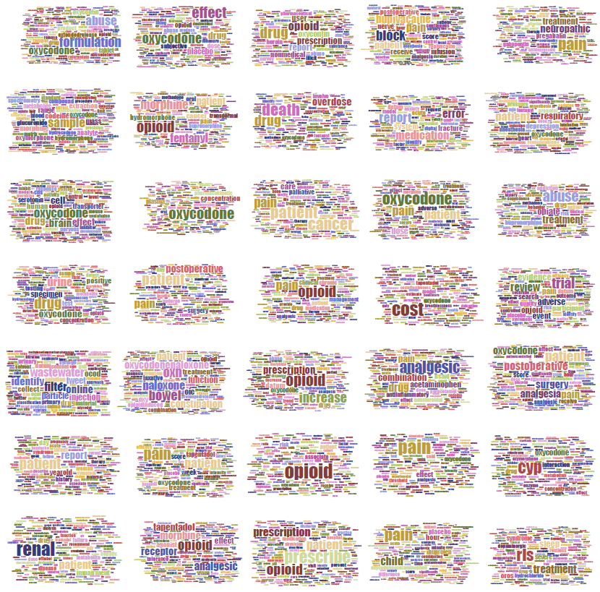

- 40 word clouds for methadone dataset
