Figure 1S: Comparison in the Q-Q profiles between Optim-GRAMMAR and the four competing methods. The simulated phenotypes are controlled by 40, 200, 1,000 QTNs with the low, moderate and high heritabilities in 1) human and 2) maize.

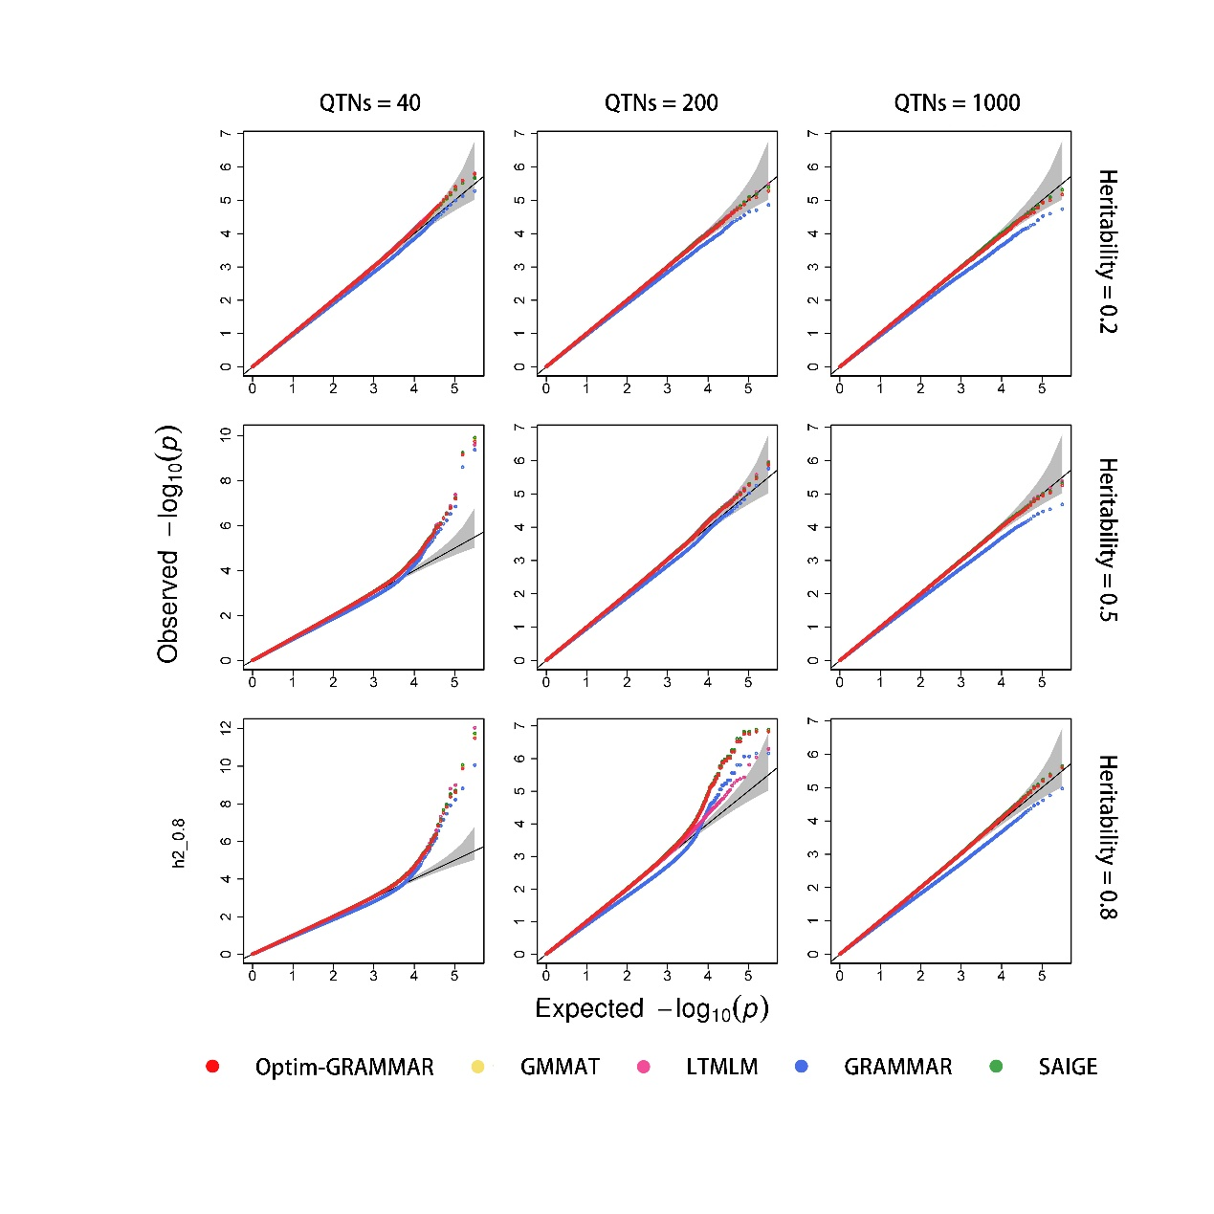

(1)

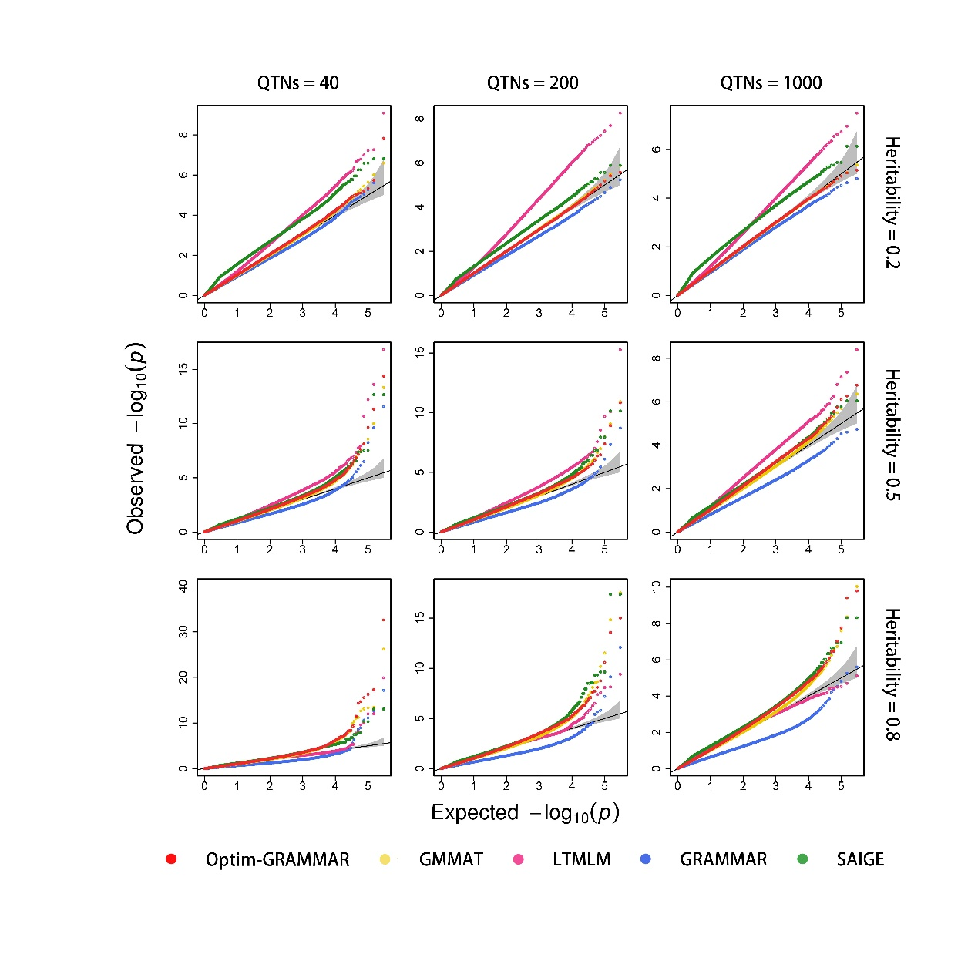

(2)

Figure 2S: Comparison in the ROC profiles between Optim-GRAMMAR and the four competing methods. The ROC profiles are plotted using the statistical powers to detect QTNs relative to the given series of Type I errors. Here, the simulated phenotypes are controlled by 40, 200, 1,000 QTNs with the low, moderate and high heritabilities in 1) human and 2) maize.

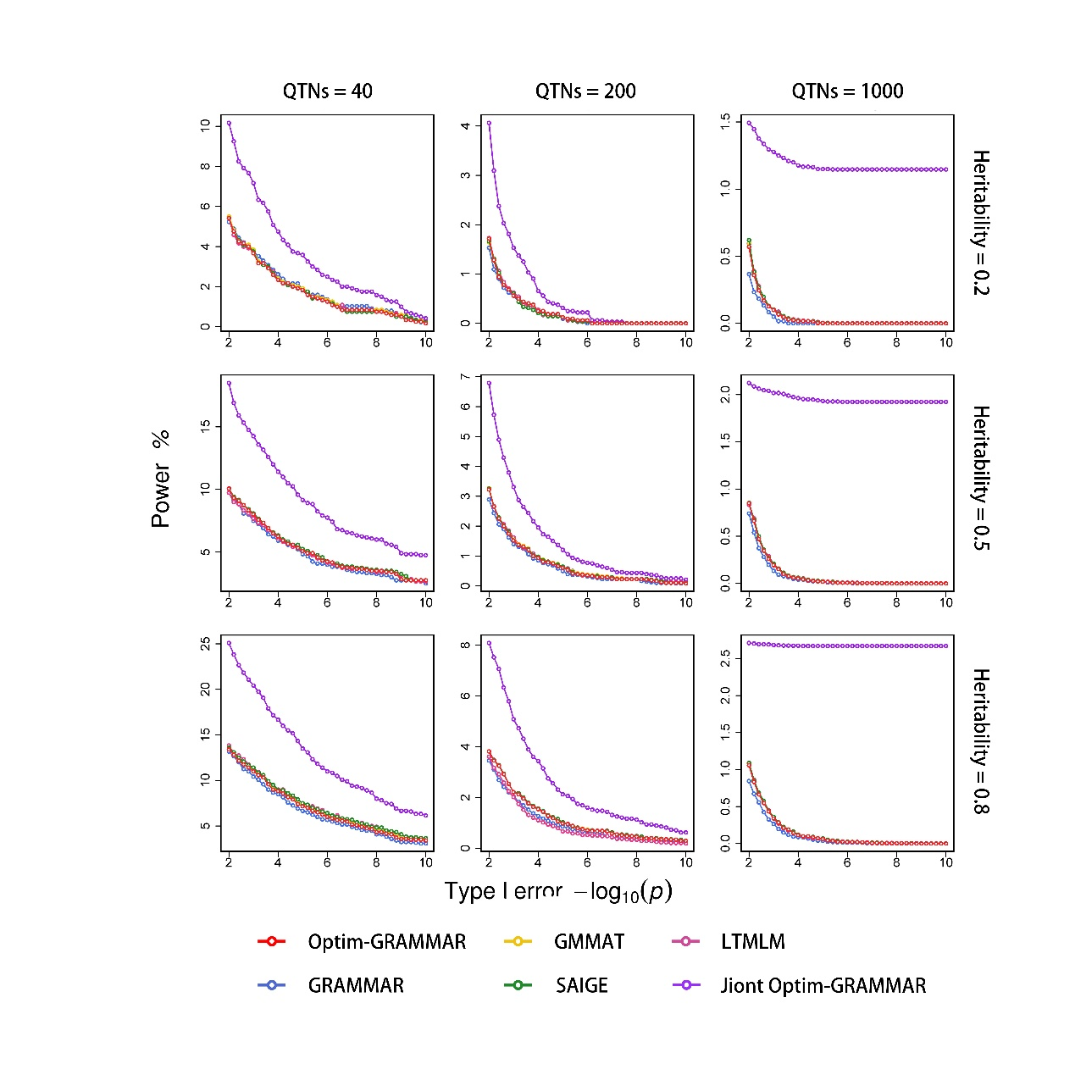

(1)

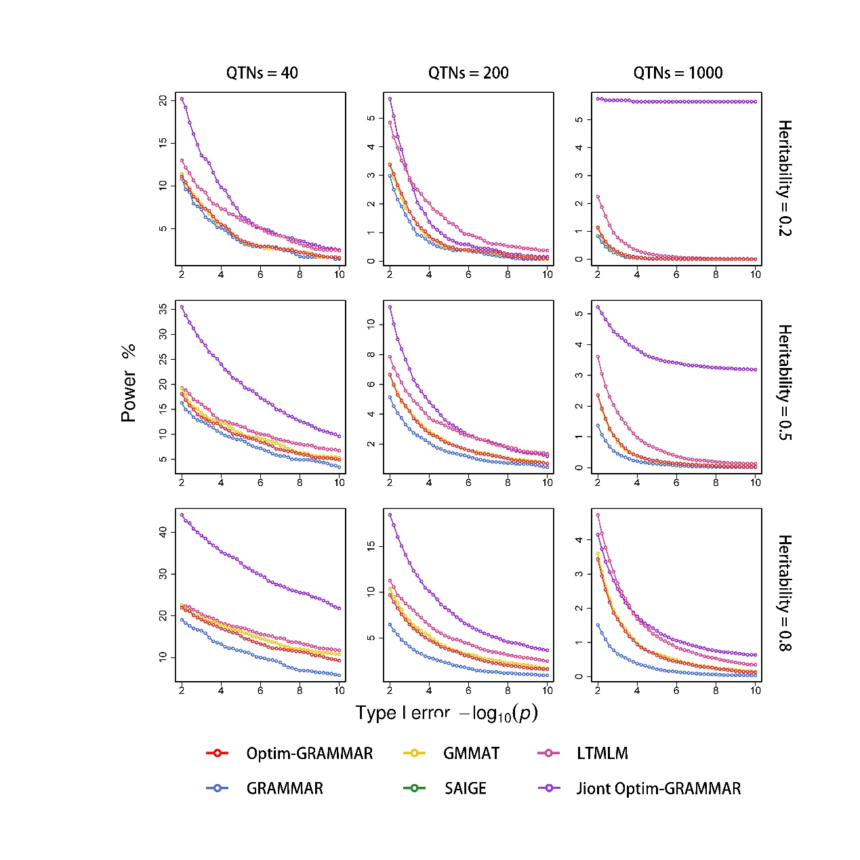

(2)

Figure 3S: Changes in Q-Q profiles with the number of sampling SNPs for Optim-GRAMMAR. The simulated phenotypes are controlled by 40, 200, 1,000 QTNs in human and maize.
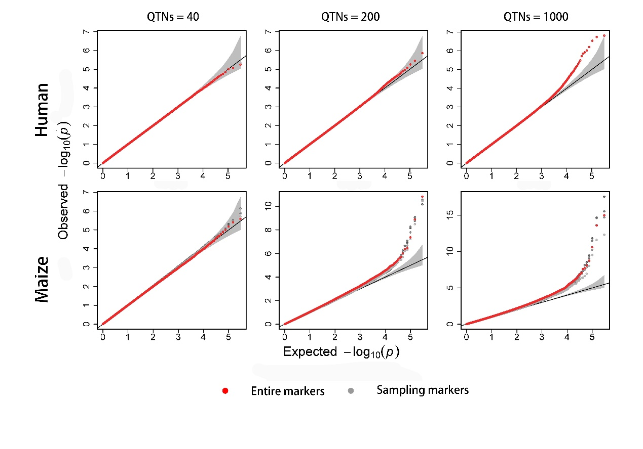

Figure 4S: Manhattan and Q-Q profiles for 1) BD; 2) CAD; 3) HT; 4) RA; 5) T1D and 6) T2D under standard quality control. The bottom is for joint association analysis

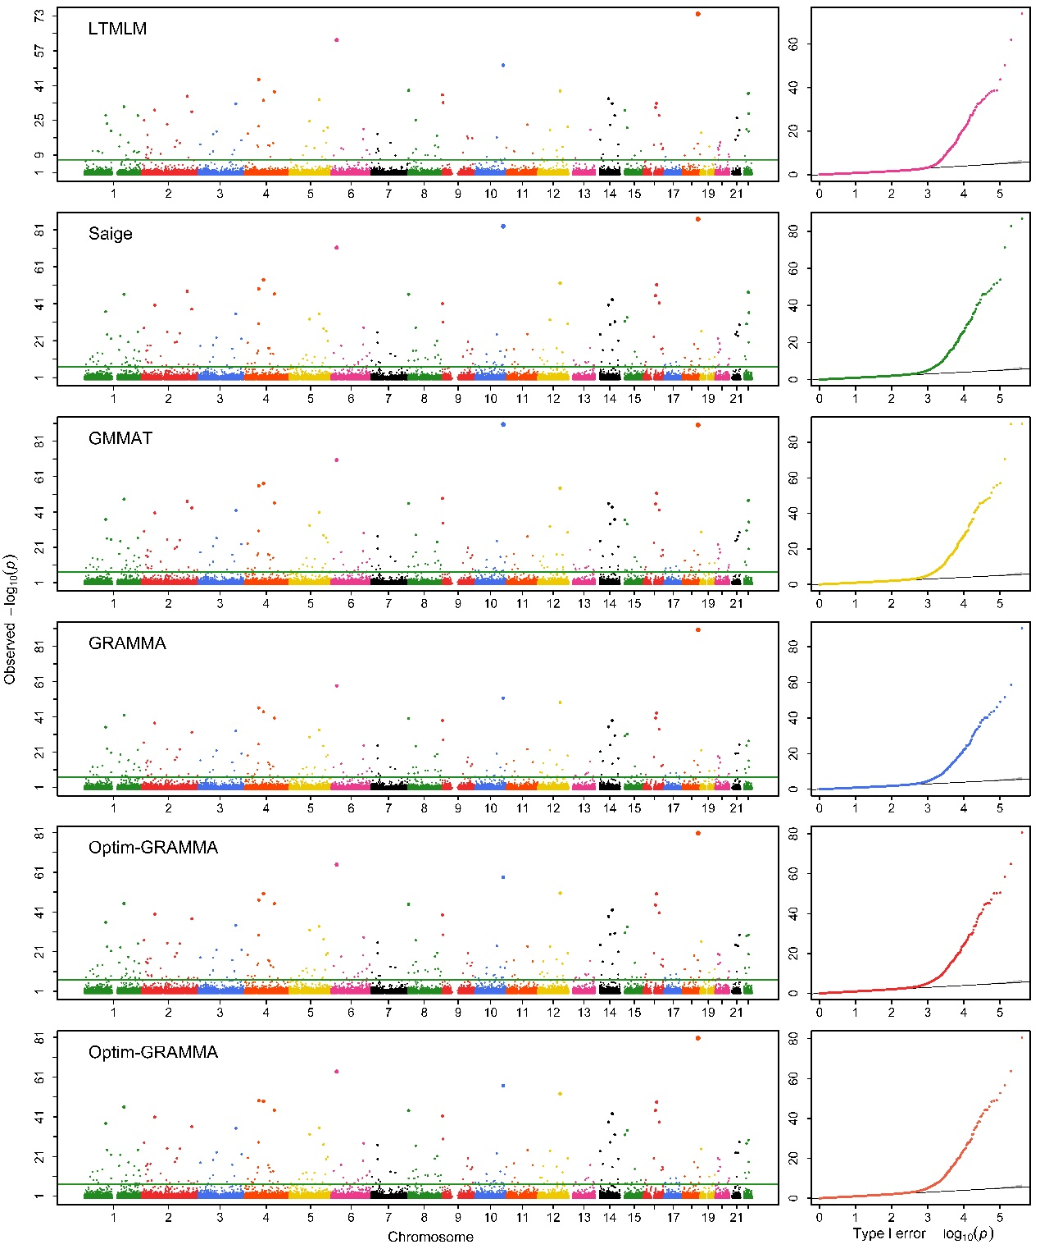

(1)

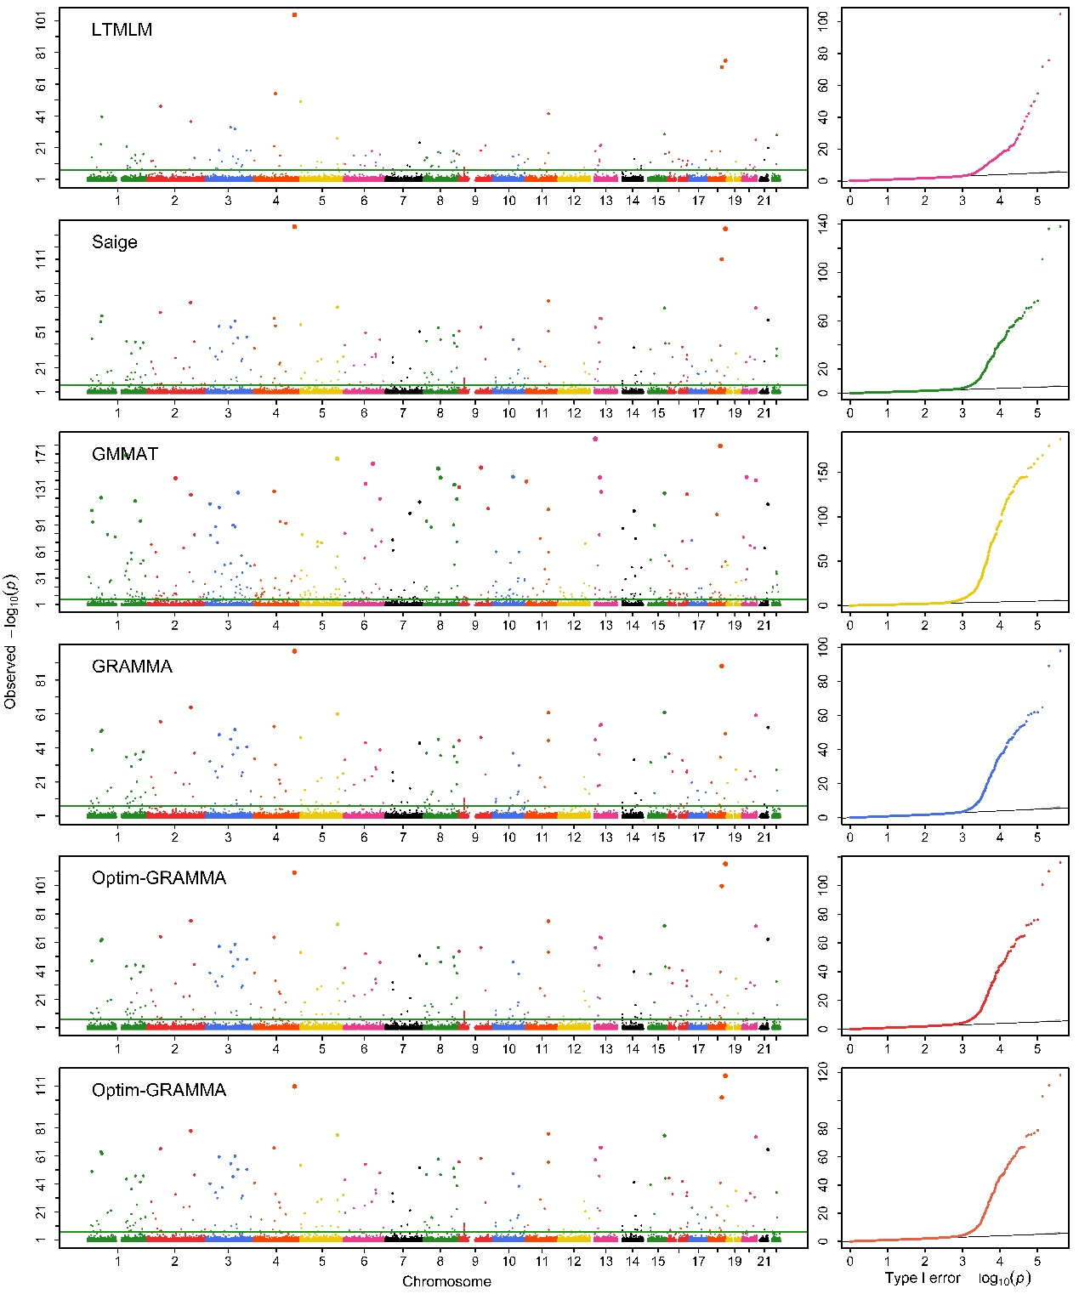

(2)

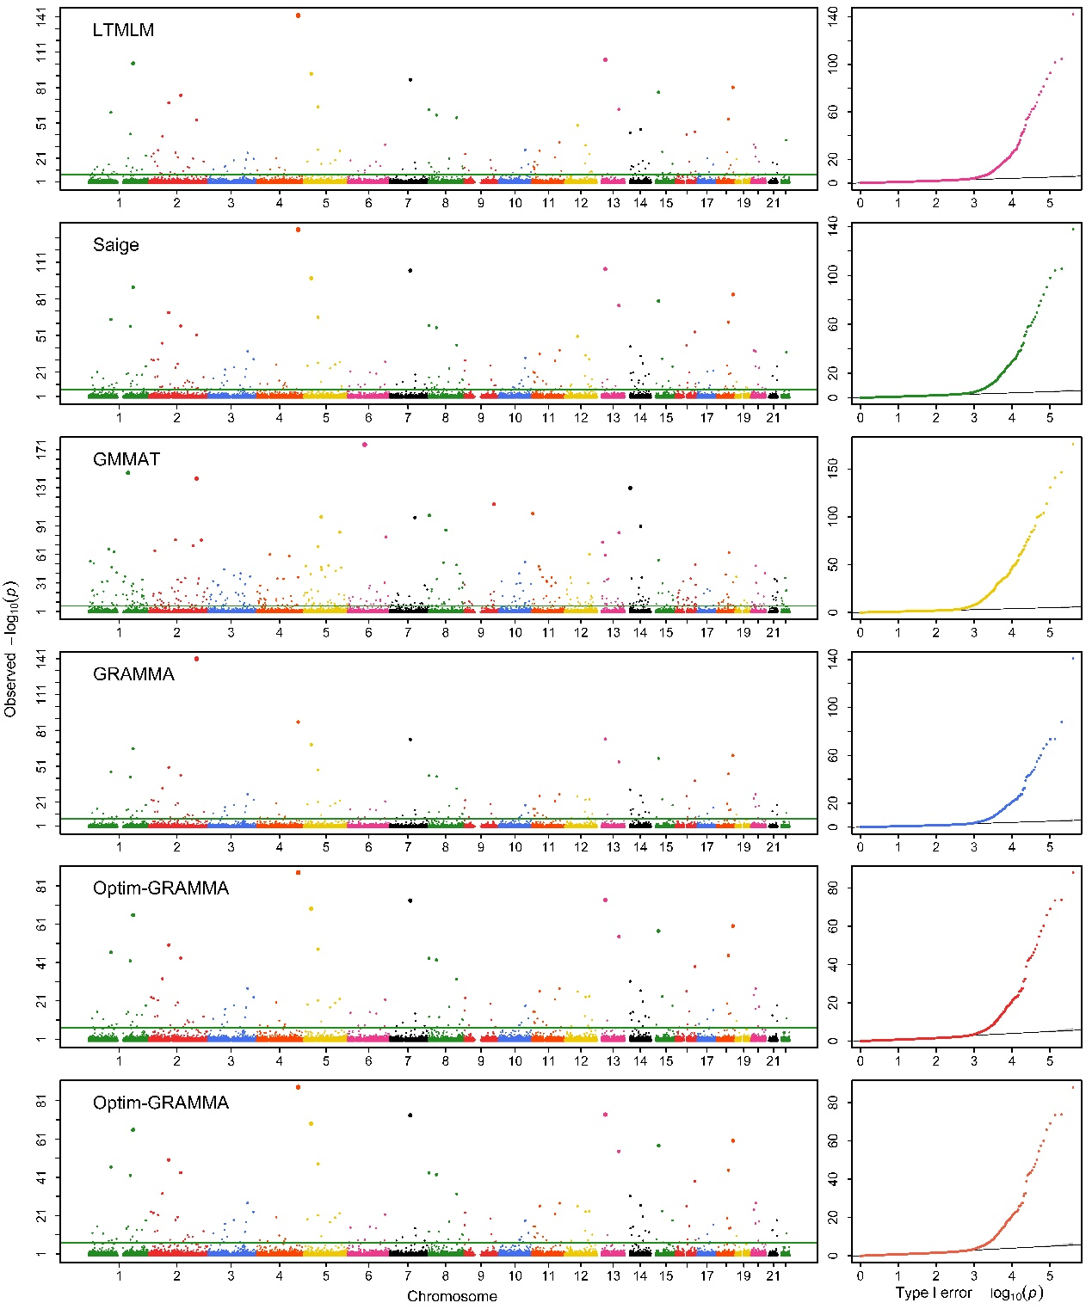

(3)

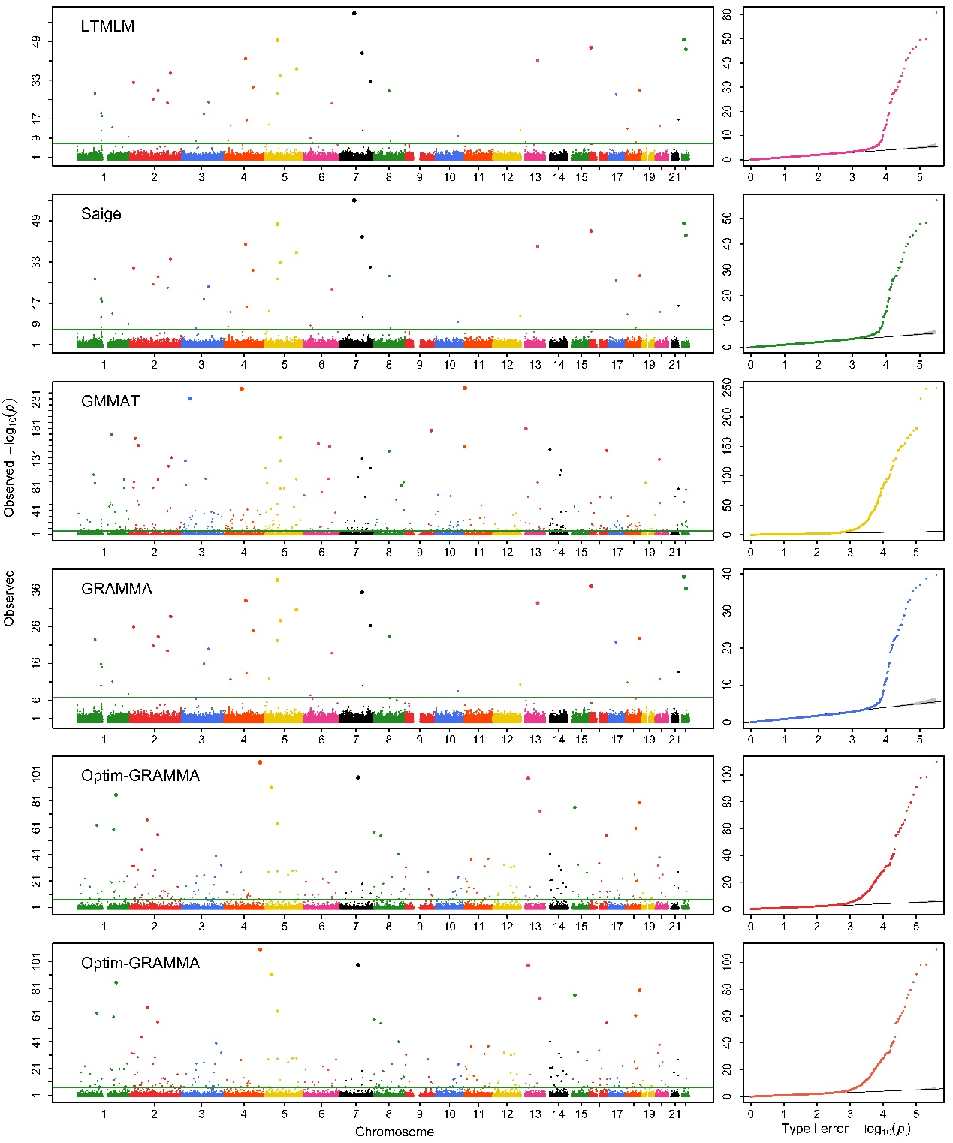

(4)

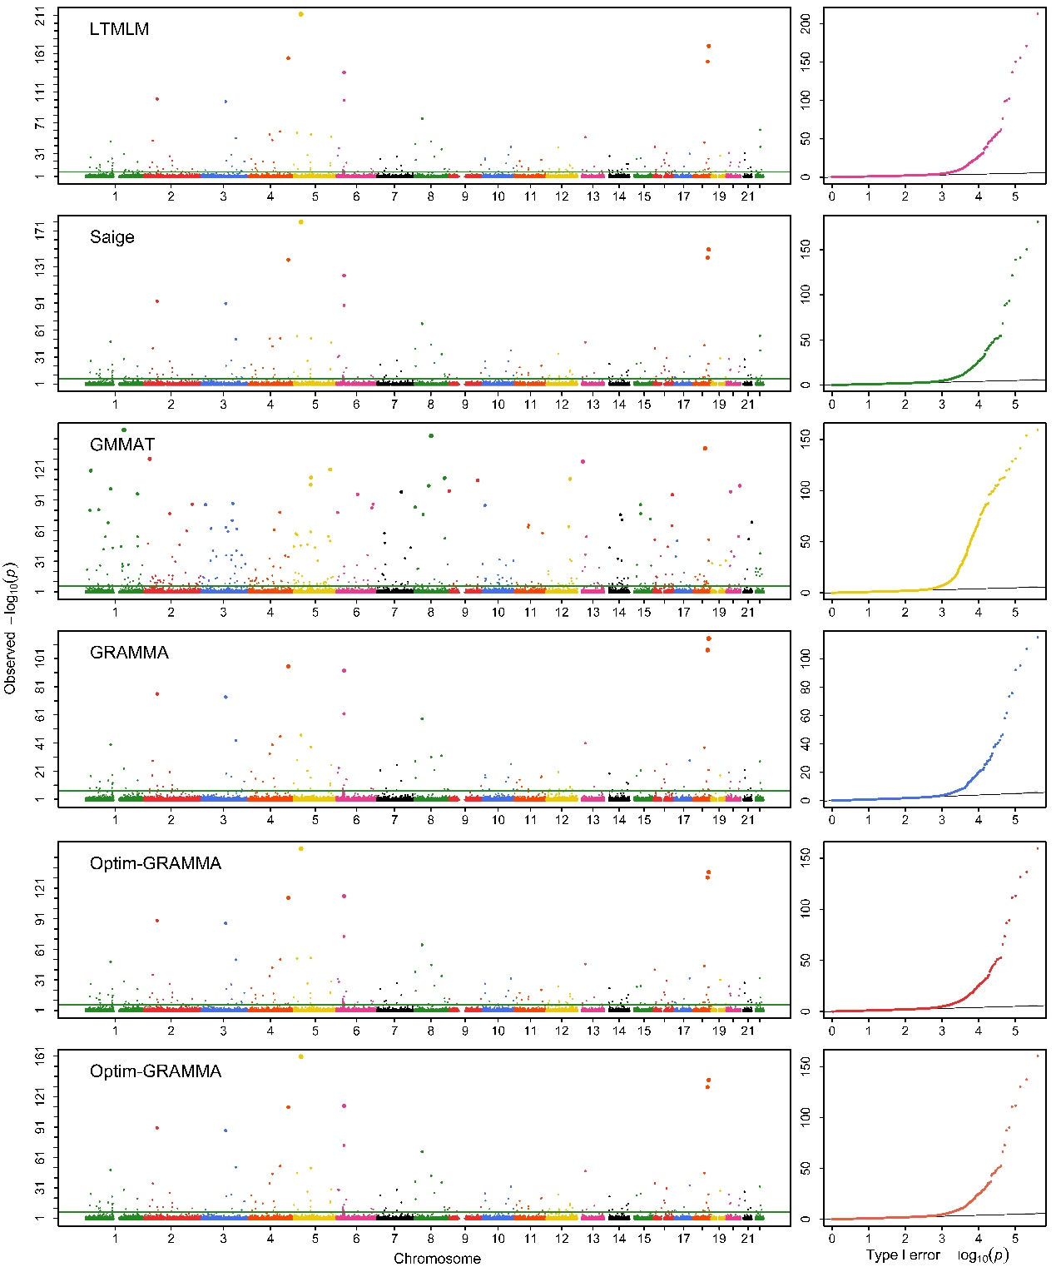

(5)

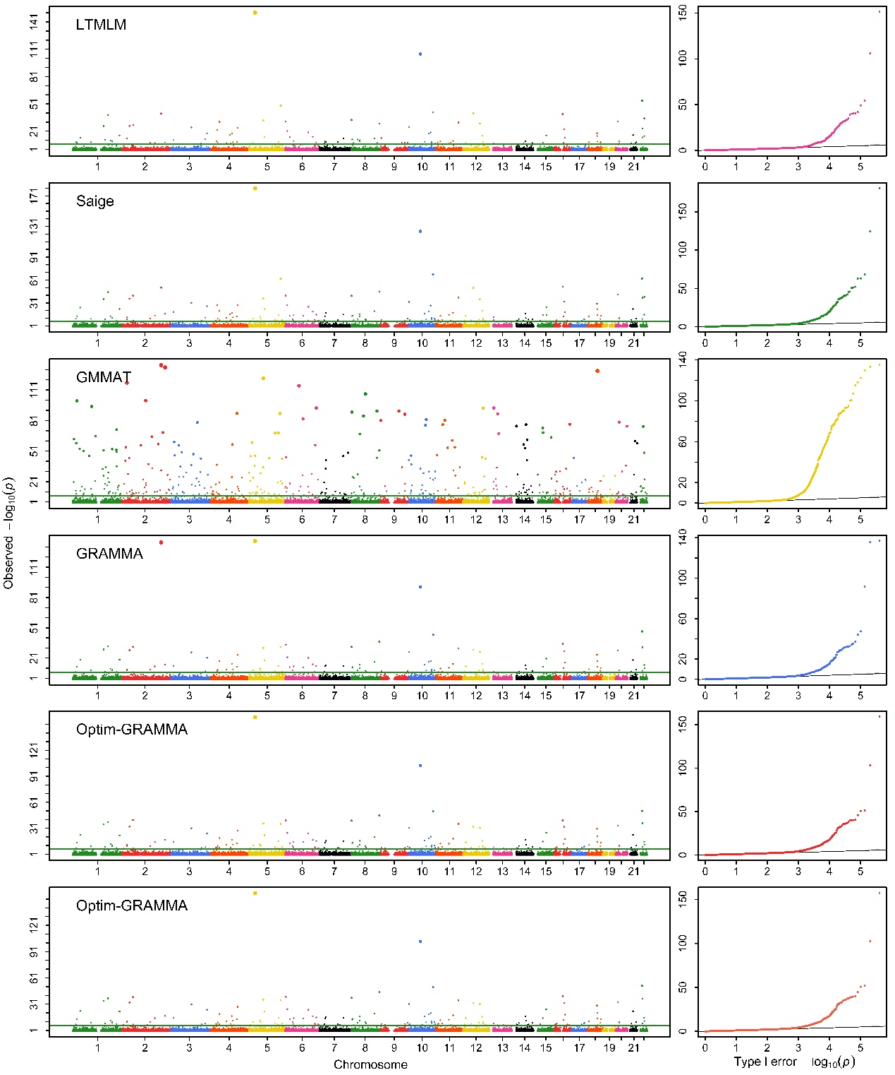

(6)

Figure 5S: Manhattan and Q-Q profiles obtained with Optim-GRAMMAR that uses entire markers to estimate genomic heritability and GBVs (upper), and uses sampling markers to estimate only GBVs with given specified heritability, a test at once (middle) and joint association analysis (lower) for 1) BD; 2) CAD; 3) HT; 4) RA; 5) T1D and 6) T2D under standard quality control

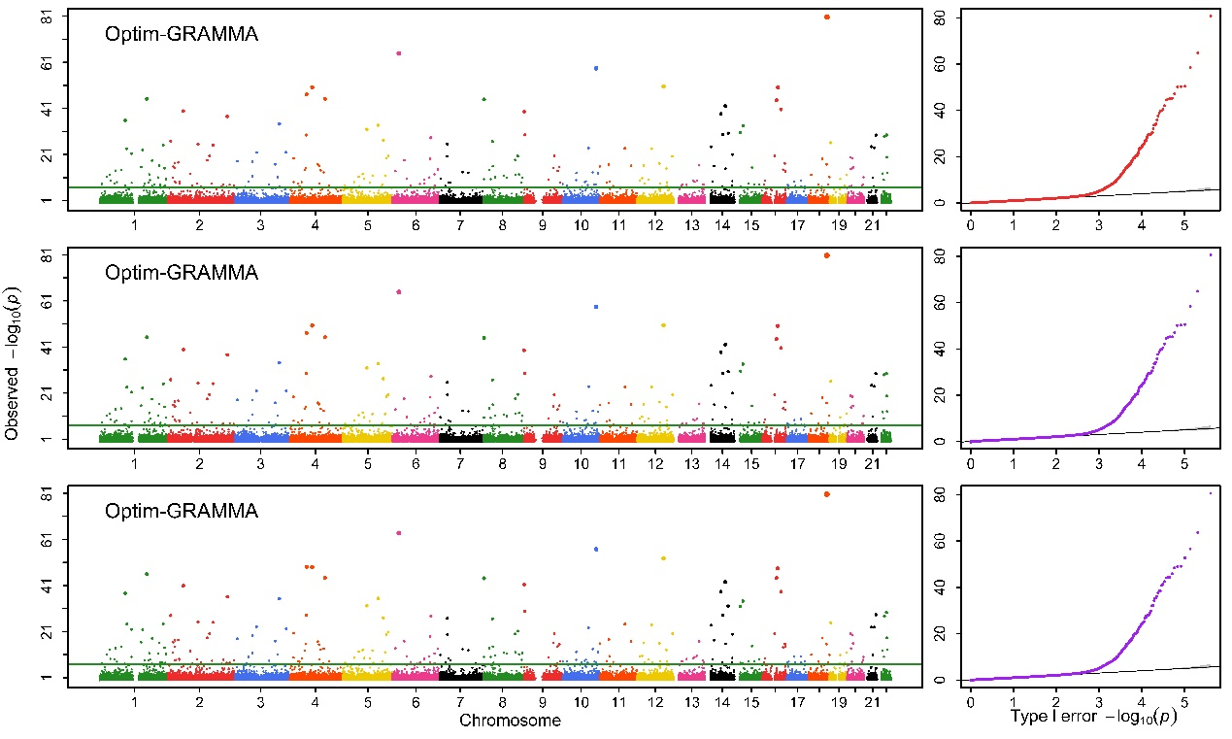
(1)

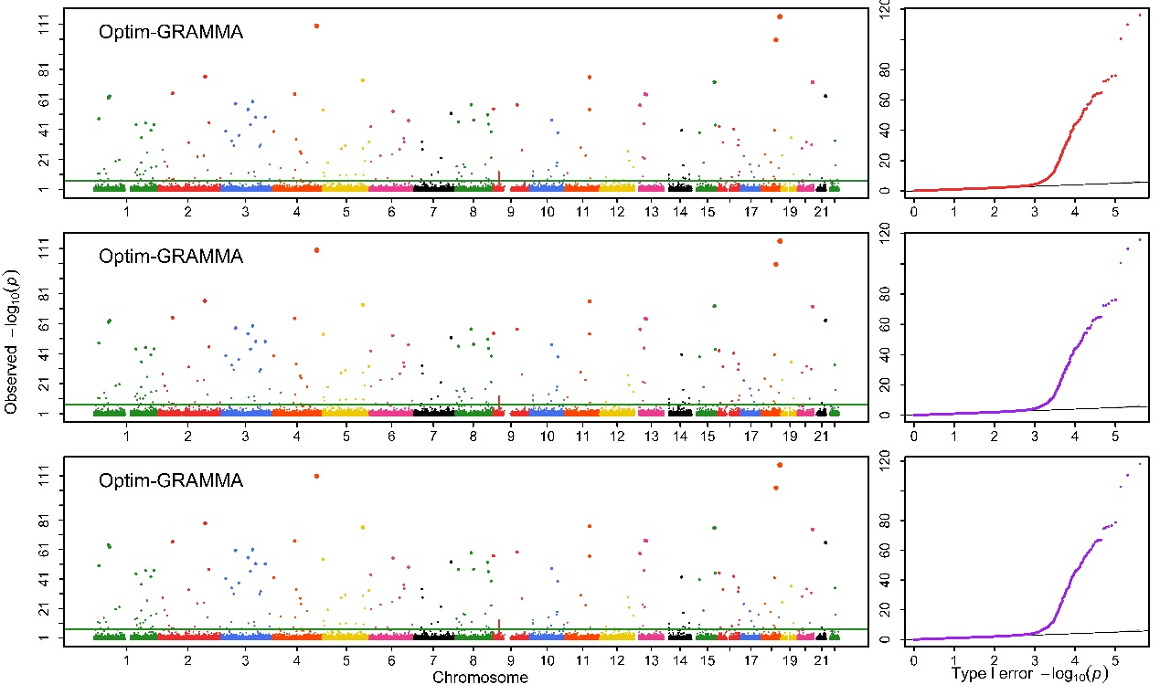

(2)

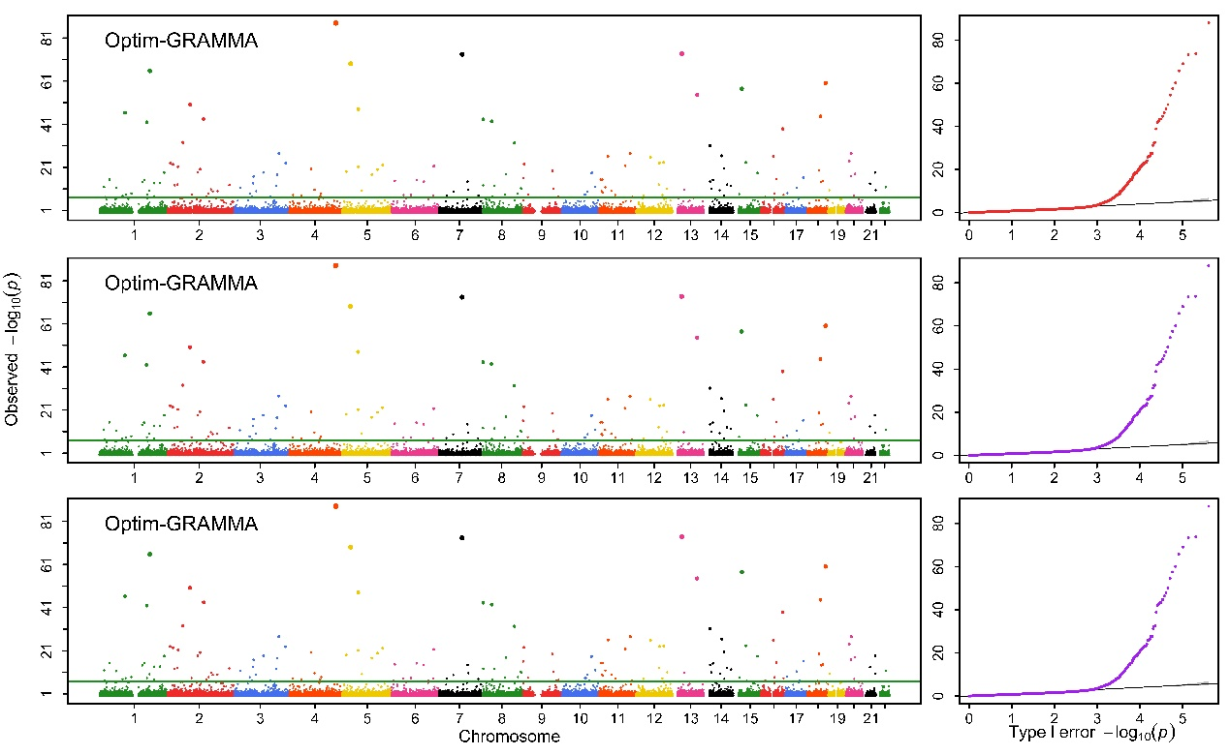

(3)

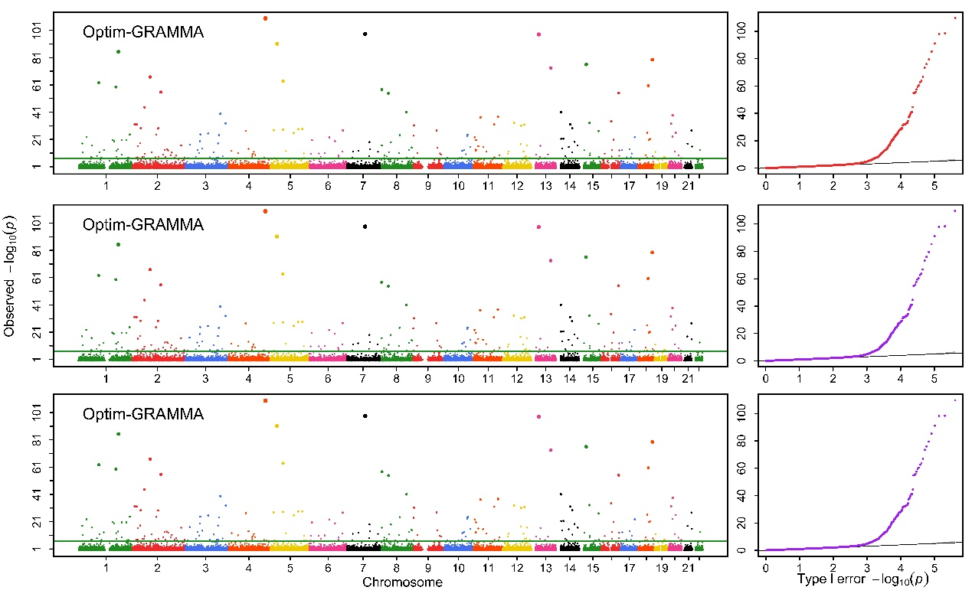

(4)

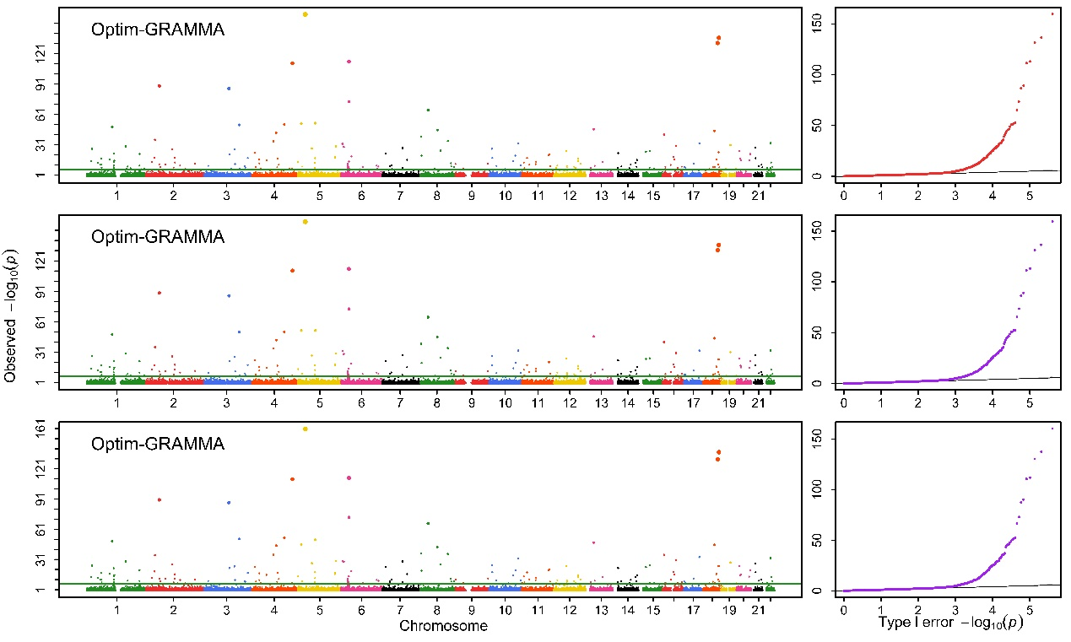

(5)

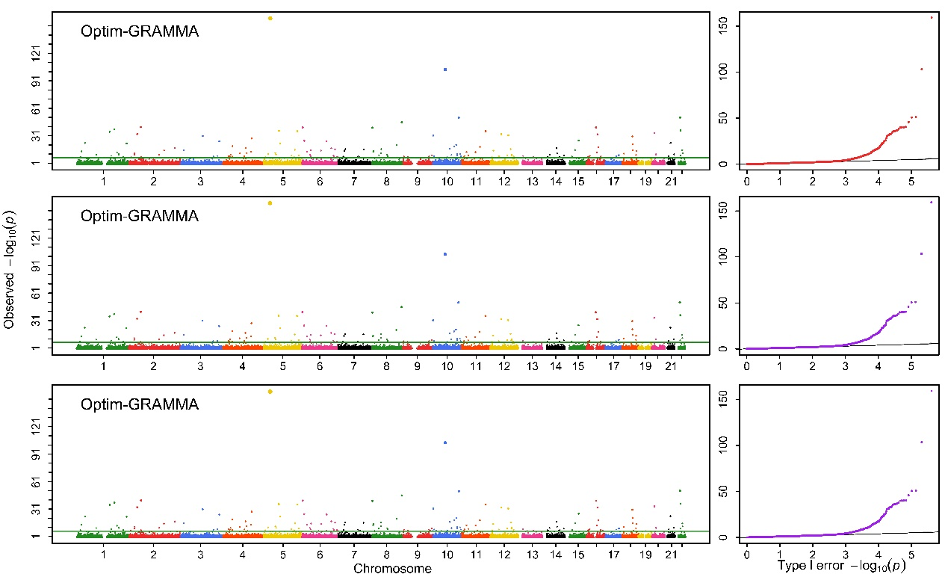

(6)

Figure 6S: Manhattan and Q-Q profiles for 1) BD; 2) CAD; 3) HT; 4) RA; 5) T1D and 6) T2D under strict quality control. The bottom is for joint association analysis

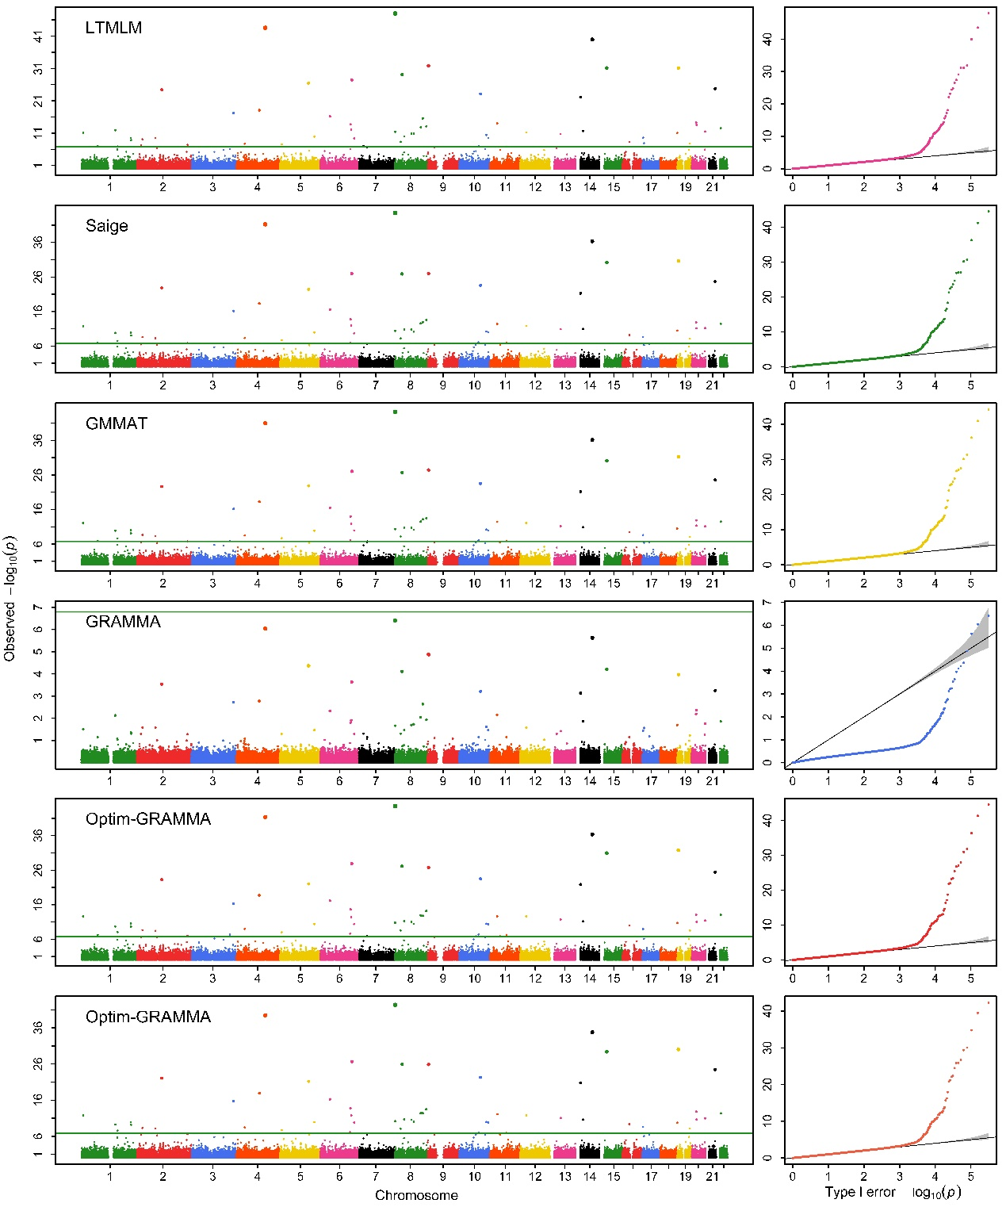

(1)

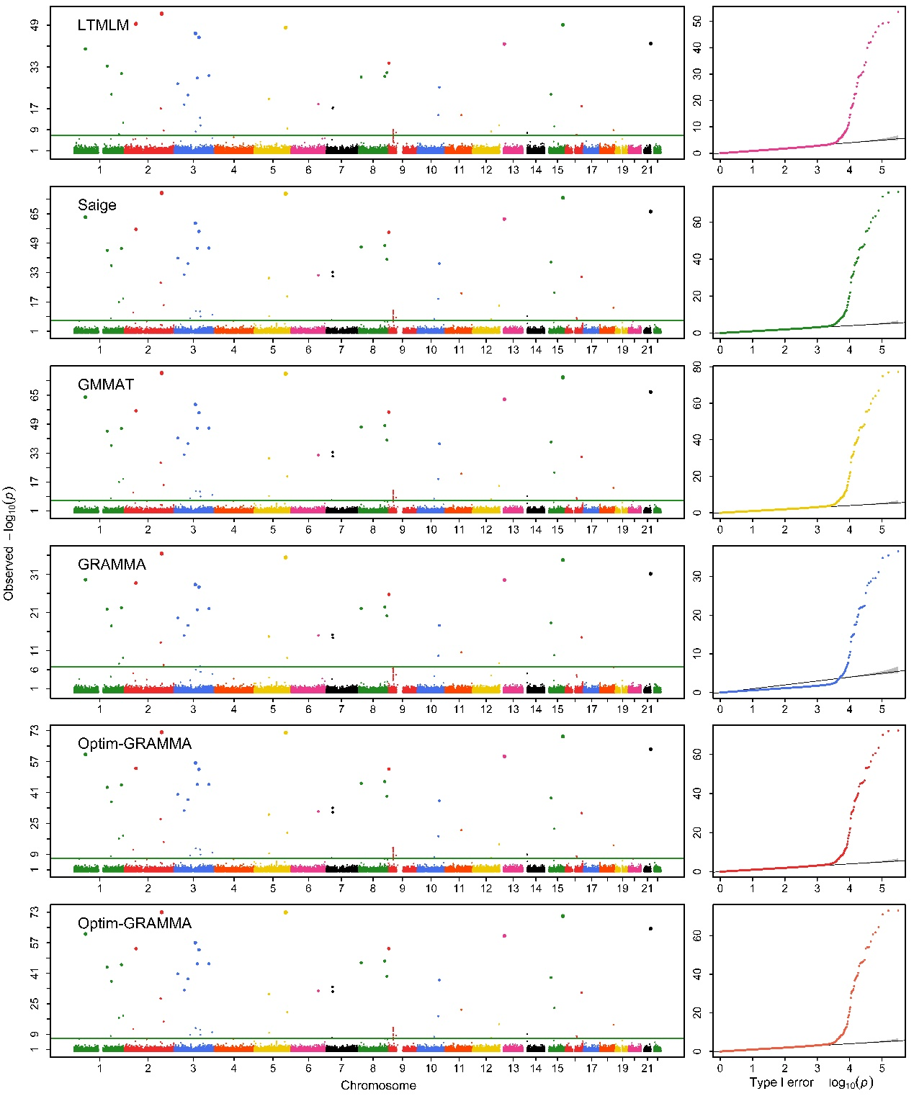

(2)

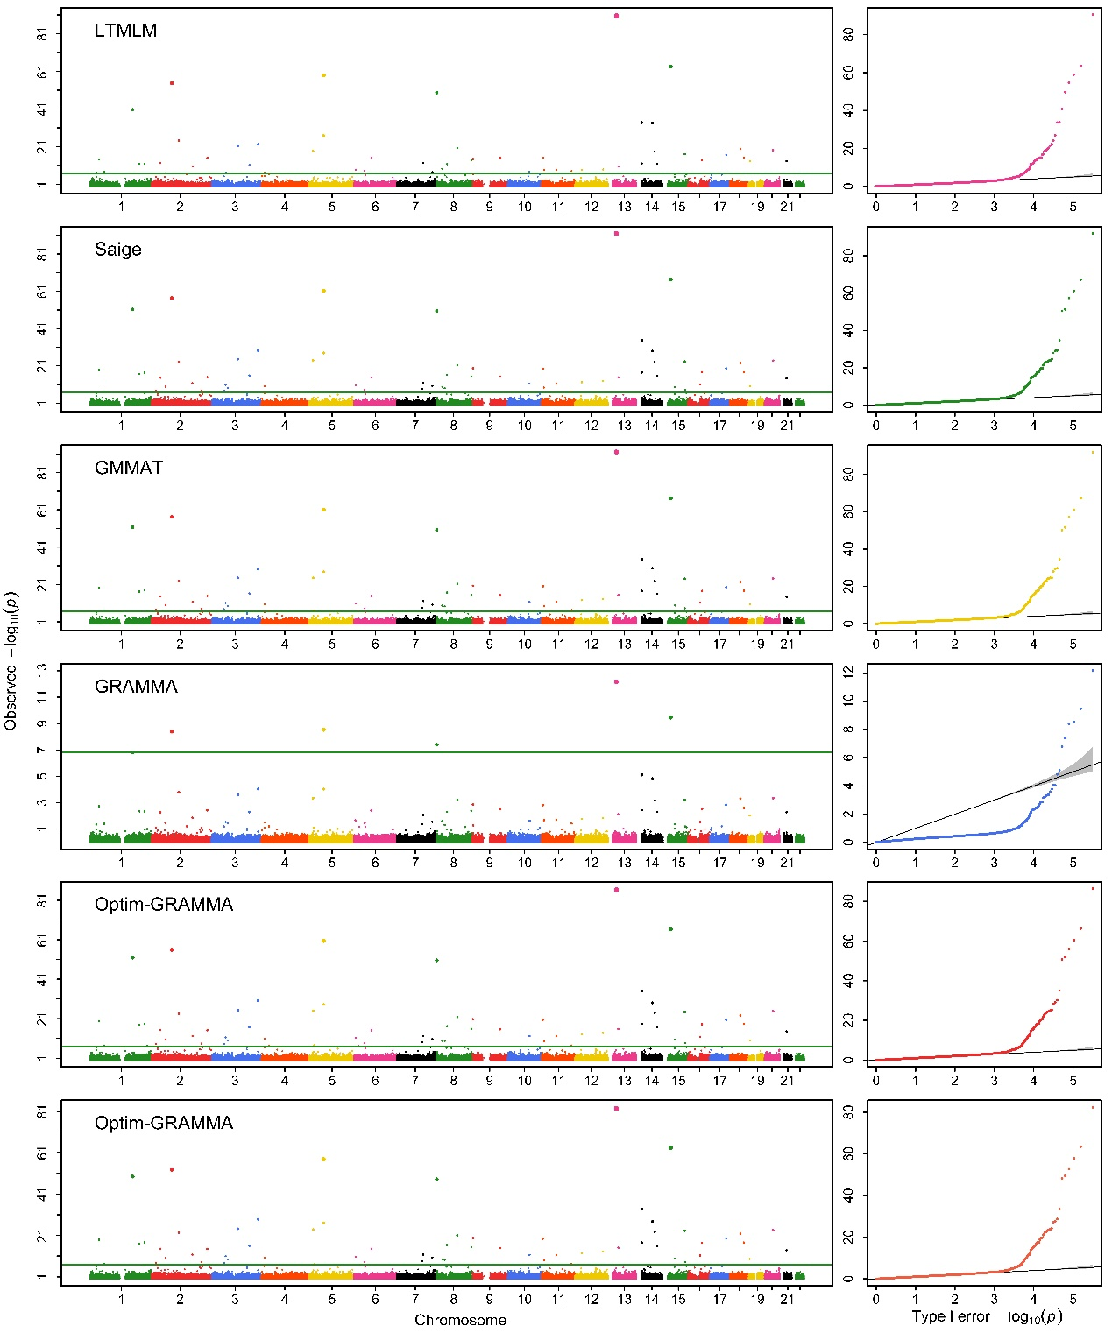

(3)

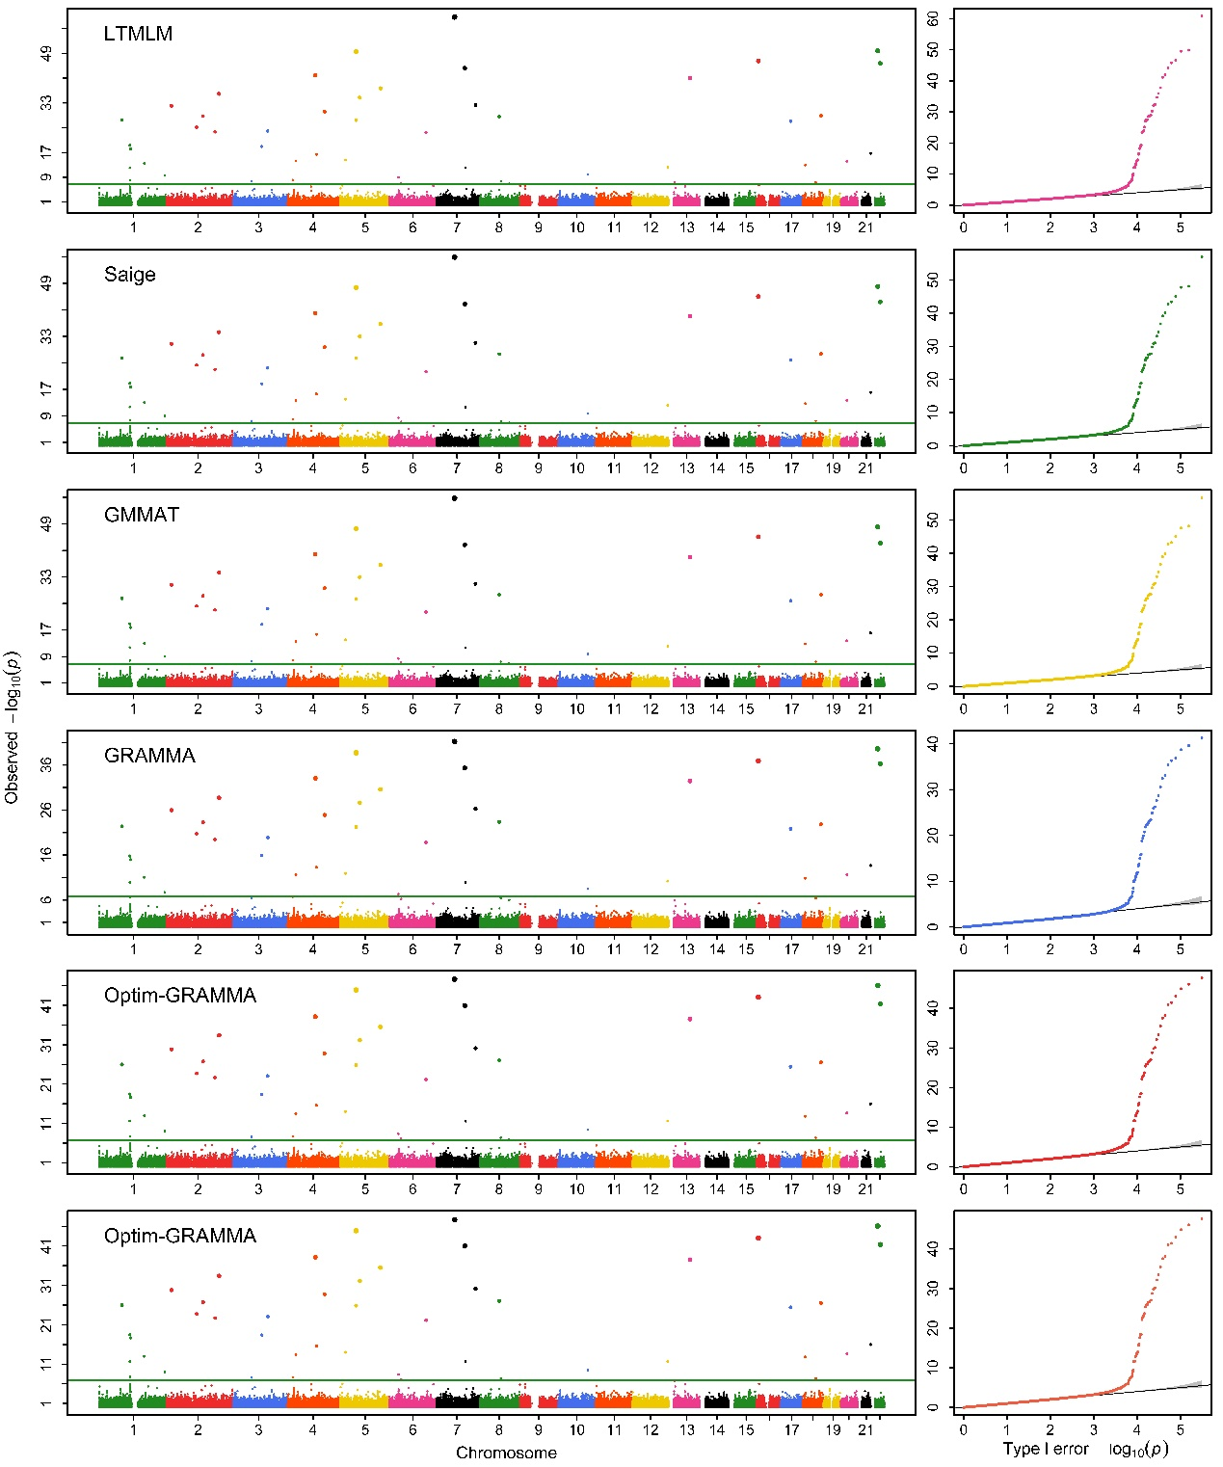

(4)

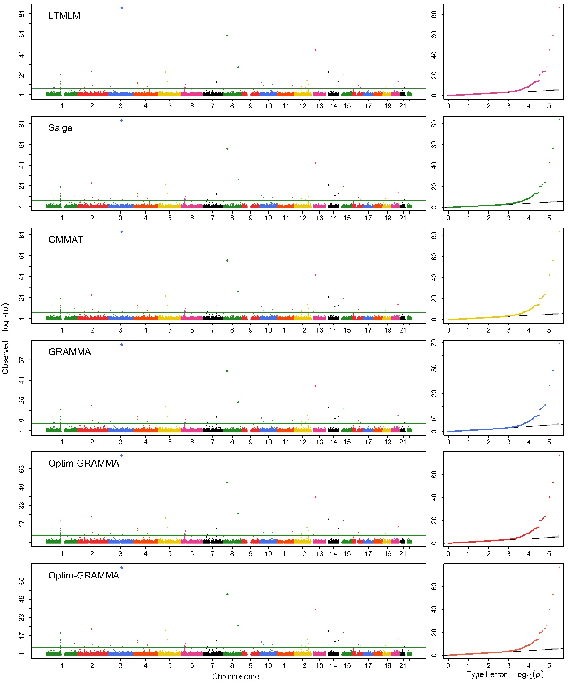

(5)

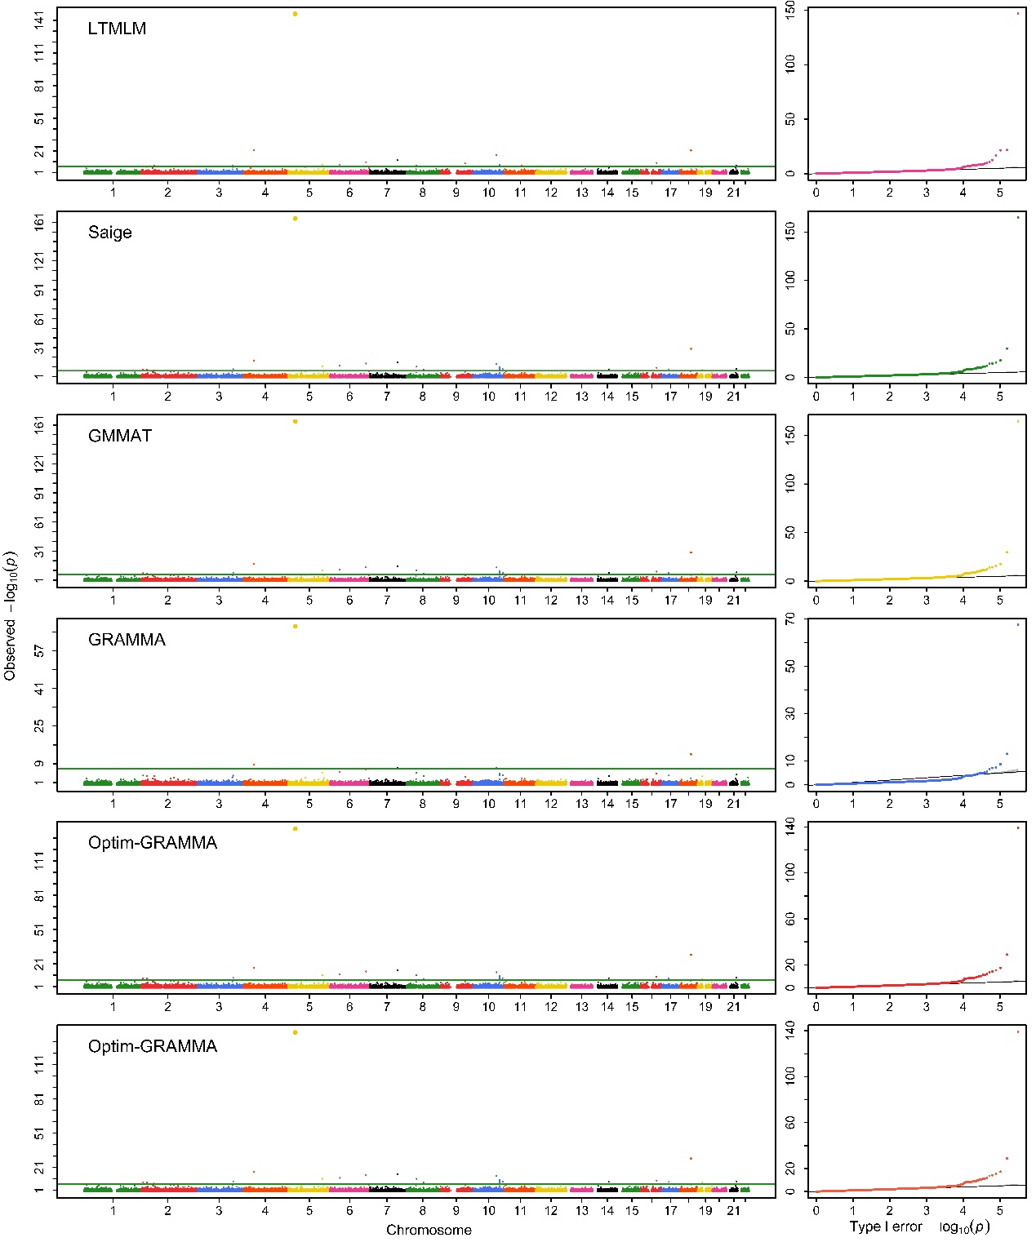

(6)

Figure 7S: Manhattan and Q-Q profiles obtained with Optim-GRAMMAR that uses entire markers to estimate genomic heritability and GBVs (upper), and uses sampling markers to estimate only GBVs with given specified heritability, a test at once (middle) and joint association analysis (lower) for 1) BD; 2) CAD; 3) HT; 4) RA; 5) T1D and 6) T2D under strict quality control

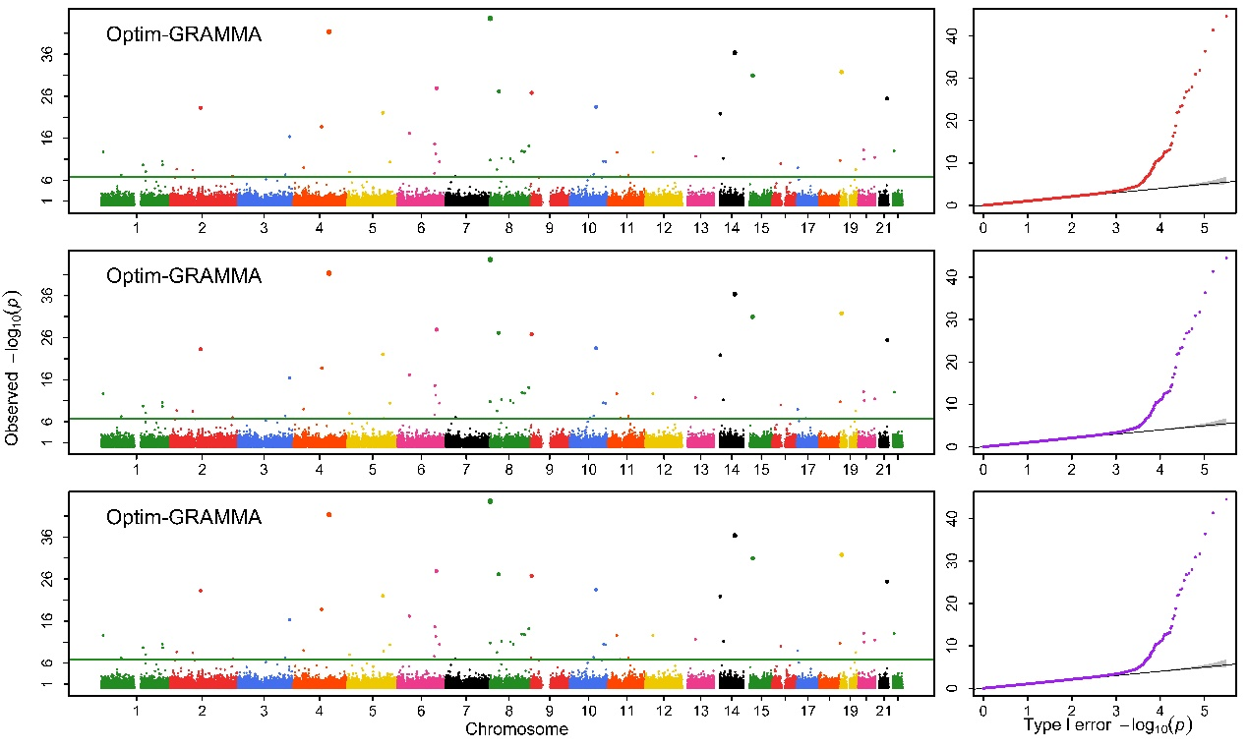

(1)

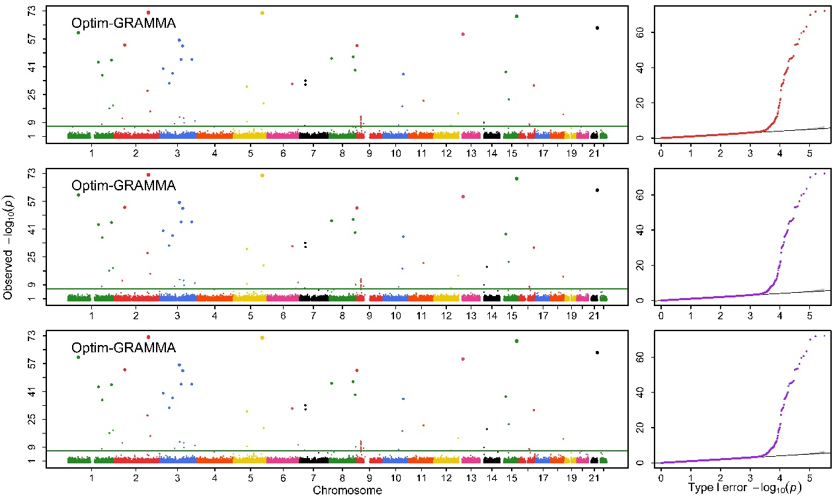

(2)

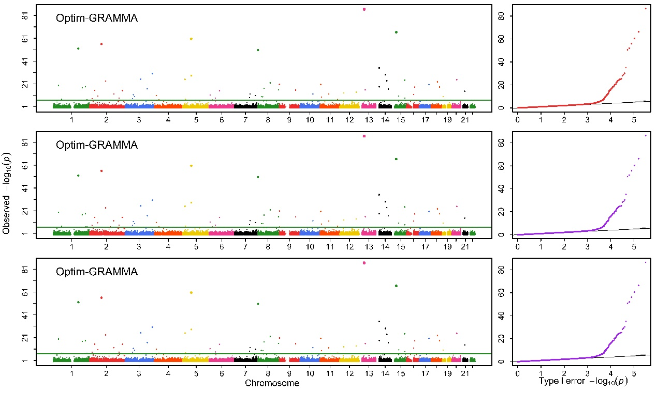

(3)

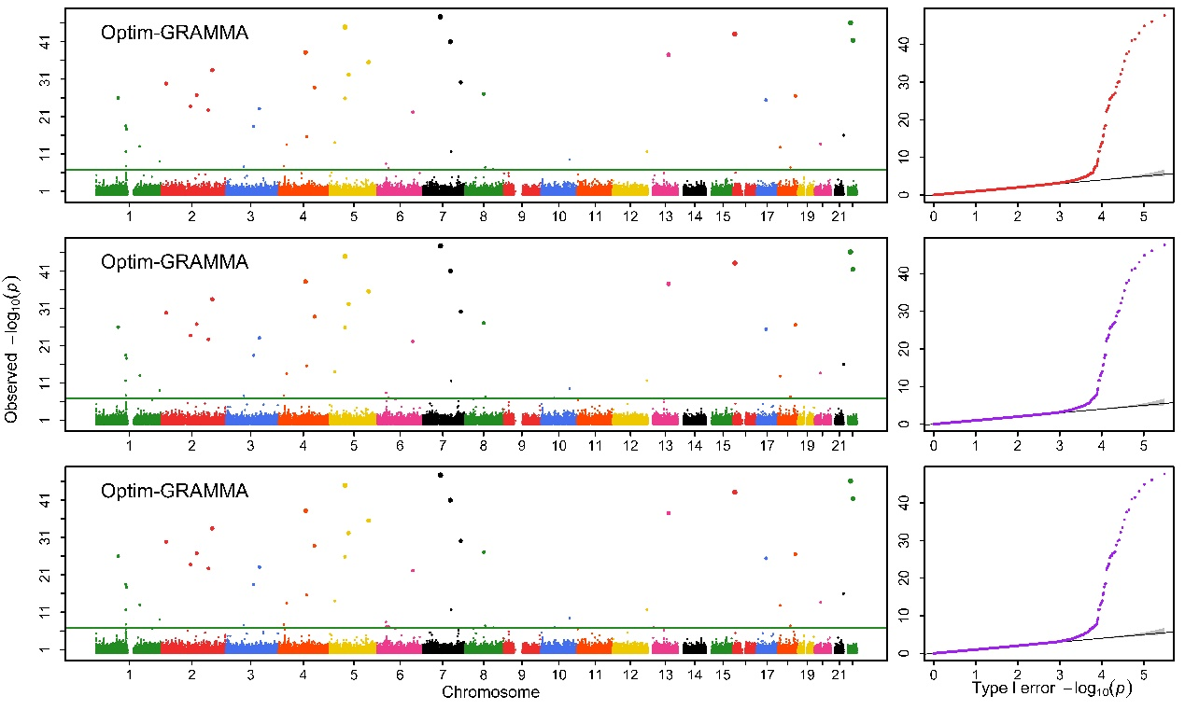

(4)

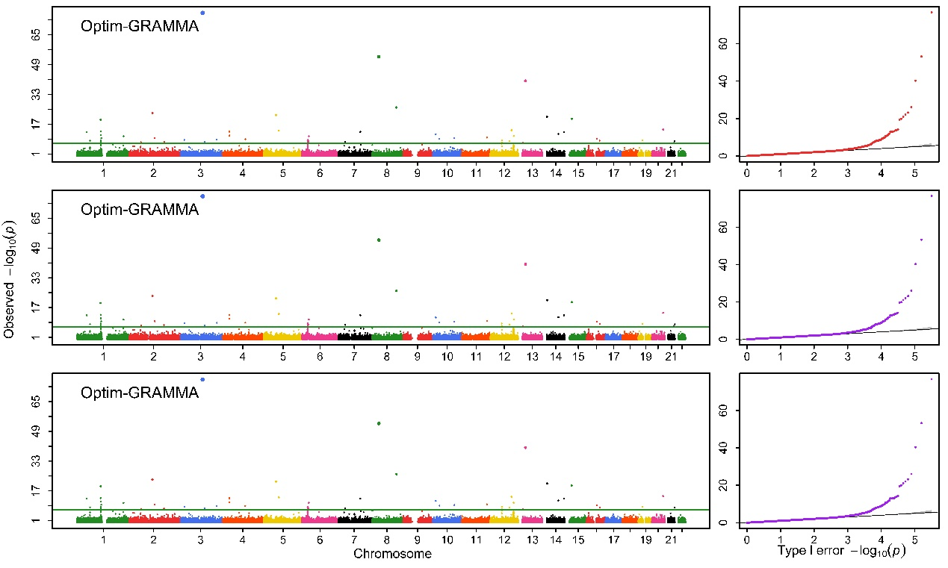

(5)

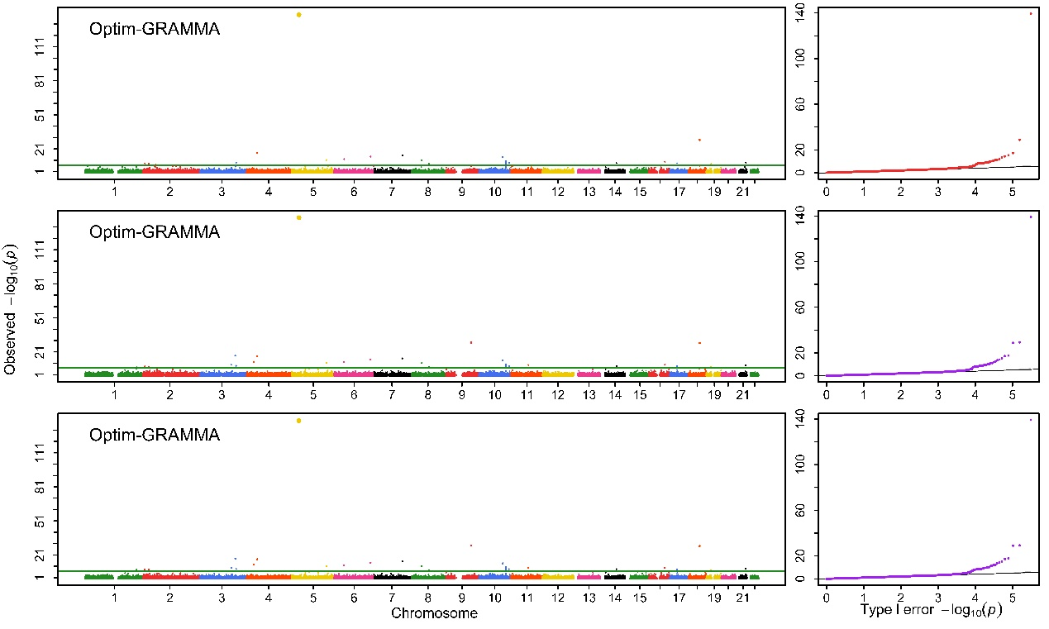

(6)

Table 1S. Genomic control values obtained with the five competing methods for all the simulated phenotypes
Dataset | Method | 0.2 |  |  | 0.5 |  |  | 0.8
 |  | 40 | 200 | 1000 | 40 | 200 | 1000 | 40 | 200 | 1000
Human | Optim-GRAMMAR | 0.983(0) | 1.003(0) | 0.986(0) | 0.989(0) | 0.997(0) | 0.999(0) | 1(0) | 1.001(0) | 0.994(0)
 | GRAMMAR | 0.941(0.002) | 0.943(0.003) | 0.919(0) | 0.920(0.002) | 0.936(0.001) | 0.909(0.003) | 0.909(0.005) | 0.873(0) | 0.892(0)
 | LTMLM | 1(0) | 1.001(0) | 1.001(0) | 1(0) | 1.001(0) | 1.001(0) | 1(0) | 0.991(0) | 1.002(0)
 | GMMAT | 0.995(0) | 0.997(0) | 0.997(0) | 0.997(0) | 0.997(0) | 0.999(0) | 0.997(0) | 1(0) | 0.999(0)
 | SAIGE | 0.997(0.001) | 1(0.001) | 1(0) | 1(0.002) | 0.999(0.001) | 1.001(0) | 1(0.003) | 1.001(0.001) | 1.001(0)
Maize | Optim-GRAMMAR | 1.015(0.002) | 1.001(0.003) | 1.044(0) | 1.044(0) | 1.020(0) | 1.049(0) | 1.050(0.001) | 1.046(0) | 1.046(0)
 | GRAMMAR | 0.909(0) | 0.885(0.001) | 0.917(0) | 0.781(1.686) | 0.745(0) | 0.999(0) | 0.531(0.001) | 0.556(0) | 0.529(0)
 | LTMLM | 1.576(0.482) | 1.370(0.097) | 1.261(0.09) | 1.216(0.094) | 1.239(0.183) | 1.539(0.196) | 1.080 (0.52) | 1.144(0.499) | 1.112(0.258)
 | GMMAT | 0.998(0.031) | 0.998(0.032) | 0.997(0) | 0.997(0.164) | 0.998(0) | 1.228(0) | 0.991 (0) | 0.995(0) | 0.997(0)
 | SAIGE | 1.956(0.480) | 1.536(0.481) | 1.975(0.480) | 1.368(0.685) | 1.335(0.522) | 1.331(0.480) | 1.343(0.580) | 1.366(0.455) | 1.423(0.458)

Table 2S. Computing complexity (Computing time/ Memory footprint, Min/Gb) of the four competing methods for the six diseases analyzed
Disease | Population | SNPs | LTMLM | SAIGE | GMMAT | GRL¹ | GRL² | Optim-  GRAMMAR¹ | Optim-  GRAMMAR²
CAD | 4,992 | 409,517 | 26.14/33.1 | 15.60/1.2 | 6.78/2.1 | 1.09/0.4 | 0.21/0.6 | 2.47/0.4 | 0.91/0.6
RA | 5,003 | 409,924 | 27.46/33.1 | 15.19/1.2 | 6.82/2.1 | 1.02/0.4 | 0.22/0.6 | 2.56/0.4 | 0.96/0.6
T1D | 5,004 | 409,674 | 27.31/33.1 | 14.16/1.2 | 6.78/2.1 | 1.00/0.4 | 0.22/0.6 | 2.38/0.4 | 0.93/0.6
T2D | 5,003 | 409,805 | 25.83/33.1 | 15.22/1.2 | 6.54/2.1 | 1.09/0.4 | 0.21/0.6 | 2.41/0.4 | 0.94/0.6
HT | 5,005 | 409,742 | 28.61/33.1 | 14.67/1.2 | 6.57/2.1 | 1.03/0.4 | 0.23/0.6 | 3.02/0.4 | 0.89/0.6
BD | 5,002 | 409,642 | 26.88/33.1 | 14.85/1.2 | 6.74/2.1 | 1.04/0.4 | 0.22/0.6 | 2.04/0.4 | 0.91/0.6

1 represents using entire markers and 2 sampling markers for Optim-GRAMMAR

