Mobility index | included Points Of Interest (POIs)
Retail & Recreation | Restaurants, cafes, shopping centers, theme parks, museums, libraries, and movie theaters·
Grocery & Pharmacy | Grocery markets, food warehouses, farmers markets, specialty food shops, drug stores, and pharmacies·
Parks | National parks, public beaches, marinas, dog parks, plazas, and public gardens·
Transit Stations | Public transport hubs such as subway, bus, and train stations
Workplaces | Places of work
Residential Areas | Places of residence

Supplementary Table 1: Google mobility indices and corresponding Points Of Interests (POIs). Insights are based on data from users who have opted-in to Location History for their Google Account.

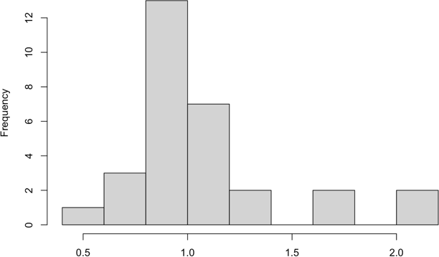

Supplementary figure 1: Histogram of Lombardy Rt frequency distribution. Available samplings display a non- normal, positively skewed distribution of Rt frequency.

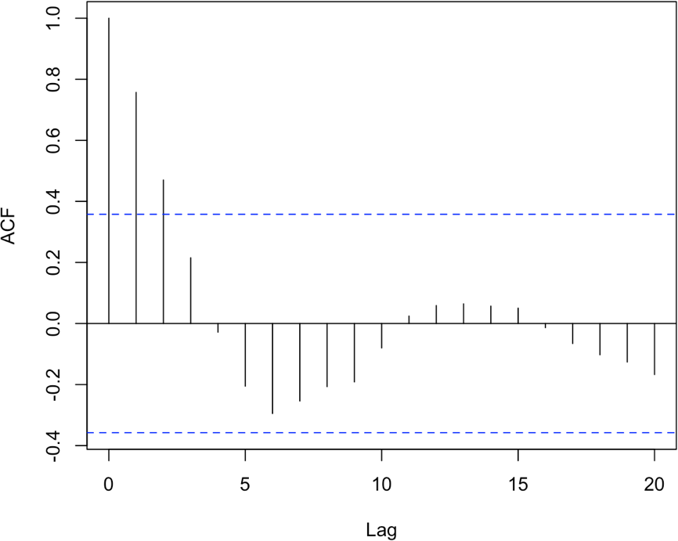

Supplementary figure 2: Autocorrelation of Rt time series. Vertical lines represent autocorrelation at different time lags (weeks). Dashed lines represent level of significance at 95%. Autocorrelation function (ACF) displayed a significant correlation in Rt time series.

 | UV-index | Retail & Recreation | Grocery & Pharmacy | Workplaces | Transit Stations | Parks
UV-index | 1·00 | 0·51* | -0·35 | 0·61 | 0·21 | 0·84*
Retail & Recreation | ·· | 1·00 | 0·55* | 0·63* | 0·92* | 0·76*
Grocery & Pharmacy | ·· | ·· | 1·00 | 0·76* | 0·74* | -0·06
Workplaces | ·· | ·· | ·· | 1·00 | 0·71 | 0·16
Transit Stations | ·· | ·· | ·· | ·· | 1·00 | 0·54*
Parks | ·· | ·· | ·· | ·· | ·· | 1·00

Supplementary Table 2: Comparison of R (Pearson correlation coefficient) among the explanatory variables. Asterisk (*) indicates significant correlation at the probability level of 0·01.

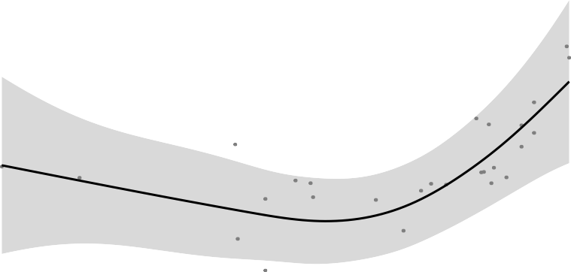
0.50
A

0.25

0.00
f(Workplaces)

−0.25

−0.50

−0.75

−50 −40 −30 −20
Workplaces

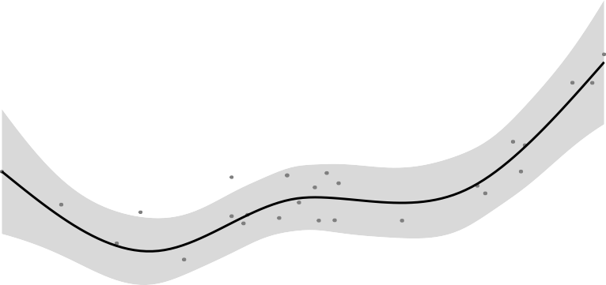
0.8
B

0.4

0.0
f(Grocery and Pharmacy)

−0.4

−0.8

−25 −20 −15 −10 −5
Grocery and Pharmacy

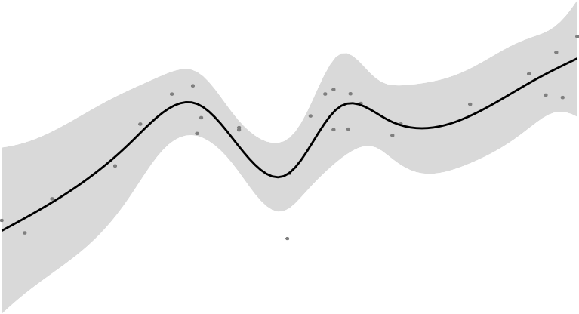
0.5
C

0.0

−0.5
f(Transit stations)

−1.0

−60 −50 −40 −30 −20
Transit stations

Supplementary figure 3: Smoothing component plots for log(Rt) associated with mobility indices, accounting for UV-index. The smooth terms for Workplaces (A), Grocery & Pharmacy (B), and Transit stations (C) show an effect of mobility indices reduction in curbing Rt, irrespective of environmental seasonality. Y-axis is the partial effect of the variable and shadow section is the standard-error confidence intervals. An apparent Rt increase is observable for extreme levels of reduction of Workplaces and Grocery & Pharmacy mobility indices. Left parts of the smoothing components plots were built by the model fitting on a small number of observations, limiting the predictive value of the models in these sections, as shown by the enlargement of confidence intervals.

