Additional file 2: Supplementary Figures

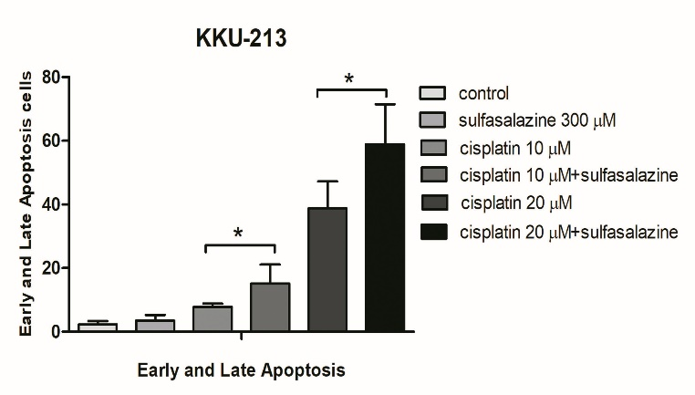
Fig S1. Cisplatin combined with sulfasalazine activates more CCA cell apoptosis than a single
treatment. The number of KKU-213 apoptotic cells with annexin-5 positive staining in early and
late stage counted and summarized as the mean±standard deviation of independent, triplicate
experiments.

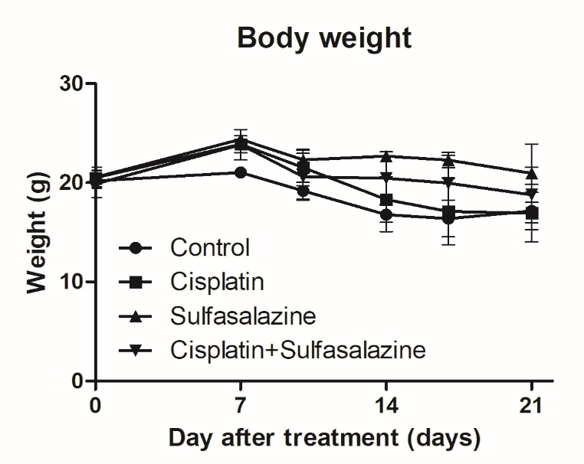
Fig S2. Body weight of nude mice between control and treatment groups

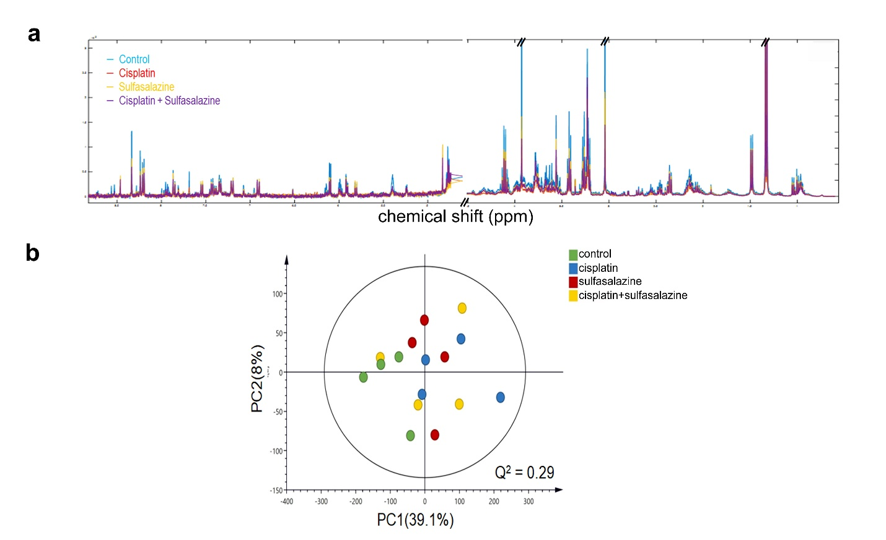

Fig S3. Difference metabolite profile between control and treatment groups (a) 1 H NMR spectra
plot shows median intensity of control and treatment groups, (b) Principle Component Analysis
(PCA) plot of all groups shows the components of control did not differ when compared with
treatment samples.

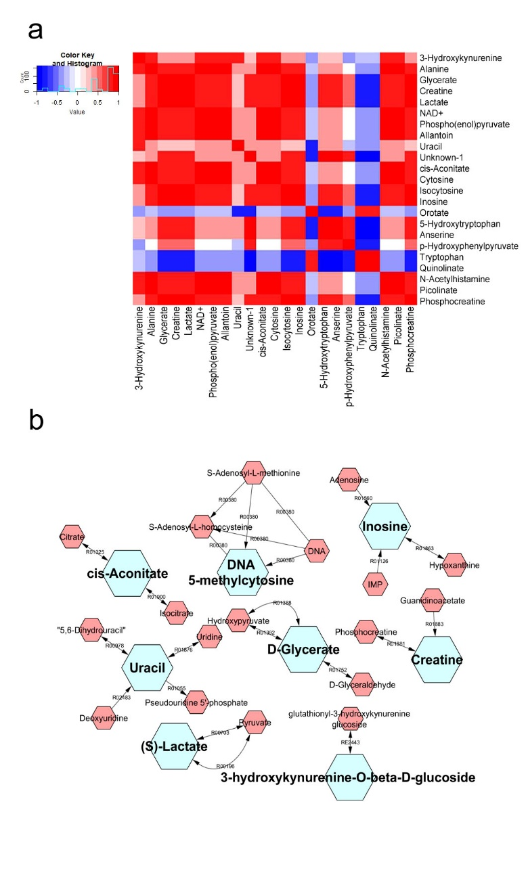
Fig S4. Network analysis demonstrates the association of significant metabolites. (a) a heat-map
correlation of significant metabolites in all treatment groups compared with untreated group, (b).
The metabolic network generated by MetScape and the proposed altered pathways in drug
response.
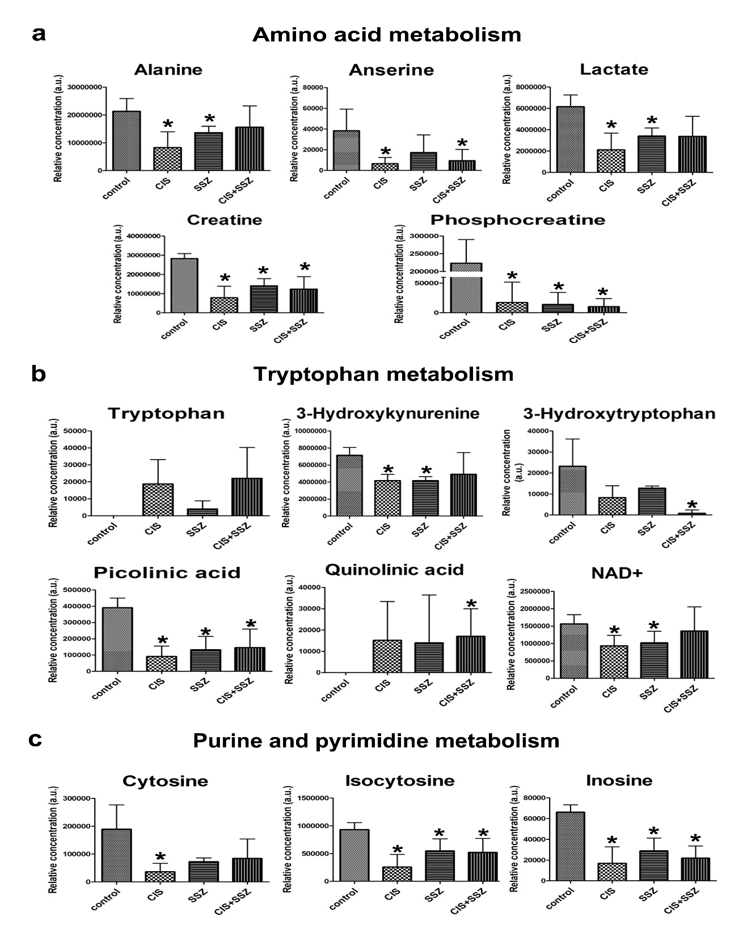
Fig. S5. Significant metabolic pathway of tumor tissue extraction between control and
treatment with cisplatin, or sulfasalazine, or a combination of both. The bar graphs present the
relative concentration of metabolites in (a) amino acid metabolism, (b) tryptophan metabolism and
(c) the purine and pyrimidine pathway.

