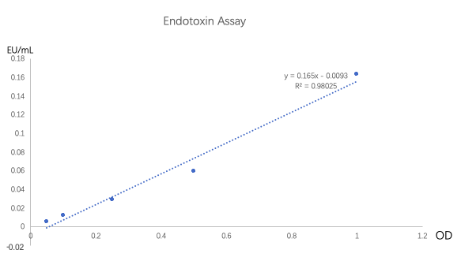

The standard curve of Endotoxin Assay

The check result of the polyporus polysaccharide
Concentration | 1μg/mL | 0.05 μg/mL
PPS | － | －

-: not detected

