Supplementary material
Appendix Table of Contents
Figure e-1. Receiver operating curves to access diagnostic accuracy of CSF α-synuclein and other biomarkers for AD dementia. 2
Figure e-2. Conversion from CN to pMCI as predicted by baseline CSF biomarkers. 3
Figure e-3. Conversion from Aβ-negative status to Aβ-positive group as predicted by baseline CSF biomarkers. 4
Figure e-4. Receiver operating curves for predicting converting from AD pathophysiology (tau and amyloid-β) negative to positive. 5

Figure e-1. Receiver operating curves to access diagnostic accuracy of CSF α-synuclein and other biomarkers for AD dementia.
Receiver operating curves of logistic regression model are controlled for age at baseline, gender, educational level and APOE ε4 genotype. Abbreviations: AD, Alzheimer’s disease; CN, cognitively normal; CSF, cerebrospinal fluid; t-tau, total-tau; p-tau, phosphorylated tau; Aβ, β-amyloid.

Figure e-2. Conversion from CN to pMCI as predicted by baseline CSF biomarkers.
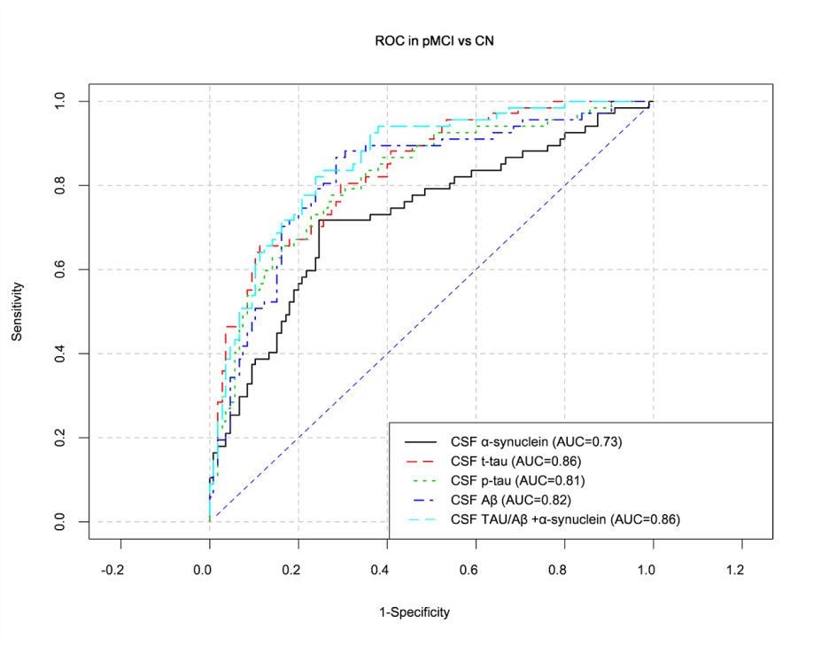

Receiver operating curves of logistic regression model controlling for age at baseline, gender, educational level and APOE ε4 genotype for predicting converting to pMCI among people with normal cognitive function. Abbreviations: pMCI, progressive mild cognitive impairment; CN, cognitively normal; CSF, cerebrospinal fluid; t-tau, total-tau; p-tau, phosphorylated tau; Aβ, β-amyloid.

Figure e-3. Conversion from Aβ-negative status to Aβ-positive group as predicted by baseline CSF biomarkers.
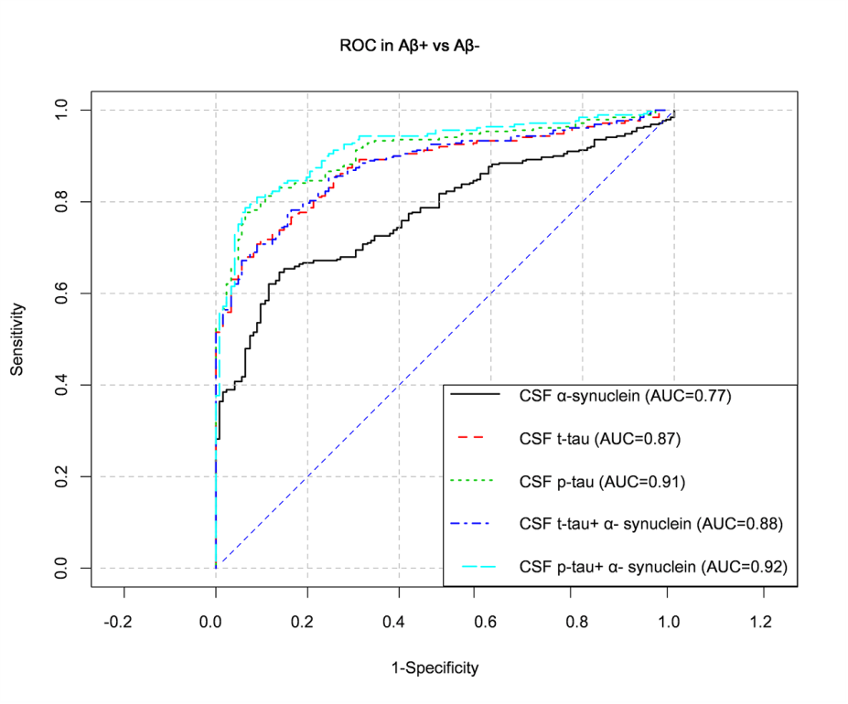
Receiver operating curves of logistic regression model are controlled for age at baseline, gender, educational level and APOE ε4 genotype for predicting converting to Aβ-positive status among Aβ-negative group. Abbreviations: CSF, cerebrospinal fluid; t-tau, total-tau; p-tau, phosphorylated tau; Aβ, β-amyloid; Aβ+, Aβ positive; Aβ-, tau negative.

Figure e-4. Receiver operating curves for predicting converting from AD pathophysiology (tau and amyloid-β) negative to positive.
Baseline model include age at baseline, gender, educational level and APOE ε4 genotype. Abbreviations: ROC, Receiver operating curves; A-, Aβ negative; A+, Aβ positive; T-, tau negative; T+, tau positive.

