Journal name: Applied Microbiology and Biotechnology
Title: Knocking out Analysis of the CpxP gene using Crispr/Cas9 in Escherichia coli MG1655
Authors' names: Xiaoliang He, Yuwen Ren, Wanli Meng, Xinran Yu, Xiaohui Zhou*
Authors' affiliations: School of Biological Science and Engineering, Hebei University of Science and Technology, Shijiazhang, Hebei, China
Corresponding author name: Xiaohui Zhou
Telephone: 86 311 81668487
Fax: 86 311 81668487
E-mail: zhouxh2003@aliyun.com
Address: School of Biological Science and Engineering, Hebei University of Science and Technology, NO.26 Yuxiang Street, Shijiazhang, Hebei, 050018, China

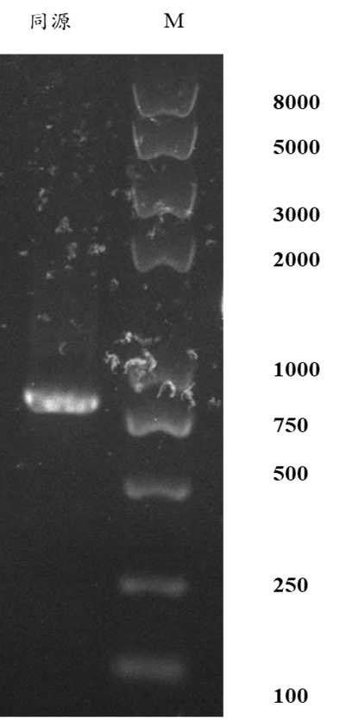
M 1 2 3 4 M
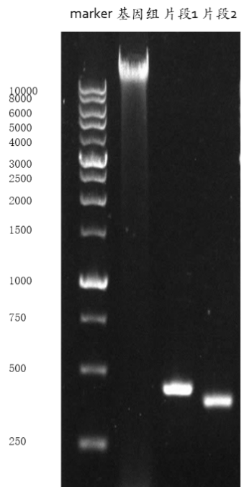

Figure S1 Cloning and identification of the cpxP gene fragments in Escherichia coil MG1655. (1) Genomic DNA of Escherichia coil MG1655. (2) PCR products MG-HR-S. (3) PCR products MG-HR-X. (4) MG-HR(MG-HR-S and MG-HR-X). M: marker.

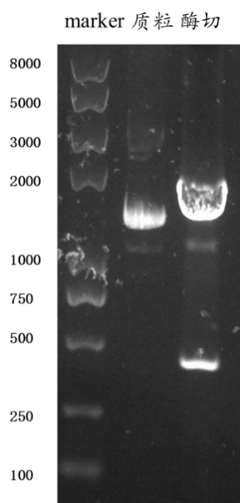
M 1 2

Figure S2 Construction and identify of pGL3-MGP-sgRNA plasmid. (1) pGL3-MGP-sgRNA plasmid. (2) Restriction enzyme identify with pGL3-MGP-sgRNA plasmid (Kpn I and BamH I). M: marker.

A M 1 2 3 4 5

B
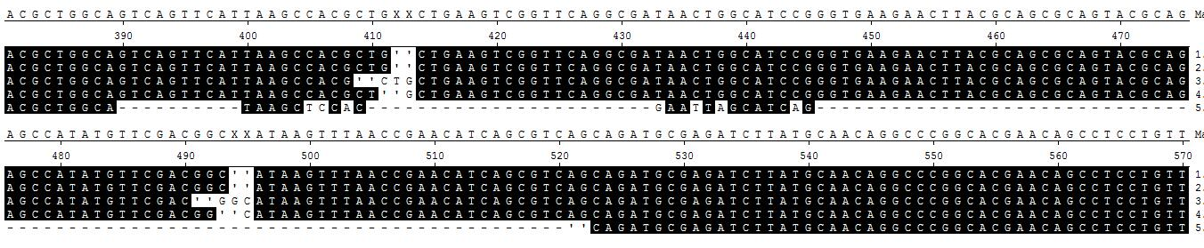
Figure S3 A. Identification of the knockout of cpxP gene. (1) PCR products of MG1655 (pCas9) with 400 μg pGL3-U6-sgRNA-PGK-puromycin. (2) PCR products of MG1655 (pCas9) with 400 μg pGL3-U6-sgRNA-PGK-puromycin. (3) PCR products of MG1655 (pCas9) with 400 μg pGL3-MGP-RNA. (4). PCR products of MG1655 (pCas9) with 400 μg pGL3-MGP-RNA. (5). PCR products of MG1655 (pCas9) with 400 μg pGL3-MGP-RNA and 1.6 μg MG-HR. M: marker. B. The sequences of PCR products. (1) The sequences of PCR products of MG1655 (pCas9) with 400 μg pGL3-U6-sgRNA-PGK-puromycin. (2) The sequences of PCR products of MG1655 (pCas9) with 400 μg pGL3-U6-sgRNA-PGK-puromycin. (3) The sequences of PCR products of MG1655 (pCas9) with 400 μg pGL3-MGP-RNA. (4). The sequences of PCR products of MG1655 (pCas9) with 400 μg pGL3-MGP-RNA. (5). The sequences of PCR products of MG1655 (pCas9) with 400 μg pGL3-MGP-RNA and 1.6 μg MG-HR.

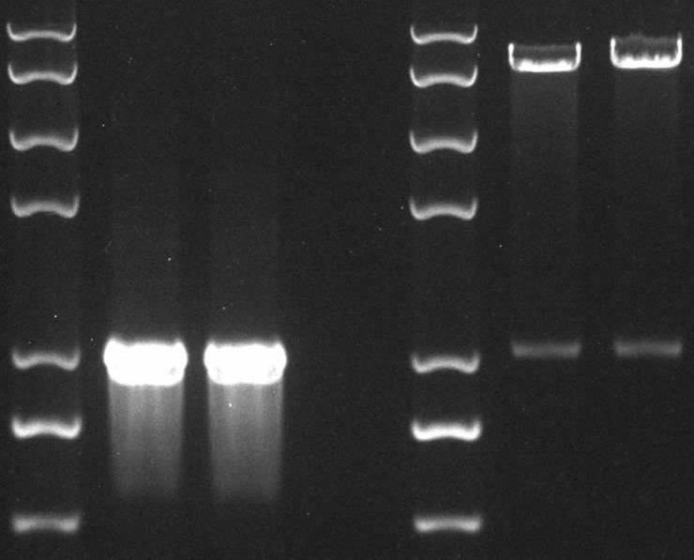
M
1
2
M
3
4
8000bp
5000bp
3000bp
2000bp
1000bp
750bp
500bp

Figure S4 Construction and identify of pBBR-cpxP plasmid. (1) PCR products of the cpxP gene expression cassette. (2) Restriction enzyme identify with the cpxP gene expression cassette (BamH I and Hind III). (3) Restriction enzyme identify with pBBR-cpxP plasmid (BamH I and Hind III) of the overexpression transformants. (4) Restriction enzyme identify with pBBR-cpxP plasmid (BamH I and Hind III) of the revertant. M: marker.

Table S1

>CDO16367.1 cpxP [Klebsiella pneumoniae]
MRNVIAAVMASTLALSAYSQAAEVVTSVNWLPGDDGGQRGSQSHMFDGISLTEQQRQQLRDLMQRARHDRLPVNVSEMETMHRLVTAENFDENAVRAQAEKMAQEQVARQVEMAKVRNQMYHLLTPEQQAVLNAKHQQRMDQLREVARMQKGSAMMLSSSSNTLQPQ
>ADD79040.1 CpxP [Pantoea ananatis LMG 20103]
MRKLTAVVIASAMVLCNASARAAEPMAPDDVHHGEFTTGSMTQNSQSHMFDGIELTEHQRQQMRDLMQQARHDRPATNIDDIAAMHDLVTADNFNEAAIRSKAEAIARVQVEQQVEMARVRNQMYHLLTPEQQAALQKNY
ERRINSLRKLSNLQPASSLQPVSRTSSNQ
>BAJ45639.1 cpxP [Escherichia coli DH1]
MRIVTAAVMASTLAVSSLSHAAEVGSGDNWHPGEELTQRSTQSHMFDGISLTEHQRQQMRDLMQQARHEQ
PPVNVSELETMHRLVTAENFDENAVRAQAEKMANEQIARQVEMAKVRNQMYRLLTPEQQAVLNEKHQQRMEQLRDVTQWQKSSSLKLLSSSNSRSQ
>CDG23226.1 CpxP [Xenorhabdus poinarii G6]
MRNIAILAVASMFVLETTETLANTADADHVPEAHSSPSCMQGDYKRNFSYYRGNQYNYSYIFGGIVLTEQ
QREQILRLAREQGGYEQPLADMQDAHFKLDDLLTEEDFDETEVRSLLEKIAEKHVLLGIEVARFNNQVYQ
LLTAEQKALLKKRKTSKCLTQNVN
>ABO77645.1 CpxP [Xenorhabdus nematophila]
MRNIAILALASMVVLRSTLALADTADTDDTPEAANPSPYCLSYEHKRDSGYYRSDEHNYNYSYVFGGITL
TEQQRQQMWDLVKKQHLHEQSIIDMRVERQKMYHLLIEREFDEAAVRLQLEKIAEKNIDLGVEIARIRNQ
MYQLLTPEQKERLYKRYEGQTAQEMH
>SUP40335.1 CpxP [Vibrio harveyi]
MKRYLLSTILLLSSANVFAEAAPTQPAAPKPFGLESITADQQAKIEEIQINLSSKLAGQQDPKAVQESAK
QFEKLVKASSFDEAKAKQLIQQAHAKQLDTQLAQLKAQHDIYNVLTAEQKSTLEKRQQEQLKKLEAMKQQ
QAQ
>KGR37247.1 CpxP [Vibrio campbellii]
MKRYLLSTILLLSSANVFAESAPAQPAAPKPFGLESITTEQQAKIEEIQIKLSSELAGNQDPKAVQESAK
QFEKLVKASSFDEVKATKLIKQAHAKQLDTQLAQLKAQHDIYNVLTAEQKATLEKRQQEQLKKFEALQKD
AQ
>AEH32085.1 CpxP [Vibrio anguillarum 775]
MMKMAKKIVLAAVILPLTLSTASVFAFGGKDQHKGPNDECGGFDRGMMQQLDLTSDQQAKLKGMREANRE
AMKGEHKGQRQAKMKAHHDKVQALVLAESFDAAAANELAKEMVDQQVAHRVKMLEKRHDMMSVLTPEQKAKLQTLQQDRMQKCMENGPKHMKKNS
>WP_136196533.1 cell-envelope stress modulator CpxP [Pantoea allii]
MRKLTAVVLASAMALSVASADAKDATTIDEMHHGGLPTGSMTQNPQSHMFDGIELTEEQRQQMRDLMQQARHDRPVVHIDDIAALHELVTADQFNEAAIRQKAEVIARVQVEQQVEMARVQNQMFQLLTPAQQSTLQKNY
QRRLNELRQFSNLQSASSLQAVSSTSSNQ
>WP_133562477.1 CpxP family protein [Marinomonas communis]
MNLSKKLMMVTLALPLAFGTASSFAAGDQHERGGKGGRGHGEHQVCSGTAGLIYKLDLSDAQKEQLKELR
SVRHAQAKANAEKDIEQKRADRAQAHATMQKIVMADKFDTAAAKQFAGGMASKRAERNVMKMEAEHEMFSVLTAAQKEQFLELQKTAGDDCKAKKKGKDGKRRHHEKAEQK
>WP_119464546.1 stress adaptor protein CpxP [Vibrio sp. PID23_8]
MKRLKSRTIEMLILPLVFASTSAIADSHEQEYDEKFHDKCGISMNLDRGMVHQLDLTDEQKAKLKSIREA
HKQEKKQTNVNRKVEQKERHQRMQAIVLESEFNHAKANGFAQEVAAIQAERSVQMMKNKHEMLSVLTTEQ
KAKFVQLQDDRQKECSNKRHQRNDSKMTE
>WP_117028660.1 stress adaptor protein CpxP, partial [Klebsiella pneumoniae]
SLTEHQRQQMRDLMQQARHEQPPVNVSELETMHRLVTAENFDENAVRAQAEKMANEQIARQVEMAKVRNQMYRLLTPEQQAVLNEKHQQRMEQLRDVTQWQKSSSLKLLSSSNSRSQ
>GES56433.1 periplasmic repressor CpxP [Desulfuromonas sp. AOP6]
MKKRLIALTLLATALGGFVVAPTLALAADQNPAAETNQEERRCGKRGSCNGPFEGRMAAKLNLTSEQQAQ
IKAIVEAERERIAPLREQQREQRAQLQAAMKAQPFDENTVRQLAASQADARTEMIVHRARVQNQINAVLT
EEQREQAEQMRASKKDRRCNKGHRGFGFGFDQQNS
>WP_152321591.1 cell-envelope stress modulator CpxP [Erwinia endophytica]
MRKVTAVVVVPTLILSFSTAWATEVTTTDEMHQDNAVPRSMAQIPQSHMFDGISLTEQQRQQMRDLMQQA
RHERSPISISDLEQLHDMIIADKFDETAYRARLDKIAQAEVARQVEIAHVRNQMYHLLTPAQQDVLNQKH
QQRMDEMRKLASMPQASSLQAVSSTQQ
>WP_152196962.1 cell-envelope stress modulator CpxP [Rouxiella sp. S1S-2]
MCKVAAMIMASMLALSSSVALAESAKFMPADTLAHDGNMLDRRNTMFDGINLTEQQRQQMRDLMHQARRDSPQINLKQMETMHELVTAENFDQAAVRAQAEKIAQEQVDRQVEMARIRNLMFNLLTPQQKEILNQKHEQRMQVLAAQISGLQPTSTQKPVISTQ
>WP_151406482.1 cell-envelope stress modulator CpxP [Enterobacter hormaechei]
MTLRCFTPLTHVCSLNRRLSLVESRHERFWEQVMRKVTAAVMASTLAFSAFSRAAVAIISDNGSSAEGAT
QHSSQSHMFDGISLTEHQRQQMRDLMQRARHDQPLLMLAKWRQCIALSPQKILTKALYALRPKKWRRNRL
PAVEMAKVRNQMFHLLTPEQQAVLNTKHQQRMNQLREVARMQRSSDMTLFSSNSSTRSNQ
>WP_151258205.1 cell-envelope stress modulator CpxP [Salmonella enterica]
MRKVTAAVMASTLAFSFLSHAAEVVTSDNWHPGDGATQRSAQNHMFDGISLTEHQRQQMRDLMQQARHEQPPVNVSEMETMHRLVTAEKFDESAVRAQAEKMAQEQVVTAEKFDESAVRAQAEKMAQEQVARQVEMARVRNQMYRLLTPEQQAVLNEKHQQRMEQLRDVAQWQKSSSLKLLSSSNSRSQ
>AVL37048.1 stress adaptor protein CpxP [Yersinia intermedia]
MRKVTKVTTLIMASMLVLGSQAAFAADKTGATDDWCHGDGTMMNKKDGRGHHNMFDGVNLTEQQRQQMRDLMRQSRQGQPRLDMADRDAMHKLVTADKFDEAAVRAQAEKMSKDQVERQVEMAKVRNQMFNLLTPEQKAVLNQKHQQRIEKMQQAPAAQPSSAQK
>ATM97744.1 stress adaptor protein CpxP [Yersinia frederiksenii]
MRKVTKVSTLIMASMLVLGSQAAFAVDKTGPNDGWCHGDGMMMNKKDGRGHHNMFDGVNLTEQQRQQMRDLMRQSRQGQPRMDIADREAMHKLITADKFDEAAVRAQAEKMSKDQVDRQVEMAKVRNQMFNLLTPEQKAALNQKHQQRIEKMRQVPAPAAQPASAQK
>ATM76298.1 stress adaptor protein CpxP [Serratia fonticola]
MVKVTAVVMASILALGSTAAFAADTTPETVQPPANDALLRALGQNHMFDGVRLTEQQRQQMRDLMRQARY
DLPGVNVDEVETMHKLVTADKFDEAAVQAQAEKMAQEQVKRQVEMARVRNQMYNLLTPEQKSVLDQKHQQRVQLMKQQISGLQQTSAQKLSMTE
>ASE76160.1 stress adaptor protein CpxP [Salmonella enterica]
MRKVTAAVMASTLAFSFLSHAAEVVTSDNWHPGDGATQRSAQNHMFDGISLTEHQRQQMRDLMQQARHEQPPVNVSEMETMHRLVTAEKFDESAVRAQAEKMAQEQVARQVEMARVRNQMYRLLTPEQQAVLNEKHQQRMEQLRDVAQWQKSSSLKLLSSSNSRSQ
>ARB82305.1 stress adaptor protein CpxP [Vibrio cholerae]
MKLAKKMILAAAVLPLTLGTTAALAYGGHGWDKEGDGHCGDRGERGIWKQLDLTAEQQAQLKEMREAGRE
EMRANRGQSHDAMKALHAQERALVLAADFDQAAAENLAKQMVDQQVTHRVKMMEKRHQMMSILTAEQKAKLQTLQQEKMAECMQDGQHGKGKKHASQ
>AVH33162.1 stress adaptor protein CpxP [Vibrio fluvialis]
MKTAKKLMLAAVVLPIVLGSASALAAGGKNKGPDGEMCGPDGERGIFKQLNLTAEQHAKLRQMREEGREQ
MQQKRQAGPSEQMKAMRDKERALMLAPNFDKAQATELAKQMVDMQVERRVQMMEKRHQMLNVLTPEQKTQFQNLQQERMAKCWENGPREGHHGDKGPKGQNMMPPAPPVGE
>AVG07722.1 stress adaptor protein CpxP [Klebsiella pneumoniae]
MRNVIAAVMASTLALSAYSQAAEVVTSVNWLPGDEGGQRGSQSHMFDGISLTEQQRQQLRDLMQRARHDR
LPVNVSEMETMHRLVTAENFDENAVRAQAEKMAQEQVARQVEMAKVRNQMYHLLTPEQQAVLNAKHQQRMDQLREVARMQKGSAMMLSSSSNTLQPQ
>AVF96377.1 stress adaptor protein CpxP [Vibrio diabolicus]
MKSAKKLVLAAVVLPLTLGAASAFAYGGKNHHQGPRDECGMGMDRGIMRDLNLTDAQKDQLKSFREANRA
QMKGKYSENREARMAERQAHHAKMQSLLLADSFDEAQATALAKEMVERQTEHRVQMLERKHQMLSVLTPE
QKAEFVKLQNERMQECGDRMHKRMEKYRNN
>AVF75712.1 stress adaptor protein CpxP [Vibrio alginolyticus]
MKSAKKLVLAAVVLPLTLGAASAFAYGGKNHHKGPRDECGMGMDRGVMRQLDLTDAQKDQLKEMREANKA
EMKAKFADGKEARMAERQAHHAKVQSLLLADNFDEAQASELAKEMVERQTERRVQMLERKHQMLSVLTPE
QKAKFVELQNERMQECGDRMHKRMEKSRNN
>AVF58470.1 stress adaptor protein CpxP [Vibrio diabolicus]
MKSAKKLVLAAVVLPLTLGAASAFAYGGKNHHQGPRDECGMGMDRGIMRDLNLTDAQKDQLKSFREANRA
QMKGKYSENREARMAERQAHHAKMQSLLLADSFDEAQATALAKEMVERQTEHRVQMLERKHQMLSVLTPE
QKAEFVKLQNERMQECGDRMHKRMEKYRNN
>ATM89274.1 stress adaptor protein CpxP [Klebsiella aerogenes]
MRNVIAAVMASTLALSATSQAAEVVTGVNWLHGEEGAQRSGQSHMFDGISLTEQQRQQLRDLMQRARHDR
LPVNVSELETMHSLVTADKFDESAVRAQAEKMAQEQVARQVEMAKVRNQMYHLLTPEQQAVLNAKHQQRMDQLREVARMQKGSAMMLSSSSSTVQPK
>ATM14939.1 stress adaptor protein CpxP [Raoultella planticola]
MRNVIAAVMASTLALSAYSQAAEVVTSVNWLPGDDGAQRTSQSHMFDGISLTEQQRQQLRDLMQRARHDR
QPINVSEMETMHRLVTAENFDENAVRAQANKMAQEQVTRQIEMAKVRNQMYHLLTPEQQAVLNAKHQQRMDQLREVARMQKGSATMLSSSSNTVQPQ
>ATF69321.1 stress adaptor protein CpxP [Salmonella enterica subsp. enterica serovar Saintpaul]
MRKVTAAVMASTLAFSFLSHAAEVVTSDNWHPGDGATQRSAQNHMFDGISLTEHQRQQMRDLMQQARHEQPPVNVSEMETMHRLVTAEKFDESAVRAQAEKMAQEQVARQVEMARVRNQMYRLLTPEQQAVLNEKHQQRMEQLRDMAQWQKSSSLKLLSSSNSRSQ
>ATF55227.1 stress adaptor protein CpxP [Morganella morganii]
MGKIATITLASMFVMQSAPGLAQDSESDSCVTPVQSHSQYKGITTSGGDGYTSMLTGIRLTEEQRMQLRD
LMHNYRDQLRNVRNLAEDDIALYELVKAEKFDETAVRNQLEKEMRKRLDYQVEMIRVHHQMYQLLNPEQK
MQLDANFEPESIHTSSASSAQNMPE
>ATF51432.1 stress adaptor protein CpxP [Citrobacter werkmanii]
MGKVTAAVMASTLALSTFSHAAEVVTSDHWHLGESSSQRNAQSHMFDGISLTEHQRQQMRDLMQQARHEQPPVNVSEMETMHRLVTAENFDESAVRAQAEKMAQQQVARQVEIAKVRNQMYRLLTPEQQAVLNEKHEQRMEQLRDVAQWQKSSSLNLLSSSNSRSQ
>AMG56851.1 stress adaptor protein CpxP [Pantoea vagans]
MRKLTAVVLASAMALSVASAGAKDATTIDEMHHDGGLPTGSMTQNPQSHMFDGIELTEEQRQQMRDLMQQARHERPVVHIDDIAALHDLVTADQFNEAAIRVKAEVIARVQVEQQVEMARVQNQMFQLLTPDQQATLQKN
YQRRLNELRQFSNLQSASSLQAVSSTSSNQ
>AMG13374.1 stress adaptor protein CpxP [Vibrio vulnificus]
MSKELIMKLAKKMVLAAVVLPLTLGTASAFAFGGGKGHHKGPDGECGMGMERGMMRQLDLTDAQKEQLDA
MRGSNRAQMKEMHQGNFAANQAERQAQHAKVQALLLADNFDQATANELAKQMAEKQAERRVKMLEKQHQMLSILTPEQKAKFVELQNERMQECGDKMQKRMEKHAKN
>AMG03049.1 stress adaptor protein CpxP [Vibrio mimicus]
MKLAKKMTLAAAILPLTLGTTAAFAYGGHGWDKEGDGPCGGHGERGIWKQLDLTAEQQTQLKEMRDANRE
EMRANRGQNRDAMKALHTQERALVLAADFDQAAAENLAKQMVDQQVAHRVKMMEKRHQMMSILTAEQKTKLQSLQQAQMDRCMMDGEHGKGKPRHQ
>AMF97732.1 stress adaptor protein CpxP [Vibrio harveyi]
MKTAKKLVLAAVVLPLTLGTASAFAFGGKDHKGHRGECGMGMDRGIMRQLDLTDAQKDQLKEMREANKAE
MKAKFADGKEARMAERQAHHEKVQALLLADNFDAAAANDLAKEMVEKQTERRVKMMEKKHQMLSVLTPEQKTKFVELQKERQQKCGEKMQKRMEKHHNS
>AMF95918.1 stress adaptor protein CpxP [Vibrio fluvialis]
MKTAKKLMLAAVVLPIVLGSASALAAGGKNKGPDGEMCGPDGERGIFKQLNLTAEQHAKLRQMREEGREQ
MQQKRQAGPSEQMKAMRDKERALMLAPNFDKAQATELAKQMVDMQVERRVQMMEKRHQMLSVLTPEQKTQFQNLQQERMAKCWENGPREGHHGGKGSKGQNMMPPAPPAGE
>WP_150436052.1 cell-envelope stress modulator CpxP [Brenneria sp. L3-3HA]
MRQVSALSLVSLLVLGSSAAASETDNASKGIWSHDETATVTVSGHQGMFDGVRLTELQRQQMRDLMQLAR
QELPELNTNDVEVMHRLIIAEKFDEAAVRAQAEKMAQRQVVRQVEMAKVRNQMYNLLTSEQKQILAQKHQ
QRMESMRQQMDRVNQASARKQ
>AVR01871.1 stress adaptor protein CpxP [Pluralibacter gergoviae]
MRNVFAAVMASTLALSAHSQAAEVVNSVNWHPNEGVAQTSSQGHMFDGISLTEHQRQQMRDLMQQAMRKQPPVNVSEIETMHKLVTAEKFDETAVRAQAEKMAQEQVARQVEMAKVRNQMYHLLTPEQQAVLNQKHQQRMDQLREVARMQQGAMPMLYSSNRSHQ
>AVL80131.1 stress adaptor protein CpxP [Klebsiella oxytoca]
MRNVIAAVMASTLALSAYSQAAEVVTSVNWLPGDEGVQRSSQSHMFDGISLTEHQRQQLRDLMQRARHER
PPVNVSEMETMHRLVTAENFDENAVRAQADKMAQEQVARQVEMAKVRNQMYHLLTPEQQAVLNAKHQQRMNQLREVARMQKGSAMMLSSSSNTLQPQ
>AVL80131.1 stress adaptor protein CpxP [Klebsiella oxytoca]
MRNVIAAVMASTLALSAYSQAAEVVTSVNWLPGDEGVQRSSQSHMFDGISLTEHQRQQLRDLMQRARHER
PPVNVSEMETMHRLVTAENFDENAVRAQADKMAQEQVARQVEMAKVRNQMYHLLTPEQQAVLNAKHQQRMNQLREVARMQKGSAMMLSSSSNTLQPQ
>ASE43848.1 stress adaptor protein CpxP [Citrobacter braakii]
MGKVTAAVMASTLALSTLSHAAEVVTGDHWHLGEGSAQRSVQSHMFDGISLTEHQRQQMRDLMQQARHEQPPVNVSEMETMHRLVTAEKFDERAVRAQAERMAQEQVARQVEIAKVRNQMYRLLTPEQQAVLNERHEQRMEQLRDVAHWKKSSSLNLLSSSNSRSQ
>AMH12739.1 stress adaptor protein CpxP [Citrobacter sp. FDAARGOS_156]
MGKVTAAVMASTLALSTLSHAAEVVTGDHWHLGEGSSQRSVQSHMFDGISLTEHQRQQMRDLMQQARHEQPPVNVSEMETMHRLVTAEKFDESAVRAQAEKMAQEQVARQVEIARVRNQMYRLLTPEQQAVLNEKHEQRMEQLRDVAHWKQSSSLNLLSSSNSRSQ
>AMH10246.1 stress adaptor protein CpxP [Klebsiella aerogenes]
MRNVIAAVMASTLALSATSQAAEVVTGVNWLHGEEGAQRSGQSHMFDGISLTEQQRQQLRDLMQRARHDR
LPVNVSELETMHSLVTADKFDESAVRAQAEKMAQEQVARQVEMAKVRNQMYHLLTPEQQAVLNAKHQQRMDQLREVARMQKGSAMMLSSSSSTVQPK
>AMG95152.1 stress adaptor protein CpxP [Citrobacter amalonaticus]
MRKVTAAVMASTLALSTVSHAAEVVTGDNWHPGESPAPRTVQSHMFDGISLTEHQRQQMRDLMQQARHEQAPVNVSEMETMHRLITAENFDETAVRAQAEKMAQAQVSRQVEMARVRNQMYRLLTPEQQAVLNEKHQQRMEQLRDVTQWQKSSSLKLLSSSNSRSQ
>AMG71767.1 stress adaptor protein CpxP [Morganella morganii]
MGKIATITLASMFVMQSAPGLAQDSESDSCVTPVQSHSQYKGITTSGGDGYTSMLTGIRLTEEQRMQLRD
LMHNYRDQLRNVRNLAEDDIALYELVKAEKFDETAVRNQLEKEMRKRLDYQVEMIRVHHQMYQLLNPEQK
MQLDANFEPESIHTSSASSAQNMPE
>AMG55948.1 stress adaptor protein CpxP [Citrobacter amalonaticus]
MRKVTAAVMASTLALSTVSHAAEVVTGDNWHPGESSAPRTVQSHMFDGISLTEHQRQQMRDLMQQARHEQPPVNVSEMETMHRLITAENFDETAVRAQAEKMAQAQVARQVEMARVRNQMYRLLTPEQQAVLNEKHQQRMEQLRDVTHWQKSSSLKLLSSSNSRSQ
>AMG18626.1 periplasmic protein CpxP [Shigella sonnei]
MRIVTAAVMASTLAVSSLSHAAEVGSGDNWHPGEELTQRSTQSHMFDGISLTEHQRQQMRDLMQQARHEQ
PPVNVSELETMHRLVTAENFDENAVRAQAEKMANEQIARQVEMAKVRNQMYRLLTPEQQAVLNEKHQQRM
>WP_150046527.1 cell-envelope stress modulator CpxP, partial [Klebsiella pneumoniae]
HMFDGISLTEQQRQQLRDLMQRARHDRLPVNVSEMETMHRLVTAENFDENAVRAQAEKMAQEQVARQVEMAKVRNQMYHLLTPEQQAVLNAKHQQRMDQLREVARMQKGSAMMLSSSSNTLQPQ
>AVH27662.1 stress adaptor protein CpxP [Vibrio diabolicus]
MKSAKKLVLAAVVLPLTLGAASAFAYGGKNHHQGPRDECGMGMDRGIMRDLNLTDAQKDQLKSFREANRA
QMKGKYSENREARMAERQAHHAKMQSLLLADSFDEAQATALAKEMVERQTEHRVQMLERKHQMLSVLTPE
QKAEFVKLQNERMQECGDRMHKRMEKYRNN
>AVG32119.1 stress adaptor protein CpxP [Salmonella enterica subsp. enterica serovar Heidelberg]
MRKVTAAVMASTLAFSFLSHAAEVVTSDNWHPGDGATQRSAQNHMFDGISLTEHQRQQMRDLMQQARHEQPPVNVSEMETMHRLVTAEKFDESAVRAQAEKMAQEQVARQVEMARVRNQMYRLLTPEQQAVLNEKHQQRMEQLRDVAQWQKSSSLKLLSSSNSRSQ
>AVF87129.1 stress adaptor protein CpxP [Klebsiella quasipneumoniae]
MRNVIAAVMASTLALSAISQAAEVVTSVNWLPGDEGGQRGSQSHMFDGISLTEQQRQQLRDLMQRARHDR
LPVNVSEMETMHRLVTAENFDENAVRAQAEKMAQEQVARQVEMAKVRNQMYHLLTPEQQAVLNAKHQQRMDQLREVARMQKGSAMMLSSSSNTLQPQ
>AMG25549.1 stress adaptor protein CpxP [Salmonella enterica]
MRKVTAAVMASTLAFSFLSHAAEVVTSDNWHPGDGATQRSAQNHMFDGISLTEHQRQQMRDLMQQARHEQPPVNVSEMETMHRLVTAEKFDESAVRAQAEKMAQEQVARQVEMARVRNQMYRLLTPEQQAVLNEKHQQRMEQLRDVAQWQKSSSLKLLSSSNSRSQ
>AMG06313.1 stress adaptor protein CpxP [Vibrio parahaemolyticus]
MKSAKKLVLAAVVLPLTLGTASAFAFGGKDHHKGPRDECGMGMDRGIMRDLNLTDAQKDQLQSFRDANRA
EMKGKYSQNREARMAERQAHHAKMQSLLLADTFDEAQATALAKEMVERQTEHRVKMLERKHQMLSVLTPE
QKAEFVKLQNERMQECGDQMQQRMGKHRNN
>AVG35842.1 stress adaptor protein CpxP [Enterobacter cloacae complex sp.]
MRKVTAAVMASTLAFSAFSQAAEAIISDNSPLQEGATQNSSQSHMFDGISLTEHQRQQMRDLMQRARHDQ
PPVNVSEMETMHRLVTAENFDESAVRAQAEKMAQEQVARQVEMAKVRNQMFHLLTPEQQAVLNTKHQQRMDQLREVARMQRSSETSFFSSNSSTRSNQ
>AUU33472.1 periplasmic protein CpxP [Shigella flexneri]
MRIVTAAVMASTLAVSSLSHAAEVGSGDNWHPGEELTQRSTQSHMFDGISLTEHQRQQMRDLMQQARHEQ
PPVNVSELETMHRLVTAENFDENAVRAQAEKMANEQIARQVEMAKVRNQMYRLLTPEQQAVLNEKHQQRMEQLRDVTQWQKSSSLKLLSSSNSRSQ
>AUU28617.1 stress adaptor protein CpxP [Citrobacter freundii]
MGKVTAAVMASTLALSTFSHAAEVVTGDHWHLGEGSSQRSVQSHMFDGISLTEHQRQQMRDLMQQARHEQPPVNVSEMETMHRLVTAEKFDESAVRAQAERMAQEQVARQVEIARIRNQMYRLLTPEQQAVLNEKHEQRMVQLRDVAHWKKSSSLNLLSSSNSRSQEQLRDVTQWQKSSSLKLLSSSNSRSQ
>AUU03977.1 stress adaptor protein CpxP [Raoultella planticola]
MRNVIAAVMASTLALSAYSQAAEVVTSVNWLPGDDGAQRTSQSHMFDGISLTEQQRQQLRDLMQRARHDR
QPINVSEMETMHRLVTAENFDENAVRAQANKMAQEQVTRQIEMAKVRNQMYHLLTPEQQAVLNAKHQQRMDQLREVARMQKGSATMLSSSSNTVQPQ
>AUT86032.1 stress adaptor protein CpxP [Vibrio parahaemolyticus]
MKSAKKLVLAAVVLPLTLGTASAFAFGGKDHHKGPRDECGMGMDRGIMRDLNLTDAQKDQLQSFRDANRA
EMKGKYSQNREARMAERQAHHAKMQSLLLADTFDEAQATALAKEMVERQTEHRVKMLERKHQMLSVLTPE
QKAEFVKLQNERMQECGDQMQQRMGKHRNN
>AUU10389.1 stress adaptor protein CpxP [Serratia marcescens]
MRKVTALVMASLLAIGSTAAFAADTIPDTAQPPGNDAMTRIPGQHHMFDGVSLSEQQRQQMRDLMRQARH
DLPGVNVAEMEAMHKLVTAEKFDEAAVYAQAEKMAQQQVKRQVEMARVRNQMYNLLTPEQKSVLDQKHQQRMQQMEQQISGLQQASAQK
>AUT94661.1 stress adaptor protein CpxP [Citrobacter freundii]
MGKVTAAVMASTLAFSTLSHAAEVVTGDHWHLGEGSAQRSVQSHMFDGISLTEHQRQQMRDLMQQARHEQPPVNVSEMETMHRLVTAEKFDESAVRAQAERMAQEQVARQVEIAKVRNQMYRLLTPEQQAVLNEKHEQRMEQLRDVAHWKKSSSLNLLSSSNSRSQ
>AUT99711.1 stress adaptor protein CpxP [Morganella morganii]
MGKIATITLASMFVMQSAPGLAQDSESDGCVTPVQSHSQYKGITTSGGDGYTSMLTGIRLTEEQRMQLRD
LMHNYRDQLRNVRNLAEDDIALYELVKAEKFDETAVRNQLEKEMRKRLDYQVEMIRVHHQMYQLLNPEQK
MQLDANFEPESIHTSSASSAQNMPE
>WP_147200347.1 cell-envelope stress modulator CpxP [Pantoea sp. CCBC3-3-1]
MRKVTAVVVVPALILSFSAAWAAEVTTNDEMHQDGAALRSMTQIPQSHMFDGINLTEQQRQQMRDLMQQARHERSSISINDLEQLHEMIIADKFNETDYKARLDRIAKEEVTRQVEMARVRNQMYHLLTPAQQDVLKQKH
QQRMSEMRKLAQMQQAVSLQAVSSPESKQ
>WP_145890108.1 cell-envelope stress modulator CpxP [Pantoea dispersa]
MRYLTAVVIASAMVLSQASAEAADTTTIDEMHQNGGLTSGSMTQNPQSHMFDGIELTEQQRQQMRDLMQQARHERPVVSVQDIETLHDLETADQFNENAVRQQAEKQAKAQVELQVEMARVRNQMYHLLSPSQQATLQKNFERRLKEARRVAGLQPSSPLHAVSSTSSNQ
>APF15574.1 stress adaptor protein CpxP [Salmonella enterica subsp. enterica serovar Typhimurium]
MRKVTAAVMASTLAFSFLSHAAEVVTSDNWHPGDGATQRSAQNHMFDGISLTEHQRQQMRDLMQQARHEQPPVNVSEMETMHRLVTAEKFDESAVRAQAEKMAQEQVARQVEMARVRNQMYRLLTPEQQAVLNEKHQQRMEQLRDVAQWQKSSSLKLLSSSNSRSQ
>AMR13757.1 stress adaptor protein CpxP [Klebsiella quasipneumoniae]
MRNVIAAVMASTLALSAISQAAEVVTSVNWLPGDEGGQRGSQSHMFDGISLTEQQRQQLRDLMQRARHDR
LPVNVSEMETMHRLVTAENFDENAVRAQAEKMAQEQVARQVEMAKVRNQMYHLLTPEQQAVLNAKHQQRMDQLREVARMQKGSAMMLSSSSNTLQPQ
>AUX74271.1 stress adaptor protein CpxP [Erwinia pyrifoliae]
MRKVTAVVVVPALIITFFVAWSANAATTGEMHQDDGTNRTLRQVPQSNMFDGISLTEQQRQEMRDLMQQA
RYDRSPISISDLDQLHELIIADKFDKAAYEAQAKKIAHAEVARQVEMGRVRNQMYHLLTPQQQSILQQKH
QQRLGELRRLTNMQLSSPLQAASSTDSTP
>KZT49226.1 repressor CpxP [Klebsiella michiganensis M5al]
MRNVIAAVMASTLALSAYSQAAEVVTSVNWLPGDESVQRSSQSHMFDGISLTEQQRQQLRDLMQRARHDR
PPVNVSEMETMHRLVTAENFDENAVRAQADKMAQEQVARQVEMAKVRNQMYHLLTPEQQAVLNAKHQQRMDQLREVARMQKGSAMMLSSSSNTLQPQ
>KVK39538.1 repressor CpxP [Enterobacter chengduensis]
MRKVTAAVMASTLAFSAFSQAAVAINGDNGPSPEGATQLSSQSHMFDGISLTEHQRQQMRDLMQRARHDQ
PPVNVSEMETMHRLVTAENFDESAVRAQAEKMAQEQVARQVEMAKVRNQMFHLLTPEQQAVLNTRHQQRMDQLREVARMQRSSEATFFSSNSSTRSNQ
>KLU45240.1 periplasmic repressor CpxP [Klebsiella michiganensis]
MRNVIAAVMASTLALSAYSQAAEVVTSVNWLPGDEGVQRSSQSHMFDGISLTEHQRQQLRDLMQRARHDR
PPVNVSEMETMHRLVTAENFDENAVRAQADKMAQEQVARQVEMAKVRNQMYHLLTPEQQAVLNAKHQQRMDQLREVARMQKGSAMMLSSSSNTLQPQ
>KLG19547.1 periplasmic repressor CpxP [Enterobacter roggenkampii]
MRKVTAAVMASTLAFSAFSQAAVAIISDNGSSQEDTTQHSSQSHMFDGISLTEHQRQQMRDLMQRARHDQ
PPVNVSEMETMHRLVTAENFDESAVRAQAEKMAQEQVARQVEMAKVRNQMFHLLTPEQQAVLNTKHQQRMDQLREVARMQRSSETSFFSSNSSTRSNQ
>PNP30777.1 stress adaptor protein CpxP [Vibrio cholerae]
MKLAKKMILAAAVLPLTLGTTAALAYGGHGWDKEGDGHCGDRGERGIWKQLDLTAEQQAQLKEMREAGRE
EMRANRGQSHDAMKALHAQERALVLAADFDQAAAENLAKQMVDQQVTHRVKMMEKRHQMMSILTAEQKAKLQTLQQEKMAECMQDGQHGKGKKHASQ
>PNP23458.1 stress adaptor protein CpxP [Vibrio alginolyticus]
MKSAKKLVLAAVVLPLTLGAASAFAYGGKNHHKGPRDECGMGMDRGVMRQLDLTDAQKDQLKEMREANKA
EMKAKFADGKEARMAERQAHHAKVQSLLLADNFDEAQASELAKEMVERQTERRVQMLERKHQMLSVLTPE
QKAKFVELQNERMQECGDRMHKRMEKSRNN
>WP_140034292.1 cell-envelope stress modulator CpxP [Pantoea vagans]
MRKLTAVVLASVMALSVASADAKDATTIDEMHHGGLPTGSMTQNPQSHMFDGIELTEEQRQQMRDLMQQARHDRPVVHIDDIAALHELVTADQFNEAAIRQKAEVIARVQVEQQVEMARVQNQMFQLLTPAQQSALQKNY
QRRLNELRQFSNLQSASSLQAVSSTSSNQ
>WP_141177532.1 cell-envelope stress modulator CpxP [Mixta sp. BIT-26]
MRKVTAAVLASASVVLSYSSAWAADVNTVSVMQQPGEAMFGSIAQNLQSHMFDGIKLSEQQRQQMRDLMQQTQYARPLVNVKEIETLHNLIIADEFNEAAVRAQAEKLAQAQVVRQVEMSRIRNQMYHLLTPQQQAVLQT
RHEQRMNELRRLTNQQQVPSLHEASSTGSNQ
>KHS91973.1 periplasmic stress adaptor protein CpxP [Pectobacterium polaris]
MQRFATLSLASLLMLGTFTAFAAESGDASASGWHIDDSATKGAPGQQGMFDGVRLTEQQRQQMRDLMHQS
RQDKPAFNAEDVKAMHQLVTAETFDEAAVRAQITRMMSVQLERQIQMTRVRNQMYNLLTPAQKEILELKH
KQRMKEMQQQISMFNQMAAPSPGMTSQTETNNPE
>OIN15415.1 stress adaptor protein CpxP [Salmonella enterica subsp. enterica]
MRKVTAAVMASTLAFSFLSHAAEVVTSDNWHPGDGATQRSAQNHMFDGISLTEHQRQQMRDLMQQARHEQPPVNVSEMETMHRLVTAEKFDESAVRAQAEKMAQEQVARQVEMARVRNQMYRLLTPEQQAVLNEKHQQRMEQLRDVAQWQKSSSLKLLSSSNSRSQ
>THE36897.1 stress adaptor protein CpxP [Raoultella ornithinolytica]
MRNVIAAVMASTLALSAYSQAAEVVTSVNWLPGDDGAQRTSQSHMFDGISLTEQQRQQLRDLMQRARHDR
QPINVSEMETMHRLVTAENFDENAVRAQANKMAQEQVTRQIEMAKVRNQMYHLLTPEQQAVLNAKHQQRMDQLREVARMQKGSATMLSSSSNTVQPQ
>THE35073.1 stress adaptor protein CpxP [Citrobacter murliniae]
MGKVTAAVMASTLALSTLSHAAEVVTGDHWHLGESGSQRNAQSHMFDGISLTEHQRQQMRDLMQQARHEQPPVNVSEMETMHRLVTAEKFDESAVRAQAEKMAQEQVARQVEIAKVRNQMYRLLTPEQQAVLNEKHEQRMEQLRDMAQWQKSSSLNLLSSSNSRSQ
>THB85824.1 stress adaptor protein CpxP [Pantoea allii]
MRKLTAVVLASAMALSVASADAKDATTIDEMHHGGLPTGSMTQNPQSHMFDGIELTEEQRQQMRDLMQQARHDRPVVHIDDIAALHELVTADQFNEAAIRQKAEVIARVQVEQQVEMARVQNQMFQLLTPAQQSTLQKNY
QRRLNELRQFSNLQSASSLQAVSSTSSNQ
>TGX88648.1 cell-envelope stress modulator CpxP [Pantoea agglomerans]
MRKLTAVVLASAMALSVASAGAKDATTIDEMHHGGLPTGSMTQNPQSHMFDGIELTEEQRQQMRDLMQQARHERPVVHIDDIAALHELVTADQFNEAAIREKAEVIARVQVEQQVEMARVQNQMFQLLTPAQQSALQQNY
QRRLNELRQFSNLQSASSLQAVSSTSSNQ
>AUU28617.1 stress adaptor protein CpxP [Citrobacter freundii]
MGKVTAAVMASTLALSTFSHAAEVVTGDHWHLGEGSSQRSVQSHMFDGISLTEHQRQQMRDLMQQARHEQPPVNVSEMETMHRLVTAEKFDESAVRAQAERMAQEQVARQVEIARIRNQMYRLLTPEQQAVLNEKHEQRMVQLRDVAHWKKSSSLNLLSSSNSRSQ

