Suplementary Figures
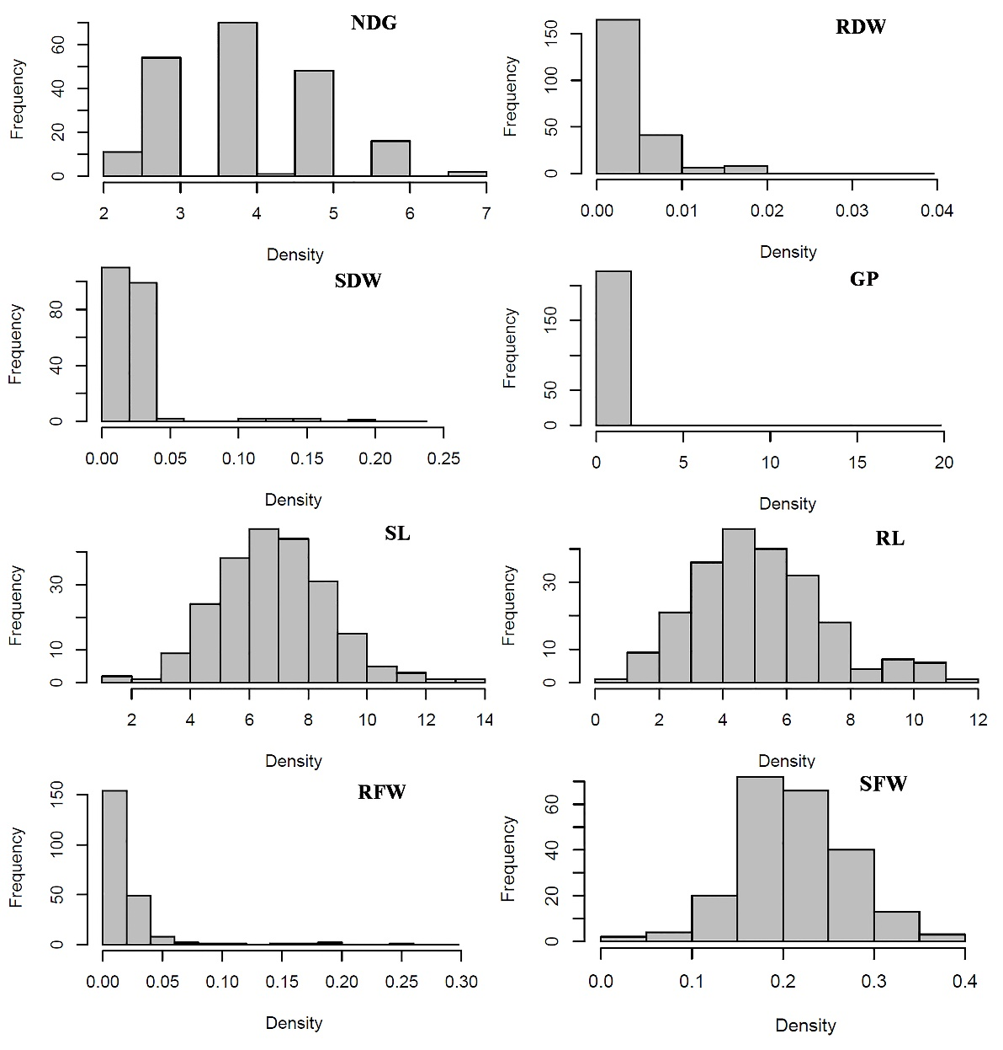
Supplementary FIGURE 1 Distribution of different traits including: NDG, RDW, SDW, GP, SL, RL, RFW, SFW.
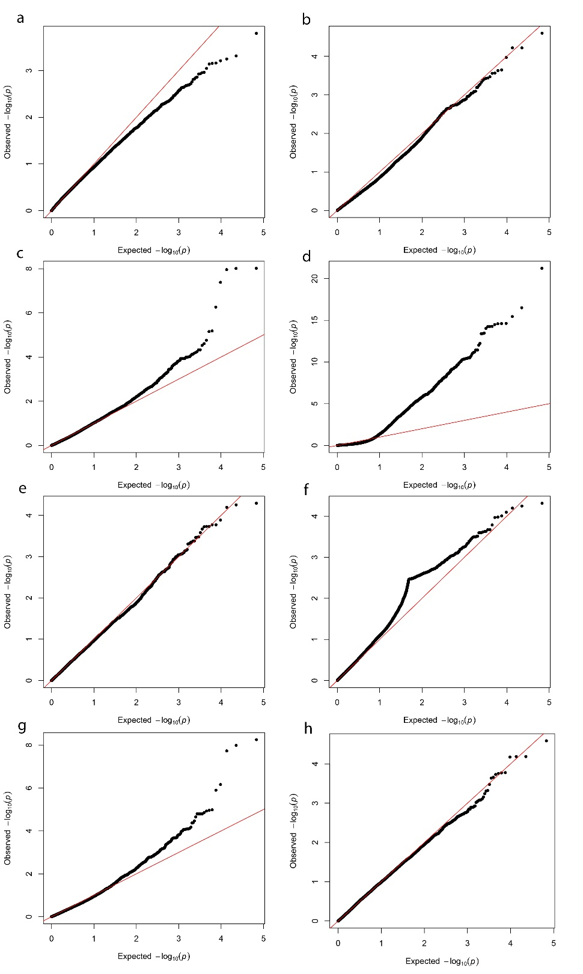

Supplementary FIGURE 2 Q-Q plots of SNPs on rice genome. The observed and expected -log₁₀ (p-values) from the GWAS were plotted for the studied traits including: a) NDG, b) RDW, c(SDW, d) GP, e) SL, f) RL, g) RFW, h) SFW.

