SUPPLEMENTARY DATA

Supplementary Figure 1
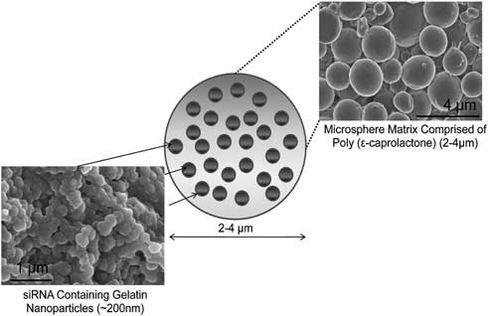

Formulation | Z-Average Particle Diameter (µm)* | siRNA Encapsulation Efficiency (%)*
Blank NiMOS | 2.66 ± 0.38* | NA
siRNA containing NiMOS | 2,63 ± 0.17 | 55.4 ± 8.13
*Mean ± S.D. (n = 4)

Supplementary Figure 1: Scanning electron micrographs of type B gelatin nanoparticles and Nanoparticles-in-Microsphere Oral System (NiMOS). Particle size and siRNA encapsulation efficiency in NiMOS are presented in the above table.

Supplementary Figure 2
A
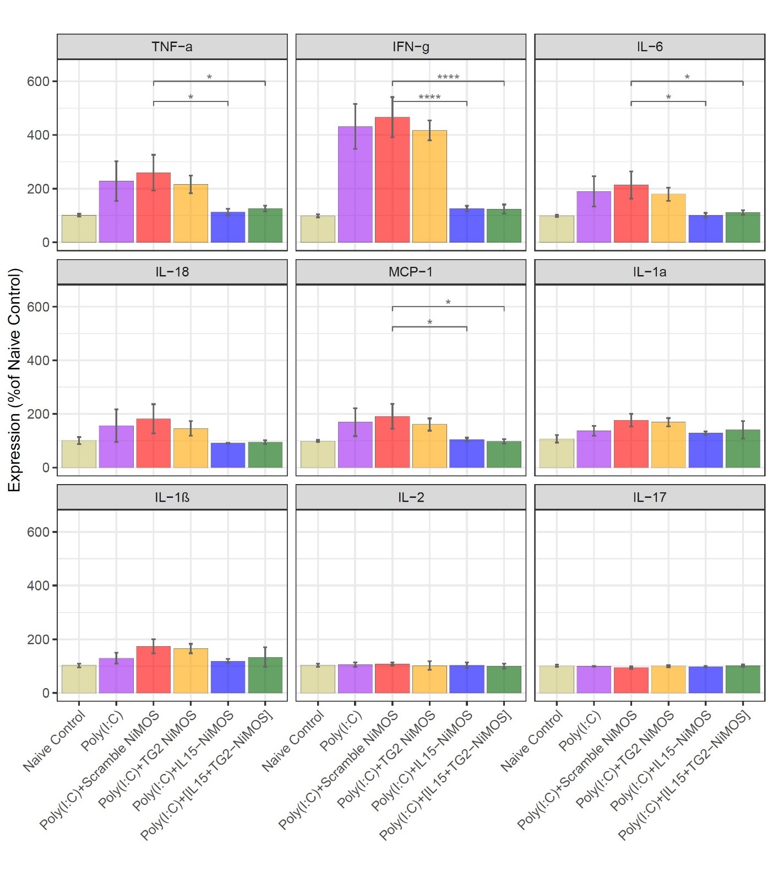
B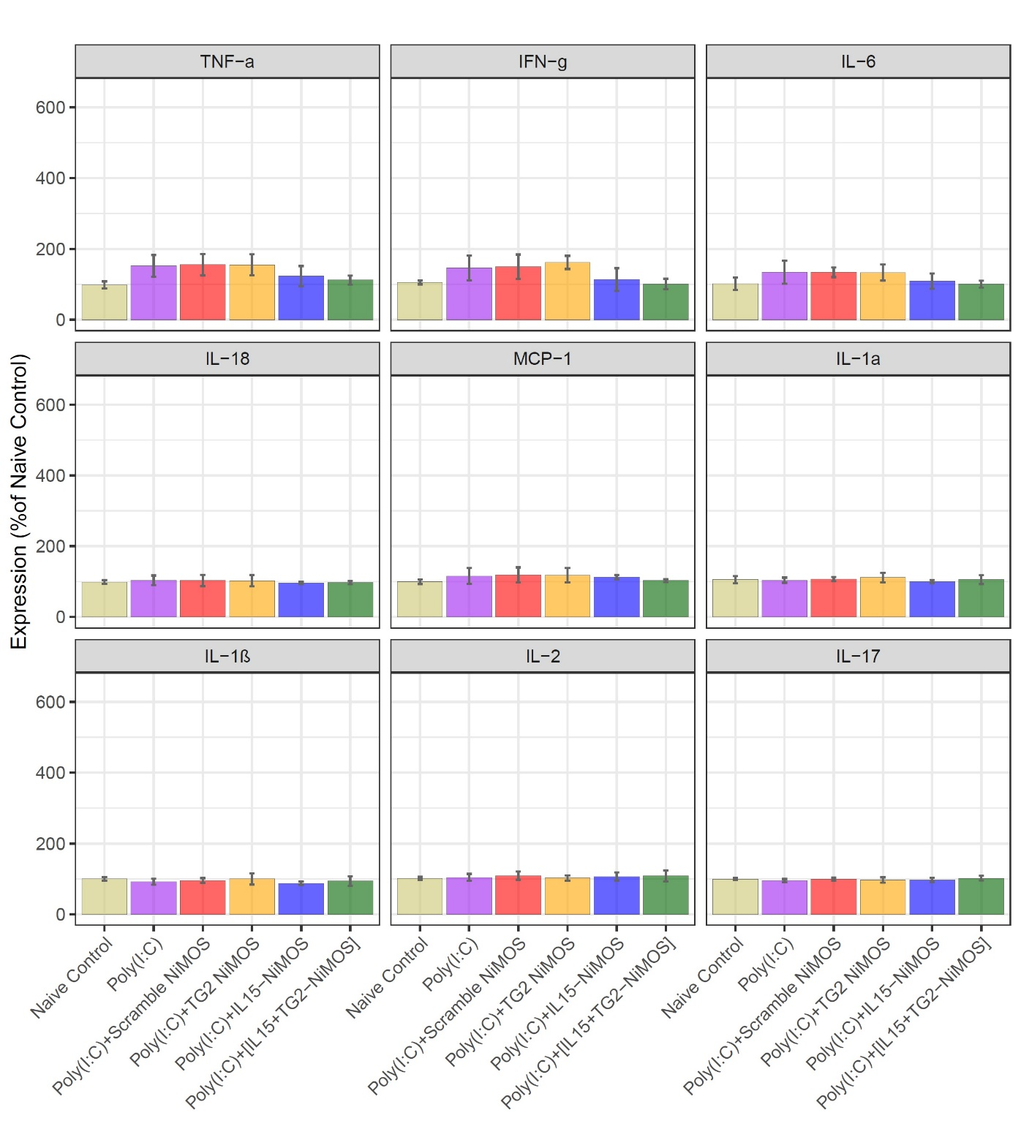
Supplementary Figure 2: Relative cytokine expression cytokines the small intestines at (A) 24-hours and (B) 72-hours post last dose; ***p<0.001, **p<0.01,*p<0.05; n=3

