Appendix
Table A. Descriptive statistics of variables
 | Variable | Obs. | Mean | Std. Dev. | Min | Max
Dependent  variables | COD Intensity | 455,558 | 3.4575 | 8.1912 | 0.0000 | 32.7958
 | SO₂ Intensity | 455,584 | 9.9004 | 19.5631 | 0.0000 | 74.5600
 | Sewage Intensity | 455,558 | 27.6416 | 52.3837 | 0.0000 | 202.1410
 | LnCOD | 455,561 | 5.1982 | 4.1747 | 0.0000 | 11.7118
 | COD Production | 429,614 | 5.5363 | 14.6244 | 0.0000 | 99.9991
 | COD Disposal | 427,911 | 2.0966 | 6.7903 | 0.0000 | 50.0000
 | lnOutput | 455,924 | 8.3816 | 1.7430 | -2.3026 | 20.0301
Independent  variables | ICT_Capital | 5,100 | 0.6552 | 1.5617 | 0.0000 | 55.5512
 | ICT_Service | 5,128 | 10.2906 | 17.7854 | 0.0000 | 99.9915
Enterprise  characteristic | lnSize | 449,428 | 5.4502 | 1.1459 | 2.3026 | 12.2009
 | lnAge | 455,927 | 2.3299 | 0.8482 | 0.0000 | 7.6059
 | Leverage | 455,927 | 0.5798 | 0.2567 | 0.1121 | 1.0000
 | FDI | 455,927 | 0.2107 | 0.4078 | 0.0000 | 1.0000
 | SOE | 455,927 | 0.1049 | 0.3064 | 0.0000 | 1.0000
 | Export | 455,927 | 0.2726 | 0.4453 | 0.0000 | 1.0000
 | lnKL | 449,328 | 4.3217 | 1.3672 | -6.7452 | 14.5032
Regional  characteristic | GDP_Target | 329 | 10.1444 | 1.4065 | 7.0000 | 15.0000
 | lnER | 329 | 4.3215 | 1.0713 | 0.0000 | 7.2564
 | Innovation | 4,629 | 58.2139 | 24.7032 | 1.0240 | 100.0000
Industry  characteristics | Industry_Open | 305 | 0.1557 | 0.1532 | 0.0045 | 0.6814
 | Industry_Size | 305 | 311.3494 | 198.0912 | 128.9000 | 1397.3500
 | Industry_Profit | 305 | 0.0597 | 0.0278 | -0.0443 | 0.1674
Technical  factors | Product_Inno | 264,198 | 3.8916 | 14.8079 | 0.0000 | 100.0000
 | TFP | 210,113 | 0.7345 | 0.4866 | 0.1012 | 2.0142
 | GTFP | 209,532 | 0.7292 | 0.4866 | 0.1022 | 2.0123
 | Technology_Up₁ | 455,927 | 0.5047 | 0.5000 | 0.0000 | 1.0000
 | Technology_Up₂ | 451,790 | 0.5998 | 0.4899 | 0.0000 | 1.0000
Notes: The classification of variables and their meanings are consistent with those in Table 1.Technology_Up₁and Technology_Up₂ refer to the dummy variables of pollution treatment technology and water-saving production technology, respectively.

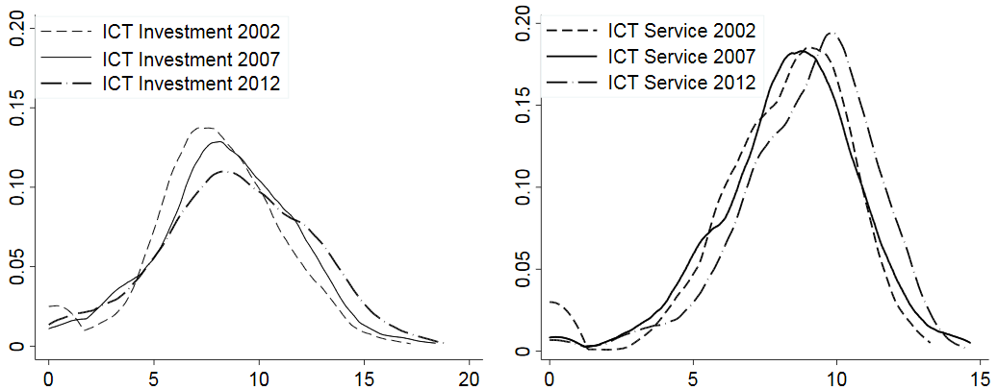
Figure A. Kernel density distribution of ICT investment and ICT services

