Supplementary Information 1
We detail the results from Weber et al¹ (originally shown for a branching process) for a system of ODEs. Same as Weber et al¹, the average generation number is defined as the mean of the generation numbers of all the cells in the population.

Minimal ODE model (Fig. 1G, H)
For cells dividing at a rate $λ$/day and dying at a rate $d$/day, according to the ODE $\frac{dN}{dt}=(λ-d)N$, the equations for change in unlabelled (DR^{GFP}, $G$) and labelled (DR^{RFP}, $R$) cells with time can be written as

$$G^{'}=(2-k)λG+kλ\left(1-p\right)G-λG-dG$$
(1)
$$R^{'}=kλpG+2λR-λR-dR$$

the fraction of DR^{RFP} labelled cells, $f_{R}$ at time $t$ is
 | $$f_{R}\left(t\right)=1-f_{G}\left(0\right)e^{-kλpt}$$ | (2)

where, $p$ is the switching probability and $k$ is the number of daughter cells that get labelled. $k=1$ is the asymmetric case when only one daughter cell can get labelled during cell division, and $k=2$ is the symmetric case when both daughter cells can get labelled during cell division.
In such a model, the average generation number, $μ_{t}=2λt$ , is independent of the death rate². For this ODE, we establish a relationship between the fraction of DR^{RFP} labelled cells in a population and its average generation number at some time $t$, as
 | $$μ_{t}=2λt=-\frac{2}{kp}ln\left(\frac{f_{G}(t)}{f_{G}(0)}\right)$$ | (3)

MEF experiment described in Fig. 1H
Linear regression on the cell number data from the MEF experiment was used to infer the division rate $λ$ (Fig. A). Using the same minimal ODE and assuming no death, the estimate for the division rate in the MEF data is$λ=0.698$/day, 0.673-0.723 (95% CI).
With the division rate and division time known, Eq. (2) was fitted to the fraction labelled to estimate the switching probability $p$. Fig. 1H shows the fits of 300 bootstraps (100 per MEF experiment) on the MEF data. The basic statistics of the switching probability estimates from these fits are:
$p$ (ODE) = 0.0053 (mean), 0.0052 (median), 0.0043-0.0063 (95% CI)

References supplementary information 1
1. Weber, T. S., Perié, L. & Duffy, K. R. Inferring average generation via division-linked labeling. J Math Biol 73, 491–523 (2016).
2. De Boer, R. J. & Perelson, A. S. Quantifying T lymphocyte turnover. J. Theor. Biol. 327, 45–87 (2013).
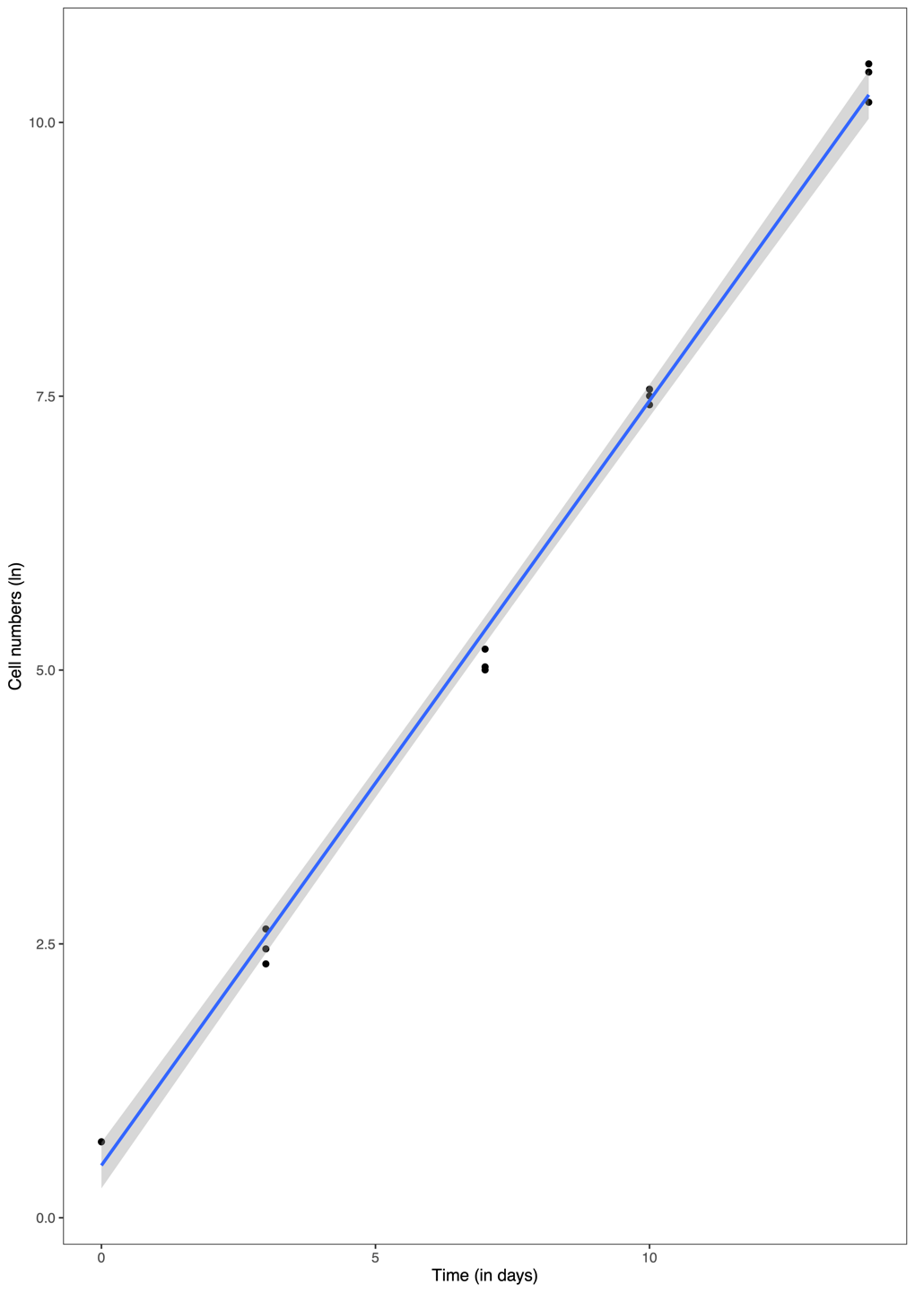
Figure A: Immortalized DivisionRecorder⁺ (DR⁺) mouse embryonic fibroblasts were cultured, counted, and analyzed every 3-4 days. Natural log of the number of DR⁺ cells is shown for three experimental replicates. The data is depicted by the circles and the best fit of the linear regression is depicted by the line. The slope of this regression line is the division rate of the cells in the MEF experiment.

Supplementary Information 2
Analysis of the early branching of memory T cells hypothesis (Fig. S1)
Consider the clonal expansion and subsequent contraction of a T cell population with two phenotypes: activated $A$ cells and quiescent $Q$ cells. Activated cells divide at a rate $λ_{A}=2$/day for 6 days (expansion phase), die at a rate $d_{A}=0.2$/day throughout, and can differentiate into quiescent cells at a rate $α_{i}$ during the expansion phase. One daughter cell of a dividing unlabelled cell (DR^{GFP}, $X_{G}$) can become permanently labelled (DR^{RFP}$,X_{R}$) with a switching probability $p=0.0013$. Labelling is permanent, i.e., all daughters of a labelled cell are also label-positive. In the model below, $i≥0$ denotes the division number.

$$A_{G_{i+1}}^{'}=λ_{A}A_{G_{i}}+\left(1-p\right)λ_{A}A_{G_{i}}-(α_{i}+ λ_{A}+d_{A})A_{G_{i+1}}$$
$$A_{R_{i+1}}^{'}=pλ_{A}A_{G_{i}}+2λ_{A}A_{R_{i}}-(α_{i}+λ_{A}+d_{A})A_{R_{i+1}}$$
(1)
$$Q_{G_{i+1}}^{'}=α_{i}A_{G_{i+1}}$$
$$Q_{R_{i+1}}^{'}=α_{i}A_{R_{i+1}}$$

We analyse two variants of the model. In the first variant, activated cells can only become quiescent when they have completed less than or equal to $n$ divisions. In the second variant, formation of quiescent cells from activated cells is allowed throughout the expansion phase, regardless of their division number (referred to as `all’). To create a similar number of quiescent cells in all cases we adjust the rate at which quiescent cells are formed. We depict two examples of the first variant in Figure 1: $n=10$ and $n=24$ (i.e., in Panel (B) we set $α_{i}=0.25$/day when $i<10$ (and $t<6$ days), and $α_{i}=0$ otherwise, and in Panel (B) we set $α_{i}=0.1$/day when $i<24$ (and $t<6$ days), and $α_{i}=0$ otherwise). The second variant shown in Figure 1(A) has the lowest rate at which quiescent cells are formed, $α_{i}=0.05$/day for all $i$.
By numerical integration of Eq. (1), we show in Fig. S1 that if the population that is persisting during the memory phase were composed of quiescent cells only, the percentage of DR^{RFP} labelled cells would decrease after the peak, regardless of when quiescent cells appear. Naturally, the decrease in the percentage of DR^{RFP} labelled cells after the peak is smaller when more quiescent cells are formed during the expansion phase. Note that we would not obtain much more quiescent cells if we would increase $α_{i}$ in the $n=10$ scenario because a too large $α_{i}$ cripples the expansion of the activated cells.

Supplementary Information 3
Phenotype model (Fig. 6D; Fig. S2E; Fig. S4F, G;)
For an experiment where DR^{RFP} label flow is asymmetrical and permanent, the DR^{RFP} accumulation in a population can be modelled by Eq. (1); see the cartoon in Fig. B. To model T cell dynamics throughout the immune response, we consider two distinct populations multipotent CD27^{HI}KLRG1^{LO} T cells (hereafter referred to as $T_{MULT}$) and terminally differentiated CD27^{LO}KLRG1^{HI} T cells (hereafter referred to as $T_{TERM}$). We model five phenotypes: clonally expanding activated $T_{MULT}$s ($M_{A}$), clonally expanding activated $T_{TERM}$s ($E_{A}$), cycling $T_{MULT}$s ($M_{C}$), cycling $T_{TERM}$s ($E_{C}$) and quiescent $T_{MULT}$s ($M_{Q}$). Each phenotype has an unlabelled (DR^{GFP}$,X_{G}$) and a labelled (DR^{RFP}, $X_{R}$) subtype. For the parameters, the model has division rates,$λ$, death rates, d, re-activation rates, $α$, de-activation rates, $μ$, differentiation/transition rates, $δ$, and a switching probability, p. The rate parameters are indexed by a subscript $i ϵ \{1,2,3\}$ to allow for different values during the expansion, contraction and memory phases, and with a subscript to allow different values for different cellular phenotypes.

$$\frac{dM_{A_{G}}}{dt}=α_{{M_{Q}}_{i}}M_{Q_{G}}+α_{{M_{C}}_{i}}M_{C_{G}}+\left(\left(1-p\right)λ_{M_{A_{i}}}-δ_{{M_{A}}_{i}}-δ_{{M_{Q}}_{i}}-μ_{{M_{A}}_{i}}-d_{{M_{A}}_{i}}\right)M_{A_{G}}$$
$$\frac{dM_{A_{R}}}{dt}=pλ_{M_{A_{i}}}M_{A_{G}}+α_{{M_{C}}_{i}}M_{C_{R}}+α_{{M_{Q}}_{i}}M_{Q_{R}}+\left(λ_{M_{A_{i}}}-δ_{{M_{A}}_{i}}-δ_{{M_{Q}}_{i}}-μ_{{M_{A}}_{i}}-d_{{M_{A}}_{i}}\right)M_{A_{R}}$$
$$\frac{dE_{A_{G}}}{dt}=δ_{M_{A_{i}}}M_{A_{G}}+α_{{E_{C}}_{i}}E_{C_{G}}+\left((1-p)λ_{E_{A_{i}}}-μ_{{E_{A}}_{i}}-d_{{E_{A}}_{i}}\right)E_{A_{G}}$$
$$\frac{dE_{A_{R}}}{dt}=δ_{M_{A_{i}}}M_{A_{R}}+pλ_{E_{A_{i}}}E_{A_{G}}+α_{{E_{C}}_{i}}E_{C_{R}}+\left(λ_{E_{A_{i}}}-μ_{{E_{A}}_{i}}-d_{{E_{A}}_{i}}\right)E_{A_{R}}$$
$$\frac{dM_{C_{G}}}{dt}=μ_{M_{A_{i}}}M_{A_{G}}+\left((1-p)λ_{M_{C_{i}}}-δ_{{M_{C}}_{i}}-d_{{M_{C}}_{i}}-α_{{M_{C}}_{i}}\right)M_{C_{G}}$$
(5)
$$\frac{dM_{C_{R}}}{dt}=μ_{M_{A_{i}}}M_{A_{R}}+pλ_{M_{C_{i}}}M_{C_{G}}+\left(λ_{M_{C_{i}}}-δ_{{M_{C}}_{i}}-d_{{M_{C}}_{i}}-α_{{M_{C}}_{i}}\right)M_{C_{R}}$$
$$\frac{dE_{C_{G}}}{dt}=δ_{{M_{C}}_{i}}M_{C_{G}}+μ_{E_{A_{i}}}E_{A_{G}}+\left((1-p)λ_{E_{C_{i}}}-d_{{E_{C}}_{i}}-α_{{E_{C}}_{i}}\right)E_{C_{G}}$$
$$\frac{dE_{C_{R}}}{dt}=δ_{{M_{C}}_{i}}M_{C_{R}}+μ_{E_{A_{i}}}E_{A_{R}}+pλ_{E_{C_{i}}}E_{C_{G}}+\left(λ_{E_{C_{i}}}-d_{{E_{C}}_{i}}-α_{{E_{C}}_{i}}\right)E_{C_{R}}$$
$$\frac{dM_{Q_{G}}}{dt}=δ_{M_{Q_{i}}}M_{A_{G}}-\left(d_{{M_{Q}}_{i}}+α_{{M_{Q}}_{i}}\right)M_{Q_{G}}$$
$$\frac{dM_{Q_{R}}}{dt}=δ_{M_{Q_{i}}}M_{A_{R}}-\left(d_{{M_{Q}}_{i}}+α_{{M_{Q}}_{i}}\right)M_{Q_{R}}$$

Upon antigen encounter, a naïve $T$ cell gets activated, starts dividing rapidly and gives rise to a continuum of different phenotypic populations. The phenotype model, as shown in the cartoon below, broadly classifies this continuum into the five phenotypes introduced above. The model assumes that cellular differentiation into subsequent phenotypes occurs continuously during the expansion phase (i.e., in presence of antigen). Activated $T_{MULT}$s can differentiate into activated $T_{TERM}$s and into quiescent $T_{MULT}$s, and quiescent $T_{MULT}$s can be reactivated into activated $T_{MULT}$s due to the presence of antigen. After the peak of the response, part of the activated $T_{MULT}$s and $T_{TERM}$s become cycling $T_{MULT}$s and $T_{TERM}$s respectively, that survive during the memory phase. The phenotype of the quiescent $T_{MULT}$s does not change during the transition from the expansion to memory phase. Due to renewed antigen exposure starting at day 86, the model undergoes the sequence of expansion, contraction, and memory formation twice.
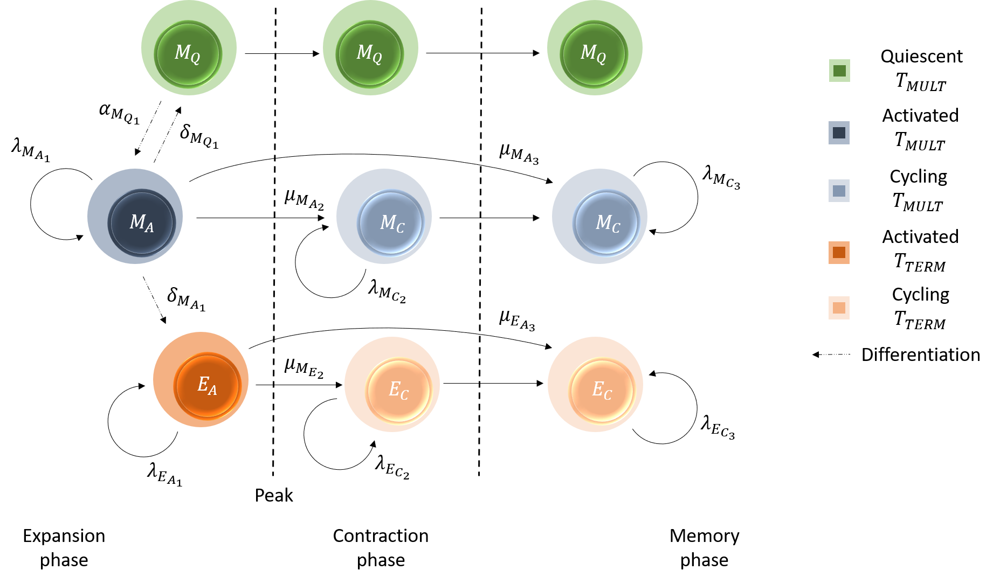
Figure B: Cartoon of the phenotype model depicting phenotypes, the considered interactions among them and the parameters associated with the interactions. The subscript of the parameters indicates the phase (1: expansion phase, 2: contraction phase, 3: memory phase) where the parameter is non-zero. For simplicity a few arrows (like the death rates) were left out.
Fitting
Three phases of an immune response were inferred from the data: the expansion phase (day 0-6 for the primary response and day 86-90 for the secondary response), the contraction phase (day 6-15 for the primary response and day 90-94 for the secondary response) and the memory phase (day 15-86 for the primary response and day 94-111 for the memory response). The length of contraction phase of the primary response (9 days) was decided based on the availability of data (day 15), whereas that of secondary response (4 days) was tuned to fit the data. The percentages of labelled cells in blood and spleen were found to be similar at most time points. Additionally, the ratio of the number of DR^{GFP} cells in the spleen to that in the blood was similar across all time points. The blood and spleen data were therefore fitted simultaneously by assuming that both compartments are well-mixed, i.e., by assuming that population densities in the blood and spleen are proportional to each other (Fig. 6D, Fig. S4G). As population sizes in the spleen are much larger than those in the blood, the initial value of the populations was taken from the day 3 spleen data (and not fitted). The estimated parameters are listed in Table S1. While constructing the model we assumed that several parameters should be zero during a subset of the phases. Since, the model has many inter-dependent parameters, our best fit could be a local optimum and should therefore be interpreted as evidence that the phenotype model can explain the data (and should not be seen as a reliable quantification of all parameters, which would need information on the identifiability of the parameters).
We challenge two of the model assumptions to illustrate that two alternative scenarios are not compatible with the data. First, we allow $T_{MULT}$ cells to differentiate into $T_{TERM}$ cells even after the peak of the response. Using the parameters found from the best fit to the data (Table S1), we allow for slow differentiation after the peak by setting $δ_{M_{C_{2}}}=0.01$/day and $δ_{M_{C_{3}}}=0.01$/day, we increase the division rate of the cycling $T_{MULT}$ cells by the same amount to not change their kinetics (i.e., we set $λ_{M_{C_{2}}}=1.6$/day and $λ_{M_{C_{3}}}=0.61$/day), and finally we slightly increase the death rate of the cycling $T_{TERM}$ cells (i.e., we set$d_{{E_{C}}_{2}}=1.2$/day and $d_{{E_{C}}_{3}}=0.21$/day) to also maintain similar population sizes for cycling $T_{TERM}$ cells. Even such a slow differentiation rate ($0.01$/day) after the peak, would increase the percentage of DR^{RFP} within the $T_{TERM}$ population much faster than we see in the data (Fig. S2E).
For the second scenario, we allow cycling $T_{MULT}$ cells to become re-activated during the secondary response (Fig. S4F), by considering various re-activation rates $α_{M_{C_{1}}}$ or $α_{E_{C_{1}}}$. Fig. S4F illustrates that even a small re-activation rate of the cycling memory cells would eliminate the drop in the percentage of DR^{RFP} cells in both $T_{MULT}$ and $T_{TERM}$ subsets, contrary to the observations.

Parameter | Description | Unit | Expansion ($i=1$) | Contraction ($i=2$) | Memory ($i=3$)
p | Probability of one unlabelled daughter becoming labelled | - | 0.0011 | 0.0011 | 0.0011
$$λ_{M_{A_{i}}}$$ | Division rate of the activated $T_{MULT}$ cells | /day | 2.52 | 0 | 0
$$λ_{E_{A_{i}}}$$ | Division rate of the activated $T_{TERM}$ cells | /day | 0.46 | 0 | 0
$$λ_{M_{C_{i}}}$$ | Division rate of the cycling $T_{MULT}$ cells | /day | 0 | 1.59 | 0.6
$$λ_{E_{C_{i}}}$$ | Division rate of the cycling $T_{TERM}$ cells | /day | 0.12 | 0.79 | 0.17
$$δ_{M_{A_{i}}}$$ | Differentiation rate of the activated $T_{MULT}$ cells into activated $T_{TERM}$ cells | /day | 0.79 | 0 | 0
$$δ_{M_{C_{i}}}$$ | Differentiation rate of the cycling $T_{MULT}$ cells into cycling $T_{TERM}$ cells | /day | 0 | 0 | 0
$$δ_{M_{Q_{i}}}$$ | Differentiation rate of the activated $T_{MULT}$ cells into quiescent $T_{MULT}$ cells | /day | 0.005 | 0 | 0
$$μ_{M_{A_{i}}}$$ | Rate of activated $T_{MULT}$s becoming cycling $T_{MULT}$s in absence of antigen | /day | 0 | 3.47 | 3.47
$$μ_{M_{E_{i}}}$$ | Rate of activated $T_{TERM}$s becoming cycling $T_{TERM}$s in absence of antigen | /day | 0 | 3.47 | 3.47
$$α_{M_{Q_{i}}}$$ | Re-activation rate of quiescent $T_{MULT}$ cells into activated $T_{MULT}$ cells | /day | 1.17 | 0 | 0
$$d_{M_{Q_{i}}}$$ | Death rate of the quiescent $T_{MULT}$ cells | /day | 0 | 0 | 0
$$d_{M_{A_{i}}}$$ | Death rate of the activated$T_{MULT}$ cells | /day | 0.03 | 0 | 0
$$d_{E_{A_{i}}}$$ | Death rate of the activated$T_{TERM}$ cells | /day | 0.02 | 0 | 0
$$d_{M_{C_{i}}}$$ | Death rate of the cycling $T_{MULT}$ cells | /day | 0.08 | 1.9 | 0.6
$$d_{E_{C_{i}}}$$ | Death rate of the cycling $T_{TERM}$ cells | /day | 0.66 | 1.17 | 0.18
$$f_{m_{i}}$$ | Ratio of $T_{MULT}$ cells in blood and spleen | - | 0.007 | 0.007 | 0.007
$$f_{t_{i}}$$ | Ratio of $T_{TERM}$ cells in blood and spleen | - | 0.044 | 0.044 | 0.044
$$α_{M_{C_{i}}}$$ | Re-activation rate of the cycling $T_{MULT}$ cells into activated $T_{MULT}$ cells | /day | 0 | 0 | 0
$$α_{E_{C_{i}}}$$ | Re-activation rate of the cycling $T_{TERM}$ cells into activated $T_{TERM}$ cells | /day | 0 | 0 | 0

Table S1: The parameters of the phenotype model. The parameter values in this table were obtained by fitting the phenotype model to the blood and spleen data simultaneously using the pseudorandom-search algorithm (see pseudoOptim) in the modFit function of the FME R package¹. Except for the $λ_{M_{C_{1}}}$= 0, suggesting that cycling $T_{MULT}$ cells do not divide during the expansion phase of the secondary response, the zeros in this Table were fixed (i.e., were not obtained by the fitting procedure). These values were zero by design or are defaults that are changed to non-zero values in the alternative scenarios.

References supplementary information 3
1. Soetaert, K., & Petzoldt, T. FME: A Flexible Modelling Environment for inverse modelling, sensitivity, identifiability, monte carlo analysis. R package version, 1 (2009).

