Supplementary information

Quantifying the local Li-ion diffusion over the grain boundaries of a protective coating, revealing the impact on the macroscopic Li-ion transport in an all-solid-state battery

Ming Liuª, Chao Wangª, Chenglong Zhao^{a,b}, Eveline van der Maasª, Kui Lin^{b}, Violetta A. Arszelewskaª, Baohua Li^{b}, Swapna Ganapathy^{a*} and Marnix Wagemaker^{a*}

ª Section Storage of Electrochemical Energy, Radiation Science and Technology, Faculty of Applied Sciences, Delft University of Technology. E-mail: s.ganapathy@tudelft.nl and m.wagemaker@tudelft.nl

^{b} Key Laboratory on Power Battery Research and Shenzhen Geim Graphene Center, Tsinghua Shenzhen International Graduate School, Tsinghua University, Guangdong 518055, China.

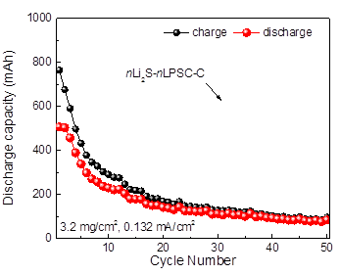
Figure S1| Cycle performance of battery with nLi₂S-nLPSC-C cathode.

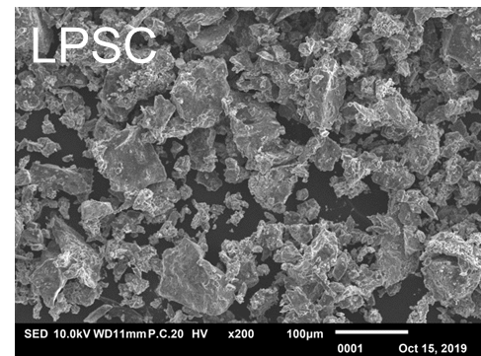
Figure S2| SEM images of micron sized LPSC.

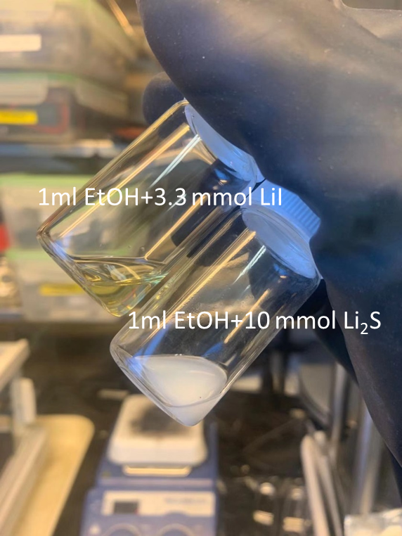
Figure S3| Optical image of 3.3 mmol fully dissolved LiI and 10 mmol partially dissolved Li₂S in 1 ml ethanol respectively.

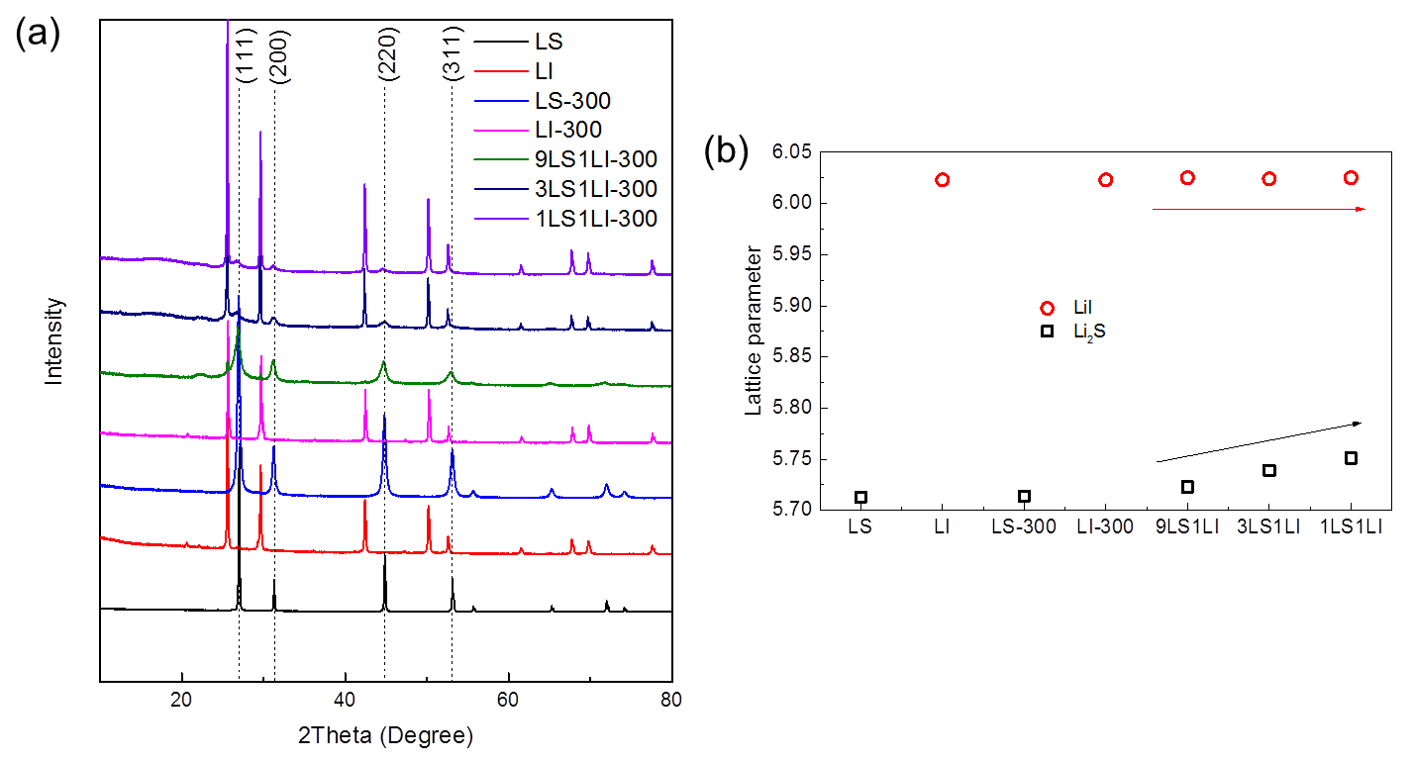
Figure S4| (a) XRD patterns and (b) fits lattice parameter of the Li₂S, LiI and Li₂S-LiI materials. All the patterns are fit with the Rietveld method as implemented in GSAS.

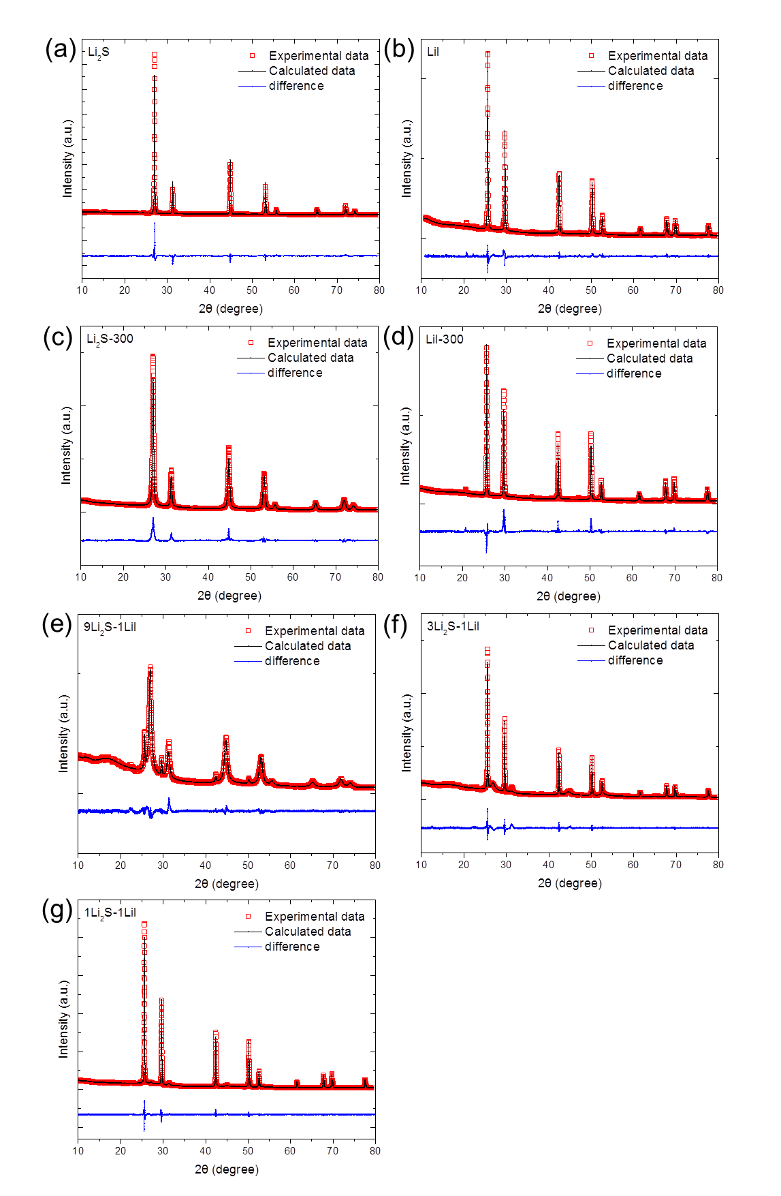
Figure S5| Rietveld refinement of Li₂S, LiI and Li₂S-LiI based on diffraction patterns given in Figure S4.

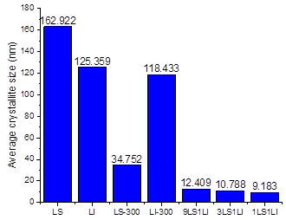
Figure S6| Average crystallite size of Li₂S, LiI and Li₂S in Li₂S-LiI based on the Rietveld refinement in Figure S5.

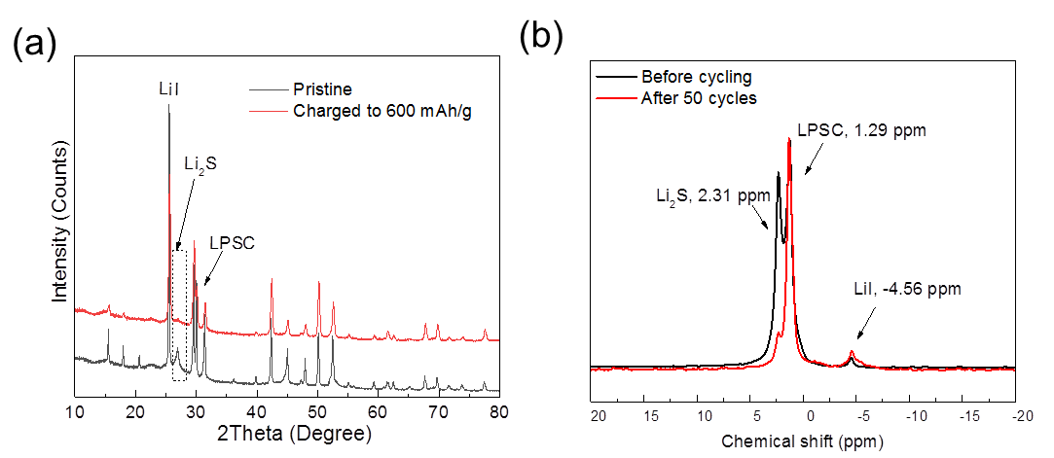
Figure S7| Post mortem (a)XRD and (b) NMR analysis of the mLi₂S(LiI)-mLPSC-C active materials after activation to 600 mAh/g and after 50 cycles to 600 mAh/g under charged state.

Table S1| Activation voltage and over potential in our work compared with open literature as shown in Figure 4d.
Title | Activation platform | Over-potential | Reference number
Accessing the bottleneck in all-solid state batteries, lithium-ion transport over the solid-electrolyte electrode interface | ~1.8 V vs. In-Li | ~400 mV | 1
Li₂S-Based Solid Solutions as Positive Electrodes with Full Utilization and Super long Cycle Life in All-Solid-State Li/S Batteries | ~2.4 V vs. In-Li | ~500 mV | 2
In Situ Generated Li₂S−C Nanocomposite for High-Capacity and Long-Life All-Solid-State Lithium Sulfur Batteries with Ultrahigh Areal Mass Loading | ~1.85 V vs. In-Li | ~300 mV | 3
High-Performance All-Solid-State Lithium−Sulfur Battery Enabled by a Mixed-Conductive Li₂S Nanocomposite | ~2 V vs. In-Li | ~700 mV | 4
High performance all-solid-state lithium-sulfur battery using a Li₂S-VGCF nanocomposite | ~2.5 V vs. In-Li | ~600 mV | 5
Cathode-Supported All-Solid-State Lithium–Sulfur Batteries with High Cell-Level Energy Density | ~2.4 V vs. In-Li | ~500 mV | 6
Carbon-coated Li₂S cathode for improving the electrochemical properties of an all-solid-state lithium-sulfur battery using Li₂S-P2S5 solid electrolyte | ~2.5 V vs. In-Li | ~200 mV | 7
This work | 1.69 V vs. In-Li | ~100 mV | 8

References

1 Yu, C. et al. Accessing the bottleneck in all-solid state batteries, lithium-ion transport over the solid-electrolyte-electrode interface. Nat Commun 8, 1086 (2017).
2 Hakari, T. et al. Li₂S-Based Solid Solutions as Positive Electrodes with Full Utilization and Superlong Cycle Life in All-Solid-State Li/S Batteries. Adv Sustain Syst 1, 1700017 (2017).
3 Yan, H. F. et al. In Situ Generated Li₂S-C Nanocomposite for High-Capacity and Long-Life All-Solid-State Lithium Sulfur Batteries with Ultrahigh Areal Mass Loading. Nano Lett 19, 3280-3287 (2019).
4 Han, F. et al. High-Performance All-Solid-State Lithium-Sulfur Battery Enabled by a Mixed-Conductive Li₂S Nanocomposite. Nano Lett 16, 4521-4527, (2016).
5 Eom, M. et al. High performance all-solid-state lithium-sulfur battery using a Li₂S-VGCF nanocomposite. Electrochimica Acta, 230, 279-284 (2017).
6 Xu, R. C. et al. Cathode-Supported All-Solid-State Lithium-Sulfur Batteries with High Cell-Level Energy Density. Acs Energy Lett 4, 1073-1079 (2019).
7 Choi, S.et al. Carbon-coated Li₂S cathode for improving the electrochemical properties of an all-solid-state lithium-sulfur battery using Li₂S-P₂S₅ solid electrolyte. Ceramics International 44, 7450-7453 (2018).

