Supplementary Information
Construction of BiOBr/g-C₃N₄/Bi₂O₂CO₃ Z-scheme photocatalyst with enhanced photocatalytic activity

Biao Zhang ª, Yu Liu ^{a,} *, Kanghong Zhou ª, Hongyu Zhu ª, Dongxu Gu ª, Wei Ge ª, Ying Gan ª, Jianyuan Hao ^{a,} *
ª School of Materials and Energy, University of Electronic Science and Technology of China, Chengdu, 610054 China
* Corresponding author: Yu Liu, Jianyuan Hao,
Yu Liu, School of Materials and Energy, University of Electronic Science and Technology of China, Chengdu, 610054, China, E-mail: poly1634@hotmail.com.
Jianyuan Hao, School of Materials and Energy, University of Electronic Science and Technology of China, Chengdu, 610054, China, E-mail: jyhao@uestc.edu.cn.

1 Experimental
1.1 Preparation of BiOBr(BOB) and Bi₂O₂CO₃(BOC) catalysts
The BOB and BOC were prepared by hydrothermal method[1]. Typically, 0.485 g of Bi(NO₃)₃·5H₂O was dissolved in 40 ml deionized water and stirred for 30 min (suspension A). 0.119 g of KBr was added to 40 ml deionized water and sonicated for 30 min (suspension B). Both A and B were mixed thoroughly with continuous stirring for another 30 min. The reactor was put into an oven and kept at 160 °C for 24 h. After being cooled to room temperature, the precipitates were washed with distilled water for three times and dried at 80 °C for 12 h. The BOC was prepared in the same way, except that KBr is replaced by urea (0.3 g).
1.2 Characterization
The crystalline phases were characterized using an X-ray diffractometer (XRD) (X' Pert PRO, Netherlands) with Cu(Kα) radiation (λ = 1.5406 Å) in the 2θ range of 5 - 80°. Fourier transform infrared spectra (FTIR) of photocatalysts were analyzed by a thermo Fisher Nicolet Is10 spectrometer. The morphology and composition were determined by scanning electron microscopy (SEM) (Hitachi, s-4800, Japan) and energy dispersive spectroscopy (EDS), respectively. Chemical composition of catalysts was determined by X-ray photoelectron spectroscopy (XPS) (ThermoFischer, ESCALAB Xi+, America). The photoluminescence (PL) spectra were measured using a Hitachi F-7000 fluorescence spectrophotometer. UV-vis diffuse reflectance spectra (UV-vis DRS) were detected by UV spectrophotometer (Shimadzu, Japan).
1.3 Evaluation of photocatalytic activity
30 mg of catalyst was added into 100 mL of rhodamine B (Rh B) solution (20 mg/L). The suspension was kept in the dark for 30 min to establish the adsorption-desorption equilibrium followed by exposure to visible light (LED, 50 W, 400 nm< λ < 800 nm (Fig. S2)) with constant stirring. At given time intervals, 4 ml of suspension was collected and centrifuged (8000 rpm, 5 min) to remove the photocatalyst particles thoroughly. The concentrations of Rh B were analyzed by UV-2450 (SHIMADZU, Japan) at 554 nm. ·O₂⁻, ·OH and h⁺ were scavenged by benzoquinone (BQ, 0.001M), isopropyl alcohol (IPA, 0.005M), triethanolamine (EDTA-2Na, 0.005M), respectively.

Fig. S1 SEM images of (a) 0.1CN (b) 0.05CN, and (c) 0.025CN.

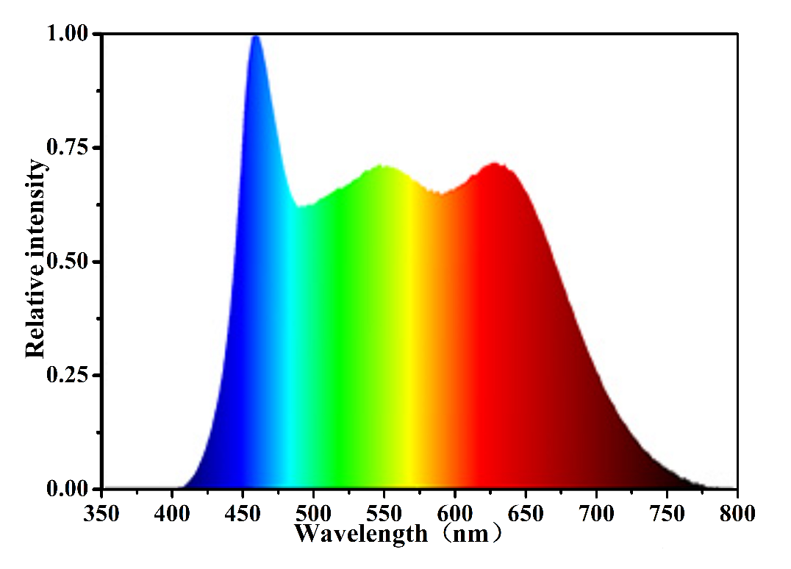
Fig. S2 Emission spectrum of Vis LED light.

Table S1
Comparisons of Rh B degradation among different photocatalysts

Photocatalysts | Catalysts quality | Initial concentration | Removal efficiency | Light | Time | Refs
PANI/Ag₃PO₄/NiFe₂O₄ | 25mg | 10 mg/L (50 mL) | nearly 100% | 65W visible lamp | 40 min | [2]
BiVO₄/g-C₃N₄/AgI | 20mg | 10 mg/L (50 mL) | 94.67% | 500W  Xe lamp | 60 min | [3]
FeWO₄/WO₃/Fe₂O₃ | 10mg | 6 mg/L (50 mL) | 90% | 300W  Xe lamp | 80 min | [4]
g-C₃N₄/ ZnS/CuS | 50mg | 10 mg/L (100 mL) | 90% | 500W  Xe lamp | 90 min | [5]
TiO2/CeO₂/Bi₂O₃ | 50mg | 8 mg/L (100 mL) | 55% | 500W  Xe lamp | 120 min | [6]
BiOBr/g-C₃N₄/Bi₂O₂CO₃ | 30mg | 20 mg/L (100 mL) | 98% | 50W  LED | 60 min | This work

References
- D. Majhi, K. Das, A. Mishra, R. Dhiman, B.G. Mishra, Appl. Catal. B. 260, 118222 (2020).
- Y. Chen, P. Zhu, M. Duan, J. Li, Z. Ren, P. Wang, Appl. Surf. Sci. 486 198 (2019).
- M. Xu, J. Yang, C. Sun, Y. Cui, L. Liu, H. Zhao, B. Liang, J. Mater. Sci. 56, 1328 (2020).
- H. Wang, C. Wang, X. Cui, L. Qin, R. Ding, L. Wang, Z. Liu, Z. Zheng, B. Lv, Appl. Catal. B. 221, 169 (2018).
- Y. Sun, J. Jiang, Y. Cao, Y. Liu, S. Wu, J. Zou, Mater. Lett. 212, 288 (2018).
- Z. Zou, C. Xie, S. Zhang, X. Yu, T. Zou, J. Li, J. Alloys Compd. 581, 385 (2013).

