Supporting information
A simple method of simultaneously endowing paper or fluff pulp with both high softness or appropriate fluffing properties and antimicrobial properties
Yongjian Xu*, Yun Shi, Xuyong Chen, Fenfen Liu, Wei Zhao
College of Bioresources Chemical and Materials Engineering, Shaanxi Provincial Key Laboratory of Papermaking Technology and Specialty Paper Development, National Demonstration Center for Experimental Light Chemistry Engineering Education, Shaanxi University of Science and Technology, Xi’an, Shaanxi Province 710021, China
Corresponding Authors: Yongjian Xu, E- mail: xuyongjian@sust.edu.cn

Results and discussion

1.1 The FT-IR and 1HNMR spectrum analysis of AQAS 2b
Fig. S1. FI-IR patterns of 1: N,N-dimethyl-tetradecylamine, 2: tris(2-chloroethy) amine and 3: AQAS 2b.
The FT-IR spectra of AQAS 2b were showed in Fig. S1. It is seen that the strong absorption peak at 1475cm⁻¹ belongs to methyl bending vibration peak in N⁺-(CH₃)₂. The bending vibration absorption peak of methyl in -CH₂-CH₃ is observed at 1375cm⁻¹, which is a characteristic absorption peak of moderate intensity. The characteristic absorption peak (around 1039 cm⁻¹) of AQAS is weakly observed, which confirmed the synthesis of AQAS 2b. In contrast with line 2, the methylene asymmetric stretching vibration absorption peak (2927cm⁻¹) and symmetric stretching vibration absorption peak (2870cm⁻¹) region in NR₂-CH₂-R still appeare in line 3. Moreover, the C-Cl stretching vibration peak (760 cm⁻¹) of -CH₂-Cl and the C-H stretching vibration peak (1280 cm⁻¹) of methylene in -CH₂-Cl are weakened, indicating a small amount of impurities may be contained in the product and it is necessary for further purification.
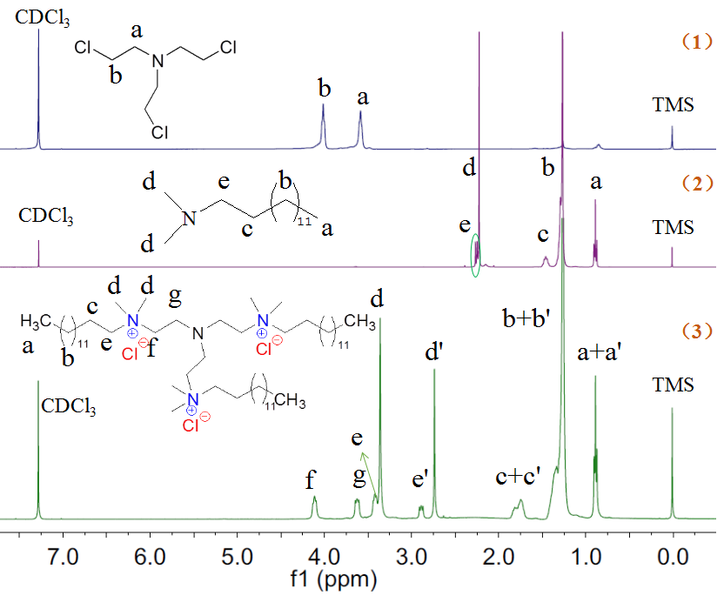
Fig S2. ¹HNMR spectra of tris(2-chloroethy)amine N-N-dimethyl-tetradecylamine and AQAS 2b (500 MHz, CDCl₃, 25ºC).
Fig. S2 shows the ¹HNMR spectrum of AQAS 2b. Compared to the ¹HNMR spectra of Fig. S2(1) and (2), the characteristic peaks at 3.62 and 4.10 ppm are attributed to methylene in N-CH₂- and N-CH₂-CH₂. The peaks at 0.89, 1.26 and 1.74 ppm are assigned to methyl in -CH₂-CH₃, methylene group of (-CH₂-)₁₁ and methylene of N⁺-CH₂-CH₂. Meanwhile, the methyl peak (3.36 ppm) of -N⁺-CH₃ and the methylene peak (3.41 ppm) of N⁺-CH₂ are also clearly seen, which indicate that the target product has been successfully synthesized (Fig. S2). In contrast with Fig. S2(2), the peaks at 2.74 and 2.89 ppm belong to methyl in -CH₂-CH₃ and methylene in N⁺-CH₂-CH₂-, which may be due to the tertiary ammonium hydrochloride appeared and the product contained impurities.

1.2 The FT-IR and 1HNMR spectrum analysis of AQAS 2c
Fig S3. FT-IR spectrum of: 1: N,N-dimethyl-octadecylamine, 2: tris(2-chloroethy) amine and 3: AQAS 2c.
The FT-IR spectrum of AQAS 2c is presented in Fig. S3. The strong absorption peaks at 1473cm⁻¹ due to the presence of methyl bending vibration peak in N⁺-(CH₃)₂ were observed, a moderate intensity characteristic absorption peak located at 1379cm⁻¹can be attributed to methyl in -CH₂-CH₃ were also observed. In addition, 1045 cm⁻¹ is the characteristic absorption frequency of AQAS, which confirmed the formation of AQAS 2c. Furthermore, the characteristic absorption peaks of methyl and QAS groups appear for the first time and the methylene asymmetric and symmetric stretching vibration absorption peaks at 2927 cm⁻¹ and 2870 cm⁻¹ region in NR₂-CH₂-R still exist in comparison with Line 2. The strong absorption peak at 760 cm⁻¹ and 1280 cm⁻¹ are weakened, which indicated the C-Cl stretching vibration peak of -CH₂-Cl is weakened, this may be attributed to the presence of by-products that incomplete quaternary ammonium salt in the product.

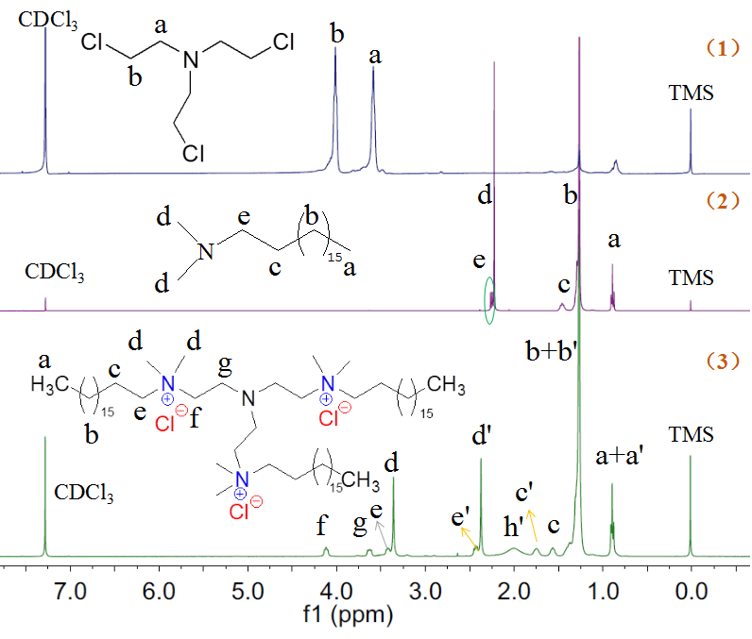
Fig S4. ¹HNMR spectrum of tris(2-chloroethy)amine，N-N-dimethyl-octadecylamine and AQAS 2c (500 MHz, CDCl₃, 25ºC).
The ¹HNMR spectra are applied to further confirm the chemical structures of AQAS 2c, and the peaks attributions are labeled in Fig. S4. Compared to the ¹HNMR spectrum of Fig. S4(1) and (2), the characteristic peaks at 3.61 and 4.10 ppm are attributed to methylene in N-CH₂- and N-CH₂-CH₂. The peaks at 3.35 and 3.41 ppm belong to methyl of -N⁺-CH₃ and methylene of N⁺-CH₂, respectively. And the peak at 0.88, 1.25 and 1.55 ppm assigned to methyl in -CH₂-CH₃, methylene group (-CH₂-)₁₅ of AQAS 2c and methylene in N⁺-CH₂-CH₂. All of them indicating the target product has been successfully synthesized (Fig. S4). In contrast with Fig. S4(2), the peaks at 2.37 and 2.43 ppm belong to methyl in -CH₂-CH₃ and methylene in N⁺-CH₂-CH₂-, which indicated that there may appear part tertiary ammonium hydrochloride and the product contained impurities.

