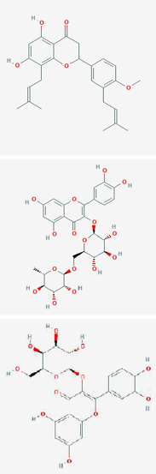
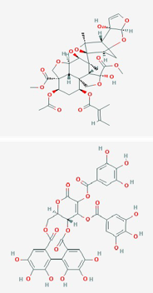
Table1. List of natural compounds agents docked against COVID-19
S.No. 1. | Molecular name of Ligands  Nimbaflavone | 2D Structure | Compound CID  14492795 | Plant  Azadirachta indica | Target or inhibition Anti-Influenza
2. | Rutin |  | 5280805 | Azadirachta indica | Anti-Influenza
3. | Hyperoside |  | 5281643 | Azadirachta indica | Anti-Influenza
4. | Azadirachtin |  | 5281303 | Azadirachta indica | Anti-Dengue
5. | Emblicanin A |  | 119058016 | Phyllanthus emblica | Anti-oxidant

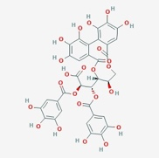
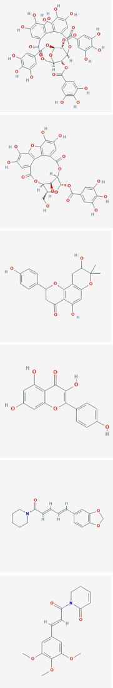
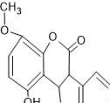
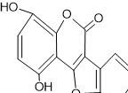
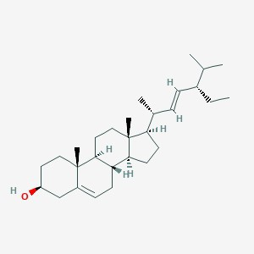
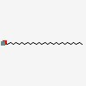

6. | Punigluconin | 21637585 | Phyllanthus emblica | Anti-viral
7. | Punicafolin | 5320800 | Phyllanthus emblica | Anti-viral
8. | Phyllanemblinin A | 3084341 | Phyllanthus emblica | Anti-pyretic
9. | Flavonoid | 44257868 | Phyllanthus emblica | Anti-viral
10. | Kaempferol | 102004842 | Phyllanthus emblica | Anti-viral
11. | Piperine | 638024 | Piper longum | Anti-viral
12. | Piper longumine | 637858 | Piper longum | Anti-cancer and Anti-inflamatory
13. | Weddolactone | chemsketch | Eclipta prostrata | Inhibit protease activity as well as the activity of phospholipase A2
14. | Desmethylweddolactone | chemsketch | Eclipta prostrata | Inhibit protease activity as well as the activity of phospholipase  A2
15. | Stigmasterol | 5280794 | Eclipta prostrata | antitumor, hypoglycaemic, antimutagenic, antioxidant, and anti-  inflammatory
16. | Heptacosanol | 74822 | Eclipta prostrata | Anti-microbes

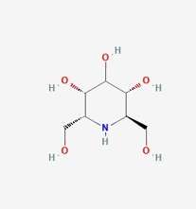
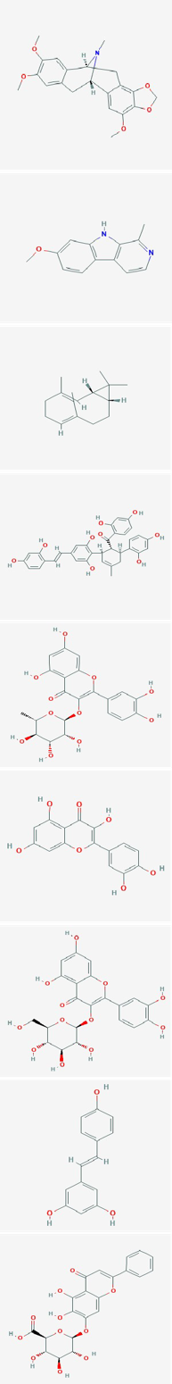

17. | Hentriacontanol | 74822 | Eclipta prostrata | Anti-microbes, and Antidiabetic
18. | Homonojirimycin | 159496 | Omphalea diandra | Anti-HSV
19. | Thalimonine | 10893946 | Thalictrum simplex L. | Anti-influenza
20. | Harmine | 5280953 | Peganum harmala | Inhibition of viral entry
21. | Bicyclogermacrene | 13894537 | Glechonm arifolia | Inhibition of viral attachment
22. | Kuwanon x | 14334306 | Morus alba | Inhibition of early stage of viral infection
23. | Quercitrin | 5280459 | Houttuynia cordata | Inhibition of viral entry and binding
24. | Quercitin | 5280343 | Houttuynia cordata | Inhibition of viral entry and binding
25. | Isoquercitrin | 5280804 | Houttuynia cordata | Inhibition of viral entry and binding
26. | Resveratrol | 445154 | Veratum grandiflorum | Inhibition of viral replication
27. | Baicalin | 64982 | Scutellaria baicalensis | Anti-HIV

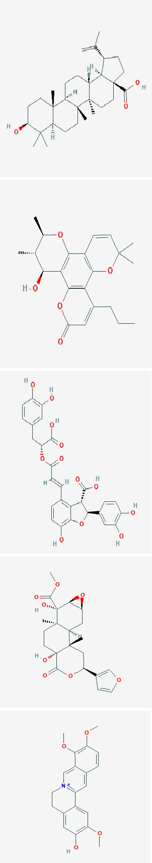
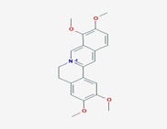
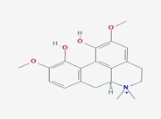
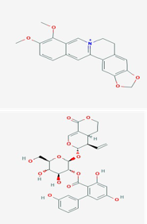
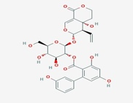
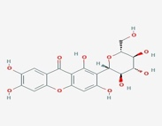
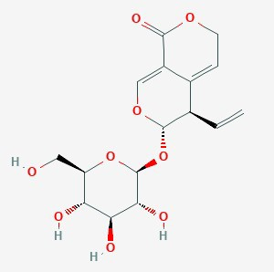

28. | Betulinic acid | 64971 | Symplocosrac emosa | Anti-HIV
29. | Calanolide A | 64972 | Calophyllum Spp. | Anti-HIV
30. | Lithospermic Acid | 6441498 | Salvia miltiorrhiza | Anti-HIV
31. | Tinosoprin A | 122206355 | Tinospora cordifolia | Anti-HIV
32. | Jatrorrhizine | 72323 | Tinospora cordifolia | Anti- inflammatory effect, Anti microbial and  anti fungal
33. | Palmatine | 19009 | Tinospora cordifolia | Inhibitor of West Nile virus
34. | Magnoflorine | 73337 | Tinospora cordifolia | Anti-viral
35. | Berberine | 2353 | Tinospora cordifolia | Anti-influenza
36. | Amarogentin | 115149 | Swertia chirata | Anticancer, Anti- Infective, Anti- diabetic and anti- oxidative
37. | Amaroswerin | 45359883 | Swertia chirata | Anti-inflamatory and anti- gastrointestinal disease
38. | Mangiferin | 5281647 | Swertia chirata | Antioxidative, Antiaging, Antitumor, Antibacterial,  and Antiviral
39. | Gentiopicrin | 88708 | Swertia chirata | Anti- gastrointestinal disease

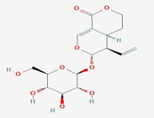
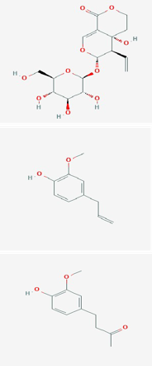
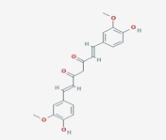
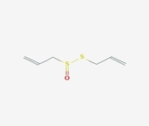
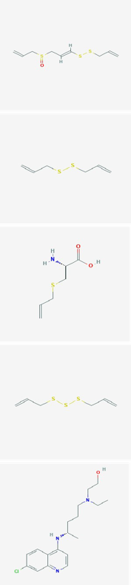
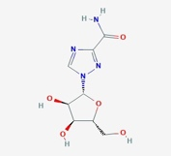

40. | Sweroside | 161036 | Swertia chirata | Anti-fungal, Anti-diabetic, Anti- inflammatory
41. | Swertiamarin | 442435 | Swertia chirata | Anti-HBV
42. | Eugenol | 3314 | Eugenia Carophyllous | Anti-viral
43. | Zingerone | 31211 | Zingiber officinale | Anti-viral
44. | Curcumin | 969516 | Curcuma longa | Antiviral
45. | Allicin | 65036 | Allium sativum L | Anti-viral
46. | Ajoene | 5386591 | Allium sativum L | Anti-virus
47. | Diallyl disulfide(DDS) | 16590 | Allium sativum L | Anti-infectious bronchitis virus
48. | S-Allyl-L-cysteine | 9793905 | Allium sativum L | Anti-infectious bronchitis virus
49. | Diallyltrisulfide (DTS) | 16315 | Allium sativum L | Anti-infectious bronchitis virus
50. | Hydroxychloroquine | 178396 | Malaria drug | Anti-malaria
51. | Ribavirin | 37542 | HIV drug | Anti-HIV

