Supplementary Information
Extracellular Matrix-Liposomes: A Novel Vehicle for Tissue Regenerative Wound Healing
Keel Yong Lee^{1,2, †}, Huong Thanh Nguyen^{1, †}, Agustina Setiawati^{1,3}, So-Jung Nam¹, Minyoung Kim¹, Il-Gyu Ko⁴, Won Hee Jung⁵, Kevin K. Parker²*, Chang-Ju Kim^{4 ,}* and Kwanwoo Shin^{1,2,}*
¹Department of Chemistry and Institute of Biological Interfaces, Sogang University, Seoul 04107, Republic of Korea
²Disease Biophysics Group, John A. Paulson School of Engineering and Applied Sciences, Harvard University, Cambridge 02138, USA
³Department of Life Science, Sogang University, Republic of Korea
⁴Department of Physiology, College of Medicine, Kyung Hee University, Seoul 02447, Republic of Korea
⁵Department of Systems Biotechnology, Chung-Ang University, Anseong, 17546, Republic of Korea

Contents:

Supplementary figures:
Fig. S1 | FN bound selectively to DOPS containing the Ld phase in GUVs.
Fig. S2 | Size distribution of SUVs (black) and FN-SUVs (green) after incubation, as measured by using the dynamic light scattering (DLS) method (n = 3).
Fig. S3 | Denaturation of FN by using various concentrations of GdnHCl measured by using FRET.
Fig. S4 | Coating of FN on the surface of a vesicle prevents the binding of S. aureus.
Fig. S5 | Growth of the fibril matrix from the delivered FN-SUVs on HDFn cells.
Fig. S6 | WST-based proliferation assay against HDFn cells with different sizes of SUVs.
Fig. S7 | Induction of UC by using acetic acid and intracolonic injection of treatments on rats.
Fig. S8 | Expression levels of inflammation indicators, including IL-1β (a), TNF-α (b), and IL-6 (c), in rats after treatments (n = 6 per group).

Supplementary videos:
Videos S1-3. Binding of S. aureus on the surface of a lipid: only GUVs, COL-GUVs or FN-GUVs. Supplementary for Fig. S3.
Video S4. Real-time imaging of the growth of the FN matrix (either red- or green-labeled) on HDFn cells. Supplementary for Fig. 2e.
Videos S5-7. Recordings of the motions and distances moved of HDFn cells in the untreated, FN-treated, and FN-SUV-treated groups. Supplementary for Fig. 3a.
Videos S8-10. Real-time imaging of gap closures in the untreated, FN-treated, and FN-SUV-treated groups during the in vitro scratch assays. Supplementary for Fig. 3c.
Video S11. Increase in the area of the growing FN matrix from an external FN-SUV on HDFn. Supplementary for Fig. S5.
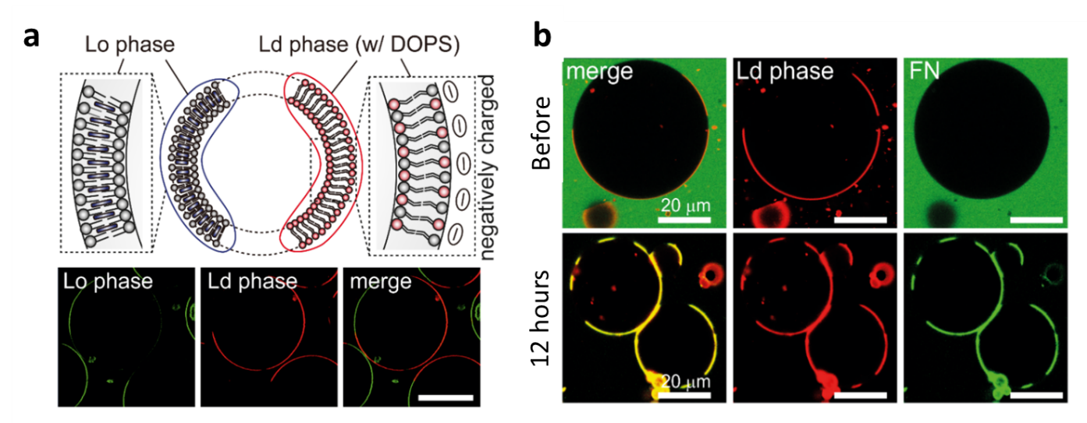
Fig. S1 | FN bound selectively to DOPS containing the L_{d} phase in GUVs. a, Schematic and confocal images of phase-separated GUVs having the Lo phase (green) and the L_{d} phase (red). DOPS is located primarily in the L_{d} phase. b, After 12 hours of incubation with FN, FN (green) was bound selectively to the membrane part of the L_{d} phase containing DOPS (red), while FN did not bind to the L_{o} phase blank (unlabeled).

Fig. S2 | Size distribution of SUVs (black) and FN-SUVs (green) after incubation, as measured by using the dynamic light scattering (DLS) method (n = 3).

Fig. S3 | Denaturation of FN by using various concentrations of GdnHCl, as measured by using FRET. The two peaks of each trace illustrate the intensity of the donor (shorter wavelength) and that of the acceptor (longer wavelength), as recorded by using spectrofluorometry.
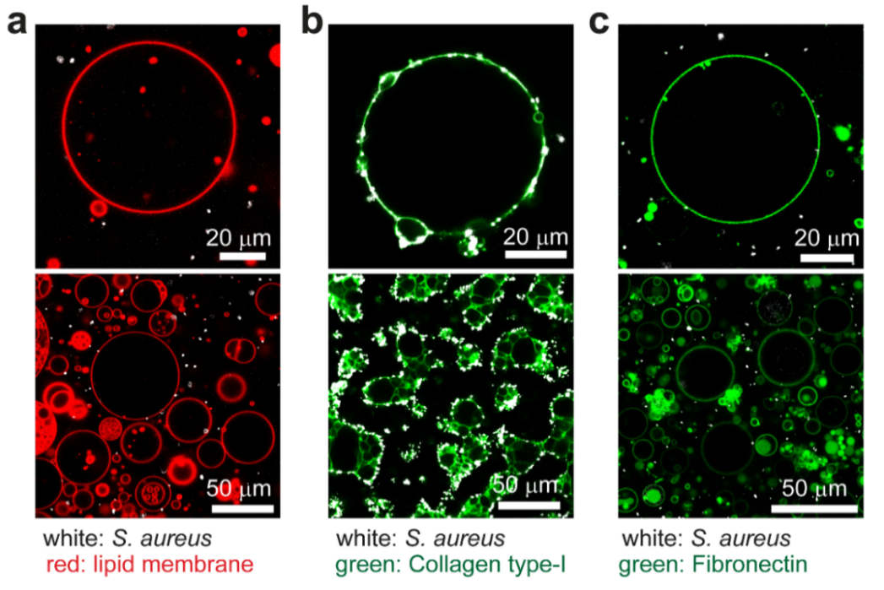

Fig. S4 | Coating of FN on the surface of the vesicle prevents the binding of S. aureus. a, Bare lipid vesicle (red). b, S. aureus (white) bound on the surface of a collagen-coated GUV (green). c, FN-coated vesicles (green) are, in contrast, unfavorable for the binding of S. aureus (white).

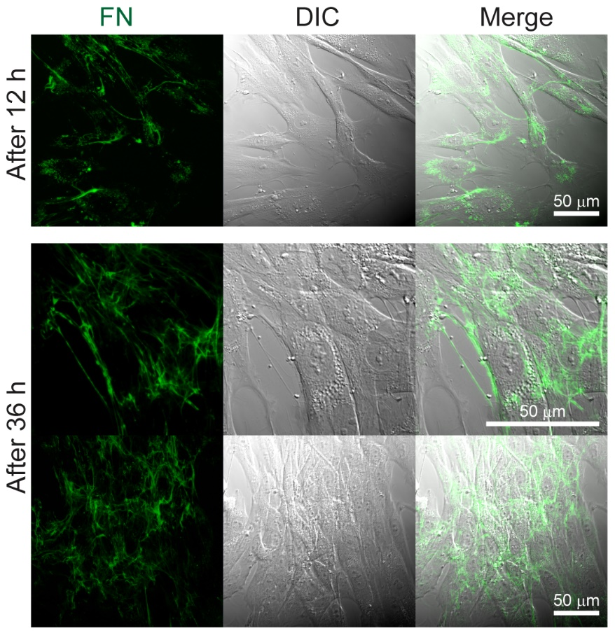
Fig. S5 | Growth of the fibril matrix from the delivered FN-SUVs on HDFn cells. Images at 12 h and 36 h after treatment show that external FN (green) was used to form the ECM matrix on HDFn cells (DIC).

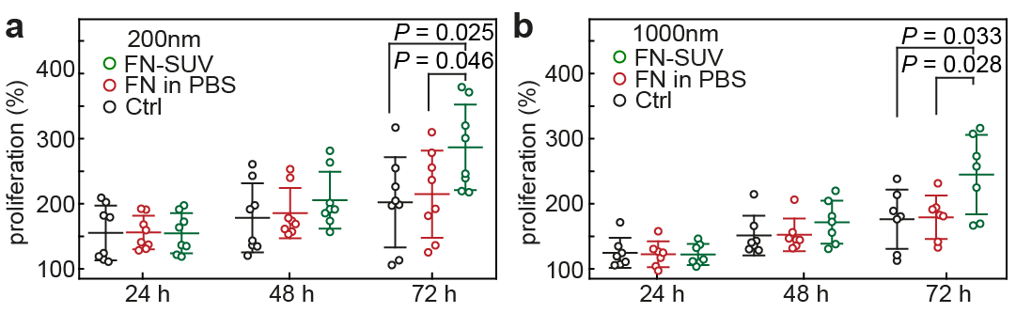
Fig. S6 | WST-based proliferation assay against HDFn cells with different sizes of SUVs. SUVs were filtered by using membranes with pore sizes of 200 nm (a) and 1000 nm (b) before being coated with FN and delivered to cells. WST was carried out every 24 h after the treatment.

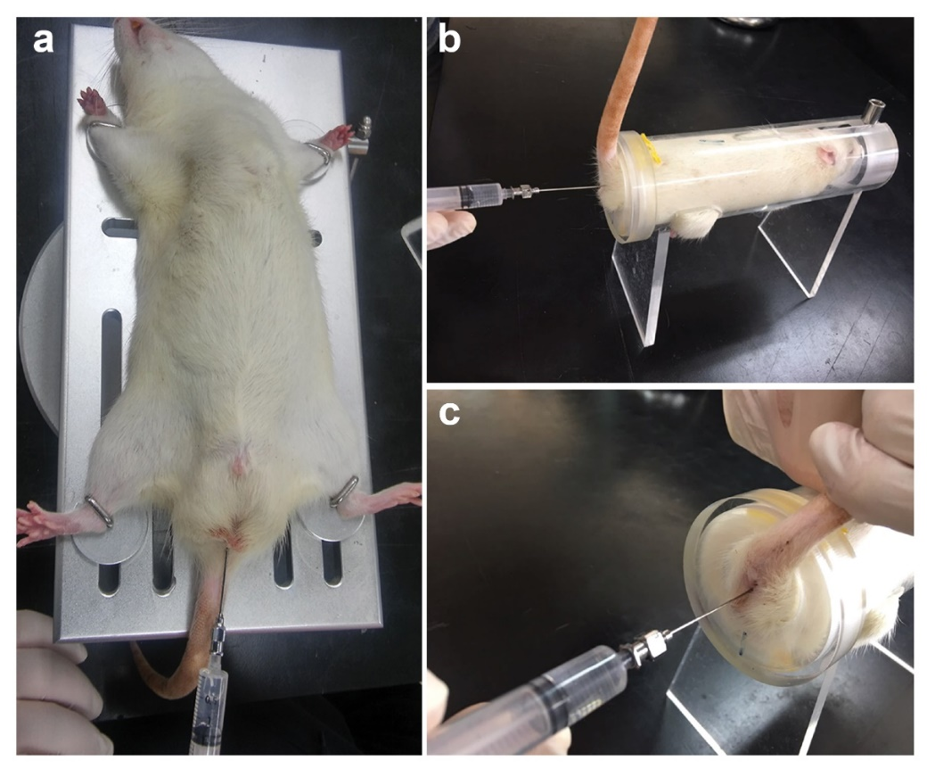

Fig. S7 | Induction of UC by using acetic acid and intracolonic injection of treatments in rats. a, A rat was maintained in a supine Trendelenburg position to prevent leakage of the liquids. b, Acetic acid was injected by using a stainless-steel needle through the anus to induce UC. c, Injection of FN-SUVs and other solutions for treatment was carried out in the same way three days after UC induction.

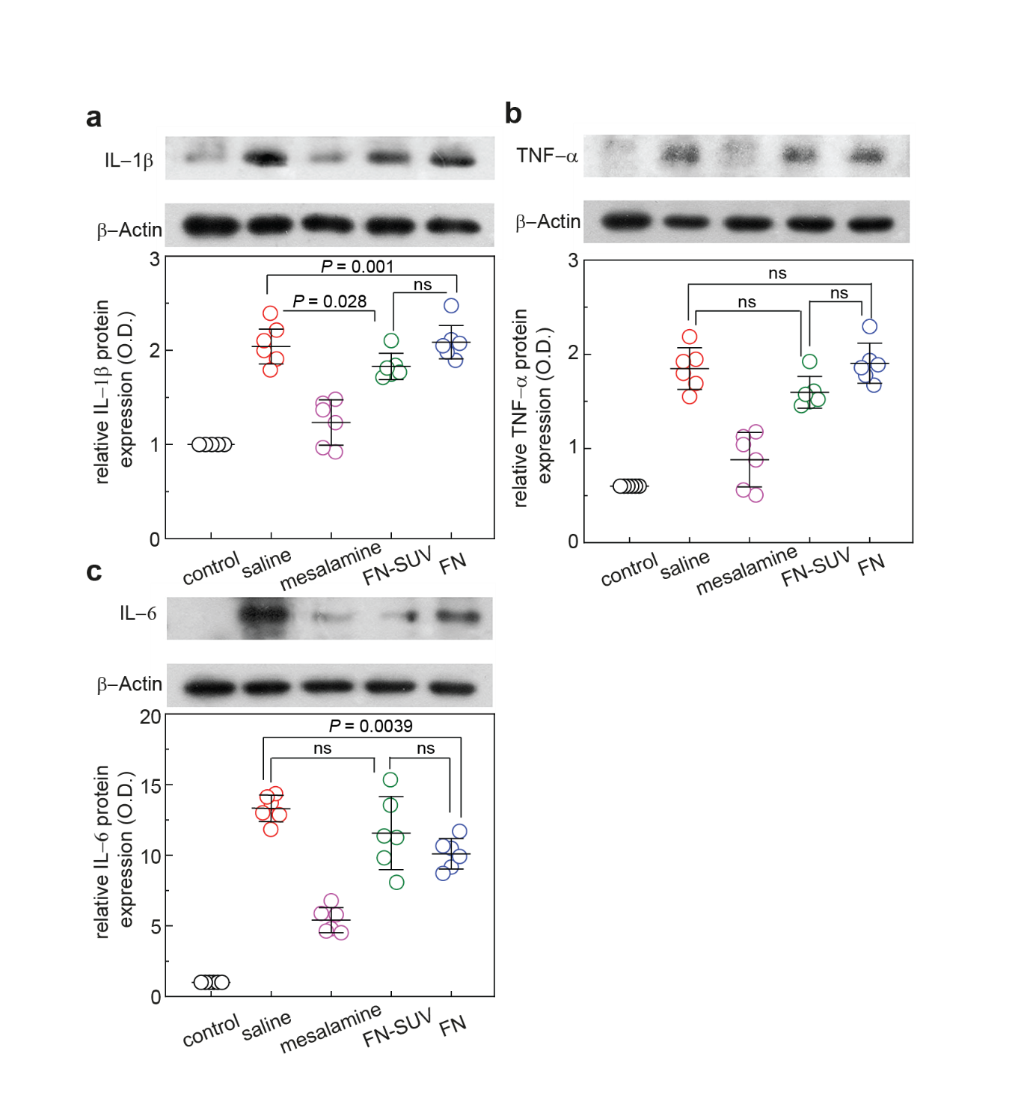
Fig. S8 | Expression levels of inflammation indicators, including IL-1β (a), TNF-α (b), and IL-6 (c), in rats after treatments (n = 6 per group). -actin was used as the control. P values were calculated by using one-way ANOVA.
Supplementary method
Preparation of phase-separated giant unilamellar vesicles (GUVs)
GUVs were prepared from a 1-mg/ml solution of lipids in chloroform, with a 2:2:1 ratio of DOPC:SM:cholesterol (Avanti), incorporating 0.5 mol% TopFluor-Cholesterol and 0.5 mol% Liss-Rho-PE. The lipid mixture (50 µl) was coated on the ITO conductive side of an ITO-coated slide and then evaporated onto a 9-cm² area on the conductive side of each of two ITO-coated slides and dehydrated under vacuum for 1 h. After dehydration, electroformation chambers were constructed by using a homemade silicon spacer between two lipid-coated coverslips. The lipids were rehydrated with 0.3 M sucrose and 2 mM Tris-HCl, pH 7.4, and a 10-Hz sine wave of 1.2 V was applied across the chamber at 55°C for 4 h by using a function generator. The function generator was used to apply a 4-Hz square wave of 2 V across the chamber for 1 h to detach the GUVs from the slides. GUVs were then harvested using a wide-bore pipette tip and diluted in a resuspension buffer (0.3 M glucose, 2 mM MES, pH 4.2 or 0.3 M glucose, 2 mM Tris-HCl MES, pH 7.4). The samples were incubated at 37°C to incorporate FN with GUVs.
Cell proliferation (WST) assay
Cells were cultured in DMEM, and 100 μl of the culture was seeded into each well of a 96-well plate at a density of 5 x 10³ cells/well. Seeded cells were placed in an incubator and allowed to attach to the bottom of the dish for 12 h. Next, the medium was removed by suctioning and replaced with FN-SUV-containing medium at a concentration of 20 μg/ml. The FN-SUV-containing medium was changed every 24 h. At specific time points, the medium was removed by suctioning, and the WST reagent-containing medium was assayed following the manufacturer’s instructions. The absorbance of light at a wavelength of 450 nm by the product was measured using a plate-reader spectrometer. For relative quantification, the results in the control group were set as 1.00. The results are expressed as the means ± standard errors of the mean, and significance was set at P < 0.05.
Western blotting
Colon tissues were homogenized on ice, lysed with lysis buffer, and then centrifuged at 14,000 rpm for 30 min. Using the Bio-Rad colorimetric protein assay kit (Bio-Rad), the amount of protein in each sample was measured. Protein (30 μg) was separated by sodium dodecyl sulfate-polyacrylamide gel electrophoresis, and then, the protein was transferred to a nitrocellulose membrane. The primary antibodies used in this experiment were rabbit IL-1β antibody (1:1000; Santa Cruz Biotechnology, Santa Cruz, CA, USA), goat IL-6 antibody (1:1000; Santa Cruz Biotechnology), and goat TNF-α antibody (1:1000; Santa Cruz Biotechnology). Horseradish peroxidase-conjugated anti-mouse antibody (1:2000; Vector Laboratories, Burlingame, CA, USA) for β-actin, anti-rabbit antibody (1:3000; Vector Laboratories) for IL-1β, anti-goat antibody (1:2000; Vector Laboratories) for IL-6, and TNF-α were used as the secondary antibodies. Membrane transfer was conducted at 4°C using a cold pack and precooled buffer. Band detection was performed with the enhanced chemiluminescence (ECL) detection kit (Santa Cruz Biotechnology), and the detected bands were analyzed using Molecular Analyst™ (version 1.4.1, Bio-Rad).
S. aureus binding experiments
Staphylococcus aureus were culture in tryptic soy broth in a shaking incubator at 37°C. Giant unilamellar vesicles (GUVs), FN-GUVs and COL-GUVs were prepared as above. To investigate interaction between S. aureus and ECM-binding GUVs, S. aureus were suspended in a solution (0.3 M sucrose and 2 mM Tris-HCl, pH 7.4) containing GUVs or ECM-GUVs for 6 hours at 37°C. To enable the visualization of S. aureus, we treated the bacteria with Calcofluor-white (Sigma Chemical Co., St. Louis, MO, USA).

