Supporting Information
Antifreezing ionotronic skin based on flexible, transparent, and tunable ionic conductive nanocellulose hydrogels
Enwen Zhu^{a,b}, Haiyu Xu^{b}, Yuanyuan Xie^{b}, Yiheng Song^{b}, Dongning Liu^{b}, Yujiao Gao^{b}, Zhuqun Shi^{a,b*}, Quanling Yang^{b*}, Chuanxi Xiong^{b}
ª School of Chemistry, Chemical Engineering and Life Sciences, Wuhan University of Technology, Wuhan 430070, China
^{b} School of Materials Science and Engineering, Wuhan University of Technology, Wuhan 430070, China
*Corresponding author. E-mail: zqshi2016@whut.edu.cn (Z. Shi), yangql@whut.edu.c n (Q. Yang)

Table S1. Mechanical properties of the hydrogels of H⁺-TOCN, 4Li⁺-TOCN, 4Ca²⁺-TOCN, 4K⁺-TOCN.
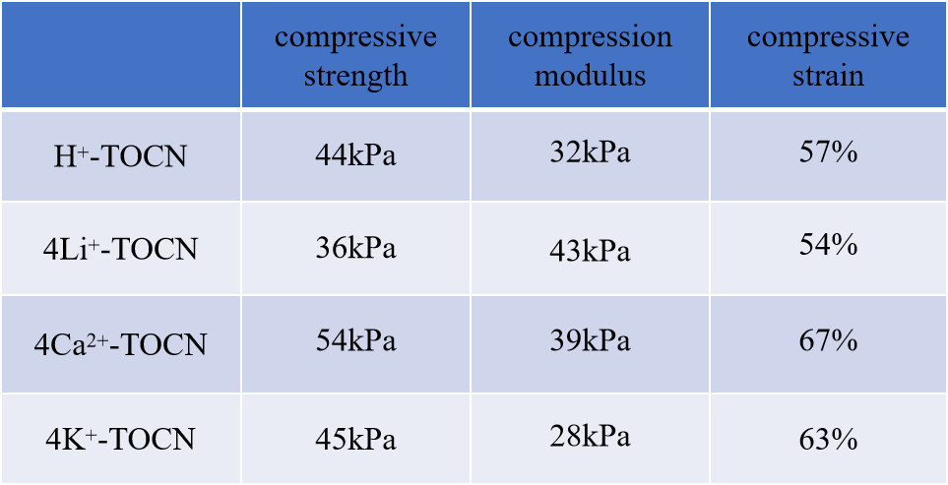

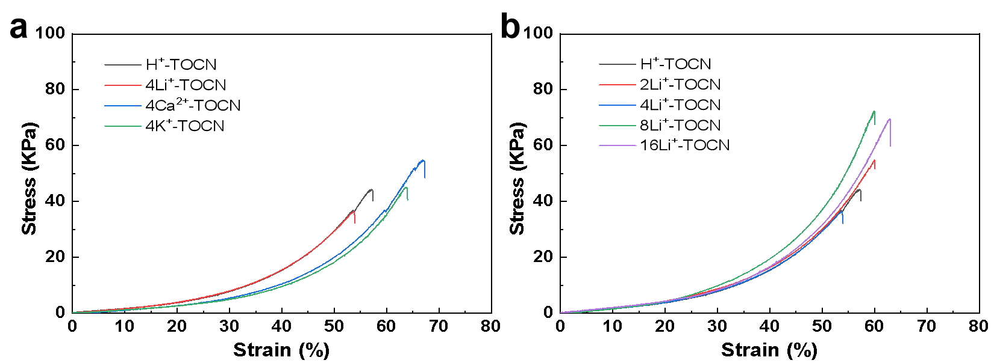
Fig. S1. Compressive stress-strain curves of (a) H⁺-TOCN, 4Li⁺-TOCN, 4Ca²⁺-TOCN, and 4K⁺-TOCN hydrogels; (b) Li⁺-TOCN hydrogels with different Li⁺ concentrations.

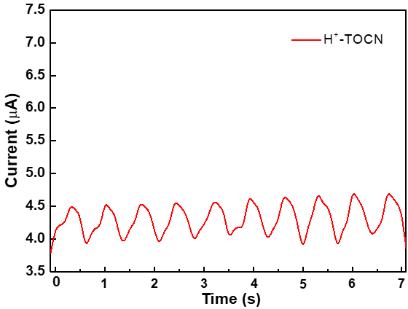
Fig. S2. Sensing properties of H⁺-TOCN hydrogel.

