Supplementary Materials：

Supporting Online Material for
Breaking a Single Chemical Bond with Mechanical Forces
Authors: Pengcheng Chen,^{1,†} Dingxin Fan,^{2,†} Yunlong Zhang,^{3,*} Annabella Selloni,⁴ Emily A. Carter,^{5,6} Craig B. Arnold,^{1,5} David C. Dankworth,³ Steven P. Rucker,³ James. R. Chelikowsky,^{*,2,7,8} and Nan Yao^{1,*}

Affiliations:
- Princeton Institute for the Science and Technology of Materials, Princeton University, Princeton, New Jersey, 08540-8211, USA
- McKetta Department of Chemical Engineering, The University of Texas at Austin, Austin, Texas 78712-1589, USA
- ExxonMobil Research and Engineering Company, 1545 Route 22 E., Annandale, New Jersey, 08801-3096, USA
- Department of Chemistry, Princeton University, Princeton, New Jersey, 08544-0001, USA
- Department of Mechanical and Aerospace Engineering, Princeton University, Princeton, New Jersey, 08544-5263, USA
- Office of the Chancellor and Department of Chemical and Biomolecular Engineering, University of California, Los Angeles, Los Angeles, CA 90095-1405, USA
- Department of Physics, University of Texas at Austin, Austin, TX 78712-1192
- Center for Computational Materials, Oden Institute for Computational Engineering and Sciences, University of Texas at Austin, Austin, TX 78712-1229

† These authors contribute equally
* To whom correspondence should be addressed: E-mail: nyao@princeton.edu; yunlong.zhang@exxonmobil.com; jrc@utexas.edu

Force Calculation
We model the CO-FePc complex, the probe tips and the Cu(111) substrate explicitly and employ an ab initio real-space, pseudopotential density functional theory (DFT) code, PARSEC¹, to compute interatomic forces. The net force acting on atom $a$, ${\vec{F}}_{net, a}$, is calculated by applying the Hellmann-Feynman theorem^{2,3} to the total ground state energy:
$${\vec{F}}_{net,a}=-\int{ρ(\vec{r}})\frac{∂V_{loc}^{a}\left(\vec{r}-{\vec{R}}_{a}\right)}{∂{\vec{R}}_{a}}dr- 2\sum_{lm,n}{<ϕ_{lm}^{a}\left|V_{l}-V_{loc}\right|ϕ_{lm}^{a}>}\frac{∂G_{lm}^{a,n}}{∂{\vec{R}}_{a}}-\frac{∂E_{i-i}}{∂{\vec{R}}_{a}} (1)$$
In Eq. (1), the first term⁴ is the local force component, where $ρ(\vec{r})$ is the valence charge density, ${\vec{R}}_{a}$ is the position of atom $a$, $V_{loc}^{a}\left(\vec{r}-{\vec{R}}_{a}\right)$ is the local pseudopotential component of atom $a$. The second term⁵ is the nonlocal force component, $ϕ_{lm}^{a}$ is the $l$th radial atomic pseudo-wavefunction multiplied by the $lm$th spherical harmonic,$V_{l}-V_{loc}$ is the difference between the $l$th component of the ionic pseudopotential and the local ionic potential, $G_{lm}^{a,n}$ is the projection coefficient with the index $n$ running over all occupied electronic states. The third term is the ion-ion force component, where $E_{i-i}$ is the ion-ion interaction energy.

Structural Relaxation
We use the extended limited memory Broyden-Fletcher-Goldfarb-Shanno algorithm⁶ for all structural relaxations. See Fig. S1 for details of the relaxed geometries.
(1) CO-FePc complex without a Cu(111) substrate
First, we model the CO-FePc complex in the gas phase without the presence of a copper substrate. We employ a cluster boundary condition that assumes that the electron wave functions are zero outside a spherical domain. We set the boundary sphere radius to 1100 pm. All atoms in the system are relaxed. The Fe-C bond length equals 168 pm in the final relaxed structure.

(2) CO-FePc and FePc complex on a Cu(111) substrate
Next, we model the CO-FePc complex on the copper substrate by placing the optimized geometries of CO-FePc complex on the surface. We model the substrate by a 4-layer 8x10 Cu(111) surface and place the CO-FePc (or FePc) complex at a bridge site. We employ an orthorhombic unit cell where a = 2042 pm, b = 2211 pm. We use a 2D slab boundary condition which assumes the system to be periodic along the x and y directions. We perform the calculations at the Γ point as the system is sufficiently large to obtain a reliable density from this point. We set the slab width to 2160 pm and fix the bottom 2 layers of the substrate during the relaxation. The Fe-C bond length increased from 168 pm to 175 pm in the final relaxed structure of CO-FePc. Furthermore, the distances between the center Fe atom and the middle of the two bridge Cu atoms decreased by ~ 30 pm upon CO removal.

(3) Probe tips with CO-FePc complex on a Cu(111) substrate
Lastly, we model the interactions between different probe tips and the CO-FePc complex on the substrate by including the tips on top of the previously optimized geometries. Here, we still use a 2D slab boundary condition and set the slab width to 2670 pm. Some groups model the probe tip as a combination of a metal cluster with an apex functionalized tip⁷⁻⁹, we obtain accurate images without including the metal cluster^{10,11} . Moreover, we find that including the Cu cluster has a negligible effect on the curvatures of interaction energy as a function of tip-sample distance¹¹.
(3.1) Cu tip
We model the Cu tip first because there are less variables involved in terms of modelling compared with the CO tip. In the presence of the Cu tip, we relax the system again including a previously optimized Cu₂ cluster on top of the complex. In our optimized model structure, Fe, C, O and two Cu atoms are lined vertically along the center axis of the molecule.
(3.2) CO tip
To model a CO-functionalized tip, we use a previously optimized Cu-CO cluster. A direct calculation of the rupture force is difficult as the position of the tip relative to the CO-FePc complex is unknown in the three-dimensional space, i.e., the x, y, z coordinates are also variables and more than one solution are possible for a given rupture force. To estimate the forces, we first optimize the vertically aligned tip-sample-substrate system with the tip above the center Fe atom. However, we find that the dative bond cannot be ruptured by varying the tip height in this vertically alighted geometry. Next, we break the symmetry by displacing the tip horizontally by a small displacement (~135 pm) from the equilibrium position and then adjust the tilting angles of the two COs so that the O-O distance (~250 pm) is kept constant. This allows for the existence of lateral forces. We then perform structural relaxation again. Once the new equilibrium structure is obtained, we compute the spatial distribution of the forces by manually displacing the CO tip to different sites while keeping all atomic positions fixed. Note that, the O-O distance is no more constant in the calculations of the force distribution. We expect the forces may be overestimated as the tip moves further away from the equilibrium position because of the fixed positions.
Image Simulations
We employ a frozen density embedding theory (FDET) based method for image simulations. Details about FDET and previous applications can be found in Ref (10-11). In addition, we apply a tip tilting correction¹² for the CO tip. Figure S2 shows the simulated nc-AFM images for CO-FePc (the first three rows) and FePc (the last row). The left column indicates the tip height, which is defined as the distance between the O atom of the CO tip and the averaged z-coordinates of the FePc complex (exclude the decorated CO). The top row shows the corresponding lateral spring constant, $k_{CO}$, of the CO tip where $a large value for k_{CO}$ corresponds to a rigid tip and a smaller value corresponds to a flexible tip. $k_{CO}$ is set to be 0.8 N/m for the simulated images in Figure 1. The tip heights are 554 pm and 300 pm in Figures 1 d and e, respectively. Before bond breaking, we can only see a bright circular spot in the middle of the molecule on the simulated image initially (554 pm). As we decrease the tip height, the FePc outline becomes slightly visible (400 pm, 430 pm). Meanwhile, the central “bright” spot becomes much larger and a dark circular region occurs in the middle as we decrease the lateral spring constant of the CO tip. This transition is in an excellent agreement with the experimental images in Figure 2 a (from +200 pm to +40 pm). After bond breaking, the cross-like structure with a four-fold symmetry can be clearly visualized on the simulated image. This reaches a good agreement with the experimental image in Figure 1 c.

Supplementary Figures
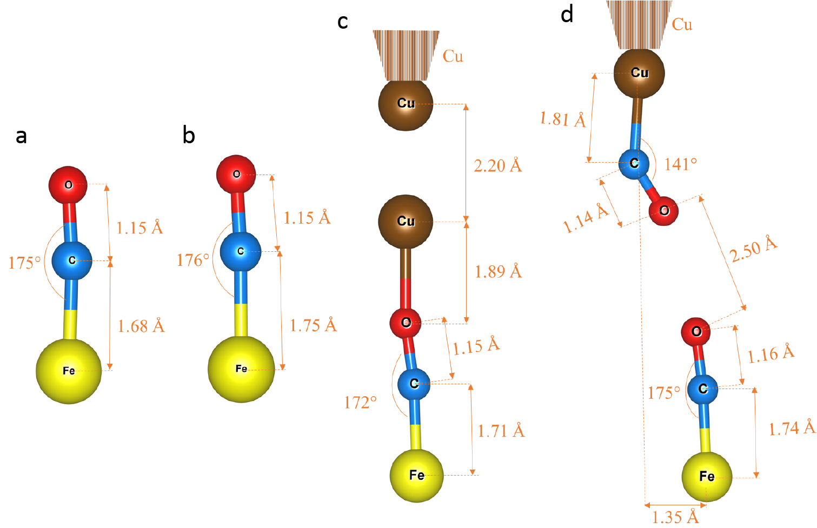
Fig S1. (Color online) Relaxed Geometries (only Fe, decorated CO, tips and tip apexes are shown). a CO-FePc. b CO-FePc + Cu(111) substrate. c Cu apex + Cu tip + CO-FePc + Cu(111) substrate. d Cu apex + CO tip + CO-FePc + Cu(111) substrate.
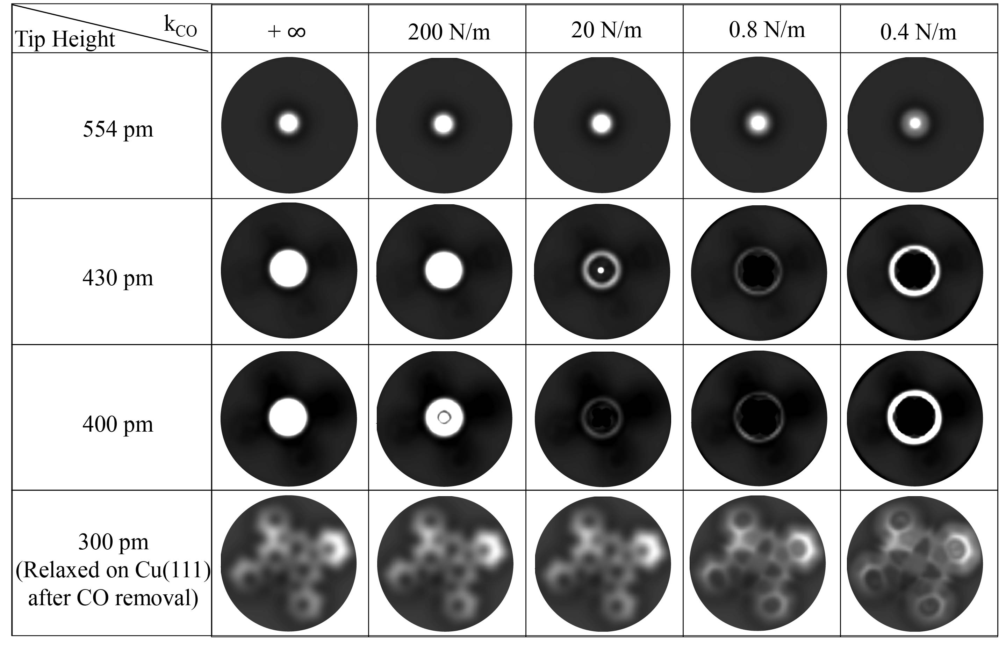
Fig S2. Simulated nc-AFM images. The left column indicates the tip height. The top row shows the corresponding lateral spring constant of CO tip.

References:
1. Perdew, J. P. & Wang, Y. Accurate and simple analytic representation of the electron-gas correlation energy. Phys. Rev. B 45, 13244–13249 (1992).
2. H. G. A. Hellman, Einührung in die Quantenchemie. Deuticke, Leipzig (1937).
3. R. P. Feynman, Forces in molecules, Phys. Rev. 56(4), 340-343 (1939).
4. L. Kronik, I. Vasiliev, M. Jain, J. R. Chelikowsky, Ab initio structures and polarizabilities of sodium clusters, J. Chem. Phys. 115, 4322 (2001).
5. X. Jing, N. Troullier, D. Dean, N. Binggeli, J. R. Chelikowsky, K. Wu, Y. Saad, Ab initio molecular-dynamics simulations of Si clusters using the higher-order finite-difference-pseudopotential method. Phys. Rev. B. 50, 12234(R) (1994).
6. J. L. Morales, J. Nocedal, L-BFGS-B: Remark on Algorithm 778: L-BFGS-B, FORTRAN routines for large scale bound constrained optimization. ACM Trans. Math. Softw. 38, 1-7 (2011).
7. P. Hapala, G. Kichin, C. Wagner, F. S. Tautz, R. Temirov, P. Jelinek, Mechanism of high-resolution STM/AFM imaging with functionalized tips. Phys. Rev. B. 90. 085421 (2014).
8. C.-S. Guo, M. A. Van Hove, R.-Q. Zhang, C. Minot, Prospects for resolving chemical structure by atomic force microscopy: a first-principles study†. Langmuir. 26(21), 16271-16277 (2010).
9. D. Fan, Y. Sakai, J. R. Chelikowsky, Discrimination of bond order in organic molecules using noncontact atomic force microscopy. Nano Lett. 19(8), 5562-5567 (2019).
10. T. A. Wesołowski, S. Shedge, X. Zhou, Frozen-density embedding strategy for multilevel simulations of electronic structure. Chem. Rev. 115, 5891−5928 (2015).
11. Fan, D., Sakai, Y. & Chelikowsky, J. R. Chemical and steric effects in simulating noncontact atomic force microscopy images of organic molecules on a Cu (111) substrate. Phys. Rev. Mater. 4, 53802 (2020).
12. C.-S. Guo, M. A. Van Hove, X. Ren, Y. Zhao, High-resolution model for noncontact atomic force microscopy with a flexible molecule on the tip apex. J. Phys. Chem. C. 119, 1483−1488 (2015).

