The original cell images of Fig. 2A
(a) Normal cell
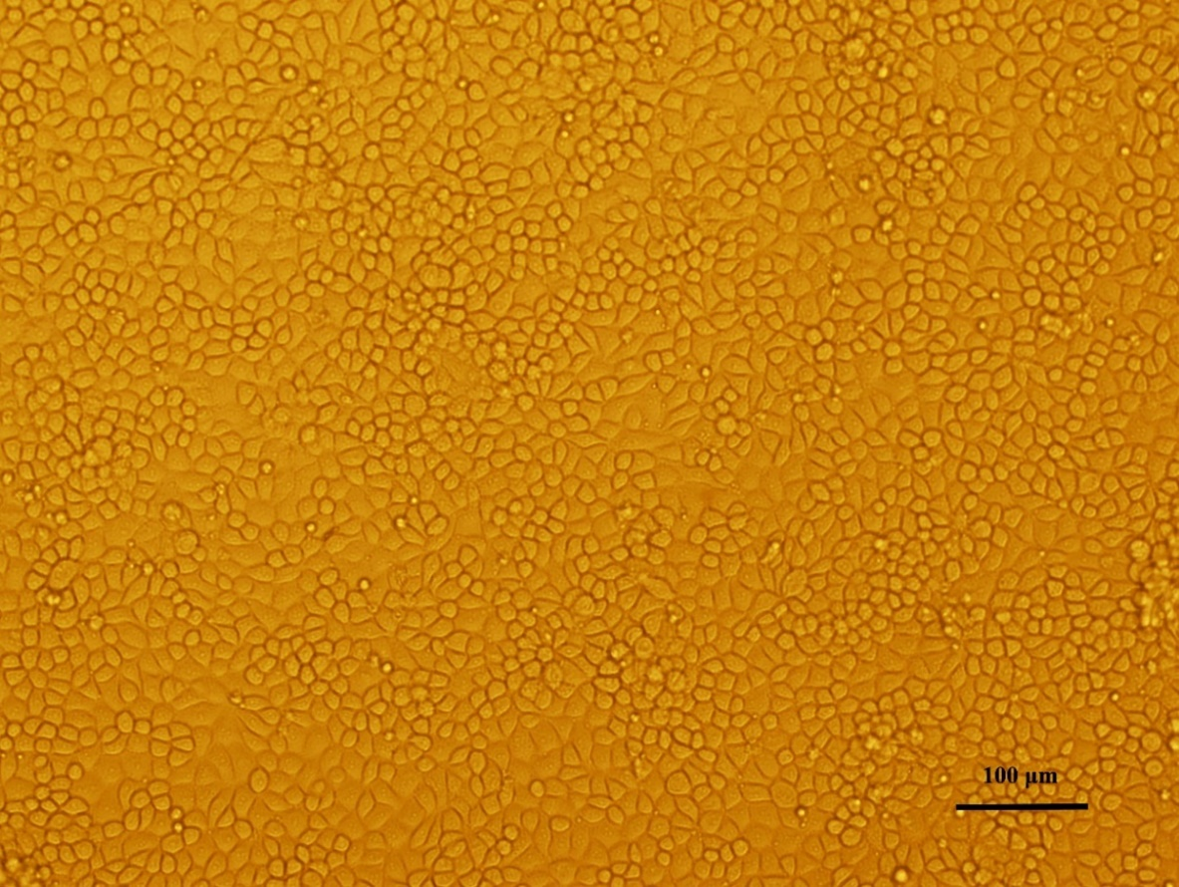
(b) Osthole 0.04 mg/mL
(c) Osthole 0.01 mg/mL
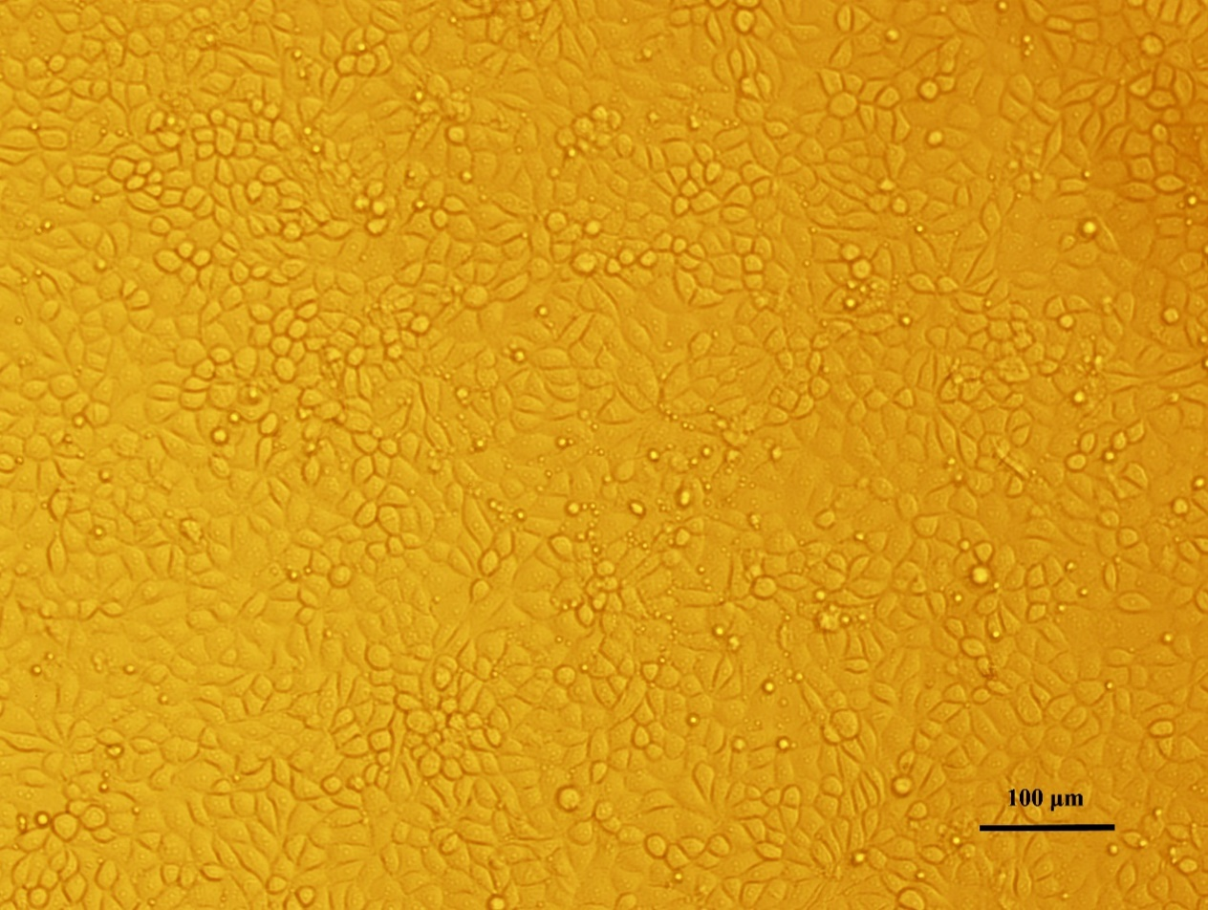
(d) Matrine 0.5 mg/mL + Osthole 0.01 mg/mL
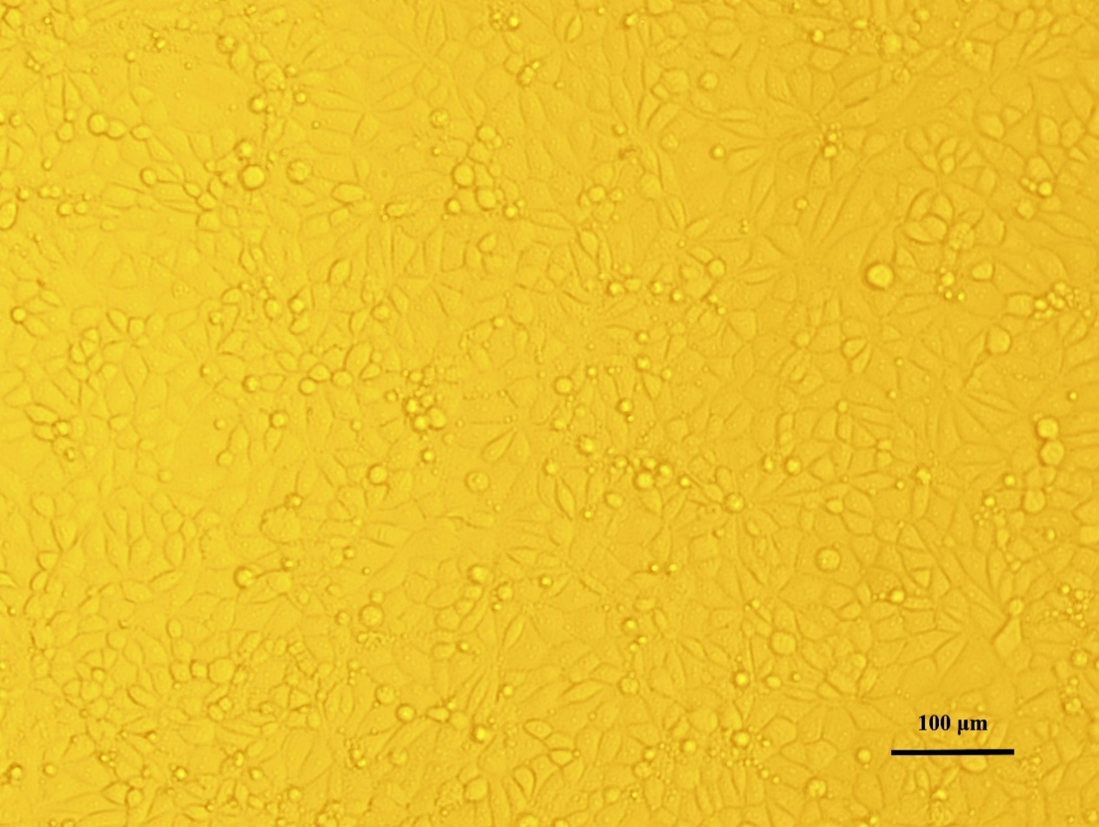
(e) Ribavirin 2 mg/mL
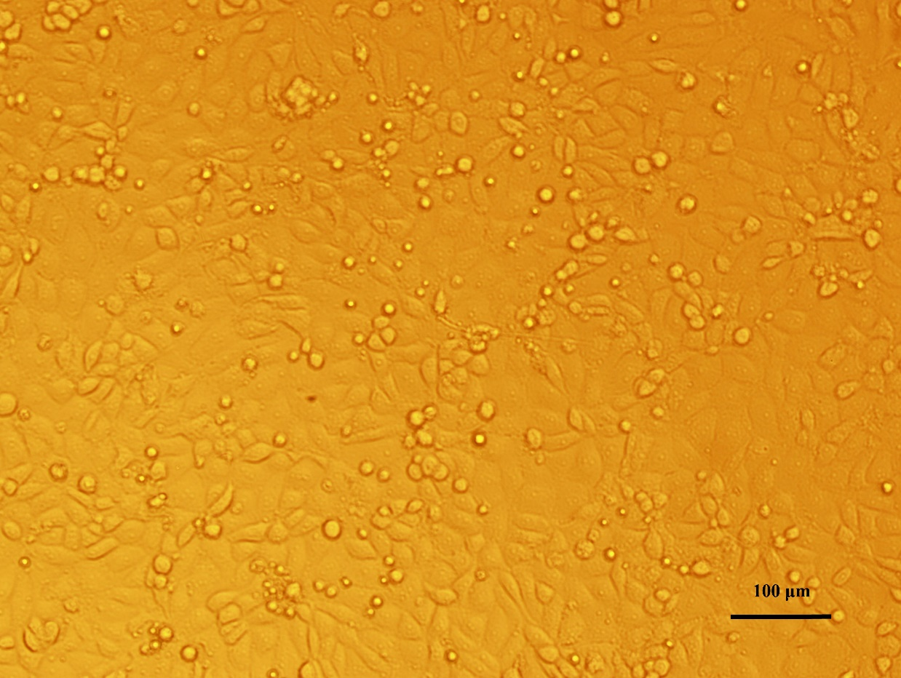
(f) Ribavirin 0.5 mg/mL
