Internal cross-linked polymeric nanoparticles with dual sensitivity for combination therapy of muscle-invasive bladder cancer
Guanchen Zhu^{1#}, KaikaiWang^{2#}, Haixiang Qin¹, Xiaozhi Zhao¹, Wei Chen¹, Linfeng Xu¹, Wenmin Cao¹, Hongqian Guo^{1*}
¹Department of Urology, Affiliated Drum Tower Hospital, Medical School of Nanjing University, Nanjing 210009, China.
²School of Pharmacy, Nantong University, Nantong 226001, China
# These authors contribute equally
*Corresponding author: dr.ghq@nju.edu.cn (Hongqian Guo)

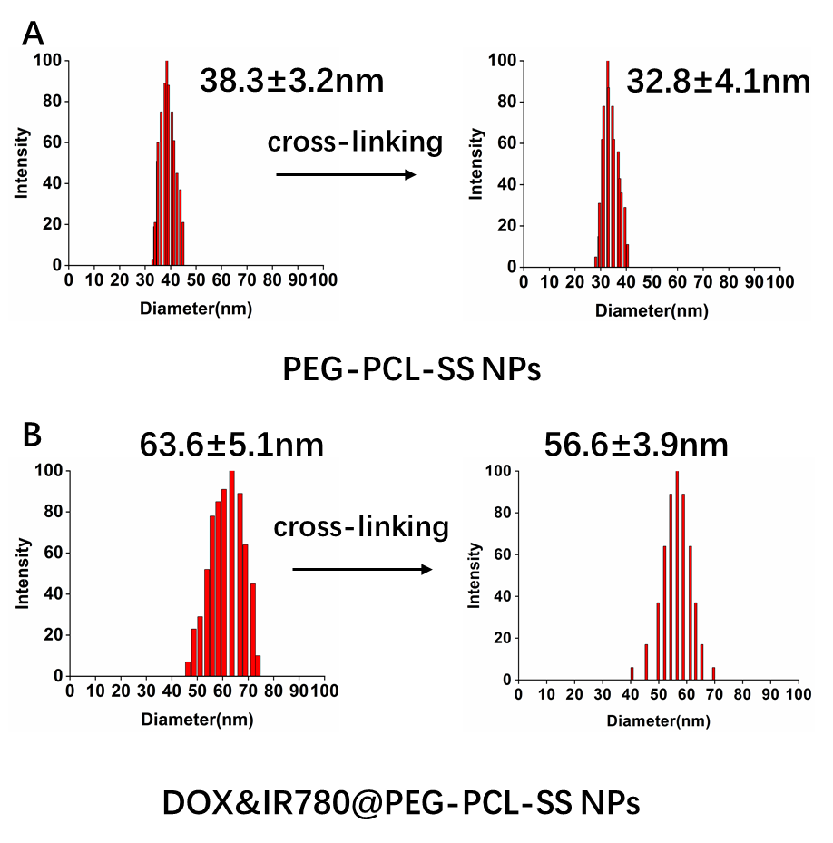
Figure S1. Size change of PEG-PCL-SS NPs, cross-linked PEG-PCL-SS NPs and drug-loaded PEG-PCL-SS NPs.
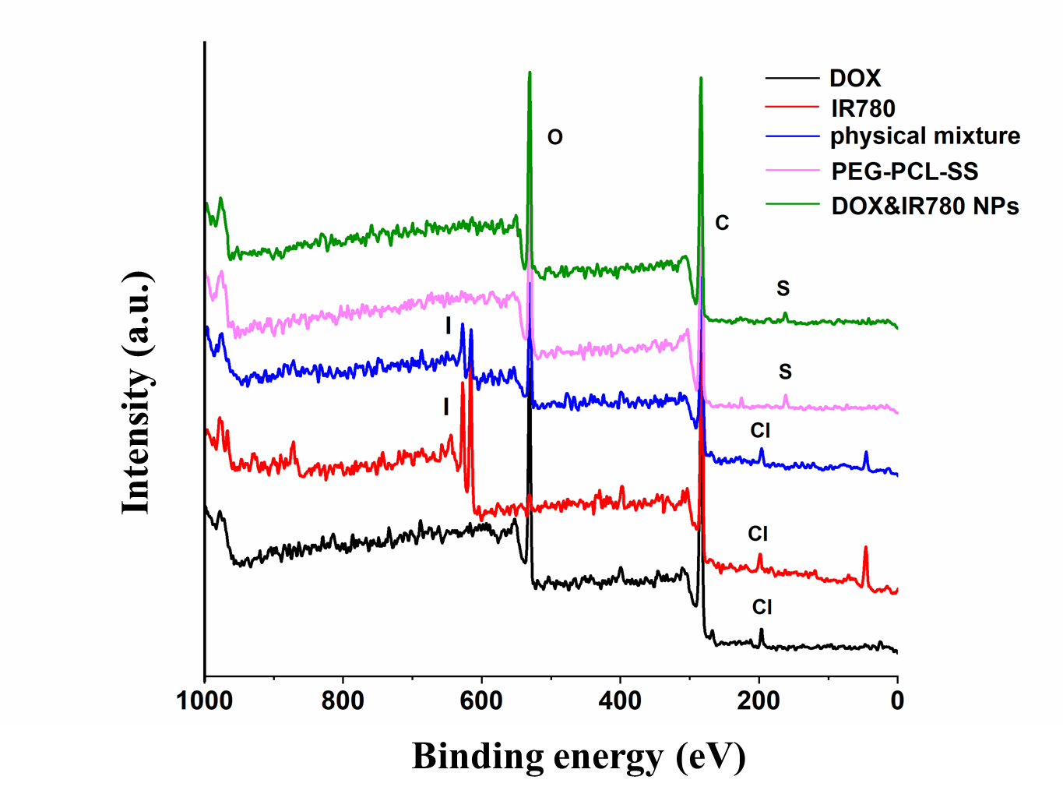
Figure S2. XPS spectra of five samples (free DOX, free IR780, physical mixture, PEG-PCL-SS and DOX&IR780@PEG-PCL-SS NPs).
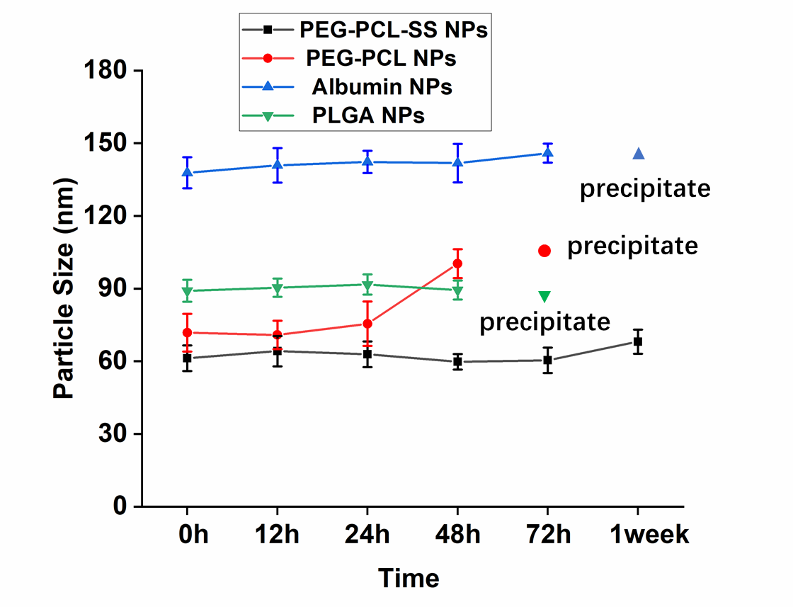
Figure S3. Particle size and stability of different nanoparticles. PEG-PCL NPs and PLGA NPs precipitated after 72 hours while Albumin NPs precipitated after one week.
Figure S4. Cell viability of IR780&DOX nanoparticles in bladder normal mucosa cells (SV-HUC-1).

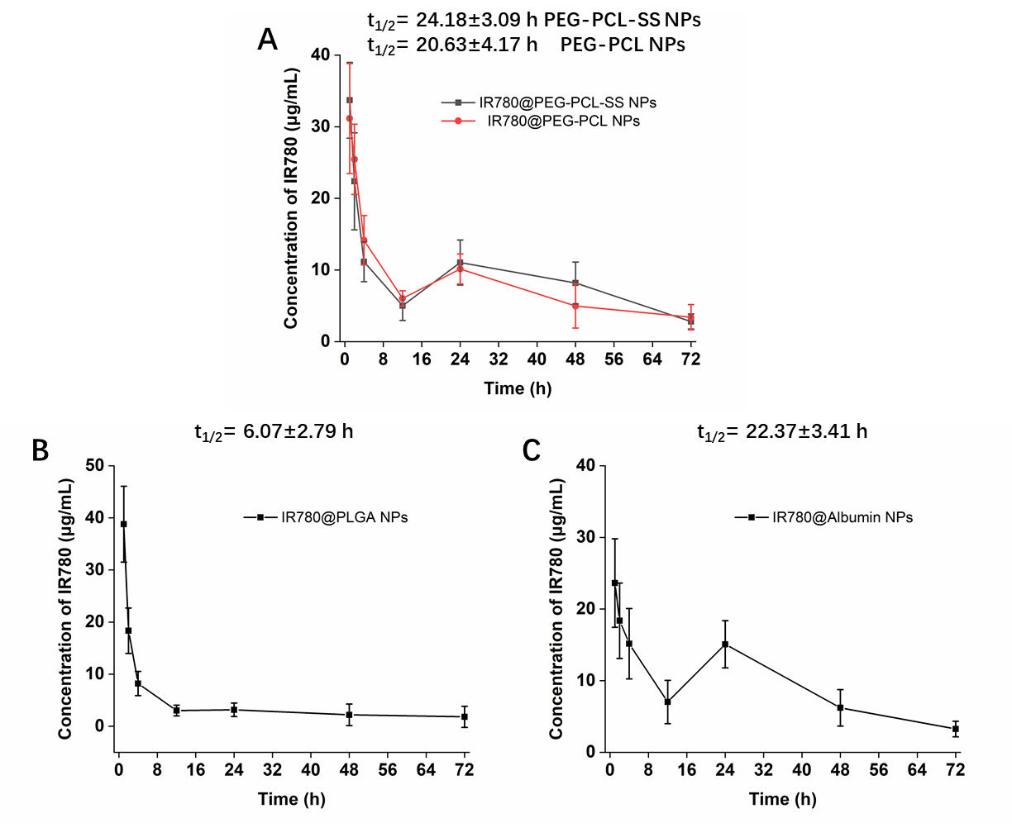
Figure S5. Pharmacokinetics of different carriers-based NPs in mice after intravenous injection determined based on IR780 absorption. A-C) Blood circulation curves of PEG-PCL-SS, PEG-PCL, Albumin and PLGA NPs at interval times (n=3). PK Solver Version 2.0, was used to calculate pharmacokinetic parameters [1].

Reference
[1] Zhang, Y., Huo, M., Zhou, J. & Xie, S. PKSolver: An add-in program for pharmacokinetic and pharmacodynamic data analysis in Microsoft Excel. Comput Methods Programs Biomed 99, 306-314 (2010).

