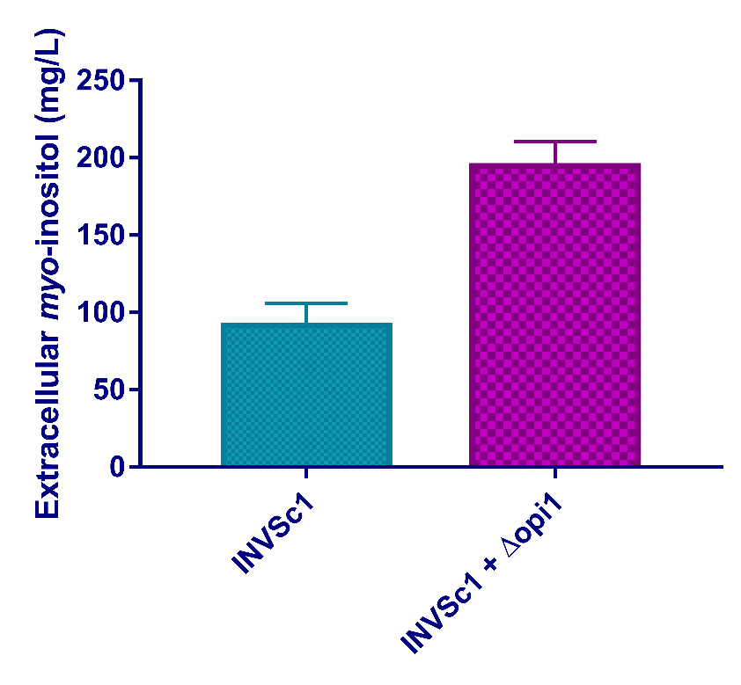
Fig. S8. Concentrations of myo-inositol produced by S. cerevisiae strains after 5 d fermentation on YPD medium. INVSc1 was the starting strain, and INVSc1 + Δopi1 the engineered S. cerevisiae whose opi1 was knocked out. Data shown here are average values of at least three biological replicates and error bars are standard deviations.

