Table S1 Effects of soil chemical properties of N and/or P addition in the subtropical evergreen broad-leaved forest. Values are means with standard errors (n=3)

Treatment | Chemical  properties | Sampling time
 |  | Apr.2018 | Jul.2018 | Oct.2018 | Jan.2019 | Apr.2019 | Jul.2019 | Oct.2019 | Jan.2020
Control treatment | SOC | 26.5 ± 0.18 | 26.7 ± 0.51 | 29.8 ± 0.40 | 27.8 ± 0.21 | 24.5 ± 0.55 | 24.5 ± 0.66 | 31.7 ± 0.36 | 28.7 ± 0.91
 | TN | 1.72 ± 0.11 | 1.59 ± 0.02 | 1.85 ± 0.18 | 1.66 ± 0.02 | 1.71 ± 0.12 | 1.71 ± 0.05 | 1.97 ± 0.11 | 1.78 ± 0.09
 | TP | 0.17 ± 0.004 | 0.19 ± 0.005 | 0.20 ± 0.006 | 0.15 ± 0.008 | 0.18 ± 0.019 | 0.17 ± 0.006 | 0.18 ± 0.010 | 0.16 ± 0.007
 | AP | 2.30 ± 0.23 | 2.36 ± 0.10 | 2.55 ± 0.12 | 2.36 ± 0.16 | 2.60 ± 0.12 | 3.11 ± 0.10 | 2.97 ± 0.26 | 2.84 ± 0.15
 | C:N ratio | 15.6 ± 0.92 | 16.8 ± 0.51 | 16.4 ± 1.88 | 16.7 ± 0.35 | 14.4 ± 0.98 | 14.3 ± 0.54 | 16.2 ± 0.84 | 16.2 ± 1.02
 | C:P ratio | 158 ± 4.87 | 141 ± 4.15 | 148 ± 4.38 | 183 ± 9.23 | 141 ± 17.0 | 145 ± 6.22 | 172 ± 10.5 | 178 ± 12.3
 | N:P ratio | 10.2 ± 0.61 | 8.36 ± 0.19 | 9.18 ± 0.90 | 10.9 ± 0.64 | 10.1 ± 1.97 | 10.2 ± 0.63 | 10.8 ± 1.19 | 11.1 ± 0.95
 | MBC | 387 ± 54.6 | 410 ± 19.2 | 323 ± 102 | 235 ± 28.5 | 300 ± 20.0 | 612 ± 53.5 | 552 ± 22.2 | 257 ± 36.6
 | pH | 4.30 ± 0.020 | 4.26 ± 0.018 | 4.34 ± 0.012 | 4.29 ± 0.019 | 4.35 ± 0.012 | 4.35 ± 0.007 | 4.39 ± 0.009 | 4.26 ± 0.003
N treatment | SOC | 27.3 ± 0.29 | 30.8 ± 0.53 | 31.0± 0.63 | 28.2 ± 0.35 | 25.2 ± 0.16 | 25.2 ± 0.98 | 31.9 ± 0.61 | 30.2 ± 0.47
 | TN | 1.71 ± 0.02 | 1.58 ± 0.05 | 1.98 ± 0.24 | 1.79 ± 0.03 | 1.94 ± 0.09 | 1.77 ± 0.16 | 2.01 ± 0.10 | 1.01 ± 0.07
 | TP | 0.16 ± 0.003 | 0.19 ± 0.028 | 0.18 ± 0.007 | 0.15 ± 0.005 | 0.15 ± 0.003 | 0.17 ± 0.014 | 0.17 ± 0.008 | 0.16 ± 0.006
 | AP | 1.72 ± 0.12 | 1.55 ± 0.07 | 2.13 ± 0.55 | 1.90 ± 0.04 | 2.09 ± 0.06 | 2.57 ± 0.10 | 2.87 ± 0.11 | 2.52 ± 0.26
 | C:N ratio | 16.0 ± 0.34 | 19.5 ± 0.94 | 16.1 ± 1.77 | 15.8 ± 0.29 | 13.0 ± 0.61 | 14.6 ± 1.42 | 15.9 ± 0.70 | 15.1 ± 0.6
 | C:P ratio | 168 ± 9.82 | 166 ± 23.0 | 170 ± 8.05 | 194 ± 8.61 | 166 ± 2.08 | 155 ± 20.0 | 192 ± 7.30 | 195 ± 10.1
 | N:P ratio | 10.5 ± 0.40 | 8.41 ± 0.82 | 10.8 ± 0.90 | 12.3 ± 0.49 | 12.8 ± 0.44 | 10.8 ± 1.70 | 12.1 ± 0.07 | 12.9 ± 0.39
 | MBC | 305 ± 14.4 | 358 ± 10.7 | 277 ± 27.9 | 181 ± 9.39 | 259 ± 30.2 | 468 ± 29.3 | 469 ± 33.2 | 225 ± 26.5
 | pH | 4.32 ± 0.007 | 4.27 ± 0.018 | 4.24 ± 0.009 | 4.06 ± 0.032 | 4.37 ± 0.029 | 4.22 ± 0.012 | 4.11 ± 0.010 | 4.12 ± 0.044
P treatment | SOC | 25.0 ± 0.30 | 25.6 ± 0.48 | 30.1 ± 0.42 | 26.3 ± 0.27 | 22.7 ± 0.45 | 24.5 ± 0.31 | 30.7 ± 0.48 | 27.9 ± 0.45
 | TN | 1.66 ± 0.04 | 1.57 ± 0.03 | 2.04 ± 0.20 | 1.49 ± 0.15 | 1.77 ± 0.05 | 1.56 ± 0.05 | 1.96 ± 0.13 | 1.84 ± 0.06
 | TP | 0.17 ± 0.003 | 0.20 ± 0.005 | 0.21 ± 0.007 | 0.17 ± 0.004 | 0.18 ± 0.012 | 0.17 ± 0.004 | 0.19 ± 0.014 | 0.18 ± 0.007
 | AP | 2.72 ± 0.06 | 3.15 ± 0.15 | 2.78 ± 0.06 | 2.88 ± 0.11 | 3.04 ± 0.06 | 3.96 ± 0.06 | 3.46 ± 0.13 | 3.68 ± 0.29
 | C:N ratio | 15.1 ± 0.28 | 16.4 ± 0.32 | 15.1 ± 1.73 | 18.1 ± 1.62 | 12.9 ±0.85 | 15.7 ± 0.41 | 15.7 ± 0.79 | 15.2 ± 0.44
 | C:P ratio | 146 ± 4.32 | 128 ± 5.56 | 146 ± 5.72 | 157 ± 5.23 | 135 ± 7.87 | 130 ± 9.34 | 167 ± 11.1 | 155 ± 7.88
 | N:P ratio | 9.76 ± 0.40 | 7.83 ± 0.37 | 9.89 ± 1.18 | 8.90 ± 1.14 | 10.1 ± 1.01 | 9.33 ± 0.51 | 10.7 ± 0.71 | 10.2 ± 0.46
 | MBC | 417 ± 26.0 | 396 ± 26.2 | 382 ± 49.4 | 232 ± 19.5 | 287 ± 32.7 | 708 ± 11.6 | 476 ± 14.2 | 310 ± 36.8
 | pH | 4.26 ± 0.019 | 4.27 ± 0.006 | 4.24 ± 0.019 | 4.27 ± 0.012 | 4.41 ± 0.023 | 4.34 ± 0.012 | 3.96 ± 0.010 | 4.09 ± 0.007
NP treatment | SOC | 25.5 ± 0.26 | 28.9 ± 0.83 | 30.2 ± 1.20 | 26.7 ± 0.55 | 23.1 ± 0.20 | 24.9 ± 1.03 | 31.1 ± 0.18 | 27.3 ± 0.35
 | TN | 1.69 ± 0.05 | 1.57 ± 0.06 | 1.98 ± 0.06 | 1.59 ± 0.07 | 1.87 ± 0.09 | 1.78 ± 0.05 | 2.10 ± 0.10 | 1.81 ± 0.01
 | TP | 0.017 ± 0.001 | 0.19 ± 0.006 | 0.20 ± 0.008 | 0.17 ± 0.010 | 0.17 ± 0.013 | 0.16 ± 0.001 | 0.23 ± 0.004 | 0.17 ± 0.025
 | AP | 2.23 ± 0.07 | 2.67 ± 0.14 | 2.50 ± 0.07 | 2.55 ± 0.20 | 2.75 ± 0.05 | 3.41 ± 0.10 | 3.11 ± 0.10 | 3.05 ± 0.26
 | C:N ratio | 15.1 ± 0.33 | 18.4 ± 0.17 | 15.3 ± 1.04 | 16.9 ± 0.9 | 12.4 ± 0.47 | 14.0 ± 0.86 | 14.9 ± 0.81 | 15.1 ± 0.12
 | C:P ratio | 149 ± 1.76 | 150 ± 3.57 | 154 ± 7.60 | 160 ± 6.07 | 137 ± 10.9 | 157 ± 7.28 | 134 ± 1.66 | 172 ± 24.1
 | N:P ratio | 9.83 ± 0.26 | 8.16 ± 0.20 | 10.1 ± 0.42 | 9.54 ± 0.74 | 11.2 ± 1.26 | 11.2 ± 0.35 | 9.04 ± 0.57 | 14.2 ± 1.57
 | MBC | 410 ± 28.8 | 535 ± 20.9 | 394 ± 22.9 | 369 ± 23.4 | 368 ± 34.7 | 848 ± 97.4 | 542 ± 28.2 | 346 ± 22.4
 | pH | 4.33 ± 0.015 | 4.45 ± 0.015 | 4.45 ± 0.009 | 4.42 ± 0.009 | 4.53 ± 0.020 | 4.53 ± 0.009 | 4.46 ± 0.009 | 4.48 ± 0.009
SOC: soil organic carbon (g kg⁻¹); TN: total N (g kg⁻¹); TP: total P (g kg⁻¹); AP: available phosphorus (mg·kg⁻¹); MBC: microbial biomass C (mg kg⁻¹); C:N ratio: ratio of soil SOC to TN concentrations; C:P ratio: ratio of soil SOC to TP concentrations; N:P ratio: ratio of soil TN to TP concentrations.

Table S2 The F- values of linear mixed effects models on the effects of N addition, P addition, sampling time and their interactions on the soil chemical properties.
Source of variance | SOC | TN | TP | AP | C:N ratio | C:P ratio | N:P ratio | MBC | pH
N | 23.1** | 5.40* | 1.9 | 49.4** | 0.26 | 12.0** | 7.84** | 0.11 | 21.1**
P | 40.3** | 0.88 | 8.93** | 87.2** | 1.65 | 28.0** | 8.32** | 46.6** | 36.3**
time | 86.8** | 9.87** | 8.62** | 19.6** | 9.40** | 5.70** | 5.02** | 53.9** | 136**
N×P | 2.64 | 0.28 | 1.73 | 0.118 | 0.06 | 2.05 | 1.51 | 30.0** | 151**
N×time | 4.24** | 0.37 | 0.87 | 0.60 | 1.52 | 0.69 | 0.70 | 0.65 | 20.8**
P×time | 1.45 | 0.7 | 1.20 | 1.80 | 0.79 | 1.25 | 0.87 | 3.46** | 47.5**
N×P×time | 0.47 | 0.51 | 1.43 | 0.43 | 0.31 | 0.60 | 0.56 | 1.14 | 122**
SOC: soil organic carbon; TN: total N; TP: total P; AP: available phosphorus; MBC: microbial biomass C; C:N ratio: ratio of soil SOC to TN concentrations; C:P ratio: ratio of soil SOC to TP concentrations; N:P ratio: ratio of soil TN to TP concentrations. N: represent effect of N addition; P: represent effect of P addition; time: represent effect of sampling time; N×time: represents interactive effect of N addition and sampling time; P×time: represents interactive effect of P addition and sampling time; N×P: represents interactive effect of combined N and P additions; N×P×time: represents interactive effect of sampling time, N and P additions. ** indicates P < 0.01; * indicates P < 0.05.

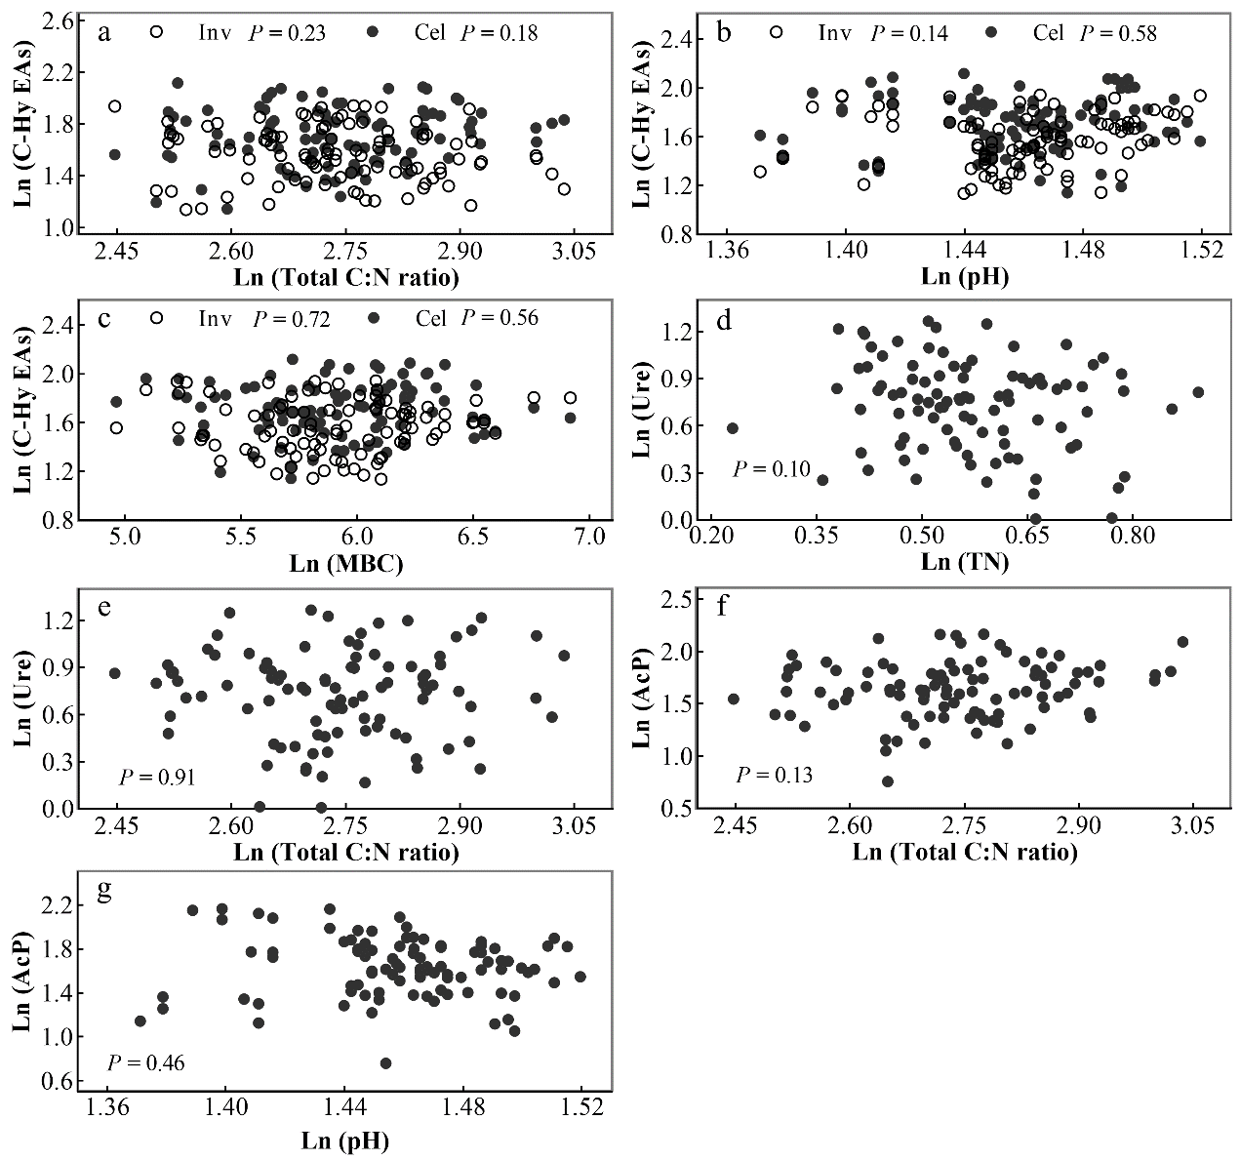Fig. S1 The relationships between the soil invertase (Inv) and cellulase (Cel) activities with soil C:N ratio, pH and microbial biomass carbon (MBC) concentration; between the soil urease (Ure) activity with soil total N (TN) concentration and C:N ratio, and between the soil acid phosphatase (AcP) activity with soil C:N ratio and pH. The parameters were Ln-transformed to maintain the same order of magnitude.

