How do we Calculate Sample Size?
Based on a formula in book “Oxford hand book of medical statistics”
We used a power of 99%, two tails test and 95% confidence level with 1:1 allocation ratio. Each treatment arm requires thirty-four patients , K =18.4[1,2].
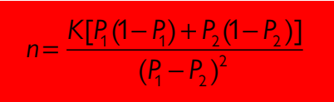
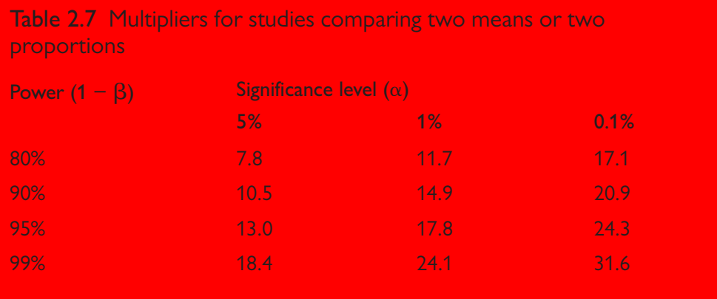
P1=0.92. Federico et al. Found that the eradication rate based on ITT was 0.92 % in modified concomitant levofloxacin-containing therapy.[3]
P2=0.5 We used tinidazole instead of metronidazole in the doxycycline-bismuth regimen for the first time, so we assumed that the eradication rate was 0.5 which give us the largest sample size. [4,5]
$$n=k×\frac{0.92×(1-0.92)+0.5×(1-0.5)}{{(0.92-0.5)}^{2}}$$
$$n=k×\frac{0.92×0.08+0.5×0.5}{{(0.92-0.5)}^{2}}$$
$$n=k×\frac{0.0736+0.25}{0.1764}$$
$$n=k×\frac{0.3236}{0.1764}$$
$$n=K×1.8344671201$$
$$33.7531=18.4×1.8344671201$$

We added five patients to each group to compensate for the predicted dropout. [6,7]
The final sample size is 39 patients in each group

Refrence:
1. Peacock JL, Peacock PJ. Oxford Handbook of Medical Statistics [Internet]. 2nd ed. Oxford Handbook of Medical Statistics. Oxford University Press; [cited 2021 Feb 11]. Available from: https://oxfordmedicine.com/view/10.1093/med/9780198743583.001.0001/med-9780198743583
2. Whitley E, Ball J. Statistics review 4: Sample size calculations. Crit Care. 2002;6:335–41.
3. Federico A, Nardone G, Gravina AG, Iovene MR, Miranda A, Compare D, et al. Efficacy of 5-day levofloxacin-containing concomitant therapy in eradication of Helicobacter pylori infection. Gastroenterology. 2012;143:55-61.e1; quize e13-14.
4. Martínez-Mesa J, González-Chica DA, Bastos JL, Bonamigo RR, Duquia RP. Sample size: how many participants do I need in my research? Anais Brasileiros de Dermatologia. scielo; 2014;89:609–15.
5. Omair A. Sample size estimation and sampling techniques for selecting a representative sample. Journal of Health Specialties. Wolters Kluwer Medknow Publications; 2014. p. 142–7.
6. Gupta K, Attri J, Singh A, Kaur H, Kaur G. Basic concepts for sample size calculation: Critical step for any clinical trials! Saudi J Anaesth. 2016;10:328–31.
7. Sakpal TV. Sample Size Estimation in Clinical Trial. Perspect Clin Res. 2010;1:67–9.

