Title: Spatial-temporal Patterns of Early Afterdepolarizations Underlying T wave Abnormalities in a Tissue Model of the Purkinje-Ventricular System
Supplementary Materials
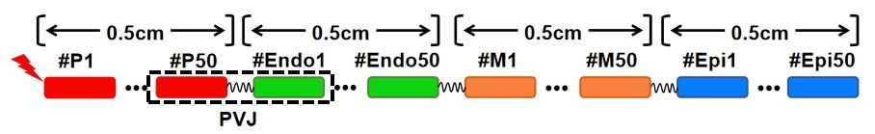
Figure S1 Model schematic of the one-dimensional (ID) Purkinje-ventricular system (PVS) tissue model with 200 electrically coupled cells (4 cell types; 50 cells per cell type) 2 cm in length. Conduction velocities (CV) and conduction delay (CD) at the Purkinje-ventricular junction (PVJ) were adjusted according to experimental measurements^{1,2}.

References:
- Veenstra, R. D., Joyner, R. W., & Rawling, D. A. (1984). Purkinje and ventricular activation sequences of canine papillary muscle. Effects of quinidine and calcium on the Purkinje-ventricular conduction delay. Circulation research, 54(5), 500–515.
- Wiedmann, R. T., Tan, R. C., & Joyner, R. W. (1996). Discontinuous conduction at Purkinje-ventricular muscle junction. The American journal of physiology, 271(4 Pt 2), H1507–H1516.

