Supplementary Material

In vitro biosynthesis of Ag, Au and Te-containing nanostructures by Exiguobacterium cell-free extracts
Orizola J., Ríos-Silva M., Muñoz-Villagrán C., Vargas E., Vásquez C. and Arenas F.

Correspondence to: Felipe A. Arenas
E-mails: felipe.arenass@usach.cl

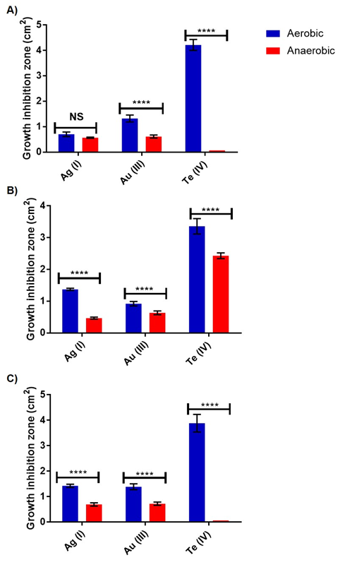
Figure 1S. Growth inhibition zones of the strains belonging to the Exiguobacterium genus exposed to Ag(I), Au(III) and Te(IV). Growth inhibition areas for E. acetylicum MF03 [A], E. aurantiacum MF06 [B] and E. profundum MF08 [C] were determined under aerobic (blue) and anaerobic (red) growth conditions. Bars indicate an average of 6 independent tests ± standard deviation. ****, Indicates significant statistical difference (p <0.0001) and ns, not significant.

