Supplementary Information

Insight into cellular uptake and transcytosis of peptide nanoparticles in a generalist caterpillar.

**Erin McGraw¹, ** Jonathan D Roberts¹, Nitish Kunte¹, Matthew Westerfield¹, Xavier Streety¹, David Held² and L. Adriana Avila¹*.

¹Department of Biological Sciences, Auburn University, Auburn, AL36849, USA.
² Department of Entomology and Plant Pathology, Auburn University, Auburn, AL, USA.

*Corresponding author: adriana.avila@auburn.edu
** E. McGraw and J.D. Roberts made equal contributions.

.

Supplementary Figure S1. Flow cytometry gating strategy. Upon treatments, SF9 cells were washed and stained with 7AAD dye and analyzed using flow cytometry. First, cells were selected based on size by plotting SSC vs FSC, then selection of singlet cells by applying FSC-height vs FSC-area and lastly, viable cells were quantified using 7-AAD (negative).

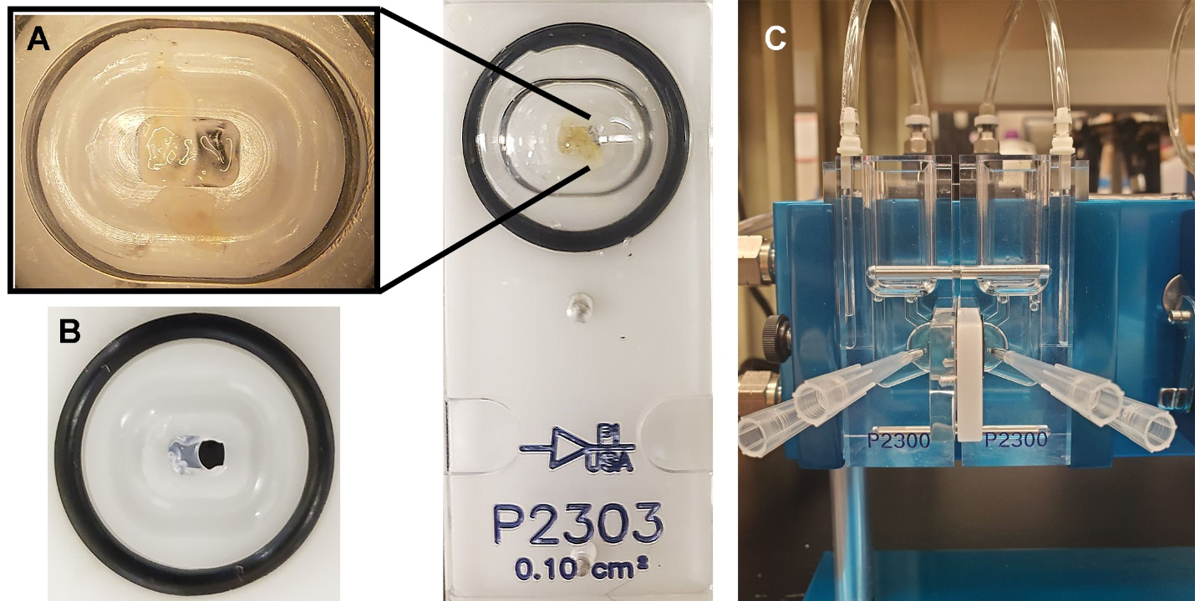
Supplementary Figure S2. Photo of Ussing chamber set-up. A) Tissues were mounted on modified 0.1cm² slide. B) Sliders were modified by coating approximately half of the area with a clear enamel. C) Full final set-up of Ussing chamber.

C

Supplementary Figure S3. SF9 cell viability assay. A) and B) The effect of endocytosis inhibitors on oxidative stress. C) Viability of SF9 cells using 7-AAD viability dye treated with endocytosis inhibitors. Concentrations tested: 5mM M-β-CD, 50µM Nystatin, 10µg/mL CPZ, 80µM Dynasore, or 4µM Cytochalasin and 50µM BAPCs with 2.5µg dsRNA for 30 min.

