Additional information

High Glucose Diet Attenuates Dopaminergic Neuronal Function
in C. elegans Leading to Acceleration of Aging Process

Arvie Camille V. de Guzman, Eun Ji Kim, Joong Hee Cho, Jin Ho Kim, and Shin Sik Choi

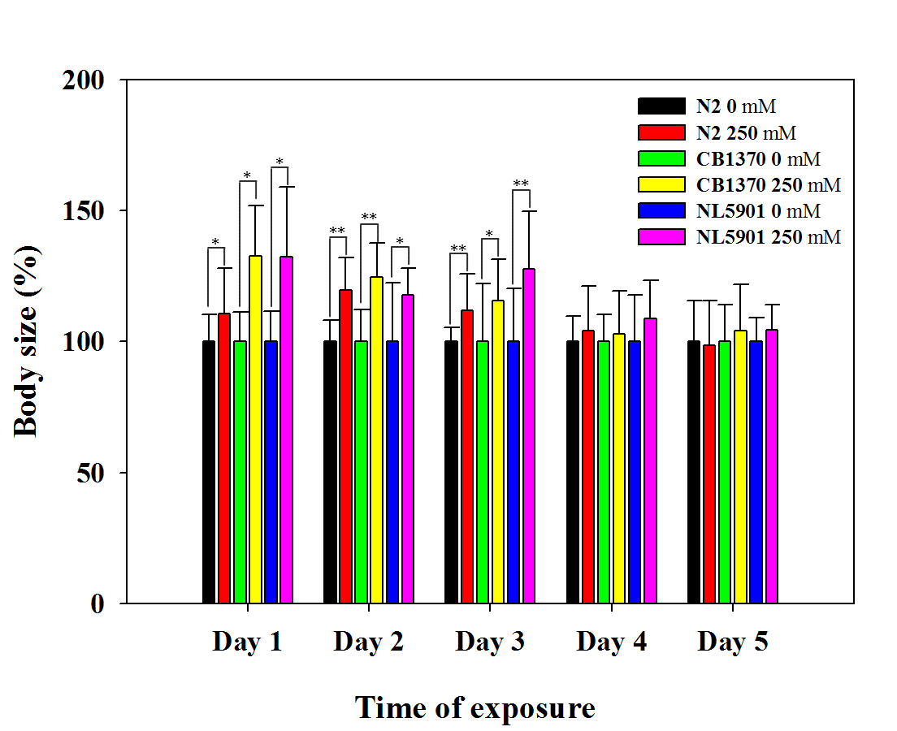

Additional file 1. Increase in the body size of all strains upon 250 mM glucose feeding. Increase in the body sizes were observed from days 1 to 3 and levels off on Day 4 and 5. Sudden increase in the body size indicates advanced aging.

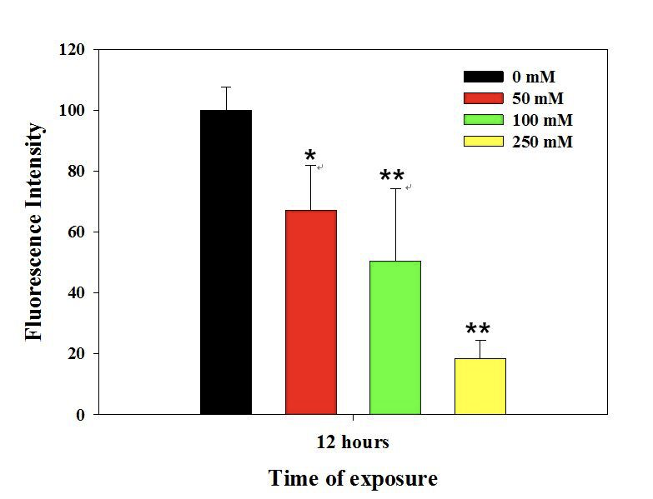
Additional file 2. Glucose concentration-dependent and neuronal cell-specific degeneration of the dopaminergic neurons. Worms were exposed to different concentrations of glucose ranging from 50 to 250 mM for 12 h to observe the degradation of dopaminergic neurons. Among dopaminergic neurons, ADE neurons were more dominantly degenerated by a high glucose diet.

Additional file 3. Basal Slowing Response of control N2 worms (not treated with glucose diet; “non-food” plate). During the BSR assay, worms that were not treated with glucose exhibited normal body movement when placed in a “non-food plate”.

Additional file 4. Basal Slowing Response of control N2 worms (not treated with glucose diet; “on-food” plate). During the BSR assay, worms that were not treated with glucose tend to slow down as they approach the bacterial lawn. Slower body movements of C. elegans was recorded when placed in an “on-food plate”.

Additional file 5. Basal Slowing Response of glucose-treated N2 worms (treated with glucose diet; “non-food” plate). During the BSR assay, worms that were not treated with glucose exhibited normal body movement when placed in a “non-food plate”.

Additional file 6. Basal Slowing Response of glucose-treated N2 worms (treated with glucose diet; “on-food” plate). During the BSR assay, worms that were treated with glucose did not exhibit any change in their movements as they approached the bacterial lawn. There were no significant changes in the worms’ body movements on- and off- food were recorded when placed in an “on-food plate”.

