Supplementary Information for
Momentum-resolved electronic band structure and offsets in an epitaxial NbN/GaN superconductor/semiconductor heterojunction

Tianlun Yu & John Wright, et al.

GaN band bending
The Ga 3d core level shows a clear energy shift as a function of hv between 350 eV to 1250 eV as shown in Fig. 5a, while the Nb 4s core level not only exhibits an approximately constant peak position, but also identical line shape. This indicates that the band bending occurs in the GaN layer, causing a shift of the Ga 3d peak of ~80 meV in our hv range (Fig. 5b). Using our deconvolution method as described in the Methods section, the U(z) profile was extracted based on the simple approximation U(z) ~ z² near the interface, as summarized in Fig. 4c, assuming that the VBM position at ~ 1 nm from the interface is equal to the experimental value -2.49 eV (Fig. 5c). Though the confidence region appears large, the determined U(z) clearly shows an upwards band bending consistent with the downward energy shift of the Ga 3d peak. The variation of U(z) by ~300 meV over a distance of ~6 nm from the interface is only ~1/3 of that observed in other GaN-based heterojunctions such as the GaN/GaAlN¹ where U(z) at the interface end is pulled down by the polarization charge and its variation with z is sharpened by a high density of the mobile electrons accumulated in the interfacial quantum well. The smoothness of this U(z) explains why the experimental band dispersions in NbN/GaN appear significantly sharper compared to those in GaN/GaAlN measured at essentially the same hv.

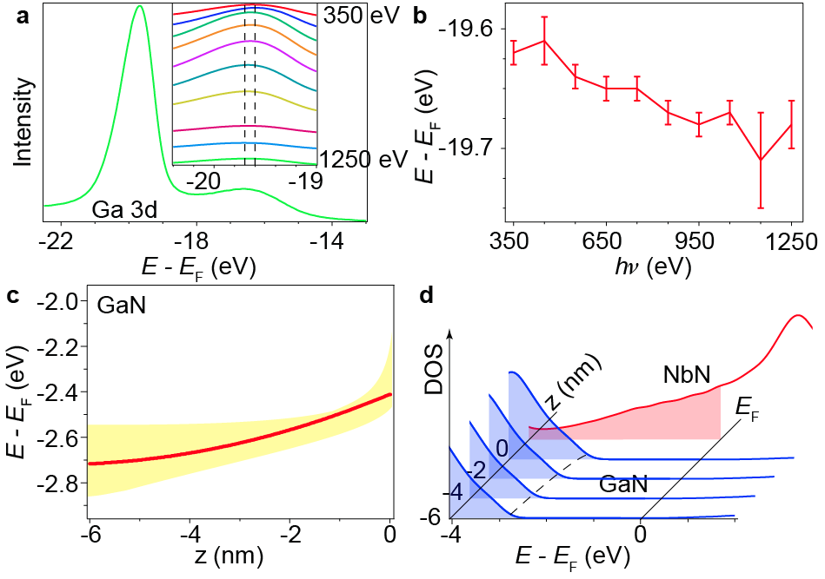
Fig. 5: The band bending in the NbN/GaN heterojunction. a, The energy-dependent core level of Ga 3d. b, The core level peak position vs hv. The error bar is determined by the E_{F} measurements before and after the core level measurement. c, The depth profile of the band bending. The yellow shading represents the confidence region and the red line is the optimum profile, assuming that the VBM position at ~ 1 nm from the interface is equal to the experimental value -2.49 eV. d, The bend profile of GaN/NbN heterojunction. The CBM of GaN is estimated by the calculation and the band bending profile extracted by experiments.

GaN band structure comparison
We present the data from Fig. 3 in the main text with the SX-ARPES and calculated band structure from GaN side-by-side for detailed comparison.

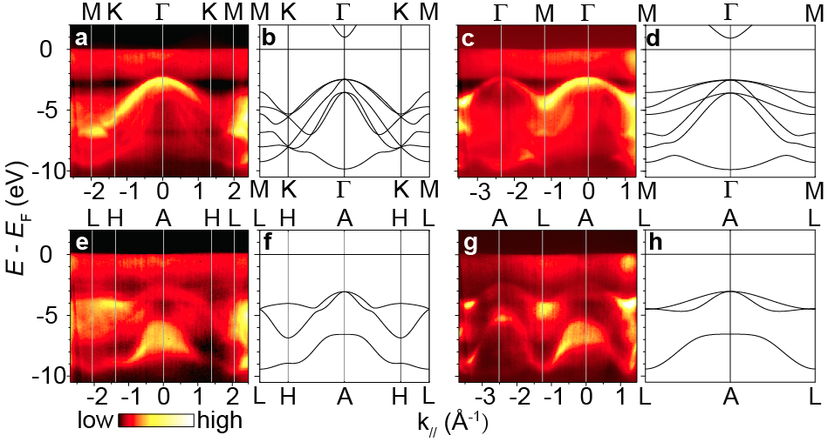
Fig. 6: Comparison between the SX-ARPES and DFT band structure of GaN.

Reference
- Lev, L. L. et al. k-space imaging of anisotropic 2D electron gas in GaN/GaAlN high-electron-mobility transistor heterostructures. Nat. Commun. 9, 2653 (2018).

