Table 1. Partial correlation coefficient of each question item
Question item | Partial correlation coefficient
Years of working experience | 0. 382
The duty number of times | 0. 381
The number of radiological technologist | 0. 353
Male-female divide | 0. 259
The change of job number of times | 0. 244
Sexual harassment | 0. 223
Overtime work | 0. 219
Digestibility of the paid vacation | 0. 195

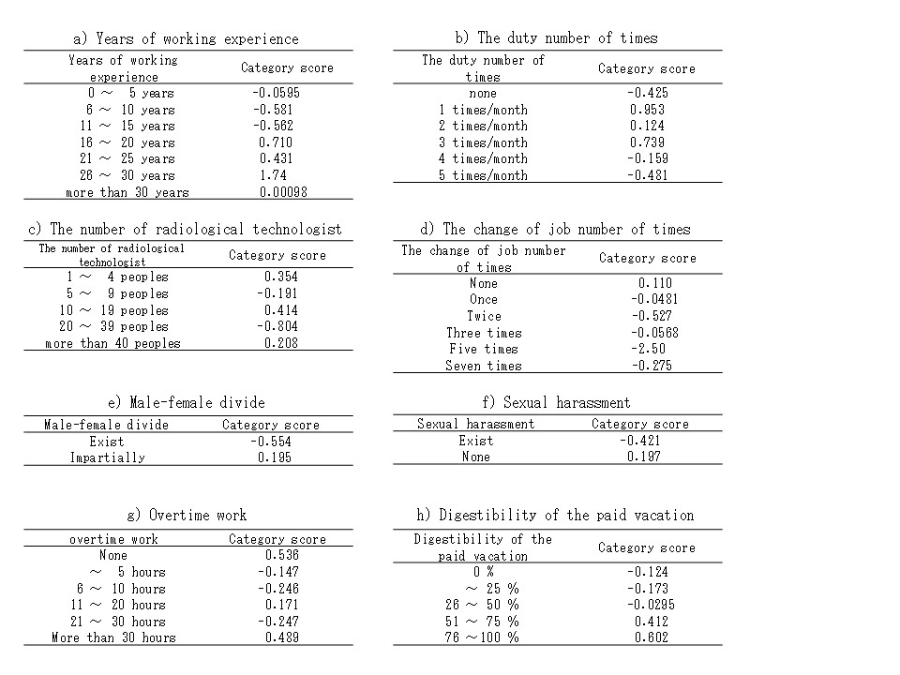
Table 2. Degree of the influence between job satisfaction and question items

