Supplementary material
Using short read sequencing to characterise balanced reciprocal translocations in pigs - Bouwman et al.
Supplementary Figure 1 – page 1
Supplementary Table 1 – page 2
Supplementary Figure 2 – page 3-5

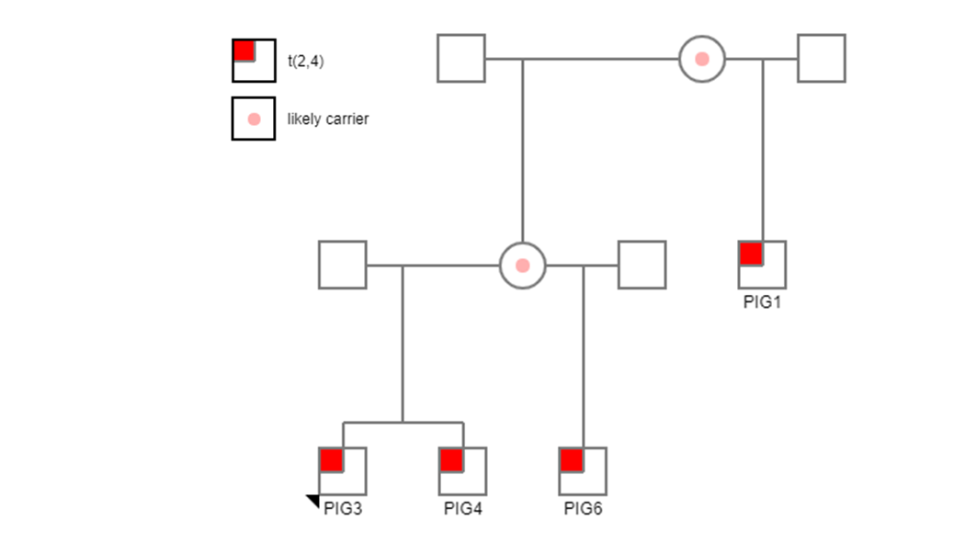
Supplementary Figure 1. Pedigree of t(2,4) carriers Pig 1, 3, 4, and 6. Circles represent females, squares represent males. The red square indicates positive t(2,4) reciprocal translocation carrier based on Giemsa staining, whereas, pink circles indicate likely t(2,4) carrier parent that transmitted the RT.

Supplementary Table 1. Results of reduced sequencing depth, with both strict and relaxed filtering criteria
Animal |  | PIG1 | PIG2 | PIG3 | PIG4 | PIG5 | PIG6 | PIG7
Karyotype |  | t(2;4) | t(6;8) | t(2;4) | t(2;4) | t(7;14) | t(2;4) | t(1;16)
10 fold | Coverage | 10.2 | 11.9 | 10.5 | 11.0 | 11.7 | 9.8 | 9.5
Strict¹ | DELLY out | 18,772 | 26,448 | 22,308 | 25,634 | 18,809 | 14,042 | 20,364
filtering | Basic filt | 146 | 267 | 166 | 168 | 209 | 139 | 146
 | Final filt³ | 4(2) | 6(3) | 0 | 2(1) | 4(2) | 0 | 4(2)
 | Visual insp | 0 | 0 | 0 | 0 | 0 | 0 | 0
10 fold | Basic filt | 2739 | 3939 | 3007 | 3084 | 3675 | 2710 | 2831
Relaxed² | Final filt³ | 32(16) | 24(12) | 28(14) | 26(13) | 40(20) | 8(4) | 28(14)
filtering | Visual insp | 0 | 0 | 0 | 0 | 1(7,14) | 0 | 0
15 fold | Coverage | 16.8 | 19.5 | 17.2 | 18.1 | 19.2 | 16.1 | 15.6
Strict¹ | DELLY out | 34556 | 46817 | 40754 | 45934 | 44923 | 35662 | 37186
filtering | Basic filt | 405 | 598 | 463 | 479 | 548 | 423 | 429
 | Final filt³ | 8(4) | 16(8) | 12(6) | 18(9) | 24(12) | 4(2) | 14(7)
 | Visual insp | 0 | 0 | 0 | 0 | 1(7,14) | 0 | 0
15 fold | Basic filt | 5854 | 7769 | 6316 | 6537 | 7465 | 5738 | 6009
Relaxed² | Final filt³ | 46(23) | 62(31) | 46(23) | 54(27) | 60(30) | 44(22) | 52(26)
filtering | Visual insp | 0 | 1(6,8) | 1(2,4) | 1(2,4) | 1(7,14) | 1(2,4) | 0
20 fold | Coverage | 20 | 23.3 | 20.5 | 21.6 | 22.9 | 19.2 | 18.6
Strict¹ | DELLY out | 33034 | 46672 | 39783 | 45198 | 44767 | 34398 | 35871
filtering | Basic filt | 569 | 697 | 549 | 621 | 717 | 554 | 564
 | Final filt³ | 20(10) | 28(14) | 16(8) | 26(13) | 30(15) | 6(3) | 30(15)
 | Visual insp | 0 | 0 | 0 | 0 | 1(7,14) | 0 | 0
20 fold | Basic filt | 7,323 | 9,586 | 7,869 | 8,215 | 9,505 | 7,210 | 7,477
Relaxed² | Final filt³ | 54(27) | 68(34) | 48(24) | 66(33) | 62(31) | 50(25) | 54(27)
filtering | Visual insp | 1(2,4) | 1(6,8) | 1(2,4) | 1(2,4) | 1(7,14) | 1(2,4) | 0
¹ Strict filtering: Basic filtering: Pass DELLY quality filter and precise position; final filtering: mapping quality=60, at least 10 split reads supporting the translocation, ≤60 discordant paired end reads, consensus alignment quality>0.9, and matching second translocation with matching connection type present
² Relaxed filtering: Translocations that failed the quality filter of DELLY (LowQual instead of PASS; basic filtering) and with 5 or more split reads supporting the translocation (final filtering) were retained.
³ one of the filter criteria for the detected inter-chromosomal translocations was the presence of a matching pair, hence between brackets are the number of reciprocal pairs, i.e. the actual number of possible RTs
Pig1
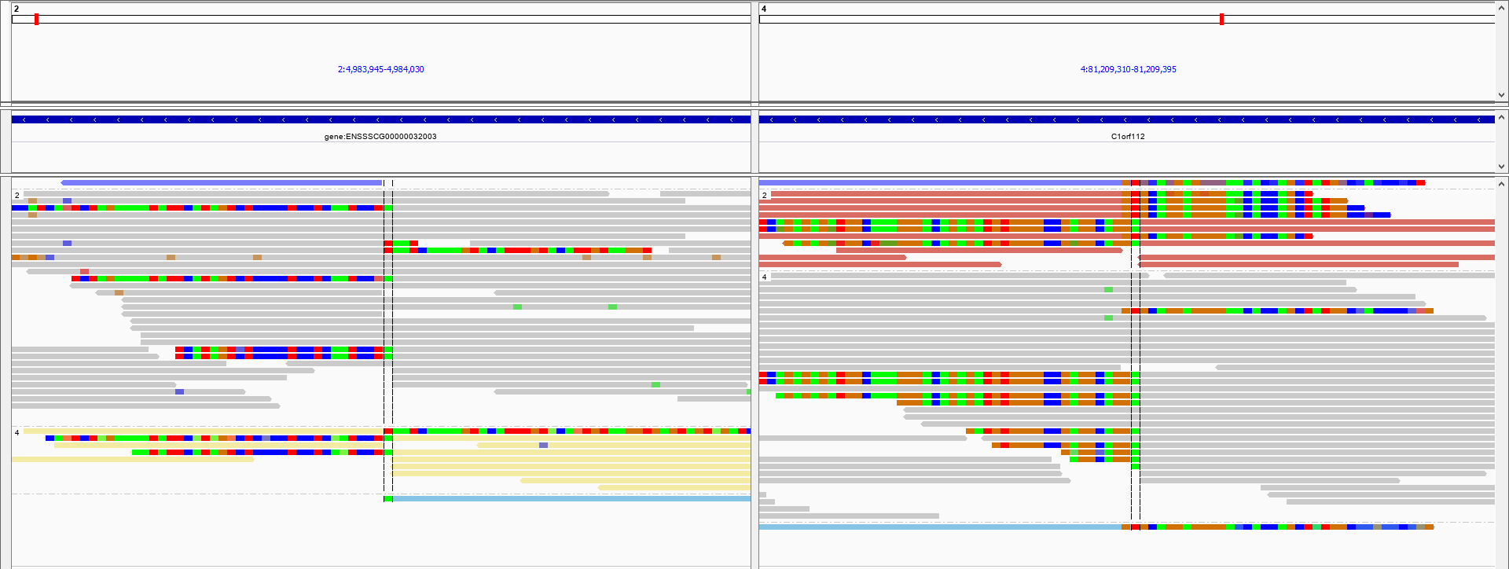
Pig2
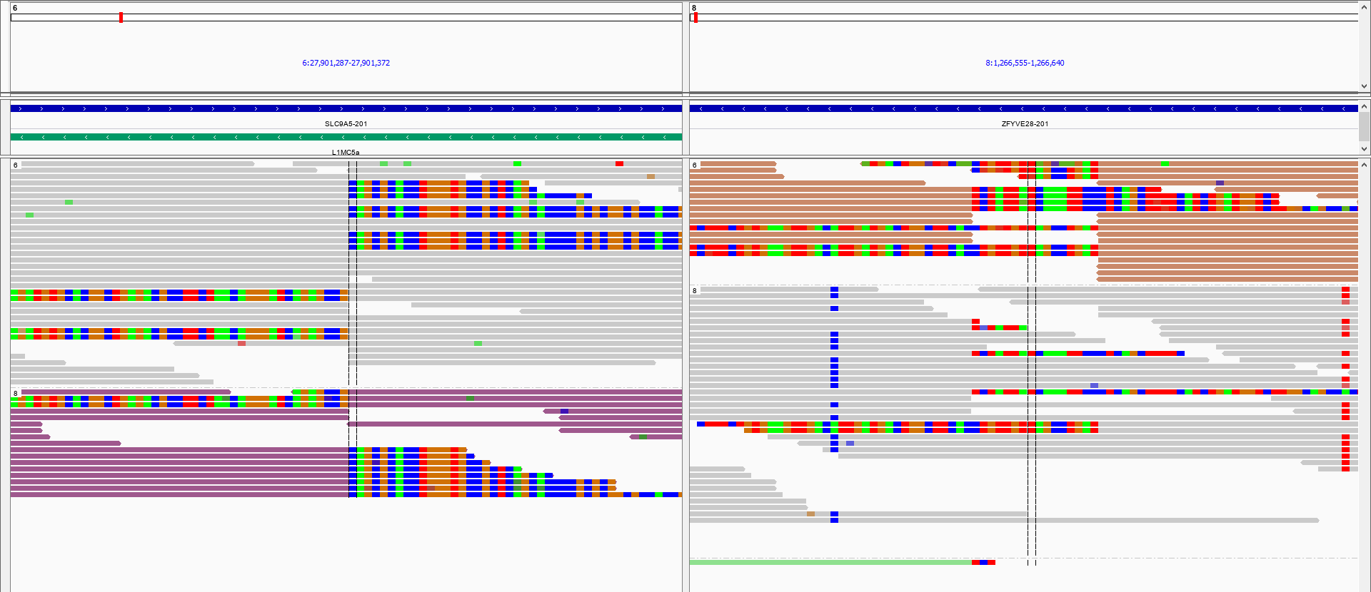
Pig3
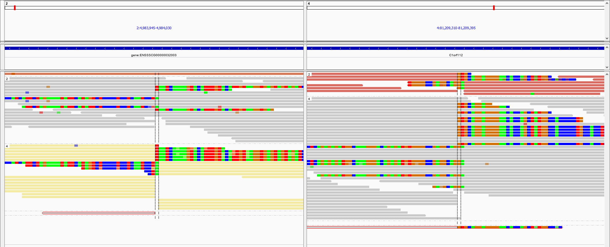

Pig4
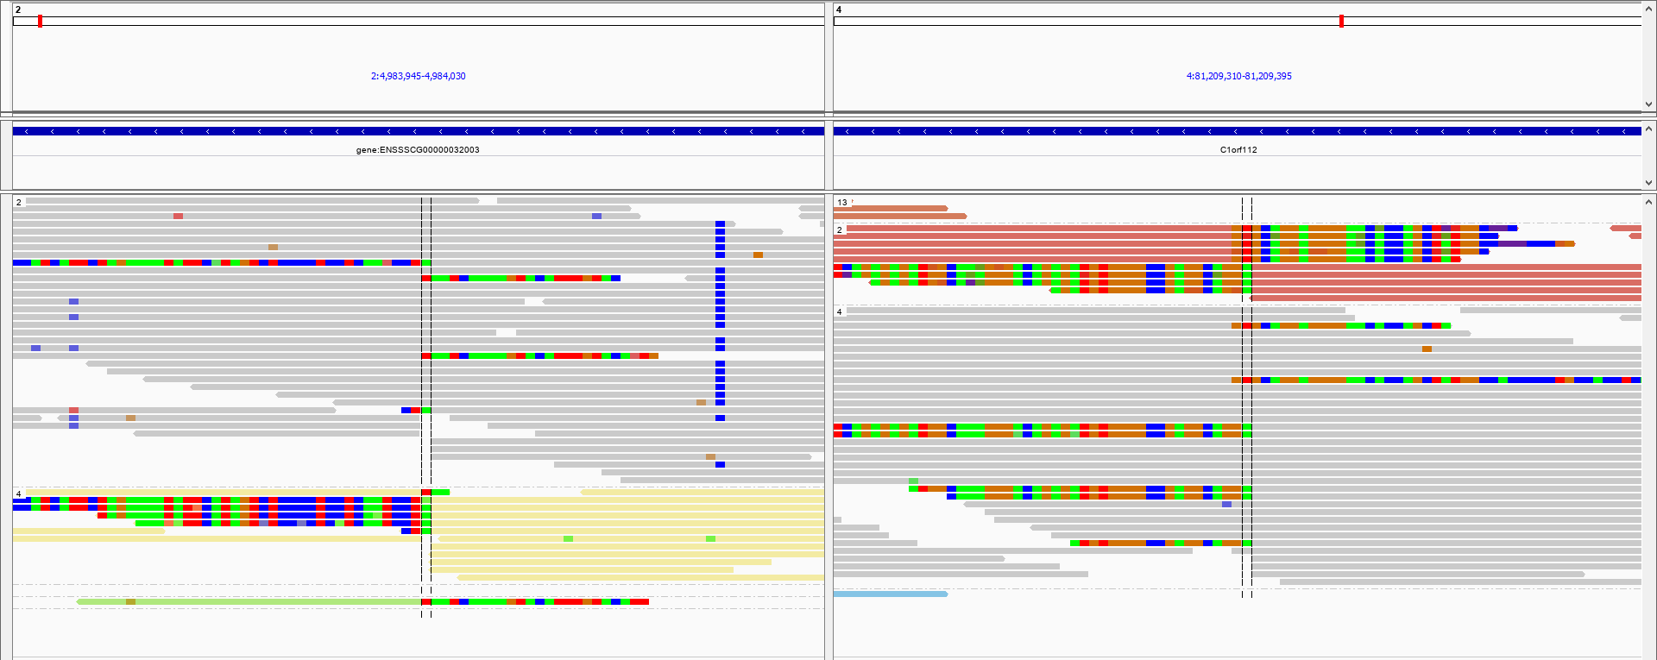
Pig5
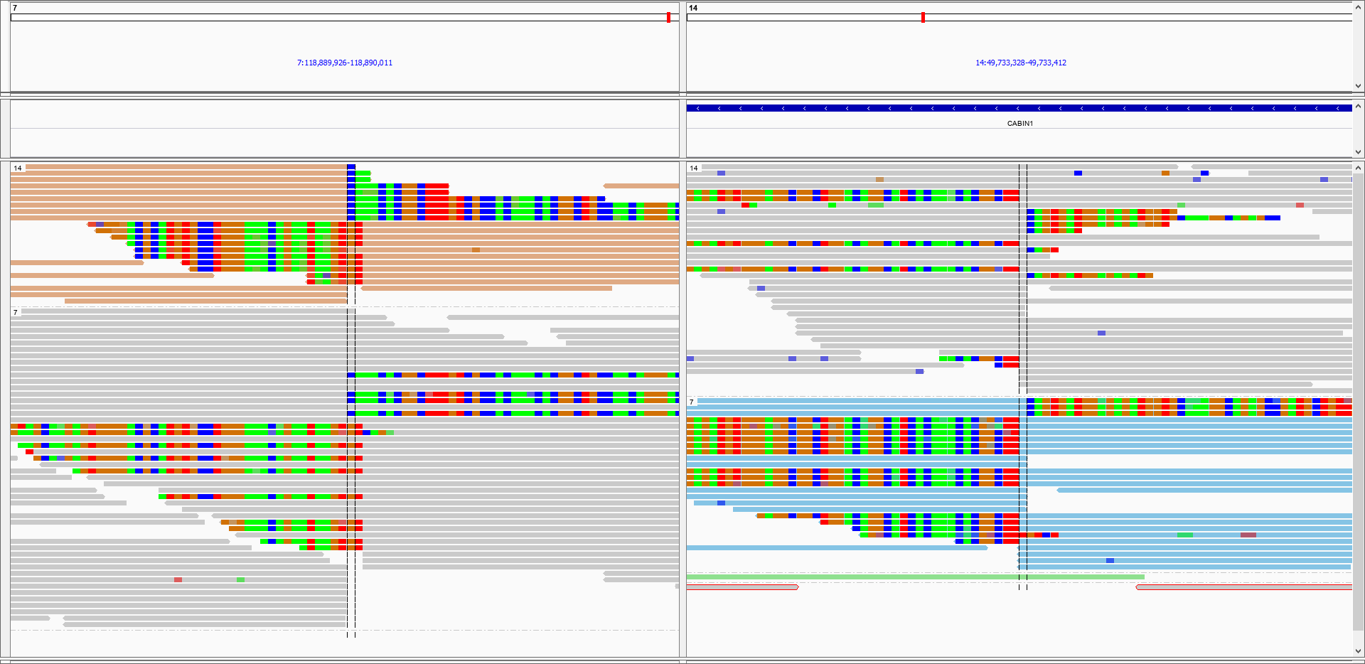
Pig6
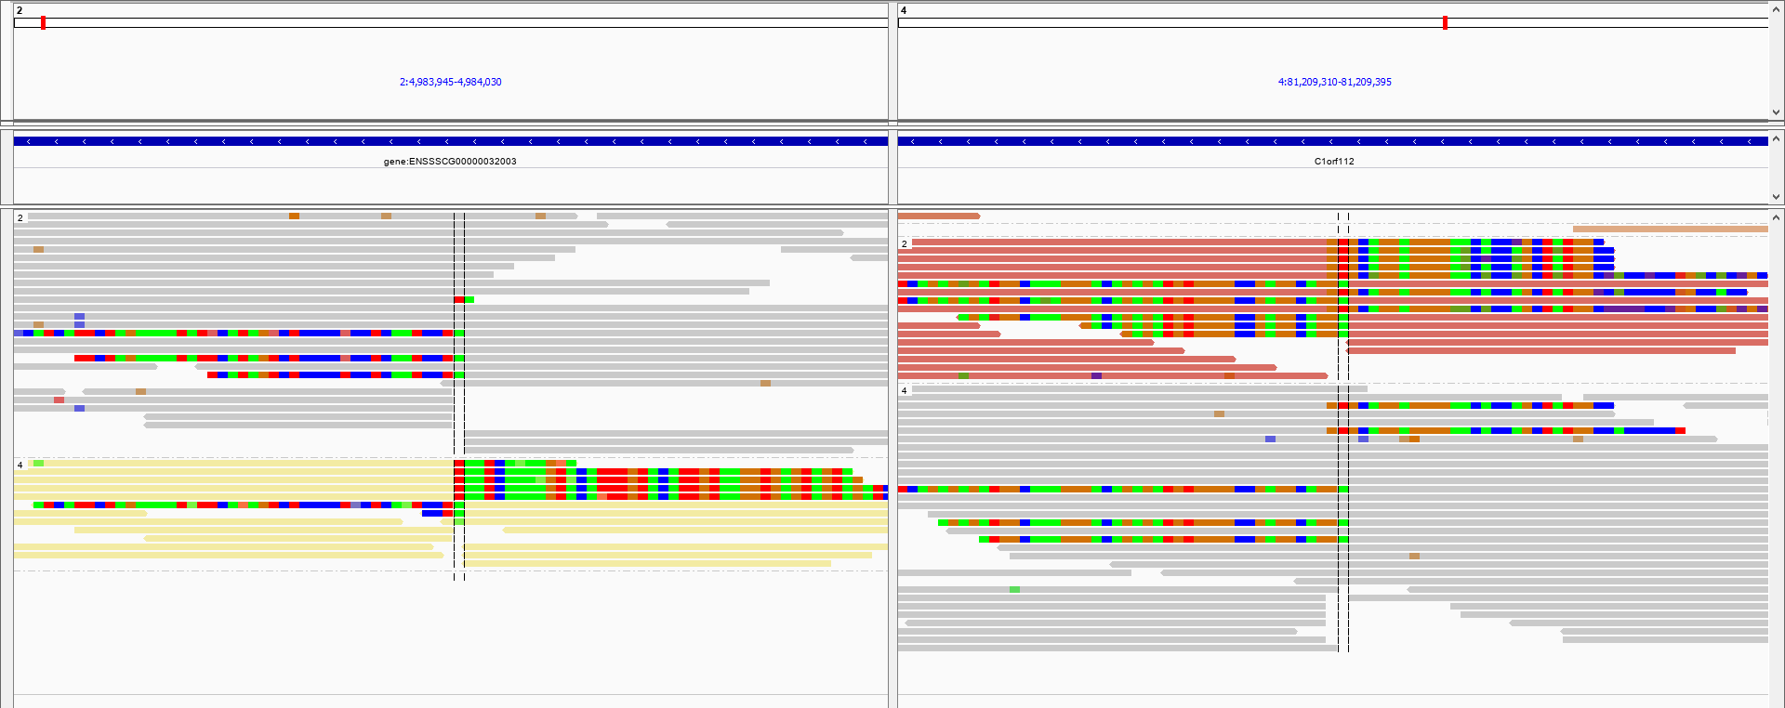
Supplementary Figure 2. IGV images of the aligned reads at the breakends on both chromosomes involved in the reciprocal translocation of each detected RT in 6 of the 7 carriers. Grey reads are normal reads. Colored reads are reads of discordant pairs (mate maps to another chromosome). Green (A), red (T), blue (C) and orange/brown (G) bases show mismatched bases from split reads. In addition, an Ensemble gene spans track (gene positions indicated with blue bars) and RepeatMasker track (repetitive elements indicated with green bars) are given at the top.

