Supplementary material
PIG1

chr2:4983945..4984030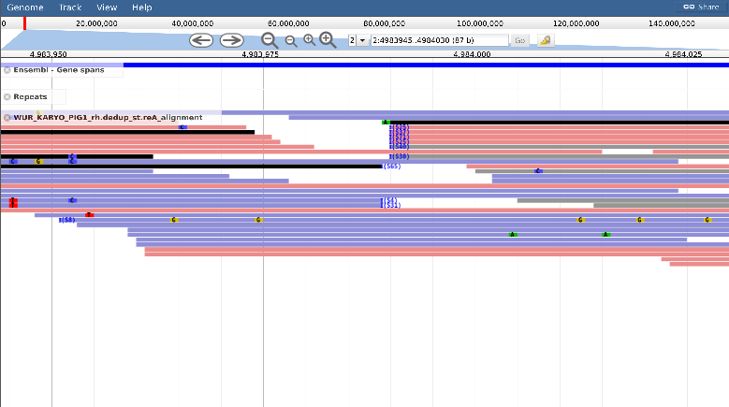

chr4:81209310..81209395
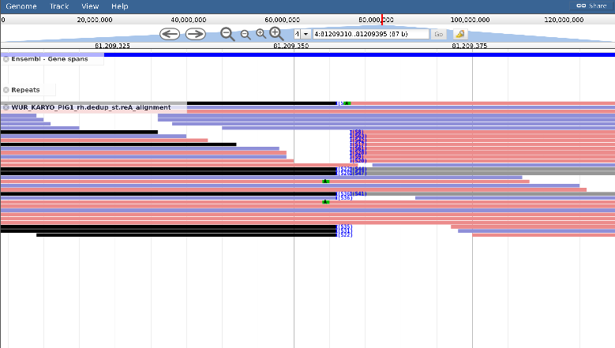

PIG2

chr6:27901287..27901372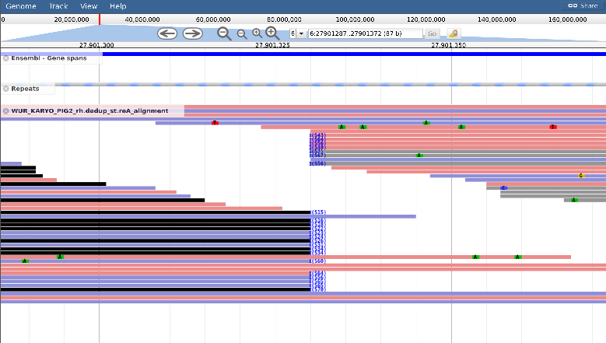

chr8:1266555..1266640
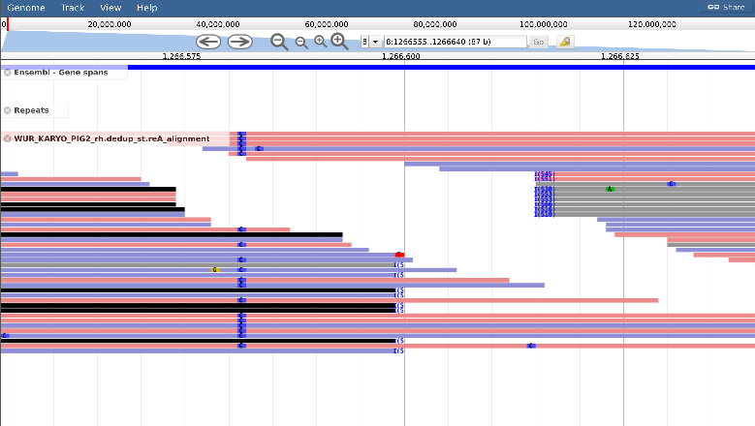

PIG3

chr2:4983945..4984030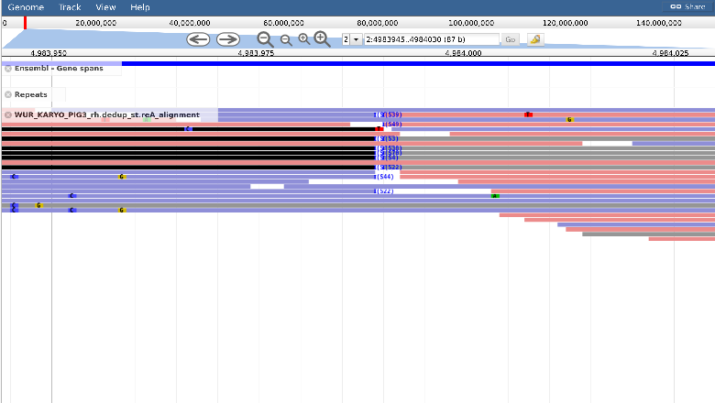

chr4:81209310..81209395
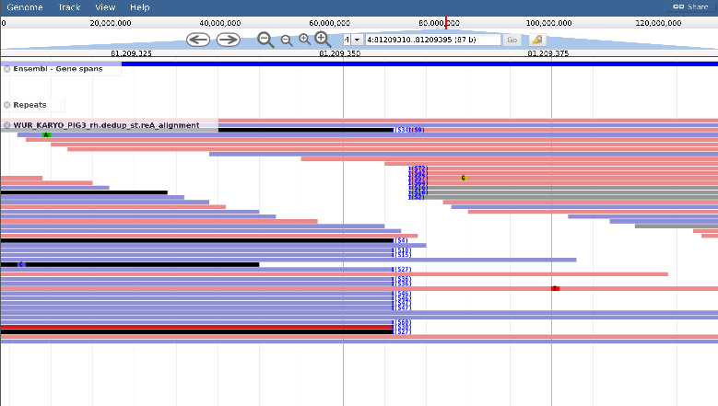

PIG4

chr2:4983945..4984030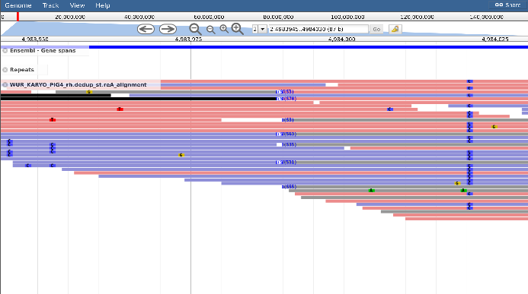

chr4: 81209310..81209395
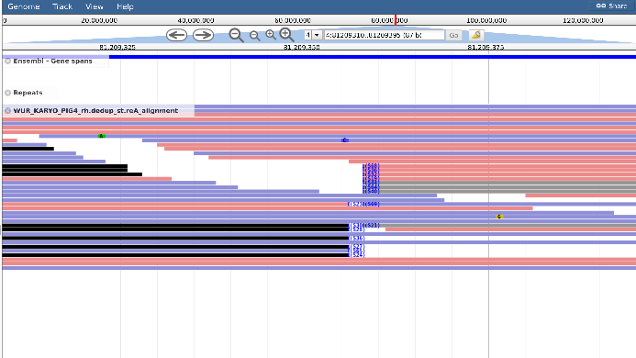

PIG5

chr7:118889926..118890011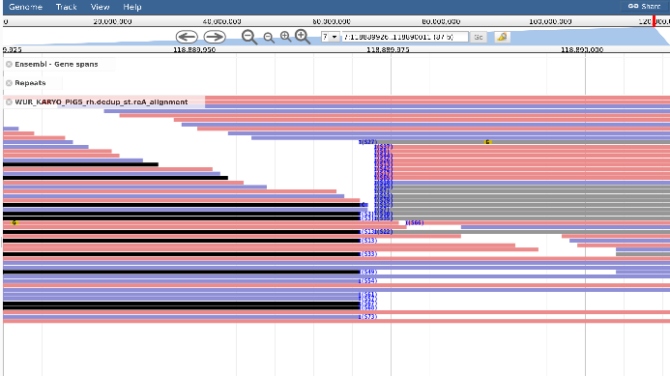
chr14:49733328..49733412
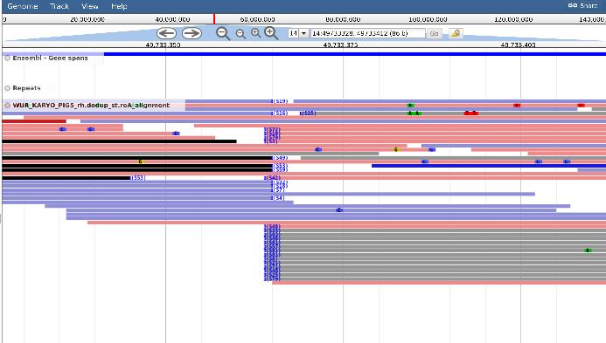

PIG6

chr2:4983945..4984030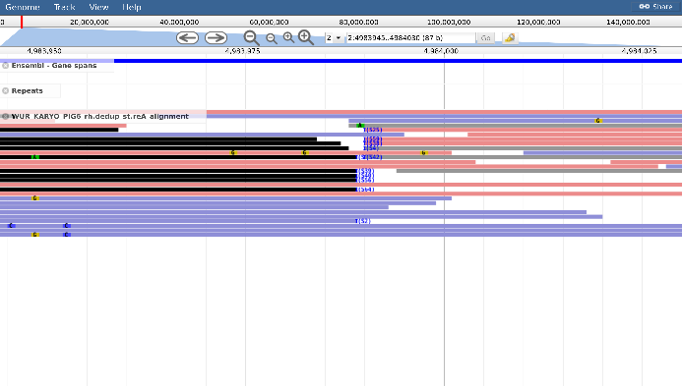
chr 4:81209310..81209395
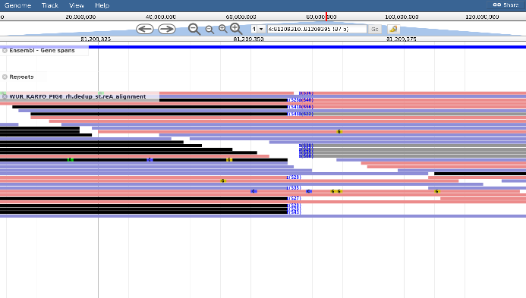
Supplementary Figure 1. JBrowse images of the aligned reads at the breakends on both chromosomes involved in the reciprocal translocation of each detected RT in 6 of the 7 carriers. In addition, an Ensemble gene spans track (gene positions indicated with blue bars) and RepeatMasker track (repetitive elements indicated with grey and blue striped pattern bars) are given at the top. Red reads are forward reads, blue reads are reverse reads, grey reads are reverse reads of a discordant pairs (its forward mate maps to another chromosome), and the black reads are forward reads of discordant pairs (its reverse mate maps to another chromosome).

