Table 1a. Clinical features included in the 3 diagnostic exams and data types
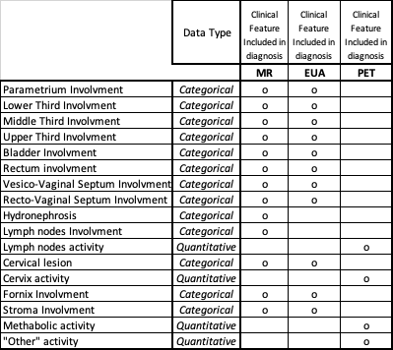
Legend: MR: Magnetic resonance; EUA: Examination under anesthesia; PET: positron emission tomography

Table 1b. Example of a patient’s pattern with convergent and conflicting features
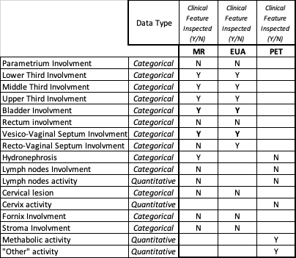
Legend: MR: Magnetic resonance; EUA: Examination under anesthesia; PET: positron emission tomography

