Supplementary materials

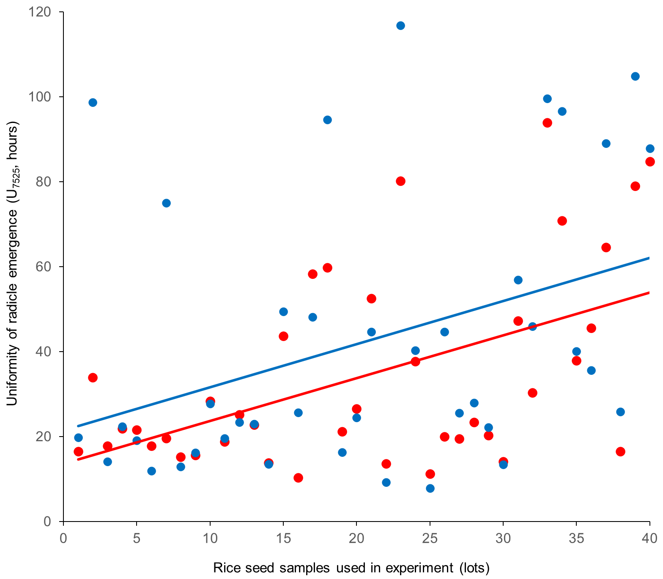

Supplementary material 1. Uniformity of radicle emergence of Indica rice seed after scoring using different methods, where red is visual analysis and blue is the SV-RICE software. Linear regression lines are shown.

Supplementary material 2. Outputs of k-means cluster analysis of 40 rice seed samples used in the experiment.*

Code | Storage time (months) | Storage condition | Maximum radicle emergence (%) | Radicle emergence speed (hours) | Uniformity of radicle emergence (hours) | Area under the curve of the radicle emergence fitted curve | Mean radicle emergence times (hours) | K-mean (K=2) | K-mean (K=3)
A | 0 | Controlled | 98.5 | 75.1 | 28.5 | 209.3 | 78.8 | 1 | 1
B | 0 | Controlled | 80.8 | 184.3 | 107.5 | 86.0 | 164.0 | 2 | 2
C | 0 | Controlled | 95.8 | 80.5 | 22.9 | 194.7 | 82.8 | 1 | 1
D | 0 | Controlled | 92.3 | 76.8 | 31.1 | 192.3 | 81.1 | 1 | 1
E | 0 | Controlled | 91.3 | 78.1 | 27.9 | 193.0 | 81.5 | 1 | 1
F | 0 | Controlled | 95.3 | 57.4 | 20.7 | 218.3 | 60.1 | 1 | 1
G | 0 | Controlled | 91.0 | 90.2 | 83.7 | 171.7 | 97.8 | 1 | 3
H | 0 | Controlled | 93.8 | 68.9 | 21.7 | 201.1 | 71.3 | 1 | 1
A | 6 | Controlled | 100.0 | 64.1 | 25.0 | 229.7 | 67.5 | 1 | 1
B | 6 | Controlled | 100.0 | 76.1 | 36.5 | 215.5 | 81.9 | 1 | 1
C | 6 | Controlled | 99.8 | 69.9 | 28.3 | 223.9 | 73.8 | 1 | 1
D | 6 | Controlled | 100.0 | 66.6 | 32.1 | 227.5 | 71.8 | 1 | 1
E | 6 | Controlled | 96.0 | 73.2 | 31.7 | 212.1 | 77.9 | 1 | 1
F | 6 | Controlled | 100.0 | 49.5 | 22.3 | 245.3 | 53.1 | 1 | 1
G | 6 | Controlled | 98.3 | 80.0 | 58.2 | 202.2 | 89.6 | 1 | 1
H | 6 | Controlled | 98.5 | 59.6 | 34.4 | 217.1 | 65.6 | 1 | 1
A | 6 | Ambient | 97.3 | 114.8 | 56.9 | 167.6 | 120.6 | 1 | 3
B | 6 | Ambient | 92.3 | 144.7 | 103.4 | 129.1 | 138.2 | 2 | 3
C | 6 | Ambient | 99.5 | 83.4 | 25.0 | 210.6 | 86.0 | 1 | 1
D | 6 | Ambient | 99.5 | 72.3 | 33.2 | 221.1 | 77.5 | 1 | 1
E | 6 | Ambient | 98.0 | 104.0 | 53.4 | 181.2 | 110.9 | 1 | 3
F | 6 | Ambient | 99.0 | 54.5 | 18.0 | 238.4 | 56.8 | 1 | 1
G | 6 | Ambient | 48.3 | 219.3 | 155.6 | 42.3 | 154.7 | 2 | 2
H | 6 | Ambient | 98.8 | 80.5 | 49.0 | 203.7 | 88.5 | 1 | 1
A | 12 | Controlled | 98.0 | 74.9 | 16.6 | 206.6 | 76.3 | 1 | 1
B | 12 | Controlled | 97.0 | 88.4 | 53.4 | 191.9 | 96.6 | 1 | 1
C | 12 | Controlled | 99.3 | 79.4 | 34.3 | 208.2 | 84.3 | 1 | 1
D | 12 | Controlled | 99.5 | 77.1 | 36.7 | 208.5 | 82.9 | 1 | 1
E | 12 | Controlled | 95.5 | 78.2 | 30.9 | 195.8 | 82.4 | 1 | 1
F | 12 | Controlled | 100.0 | 61.0 | 22.1 | 230.2 | 63.9 | 1 | 1
G | 12 | Controlled | 94.3 | 102.2 | 65.6 | 166.6 | 109.9 | 1 | 3
H | 12 | Controlled | 100.0 | 77.7 | 54.7 | 202.7 | 85.1 | 1 | 1
A | 12 | Ambient | 72.3 | 203.8 | 108.3 | 66.0 | 173.7 | 2 | 2
B | 12 | Ambient | 48.0 | 195.9 | 105.3 | 48.5 | 170.4 | 2 | 2
C | 12 | Ambient | 98.8 | 112.0 | 48.9 | 177.2 | 117.8 | 1 | 3
D | 12 | Ambient | 98.8 | 89.2 | 44.4 | 200.3 | 95.8 | 1 | 1
E | 12 | Ambient | 75.0 | 198.4 | 97.8 | 72.8 | 178.0 | 2 | 2
F | 12 | Ambient | 98.8 | 71.5 | 34.6 | 217.7 | 77.0 | 1 | 1
G | 12 | Ambient | 4.5 | 214.4 | 113.6 | 4.3 | 171.5 | 2 | 2
H | 12 | Ambient | 93.5 | 133.4 | 96.6 | 143.1 | 129.8 | 2 | 3

* Values represent the arithmetic mean of radicle emergence indices from SV-RICE package after storage for 0, 6 and 12 months under controlled and ambient conditions.

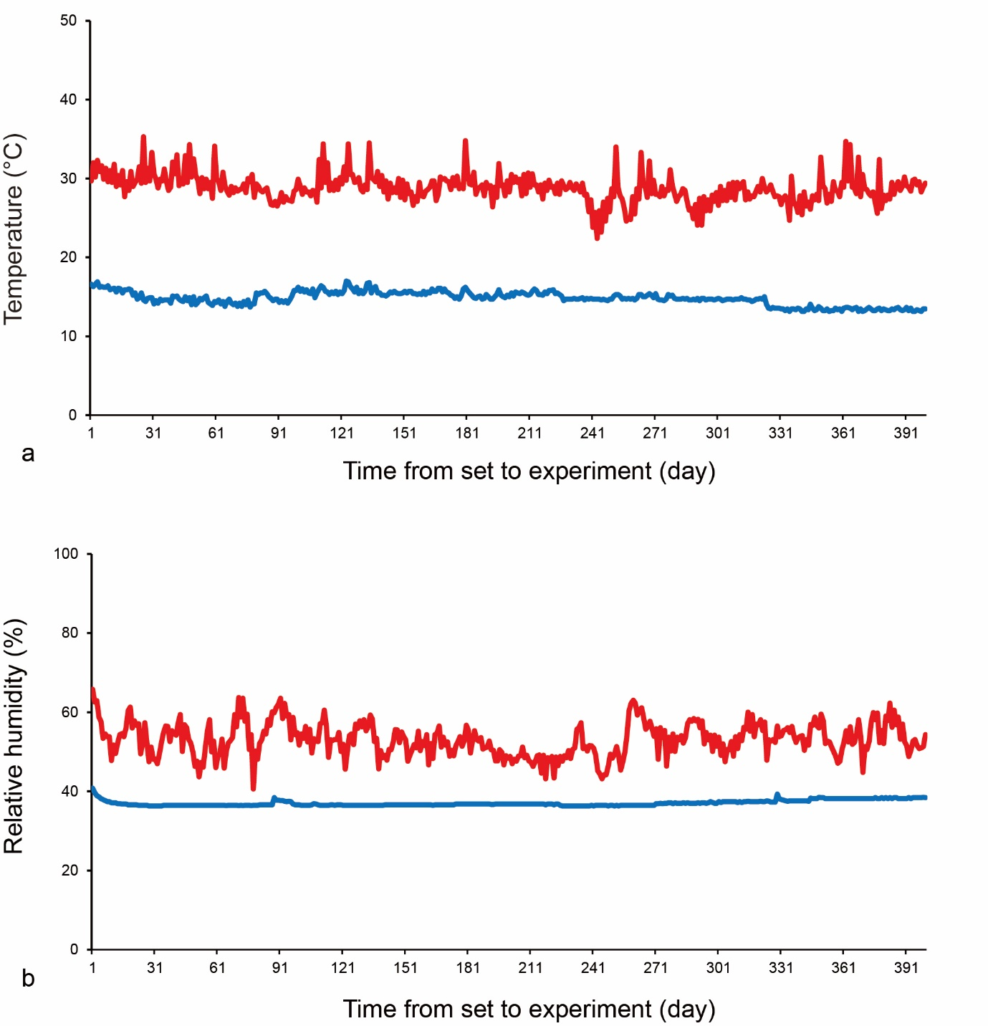

Supplementary material 3. Changes in temperature (a) and relative humidity (b) during storage under different conditions. Storage in GrainPro® bag and controlled atmosphere chamber (blue line), storage in polyethylene bag and ambient conditions on a laboratory bench (red line).

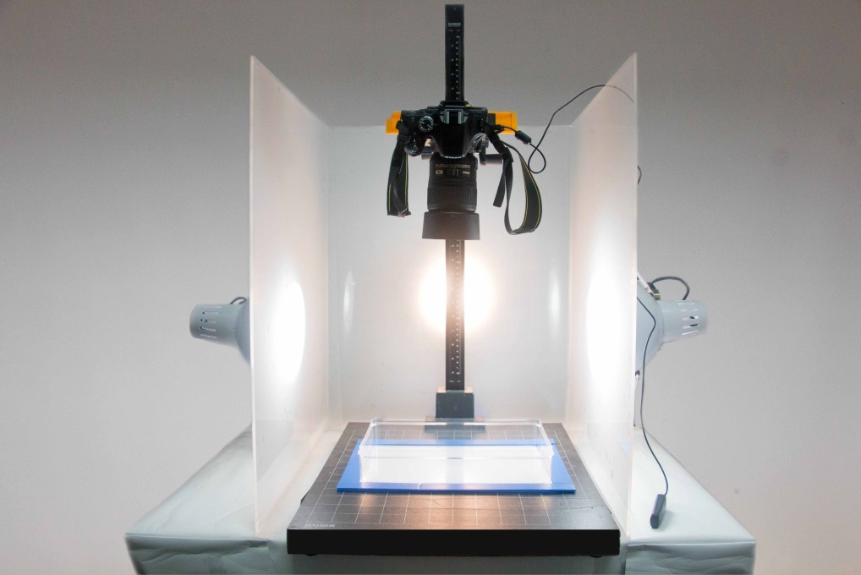

Supplementary material 4. Colour imaging system used in the experiment. Device: Nikon D5200; lens: 40mm f/2.8G; focal Length: 40mm; focus mode: AF-S; aperture: f/16; shutter speed: 1/15s; exposure comp.: +1.7EV; ISO sensitivity: ISO 1000; colour space: sRGB; filter: Nisi DW1 Wide Band Super Pro MC UV filter 52 mm.

