Table 1. AVF function classification

AVF function classification
Year<1
Year≥1

Table 2. Serum ferritin classification
Ferritin classification
Ferritin ≤200
200< Ferritin <500
Ferritin ≥500

Table 3. Hemoglobin classification
Hemoglobin classification
HB<=8
HB>8

Table 4. Classified ratio of serum iron on TIBC

SI/TIBC classification
SI/TIBC <30%
SI/TIBC ≥30%

Table 5. Extracted rules correspond to DT1

AVF Survival | AVF function  <1 / ≥1 | Extracted Rules | SI/TIBC
 |  | If SI/TIBC ≥0/3 and Ferritin≤200 and HB>8 = then (1/3)
57% | 6  8 | If SI/TIBC ≥ 0.3 and 200< Ferritin <500 and HB≤8 = then (1/3) | Greater than or equal to 30%
 |  | If SI/TIBC ≥ 0.3 and Ferritin≥500 = then (4/2)
 |  | If SI/TIBC<0.3 and Ferritin≤200 = then (10/26)
66% | 52  26 | If SI/TIBC<0.3 and 200< Ferritin <500 and HB>8 = then (12/15) | less than 30%
 |  | If SI/TIBC<0.3 and 200< Ferritin <500 and HB≤8 = then (1/1)
 |  | If SI/TIBC<0.3 and Ferritin≥500 = then (3/10)

Table 6. Confusion matrix of DT1; accuracy rate:66.07%

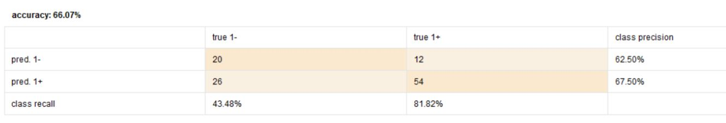

Table 7. Extracted rules correspond to DT2
AVF Survival | AVF function  <1 / ≥1 | Extracted Rules | Ferritin  Classification
70% | 31  13 | If Ferritin≤200 = then (13/31) | Ferritin≤200
 |  | If 200< Ferritin <500 and HB>8 = then (17/18) | 200< Ferritin <500
46% | 26 | If 200< Ferritin <500 and HB≤8 = then (9/5)
63% | 7  12 | If Ferritin≥500 = then (7/12) | Ferritin≥500
23

Table 8. Confusion matrix of DT2; accuracy rate: 62.50%

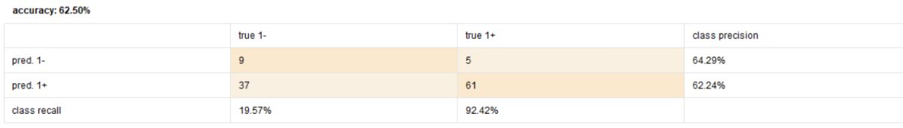

Table 9. Extracted rules correspond to DT3

AVF Survival | AVF function  <1 / ≥1 | Extracted Rules | SI/TIBC
 |  | If SI/TIBC ≥ 0.3 and Ferritin>200 = then (15/9)
56% | 18  14 | If SI/TIBC ≥ 0.3 and Ferritin≤200 and HB>8 = then (1/3) | Greater than or equal to 30%
 |  | If SI/TIBC ≥ 0.3 and Ferritin≤200 and HB<8 = then (2/2)
65% | 52  28 | If SI/TIBC < 0.3 = then (28/52) | less than 30%

Table 10. Confusion matrix of DT3; accuracy rate: 64.29%

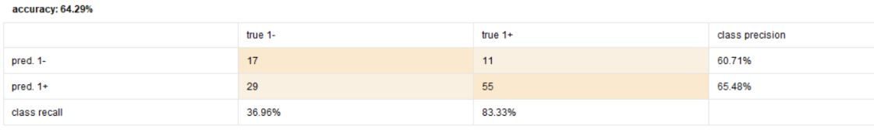

Table 11. Extracted rules correspond to DT4

AVF Survival | AVF function  <1 / ≥1 | Extracted Rules | SI/TIBC
33% | 9  18 | If SI/TIBC ≥ 0.3 and Ferritin≤200 = then (3/5) | Greater than or equal to 30%
 |  | If SI/TIBC ≥ 0.3 and Ferritin>200 = then (15/4)
65% | 52  28 | If SI/TIBC < 0.3 = then (28/52) | less than 30%

Table 12. Confusion matrix of DT4; accuracy rate: 64.29%

